**Profoliofy**

AI-Integrated Online Portfolio Building Platform

* **Vision:**

Profoliofy envisions a world where talent never goes unseen due to technical, financial, or geographic barriers.  
We are building the go-to platform for personal branding in the digital age empowering students, freelancers, and creatives from underserved regions to create beautiful, professional portfolios in minutes, no code, no cost, no complexity.

In a tech landscape dominated by bloated website builders and overpriced tools, we are simplifying the process, lowering the cost, and opening the gates. Our mobile-first, zero-code builder allows users to instantly launch portfolios, while our template marketplace creates income opportunities for designers.

Profoliofy is not just a product, it's a movement to democratize digital identity and unlock global visibility for millions.

* **Business Model:**

1. **Freemium Core:**
   * Users can sign up for free, choose from a curated selection of basic templates, and launch their portfolio on a free subdomain. (e.g., zain.profoliofy.com).
   * The free tier is designed to attract early users and provide actual value not a crippled trial.
2. **Premium Subscription — $10/month:**
   * Unlocks access to all premium templates
   * Removes branding
   * Includes advanced customization options
   * Supports multi-section pages and richer visual layouts
   * Provides more storage and bandwidth
3. **Domain Add-on — $5/month:**
   * Users can link their own custom domain (e.g., fatimaart.com)
   * Includes:
     + Basic SEO tools (meta editing, sitemap generation)
     + Basic analytics dashboard (visits, time spent, traffic source)
   * This tier structure is simple, flexible, and scalable — ideal for students, freelancers, and professionals as they grow.
4. **Creator Revenue Share:**
   * Template designers who submit premium themes receive 20% of the revenue for each month their template is used by a subscriber.
   * This encourages a healthy ecosystem of contributors while keeping design costs low.
5. **Ethical Data Revenue (Optional & Transparent):**
   * We follow strict global standards (GDPR, CCPA) to ensure all data collection is transparent and user-consented.
   * Users can opt in to anonymously share behavioral and design usage data.
   * This anonymized, aggregated data (e.g., template popularity, device usage, layout trends) can be sold to universities, UX research firms, job platforms, and edtech companies — for improving student services, hiring pipelines, or educational design tools.
   * Estimated Revenue Potential (Realistic & Ethical):
     + 100,000 users → 20% opt-in (20,000 users)
     + Monthly value per user to a research buyer: ~$0.05–$0.10
     + Monthly Side Revenue: $1,000–$2,000
     + Annual Side Revenue: $12,000–$24,000
   * This is supplementary and never replaces user-first monetization.
   * Data sales will always be opt-in, anonymized, and purpose-specific

* **ERD Diagram (MVP):**

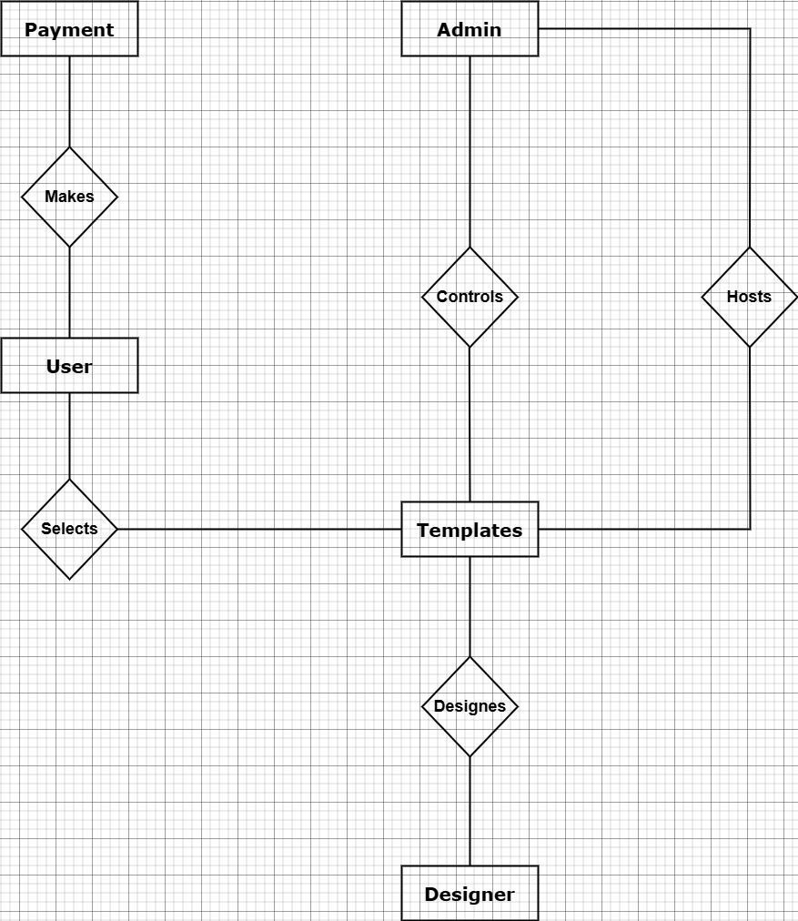

* **Wireframes:**

Following are the complete wireframes, made by **Pencil-Tool** which demonstrate the Website’s flow as well as an exemplary Portfolio Template.

**Website’s Layout:**

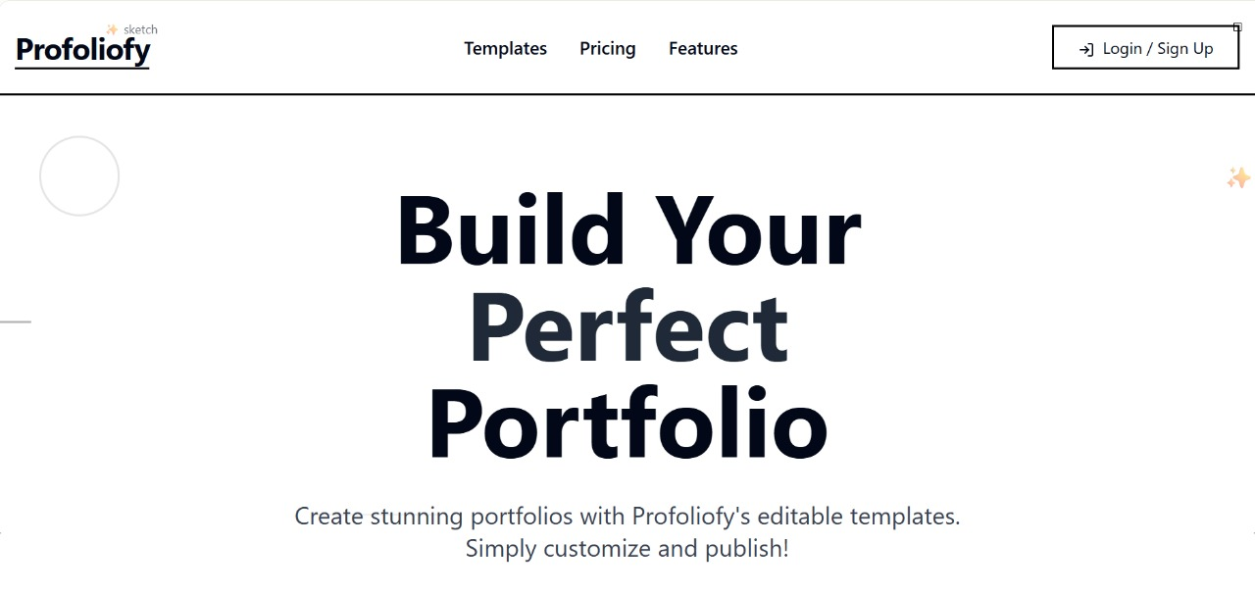

**Figure 1**

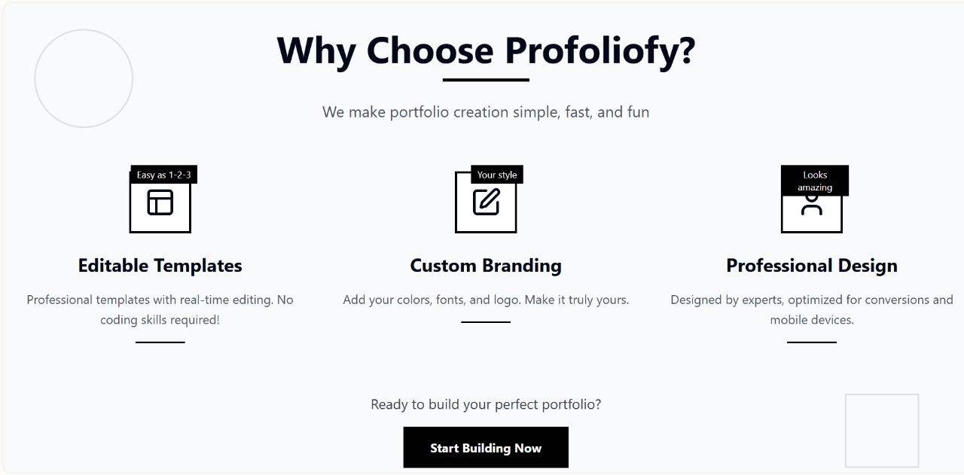

**Figure 2**

**Figure 3**

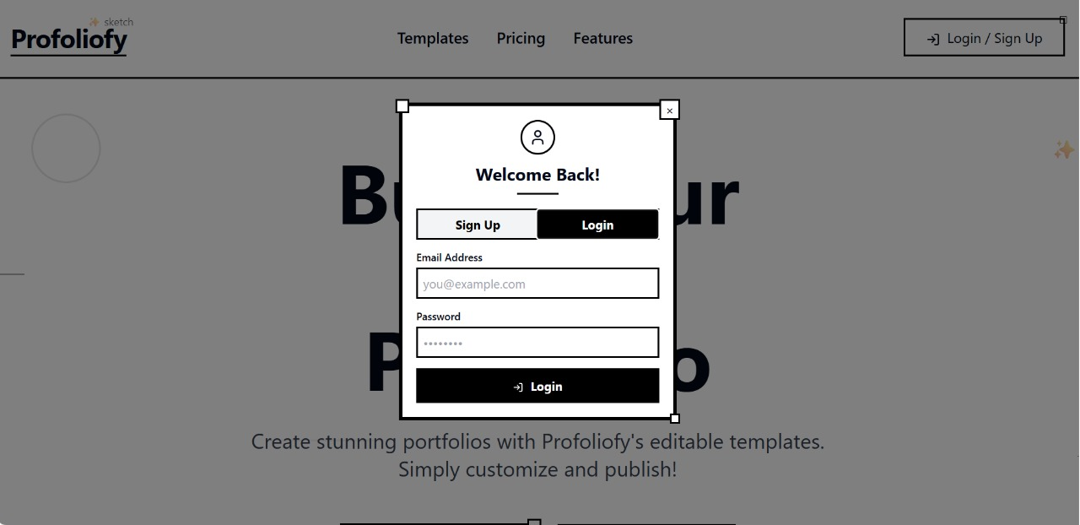

**Figure 4**

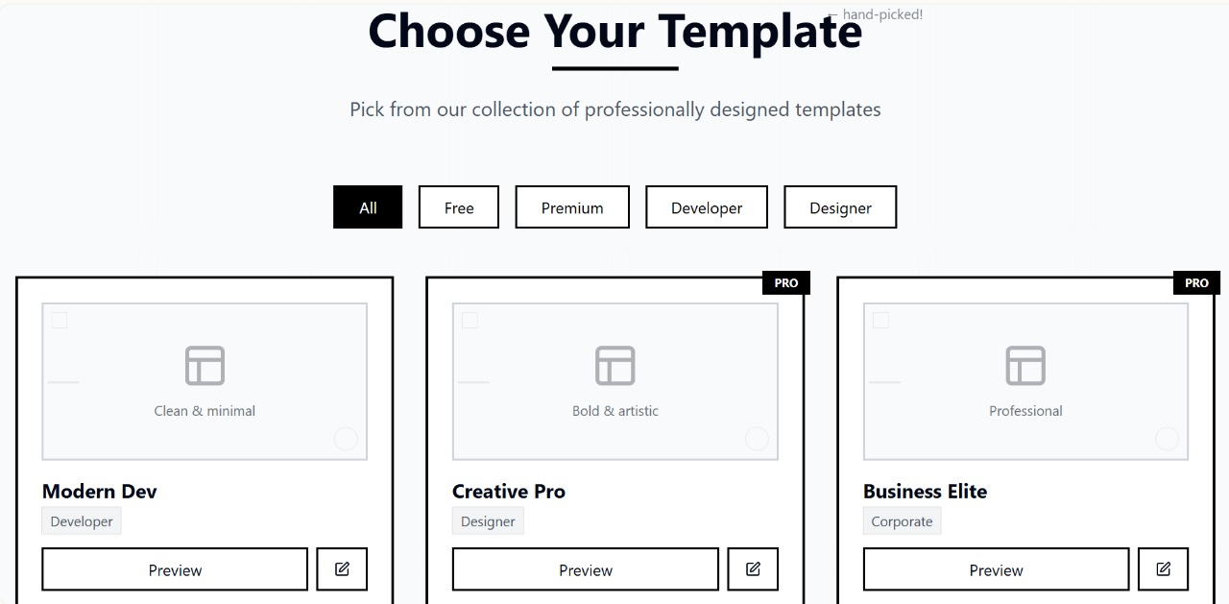

**Figure 5**

**Figure 6**

**Portfolio Template’s Layout:**

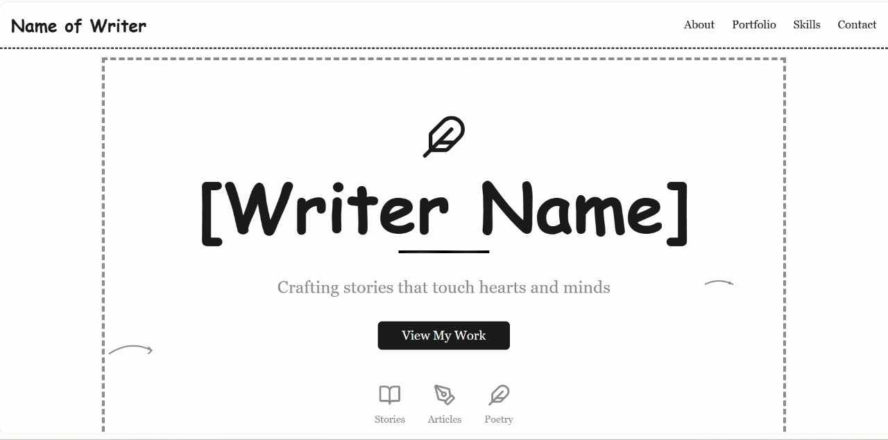

**Figure 1**

**Figure 2**

**Figure 3**

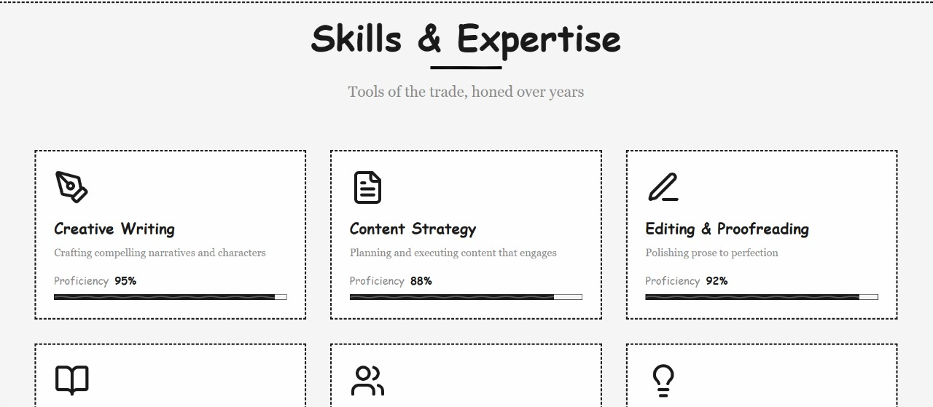

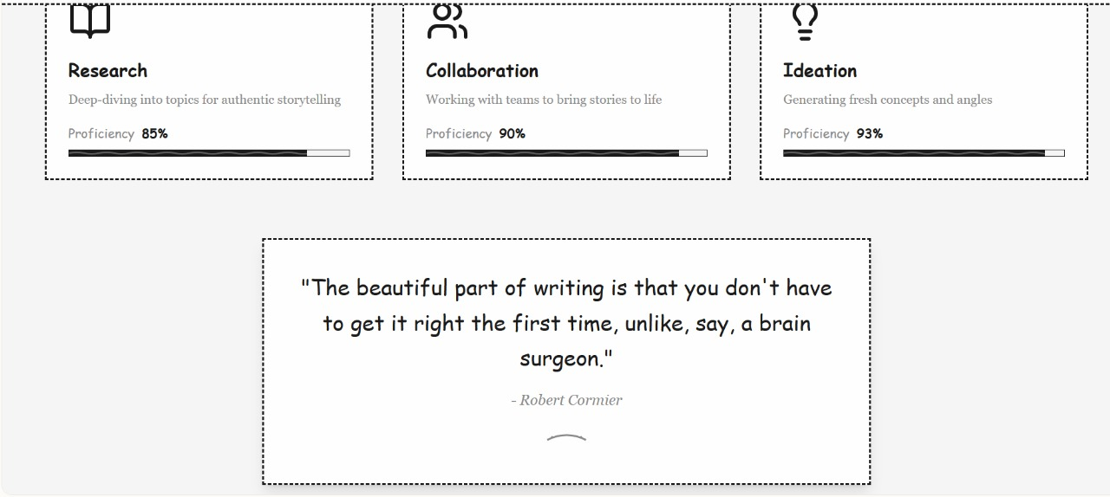

**Figure 4**

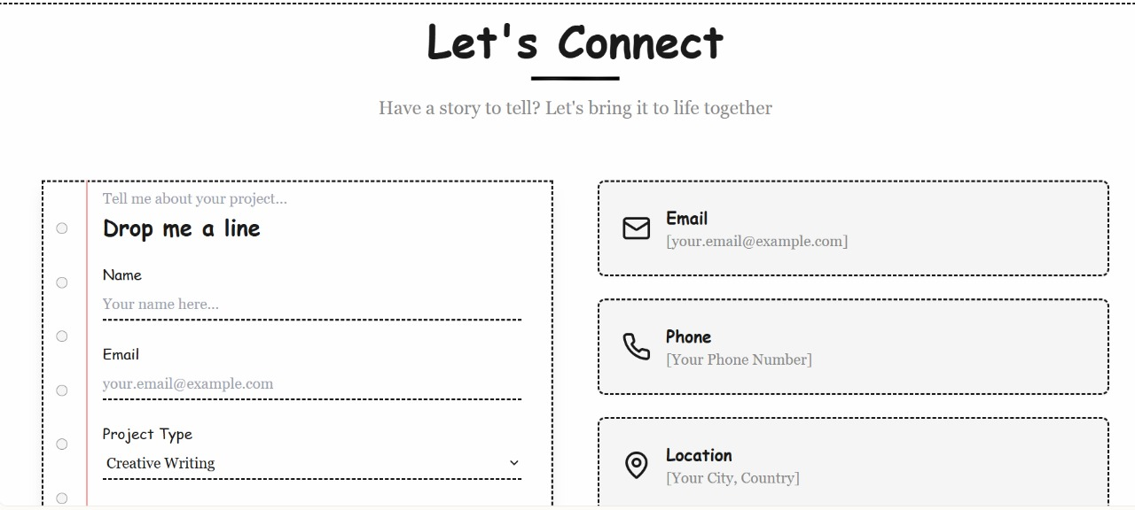

**Figure 5**

**Main Menu:**

**Figure 1**

**Admin:**

**Figure 1**

**Figure 2**

**Figure 3**

**Figure 4**

**Portfolio Creator:**

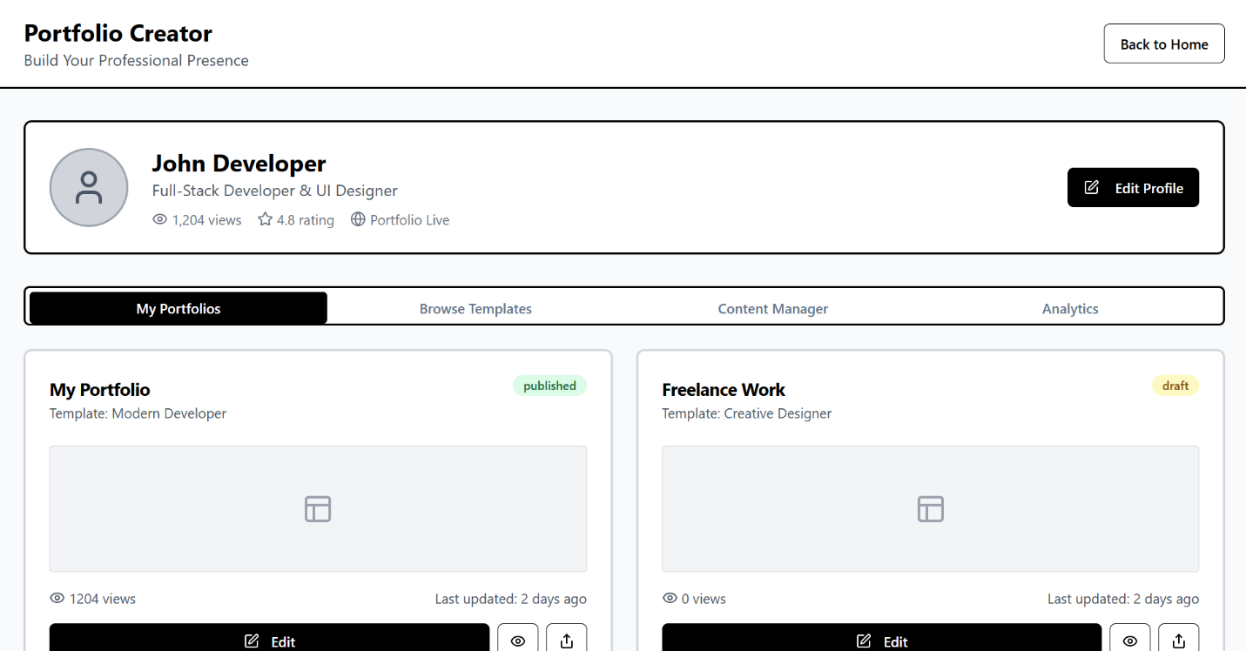

**Figure 1**

**Figure 2**

**Figure 3**

**Figure 4**

**Template Designer:**

**Figure 1**

**Figure 2**

**Figure 3**

**Figure 4**

**Portfolio Viewer:**

**Figure 1**

**Figure 2**