AirContacts User Guide

INSTRUCTIONS
- The app automatically syncs after 30 to 45 days.
- Hence, there is no need to sync manually.
- The only case in which manual sync may be performed is if a specific contact cannot be found in the user contacts.
- Frequent manual sync attempts will cause very high drainage of battery time and life.
- AirContacts is an indigenously developed App that automatically synchronizes Air Directory (PAFCOM LTE - DEFCOM - AirCom Contacts).
- Sync Button updates the contacts manually.
- On initial installation, users are requested to delete local contacts (only the first time).
- Further help is available by pressing info button at the top right.

TABLE OF CONTENTS
INSTRUCTIONS 1
TABLE OF CONTENTS 1
STEPS FOR ONLY THE FIRST TIME 2
NORMAL APP USAGE 8

STEPS FOR ONLY THE FIRST TIME
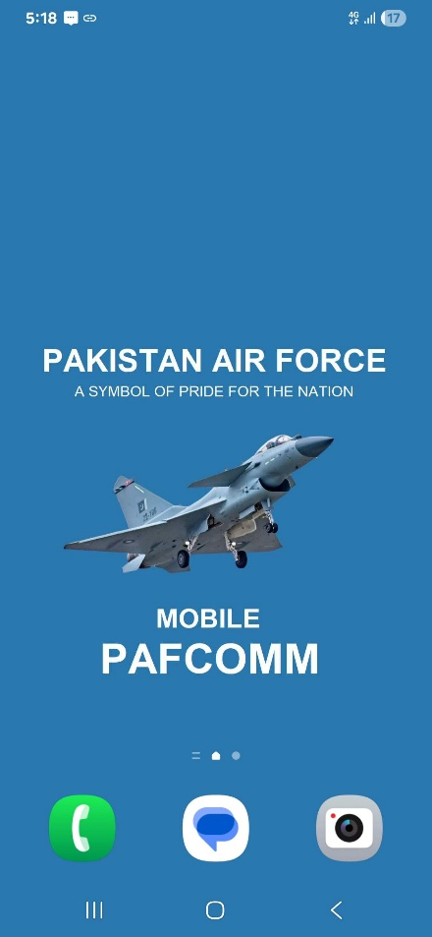
- Launch Phone App from the App Menu.

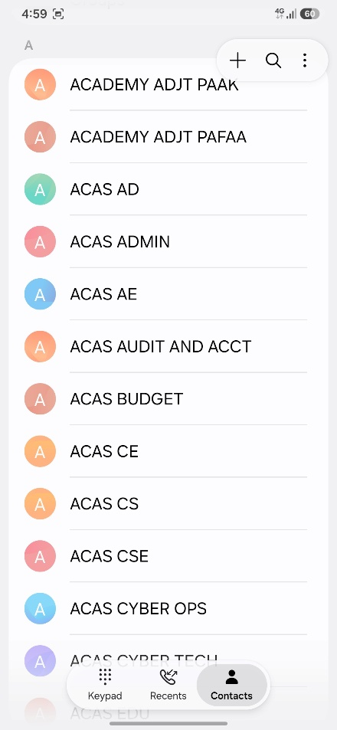
- Open Contacts tab in Phone App, and tap on in the top right corner.
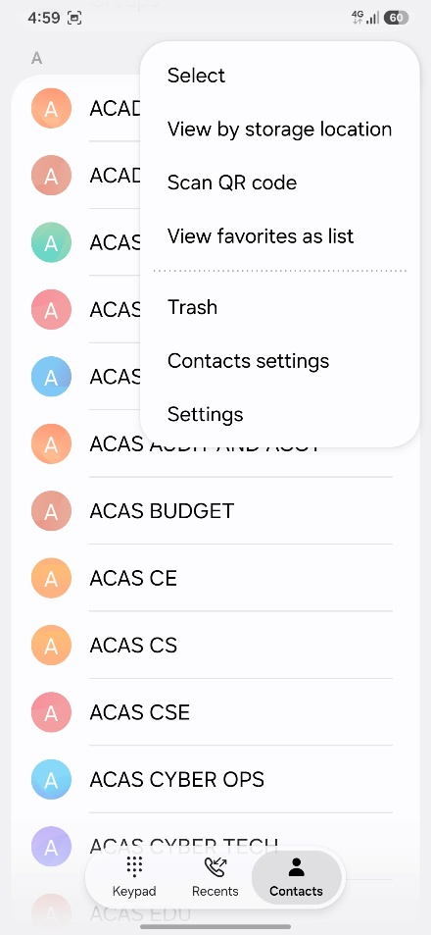
- Tap on Select.

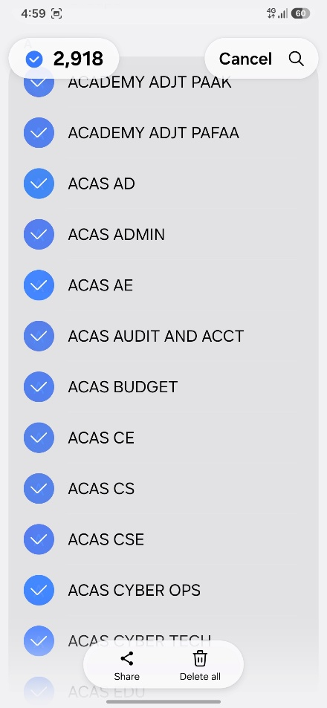
- Select ALL Contacts and Tap on Delete All.
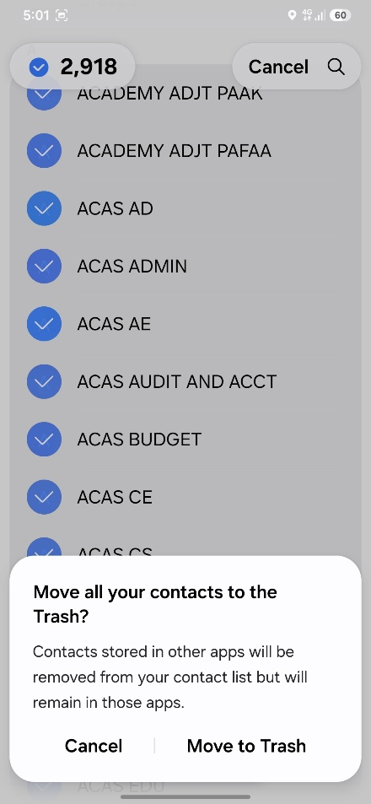
- Select Move to Trash.

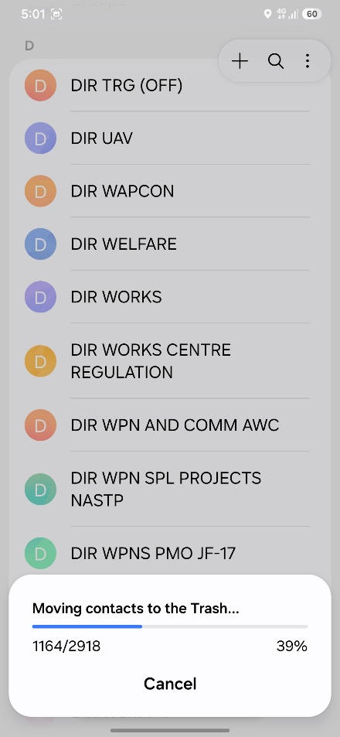
- The old phone contacts will start getting deleted.

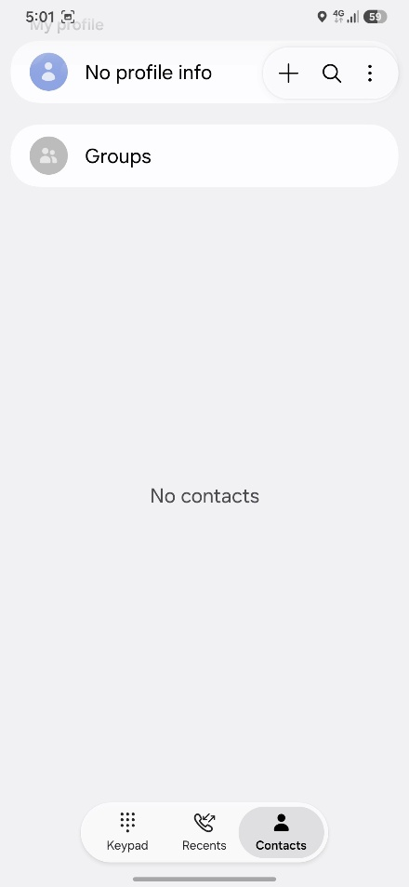
- At the end, there will be no local contact in the phone.

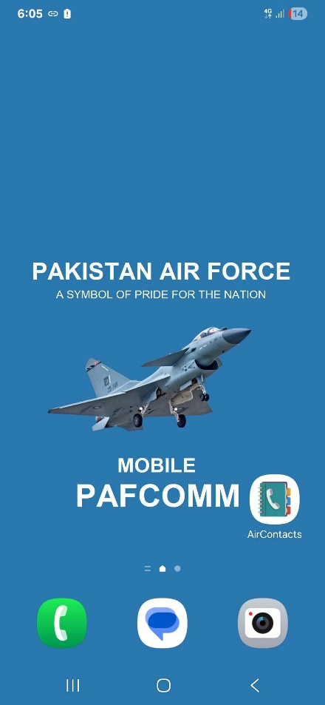
- Launch AirContacts App from the App Menu.
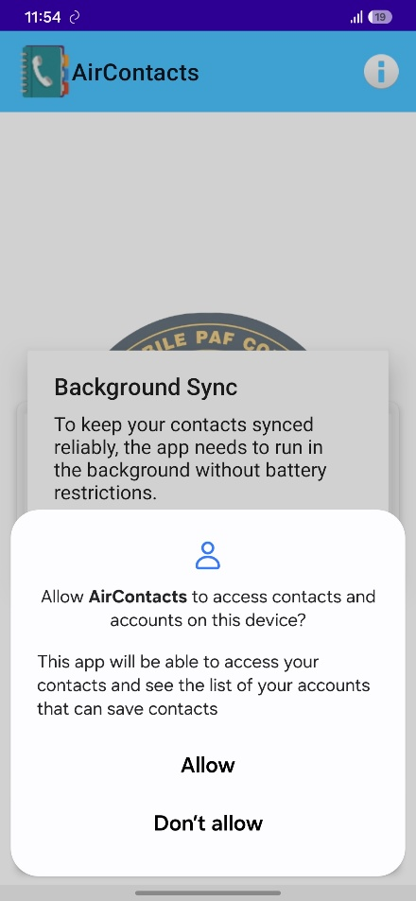
- Allow Contacts permission to the app

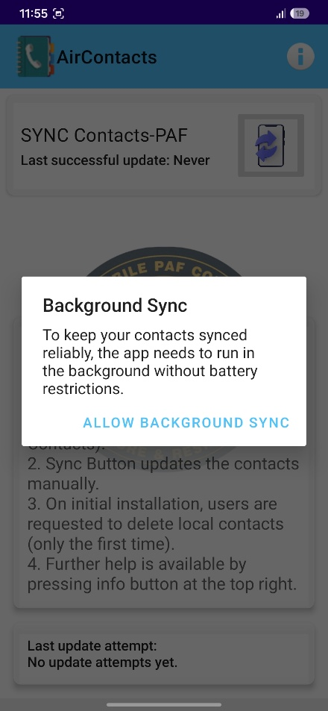
- Tap on ALLOW BACKGROUND SYNC.
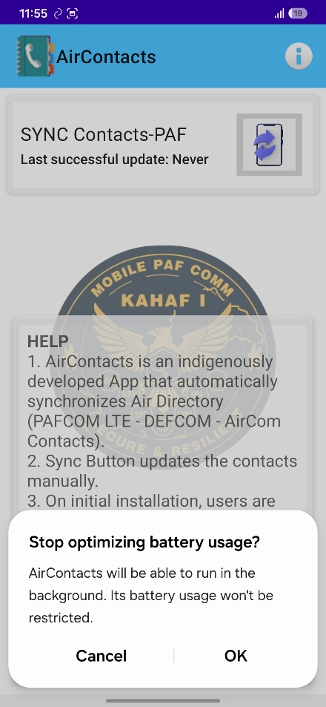
- Tap on OK to Stop optimizing background usage. This is necessary to allow the app to continuously keep syncing the contacts when required.

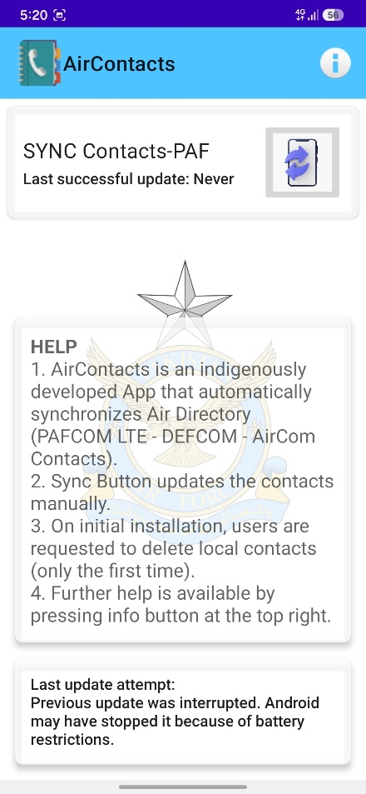
- Tap on Sync Button  to start syncing the PAFCOM LTE Contacts

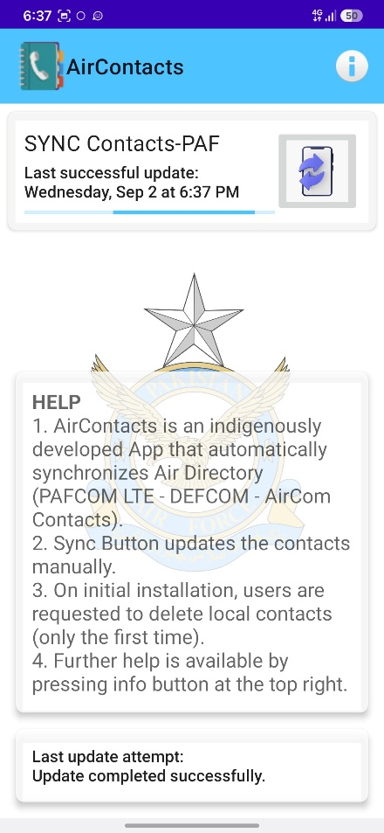
- The contacts will start syncing in the background.

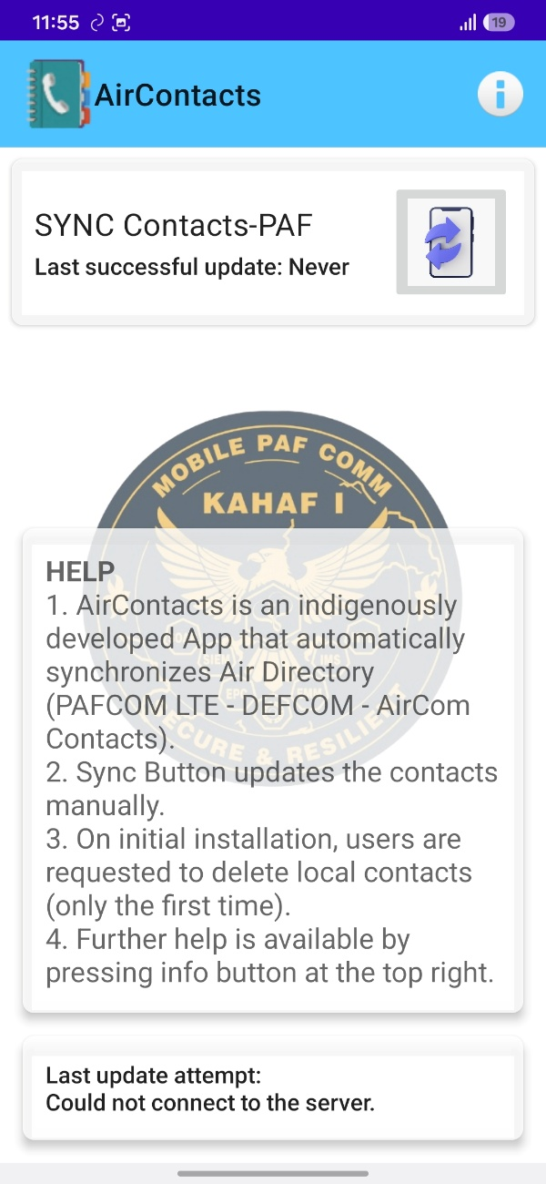
NORMAL APP USAGE

- Tapping on button will initiate a manual sync for complete contacts directory. Manual update should only be initiated in case of non-updated state of a specific contact. Frequent pressing of the sync button will significantly affect phone’s battery time and life.

- App information page can be accessed by tapping on  button in the top right corner of the main page.

- In case of any assistance, LTE Section, No 1 Comm Wing may approached.

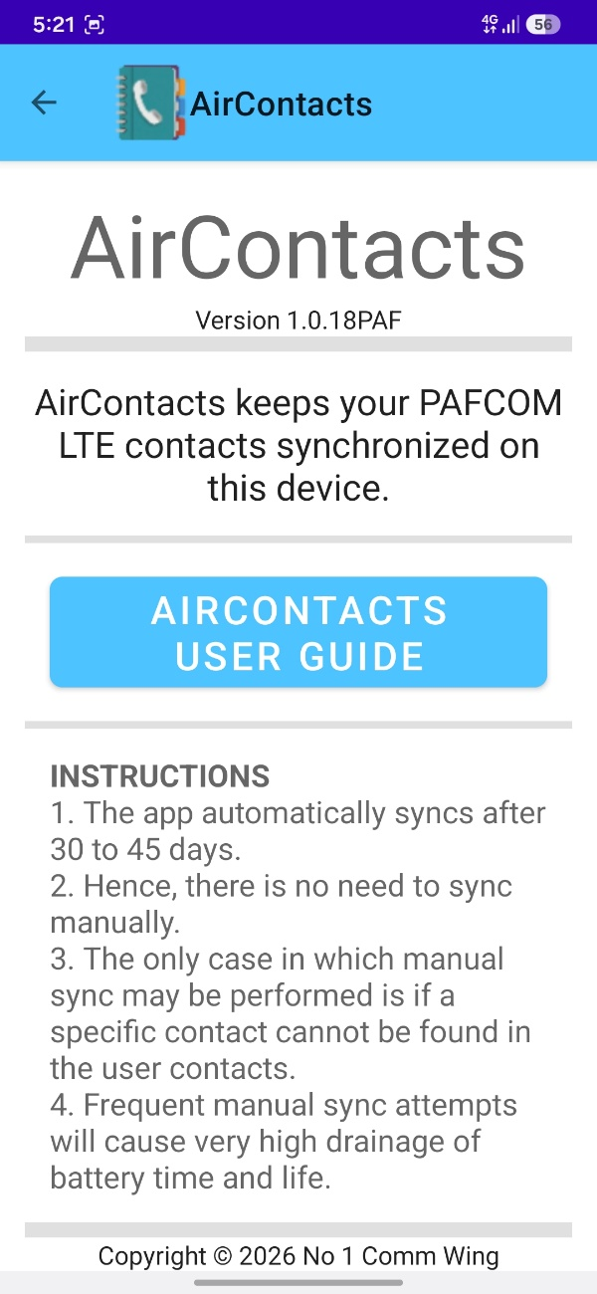

- AirContacts App Information Page

- Tapping on will take the user to this User Guide.

Copyright © 2026-Present No 1 Comm Wing, PAF Developed by: Flying Officer Muhammad Ali ALL RIGHTS RESERVED

