Assignment 1: Creating an AI-Powered Intrusion Detection Solution with real time threat detection
Course: Information Security
Aligned CLO: 4 - Create solutions to real life scenarios using different security related tools.
Total Marks: 5
Submission Mode: Individual
Viva: Mandatory (Scheduled after report submission)

1. Objective & Real-Life Scenario
In today's digital landscape, organizations face a constant barrage of network intrusions and anomalous activities that threaten their information assets. Traditional security tools like firewalls are essential but not sufficient. As an information security professional, you are tasked with creating a proactive, intelligent line of defense.
Your Mission:
You are a security analyst at "SecureNet Corp." The CISO has asked your team to explore the viability of Machine Learning as a tool to augment the existing Network Intrusion Detection System (NIDS). Your specific task is to design, develop, and evaluate a proof-of-concept ML model that can automatically classify network traffic as normal or malicious. This tool will be tested on a dataset simulating real-world network traffic.
This assignment directly addresses CLO 4 by requiring you to create a solution (an ML-based classifier) for a real-life scenario (enhancing intrusion detection) using a security-related tool (Machine Learning libraries and frameworks).

2. Task Description
You will create a solution by following this lifecycle, mirroring a real-world development process:
Tool & Scenario Selection: Select a dataset that represents a realistic security scenario (e.g., DDoS attacks, infiltration attempts, web attacks).
Data Engineering: Use data preprocessing tools (pandas, numpy) to clean and prepare the raw network data for analysis, just as you would with logs from real security tools.
Model Development: Use Machine Learning tools (scikit-learn, TensorFlow) to design and train a classification model. This model is your core security "tool."
Solution Validation: Rigorously evaluate your tool's performance using standard metrics to prove its effectiveness to management.
Reporting & Documentation: Prepare a report and code repository as if you were delivering it to the CISO for review.

3. Detailed Steps to Follow
Your project must be a complete workflow from raw data to a functioning solution.
Step 1: Problem Definition & Tool Setup (The "Why")
- Select a publicly available intrusion detection dataset (e.g., CIC-IDS2017, UNSW-NB15).
- Justify your choice by describing the real-world attack scenarios it represents. For example: "The CIC-IDS2017 dataset was chosen as it contains realistic DDoS and Brute-Force attack traffic, which are common threats to our web servers."
Step 2: Data Preprocessing with Security Tools (The "Preparation")
- Use Python data manipulation tools to handle missing values, encode categorical features (like protocol type or service), and normalize numerical features.
- Perform Exploratory Data Analysis (EDA) to understand the nature of the attacks you are defending against. This step is akin to a security analyst reviewing firewall and SIEM logs.
Step 3: Creating the ML Solution (The "Build")
- Design: Choose at least one ML algorithm suitable for classification (e.g., Random Forest, Decision Tree, Neural Network). Justify your choice based on the nature of the data (e.g., "Random Forest was selected for its high accuracy and ability to handle complex feature relationships commonly found in network traffic").
- Implement: Write the code to train your model on the prepared training data.
Step 4: Evaluating the Created Solution (The "Test")
- Use your trained model to make predictions on the unseen test set.
- Evaluate the solution's performance using metrics critical for security:
  - Overall Accuracy
  - Precision and Recall for the attack classes (High recall is often crucial to avoid missing real attacks).
  - Confusion Matrix
- Critical Analysis: Interpret the results. If your model has low recall for a specific attack, what is the security implication? (e.g., "A low recall for R2L attacks means our solution would allow many unauthorized access attempts to go undetected, which is a critical flaw.").

4. Submission Guidelines
A) MS Word Report (Submit via LMS)
The report should be structured as a Project Deliverable. Maximum 5-6 pages.
Title Page: Project Title, Your Name & ID, Course Name, CLO 4.
Executive Summary: A one-paragraph summary of the problem, your solution, and its key results.
Introduction & Real-World Scenario: Describe the security problem and the objective of creating this ML-based tool.
Methodology:
  - Dataset and Scenario Justification
  - Data Preprocessing Steps
  - Machine Learning Tool Design (Algorithm choice and justification)
Results and Security Analysis: Present metrics, graphs, and a discussion focused on the security effectiveness of your solution.
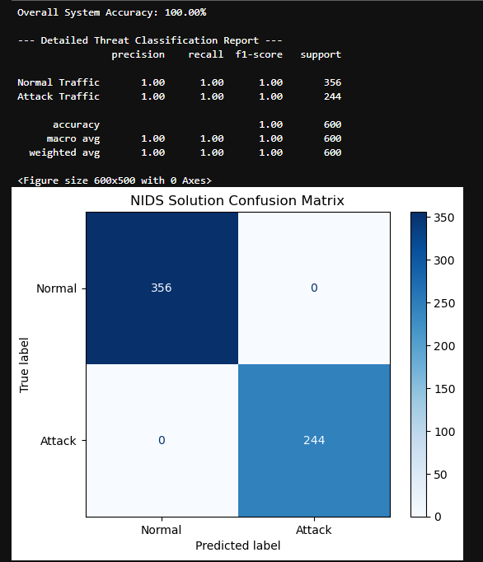
Conclusion and Future Enhancements: Conclude by reflecting on how this tool solves the initial scenario and propose how it could be improved (e.g., feature engineering, trying deep learning).
References
GitHub Profile Link
B) GitHub Repository (Public)
- Repository name: CLO4-IDS-ML-Solution or similar.
- Must contain:
  - A well-documented Jupyter Notebook (.ipynb) containing the entire code.
  - A comprehensive README.md file with: Project Title, Objective, Dataset Setup Instructions, How to Run the Code, and a brief summary of results.

Sample screens