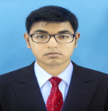Syed Muhayminul Islam

## Full-stack Developer

**Phone:** +8801935778149

**Email:** [muhayminul96@gmail.com](mailto:muhayminul96@gmail.com)

[**LinkedIN**](https://www.linkedin.com/in/syed-muhayminul-islam/)**:** in/syed-muhayminul-islam

[**Github**](https://github.com/muhayminul96)**:** github.com/muhayminul96

[**Website**](https://syed-muhayminul.web.app/): syed-muhayminul.web.app/

# Objective

I'm a Computer Engineer eager to bring my skills to your team. With a strong background in Computer Engineering, I'm always hungry to learn and try new things. Creativity is my strong suit, essential for any computer engineer. I love playing around with the latest technologies and am ready to tackle any challenge that comes my way. I'm excited to contribute to your company's success while continuing to grow and develop myself.’

# WORK EXPERIENCE

### Software engineer

Unicorn software and solutions From Aug 2022

Khulna

# OMR Checker:

# A computer vision project developed using Python.

# The research team created an engine capable of reading OMR sheets.

# Processed the engine's output, validated it for reading errors, and saved the data to a database.

# Enabled export to Excel sheets.

# Developed an API to push marks to the central result system.

# Worked as the project manager for a few months during the project.

# In this project, I aim to learn the basics of computer vision to preprocess OMR sheet images.

# E-Tax:

# Developed as a full-stack developer.

# Used React for the frontend and Express.js with a MySQL database for the backend.

# Responsible for the complete implementation of the project.

# I have learned Redux to effectively handle user authentication issues.

# VMS (Vehicle Management System):

# Utilized Laravel for the backend, React for the frontend, and MySQL as the database.

# Focused on developing the frontend.

# GPOS (Gas Distribution System):

# Built using Laravel with Laravel Blade for the frontend.

# Served as a team lead and a full-stack developer.

# Contributed to both backend and frontend development.

# Managed and guided the team.

# TRAINING EXPERIENCE

## Diploma In Software Engineering:

Name of the Organization: IICT, KUET Address: Khulna

Course Duration: 6 Months

## IT Support:

Name of the Organization: BITM Address: Dhaka

Course Duration: 4 Months

## SQA:

Name of the Organization: Khulna University Address: Khulna

Course Duration: 4 Months

## Complete Web Development Course:

Name of the Organization: Programing Hero Address: Online

Course Duration: 6 Months

# SKILLS

* HTML/CSS/Bootstrap/Tailwind
* PostgreSQl/MySQL/Sqlite3
* C, C++, Java, JavaScript, Python
* Rest API
* Tkinter
* Tailwind
* Typescript
* Scikit-Learn
* Django
* Selenium
* Beautiful Soup
* SQA
* React JS
* OpenCV

# EDUCATION

### Master in Science (CSE)

Khulna University Started February 2022

Khulna

### Bachelor in Science (CSE)

Daffodil International University Graduated April 2021

Dhaka CGPA: 3.59(4.00)

**Diploma-in-Engineering** Passed, January 2018

Khulna Polytechnic Institute CGPA 2.86(4.00)

Department: Computer

Khulna

**CONTACT DETAILS**

Permanent Address:

|  |  |  |  |
| --- | --- | --- | --- |
| Village: | Dhulgram | Thana: | Abhaynagar |
| Post Office: | Shiddipasha | Post Code: | 9207 |
| District: | Jessore | Division: | Khulna |

**REFERENCES**

## Reference 1:

Name: Md. Ashiq Mahmood

Position: Assistant Professor of IICT

Address: KUET, Khulna

E-mail: ashiqmahmoodbipu@gmail.com

Mobile: +88 01780636861

## Reference 2:

Name: Sayad Iftekhar Alam

Position: Sergeant of Bangladesh police

Address: CMP, Chittagong

E-mail: ifty_icmab@yahoo.com

Mobile: +88 01711449637

**Declaration**

I, Syed muhayminul Islam, hereby declare that the information contained herein is true and correct to the best of my knowledge and belief.



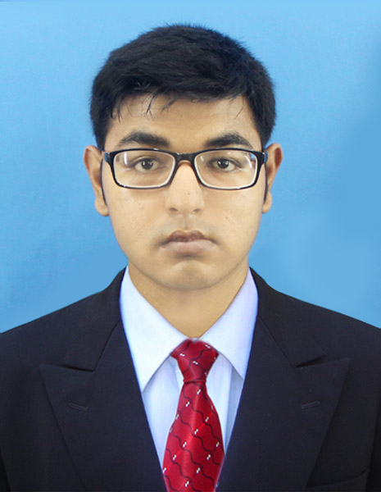



Syed Muhayminul Islam