Department of Electrical Engineering

Faculty Member:_________________ | Dated: ________________
Semester:__________________________ | Section: ________________
EE215: ELECTRONIC DEVICES AND CIRCUITS
Lab 2: Introduction to Digital Oscilloscope, Function Generator Operation
 |  | PLO4/CLO4 |  | PLO5/CLO5 | PLO8/CLO6 | PLO9/CLO7
Name | Reg. No | Viva /Quiz / Lab Performance  5 marks | Analysis of data in Lab Report  5 marks | Modern Tool Usage  5 marks | Ethics and Safety  5 marks | Individual and Team Work  5 marks
Objective
To become familiar with the operation and use of the digital osciloscope and function generator .

EQUIPMENT REQUIRED
Instruments :
- Digital Oscilloscope
- Digital multimeter
- Test Probe
- Function generator
- Resistors for potential divider circuit
- Breadboard

RESUME OF THEORY

The oscilloscope is most important available to the practicing technican or engineer. It permits the visual display of a signal that can reveal a range of information regarding the operating characteristics of a circuit or system that is not available with a standard multimeter. At first glance the instrument may appear complex and difficult to master. Be assured, however, that once the function of each section of the oscilloscope is explained and understood and the system is used throughout a set of experiments, your expertise with this important tool will develop quite rapidly.
In addition to the disply of a signal, it can be used to measure the average value, rms value, frequency and period of a sinusoidal or non-sinsousodial signal. The screen is divided in to centimeter division in the vertical and horizontal directions . The verticical sensitivity is provided (or set) volts /cm, whie the horzontal scale is provided(or set) in t time (s/cm).If a particular signal occupies 6 vertical centimeters and the vertical sensitivity is 5mV/cm, the magnitude of the signal can be determined from the following equation:
Signal voltage (un known) = vloltage ensitivity(V/cm)Xdeflection(cm)
V_{S}=(5mV/cm) (6cm)= 30mV (1.1)

If one cycle of the same signal occupies 8cm on the horizontal scale with a horizontal sensitity of 5µ/cm, the period and freqency of the signal can be determinedusing the following equations:
T=(5µ/cm) (8cm)=40µs
And f -1/T = 1/40=25kHz (1.2)
An oscilloscope (commonly abbreviated to scope or O-scope) is a type of electronic test instrument that allows signal voltages to be viewed, usually as a two-dimensional graph of electrical voltage potentials (vertical axis) plotted as a function of time (Horizontal axis). In addition one can plot a voltage potential (vertical axis) against another voltage (horizontal axis).

Although an oscilloscope displays voltage on its vertical axis, any other quantity that can be converted to a voltage can be displayed as well. The oscilloscope is one of the most versatile and widely-used electronic instruments. Oscilloscopes are widely used when it is desired to:
- Observe the exact wave shape of an electrical signal.
- Measure the amplitude of the signal
- Measure the frequency
- Observe distortion
- Show the time between two events (such as pulse width or pulse rise time), and show the relative timing of two related signals.

Calibration: Calibration is often regarded as including the process of adjusting the output or indication on a measurement instrument to agree with value of the applied standard, within a specified accuracy.

Steps:
- Align the slot in the probe connector with the button on the CH 1 BNC.
- Push to connect, and twist to the right to lock the probe in place.
- Attach the probe tip and ground lead to the PROBE COMP connector.

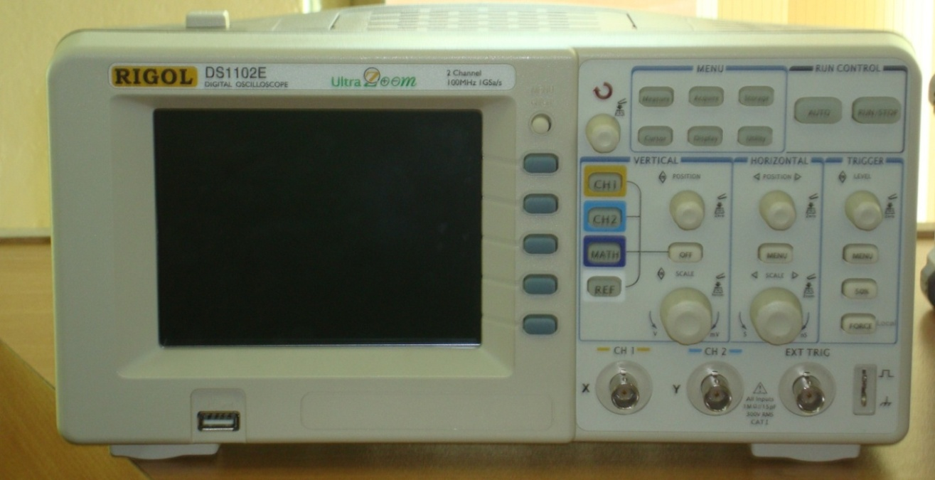

FIGURE.1

- Press auto button and the oscilloscope will set itself according to the applied signal. You can press the Run/Stop button to stop the waveform at any instant.
This device is also USB compatible. So you can store screenshots of waveforms by plugging in a flash drive and pressing the storage button. (Store it in bitmap format).
Oscilloscope Probe:
A test probe is a device used to connect electronic test equipment to the device under test.
It has a High Input resistance. (About a Mega ohm)
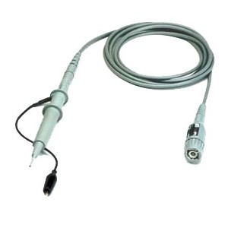
Probe has a knob for attenutation of input signal. Make sure it is at 1x.

Function generator:
The function generator is an electronic instrument that can be used a voltage supply time varying voltage waveforms like, Sinusoidal, triangular and square-waves. Most electrical signals and forcing functions are either of these functions or combinations of these basic types. Therefore, for the study and analysis of the circuit parameters like time response, frequency response the function generator acts as a required forcing function for the circuit under study.
The function generator is shown in figure 2; and some of its control knobs ad switches are shown in figures 2-2.

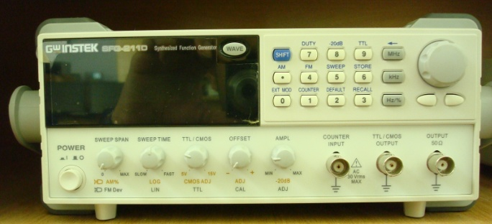
Amplitude control knob

The output from the function generator shall be taken from here

FIGURE.

Set up:
Tasks:
- Turn ON the oscilloscope and adjust the various controls to see their effects on the display.

- Connect the function generator to the CH1 of the digital oscilloscope and set the output of the generator to a 100 Hz sinusoidal waveform as shown in figure 2.1.
We can select input wave shape and also see the adjusting frequency on the screen shown in fig-2.1. Adjustment can be made as fig 2.2.

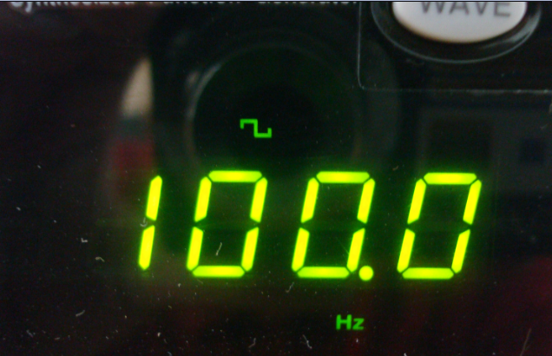
The WAVE switch cycles between the different waveforms, square, sinusoidal, and triangular
FIGURE.2.1

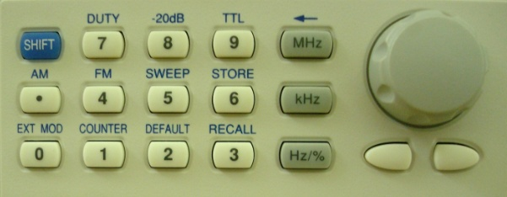

FIGURE.2.2
Frequency control knob to fine tune frequency

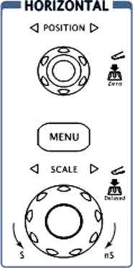
Figure.3
Horizontal Sensitivity

Figure.3 shows the HORIZONTAL controls: MENU knob, POSITION and SCALE knobs of horizontal system. Following the exercise to familiarize with the Buttons, knobs, and status bar.

- Determine the period of the100Hz sinusoidal waveform by adjusting the waveform on oscilloscope.

T=-----------------------------

- Set horizontal sensitivity of the oscilloscope to 2ms/cm by rotating the SCALE knob of the digital oscilloscope. Using the results of part c calculate the number of divisions required to properly displaying one full cycle of the 100Hz signal.

Calculate Number of divisions=-----------

The horizontal POSITION knob moves displayed signal horizontally on waveform window.
Q: Using the oscilloscope measure the number required divisions and insert below. How does the result compare the calculated number of divisions?
Ans:______________________________________________________________________________________________________________________________________________________________________________

- Change the horizontal sensitivity of the oscilloscope to 5ms/cm by rotating SCALE knob without touching any of the function generators. Using the results of part d how many horizontal divisions will now be required to display one full cycle of the 100Hz signal.

(Calculate)Number of divisions=-----------------------------
Q: Using the oscilloscope measure the number required divisions and insert below. How does the result compare the calculated number of divisions?
Ans:______________________________________________________________________________________________________________________________________________________________________________

- Change the horizontal sensitivity of the oscilloscope to 1ms/cm by rotating SCALE knob without touching any of the controls of the function generator. Using the results of part d, how many horizontal divisions will now be required to display one full cycle of the 100Hzsignal?

(Calculate)Number of divisions=----------------------

Q: Using the oscilloscope measure the number required divisions and insert below. How does the result compare the calculated number of divisions?

Ans:______________________________________________________________________________________________________________________________________________________________________________

Q: What was the effect on the appearance of the sinusoidal waveform as horizontal sensitivity was horizontal sensitivity was changed from 1ms/cm to 5ms/cm?
Ans:______________________________________________________________________________________________________________________________________________________________________________

Q: Did the frequency of the signal on the screen change with the each horizontal sensitivity? What conclusion can draw from the results?
Ans:______________________________________________________________________________________________________________________________________________________________________________

- Determine the frequency of the waveform.
Ans:______________________________________________________________________________________________________________________________________________________________________________

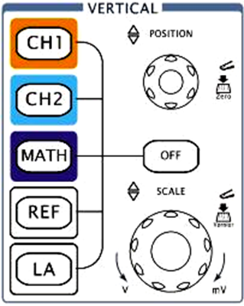

Figure .4

Vertical Sensitivity

Figure.4 shows the VERTICAL controls, CH1, CH2, MATH, REF, and OFF buttons and vertical POSITION, SCALE knobs. Following the exercise of the buttons, knobs, and the status bar to be familiar with the vertical parameters settings.

- Set the vertical sensitivity of the scope to1V/cm by rotating the SCALE knob and adjust the amplitude control of the function generator to establish, 4 V peak to peak (p-p), sinusoidal waveform on the screen.

- Do not touch the control of the control of function generator but return the sensitivity of the scope to 1v/cm and change the vertical sensitivity to 2V/cm by rotating the SCALE knob. Using the sensitivity calculate the peak-to-peak value of the sinusoidal waveform on the screen by first counting the number if the vertical division between peak values and multiplying by the sensitivity.

(Calculate) peak-to peak value=-----------------------------

- Change the vertical sensitivity of the oscilloscope to0.5V/cm by rotating the SCALE knob and repeat Part (j).

(Calculate) peak-to peak value=-----------------------------

Q: Did the peak-to peak value of the sinusoidal waveform change with the change in vertical sensitivity? What conclusion can you draw from the results?
Ans:______________________________________________________________________________________________________________________________________________________________________________

Q: What was the effect on the appearance of sinusoidal waveform as the vertical sensitivity was changed from 2V/cm to 0.5V/cm?
Ans:______________________________________________________________________________________________________________________________________________________________________________

Q: Did the peak-to peak amplitude of the signal change with the each vertical sensitivity? What conclusion can you draw from the results?
Ans:______________________________________________________________________________________________________________________________________________________________________________

Exercises

- Make all the necessary adjustments to clearly display a 5000=Hz 6Vp-p sinusoidal signal on the oscilloscope. Establish the zero volt line at the center of the screen.

Vertical sensitivity =--------------------------------

Horizontal sensitivity =--------------------------------

(Calculate)T=---------------------------------------

Store the waveform.
- Calculate the period of the waveform using the number of required horizontal divisions for a full cycle.

(Calculate)T=----------------------------------------------------
Include your labeled waveform in the lab report.

- Repeat part(a) for a 200-Hz 1.8Vp-p square waveform.

Vertical sensitivity =--------------------------------

Horizontal sensitivity =-----------------------------

(Calculate)T=---------------------------------------

- Repeat Part (a) for a 100-kHz 1.8 Vp-p triangular wave.

Vertical sensitivity =--------------------------------

Horizontal sensitivity =-----------------------------

(Calculate)T=---------------------------------------

RMS Value
- Reestablish the 1 KHz 4Vp-p sinusoidal waveform on the screen calculate the effective value of the sinusoidal waveform.

(Calculate) V (rms) =-----------------------------------

- Disconnect the function generator from the scope and measure the effective (rms0 value of the output of the function generator using the digital meter.
(DMM) V (rms ) =-----------------------------------

- Determine the percent difference between the calculate and measured values using the following equation:

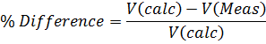

% Difference=-----------------------------------------------------

- Disconnect the function generator from the DMM and measure the rms value of the output of the function generator using the scope.

Q: What was the difference in DMM and Scope values?
Ans:______________________________________________________________________________________________________________________________________________________________________________

Using Both Input Channels Simultaneously
Set the Function generator to get a waveform corresponding to the equation
V₁=5 sin (2000t) V
Now make a potential divider circuit to get another waveform V_{2.}
Show both the Waveforms Simultaneously by using both channel 1 and 2.

Problems:

Give V=5sin (2000t) +2, Determine the following parameters using scope…

- f=
- ω=
- T=
- Peak value=
- Peak-to-peak value=
- Average Value=
- Effective value(rms)=
- DC level=

Show the waveform in your report.

Exercises
Patch the circuit, shown in figure 3, on a breadboard. Use jumper wires to avoid clutter and ease of measurements. Note that the capacitor used in the experiment will be electrolytic capacitor rather than a non-electrolytic capacitor used in simulation. Electrolytic capacitors have a positive terminal (anode) and a negative terminal (cathode). Therefore, polarity has to be considered when connecting an electrolytic capacitor.
To differentiate between the anode and cathode look closely at the two pins( terminals) of your capacitor. Both pins are not of equal length. The longer pin is normally the anode whereas the shorter pin is cathode. However, if it is difficult to differentiate the lengths of two pins, the cathode or negative terminal is usually marked with “-“ sign on the capacitor.
Leave the voltage source part as we will use a signal generator to generate a sine wave in our exercise 1.
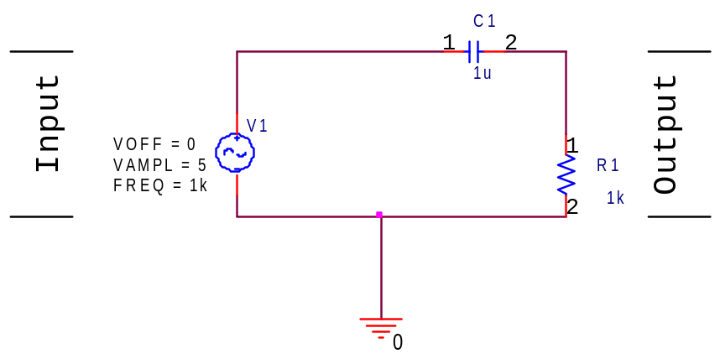
Figure-3
Exercise 1
Generating a sinewave of 1kHz
- Press key [Channel] and select “CHA Frequency” function.
- To set the frequency. Press [Freq] and select “frequency”, then press keys [1] and the soft key corresponding to [kHz] or Adjust the frequency of the channel A: press key [ ] or [ ] to move the cursor left or right, and tune the rotary knob left or right to add or subtract the digit on cursor, or to decrease or increase the digits continuously by steps, so as to make coarse or fine adjustment of the frequency.
- To set the amplitude. Press key [Ampl] and select “Amplitude”, then press keys [5] and the soft key corresponding to [Vpp]. You may also set the amplitude by passing the r.m.s value of the amplitude for that press the [Ampl] key for second time and you may set your V r.m.s.
- To select your desired signal type i.e. Sine, Square, Triangle etc. Press key [Shift] followed by the key for your desired signal type.
- Connect the probe of the channel to the circuit you have patched in figure 3.
Exercise 2
Observing the waveforms using an oscilloscope
- Now that you have completed the circuit in figure 3. It is time to obtain the results.
- Connect the probes of the oscilloscope to measure the input(Channel 1) and output (Channel 2) voltages as labelled on Figure 3. ( Take care of where you connect you alligator clip).
- Press the [auto] key and sketch the resulting waveforms.
- Play around with the vertical controls and horizontal controls and answer the following questions.
Q1. What is being controlled by turning the scale knobs on both horizontal and vertical sections.
Horizontal:_____________________________________________________
Vertical: _______________________________________________________
Measurements Using Oscilloscope
- Press [Auto] key on your oscilloscope again to return the display to initial settings. Adjust the scales if necessary.
- Press the [measure] key and set the Display setting to on.
- Read and note the following values from the table.
- Vr.m.s:_____________ , Frequency:____________, Time Period:____________, Vpeak-peak:______________
- Vmax:____________________

How to use new function Generator:
Step1:
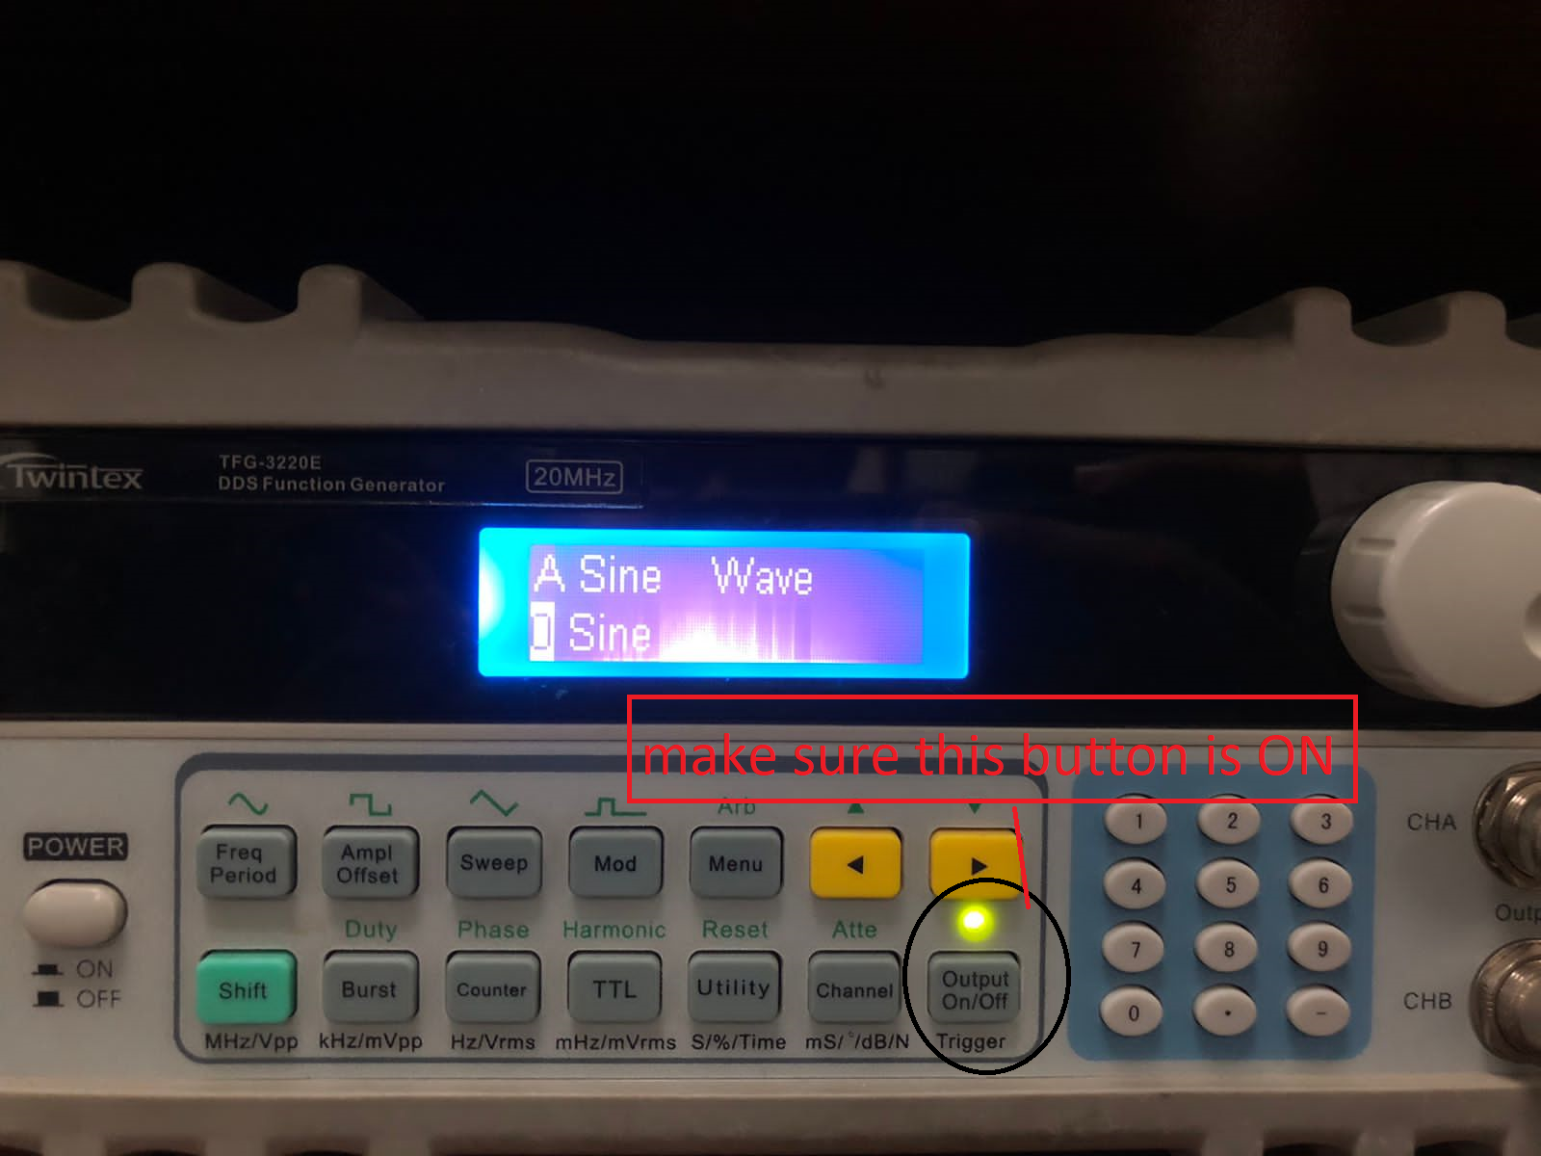

Step2:
To set the voltage press Ampl offset button:
There will be three options there:
      - Offset
      - Rms
      - Voltage
Set offset to zero by changing the knob.
Don’t change RMS value
And now set Peak to peak voltage by either by chnaging the knob or you can dial any number.

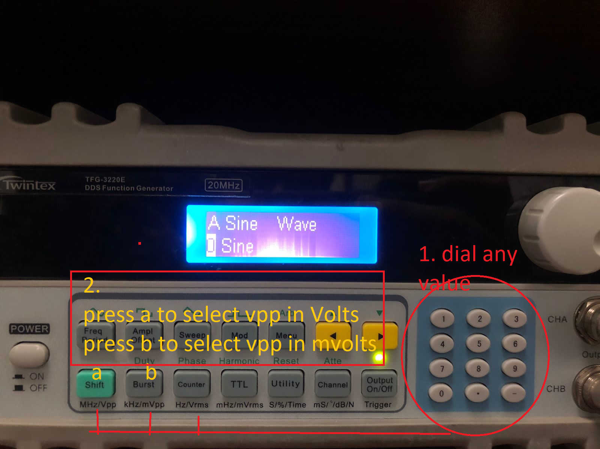

Step3:
Press frequency button and set value by using dial/ knob.
For dial: The procedure is same as explained for voltage setting. Dial any value of frequency and then press shift button for Mhz, Burst button for Khz and counter button for Hz.

