Department of Electrical Engineering

Faculty Member:____________________ | Dated: ________________
Semester:_________________________ | Section: ________________

EE-211: Electrical Network Analysis
Lab 4: Phasors and Phase Shift Circuits
 |  | PLO4/CLO4 |  | PLO5/CLO5 | PLO8/CLO6 | PLO9/CLO7
Name | Reg. No | Viva /Quiz / Lab Performance  5 marks | Analysis of data in Lab Report  5 marks | Modern Tool Usage  5 marks | Ethics and Safety  5 marks | Individual and Team Work  5 marks
Phasors and Phase Shift Circuits
INTRODUCTION
Phasor analysis is a useful tool to analyze the sinusoidal steady state behavior of circuits containing capacitors and inductors. In phasor analysis the information about the frequency of the applied signal is suppressed and only magnitude and phase are analyzed. This makes sense since linear circuits (i.e. circuits containing resistors(R), capacitors(C) and inductors (L)) can only affect the magnitude and phase of the input signal and the frequency of the sinusoid remains the same throughout the circuit. Using phasor technique, we transform the time domain V-I relations into phasor domain relations in the complex domain. This converts all the differential equations that describe the circuit in time domain to phasor equivalent linear equations in complex frequency domain. In phasor domain all passive elements are converted into respective impedances Z. All impedances in phasor domain follow the simple relation.
Where and are complex values of phasor voltage and current. The impedance Z is a complex number defined as the ratio between the voltage and current in phasor domain. Since all elements obey this form of Ohm `s law in phasor domain hence all the techniques of resistive circuit analysis are valid for R, L and C circuits in phasor domain. The impedance of resistor is purely real whereas that of capacitors and inductors is purely imaginary. The equivalent impedance of a network of RLC components is a complex number, the real part of such impedance is called “Resistance” and imaginary part is called “Reactance”.
Component | Impedance (Z) | Resistance (R) | Reactance (X)
R | R | R | 0
C | -j/ωC | 0 | -1/ωC
L | jωL | 0 | ωL

Where ‘ω’ is the frequency of the sinusoidal signal in rad/sec.
Capacitor:
As shown in the above table the impedance of capacitor is given as
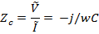
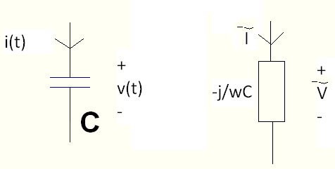
Fig No.1 Capacitor and its Impedance
There are two important inferences that can be drawn from the impedance relationship.
- The impedance is inversely proportional to the applied frequency. Hence capacitor behaves as short circuit for high frequencies and it behaves as open for low frequencies (i.e. DC signal which has zero frequency).
- The ‘-j’ in the relationship describes that phasor voltage and current of a Capacitor are at a phase angle of -90 degrees from each other.
Inductor:
As shown in the above table the impedance of inductor is given as
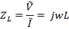
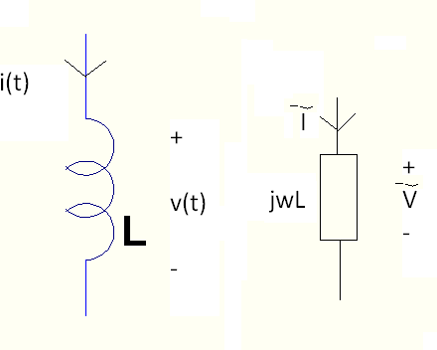
Fig No.2 Inductor and its Impedance
There are two important inferences that can be drawn from the impedance relationship.
- The impedance is directly proportional to the applied frequency. Hence inductor behaves as open circuit for high frequencies and it behaves as short for low frequencies (i.e. DC signal which has zero frequency).
- The ‘j’ in the relationship describes that phasor voltage and current of an Inductor are at a phase angle of 90 degrees from each other.
REFERENCE : Electric Circuits 9th edition. Nilsson/Riedel. (Chapter 9)
LAB TASKS
TASK#1
Attach the snapshots (simulation, hardware and theoretical calculation) of every task.
- Phase Shifter using RC combination
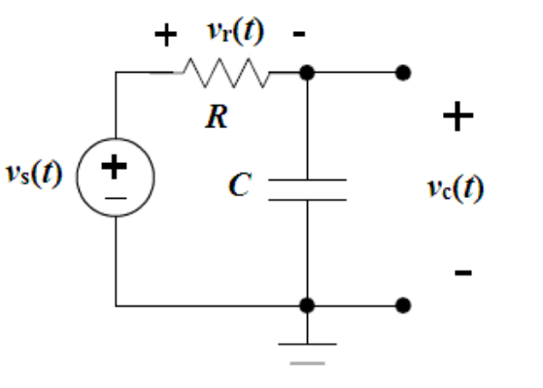
Assemble the series RC circuit with the following circuit element values:

C = 0.027 μF
R = 10 kΩ
vs(t) = Vmcos(ωt)
Vm = 5 V (Vp-p = 10V)

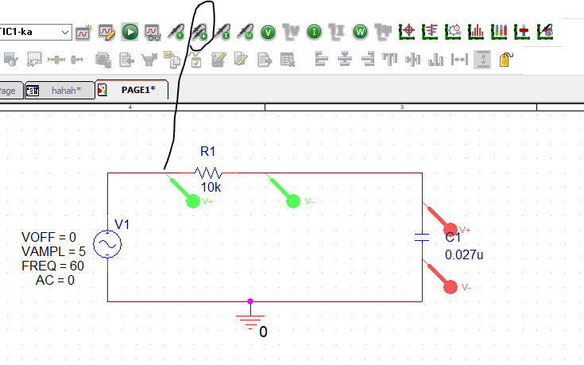
Connect the input voltage source vs(t) to Ch.A of the oscilloscope. Use Ch.B for the voltage of interest and complete table showing both theoretical and experimental results at f = 60 Hz, 500 Hz, 4 kHz, and 10 kHz for magnitude and phase of vr(t) and vc(t). Also simulate using Pspice.
Frequency (Hz) | Magnitude |  |  |  |  |  | Phase
Frequency (Hz) | vr(t) |  |  | vc(t) |  |  | vr(t) |  |  | vc(t)
Frequency (Hz) | Measured | Calculated | simulated | Measured | Calculated | simulated | Measured | Calculated | simulated | Measured | Calculated | simulated
60
500
4k
10k
Note: Don’t use differential probes across the resistor and capacitor.
Set simulation profile according to frequency:
Run to Time will be different for different frequencies. And maximum step size and saving data time will remain same for all frequencies.

Frequencies(Hz) | Run to Time (s) | Maximum Step Size (s) | Start Saving Data After(s)
60 | 50m | 0.005m | 0
500 | 10m | 0.005m | 0
4K | 2m | 0.005m | 0
10k | 0.2m | 0.005m | 0

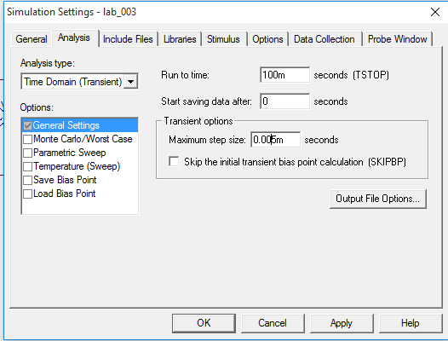

TASK#2
- Phase Shifter using RL combination
Now that the RC phase shifter has been designed and simulated. What kind of phase shift is expected from the circuit given in figure-5. Simulate this circuit and save the results and comment on the phase shift that is observed between the source voltage and V_{o} and i_{L}. In your report explain whether the phase shift observed is same as which is computed using relevant equations. Use the simulation profile as given in figure-4.
Replace the position of resistor and Inductor.
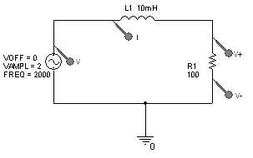
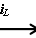

V_{o}

Frequency  (Hz) | vr(t) |  |  | vl(t) |  |  | vr(t) |  |  | vl(t)
Frequency  (Hz) | Measured | Calculated | simulated | Measured | Calculated | simulated | Measured | Calculated | simulated | Measured | Calculated | simulated
60
500
4000
10000

TABLE OF COMPONENTS
AVAILABLE IN LAB
This table gives some of the commonly used components that are available in the lab; this is just a partial list other values are also available. Please check with the LAB Technicians if you need other values.
RESISTORS |  | CAPACITORS
33 | 200 | 4.7µF | 22pF
47 | 680 | 33µF | 39pF
51 | 800 | 22µF | 200pF
75 | 1K | 100µF | 460pF
120 | 1.2K | 220µF | Capacitor box
150 | 3.9K | 470µF | Resistor box
200 | 5.6K | 5.6pF

