Applied Physics BS 101
Homework (BE-SE-1 AB)

Gauss’s Law
Problem 1: A cube with 1.4m edges is oriented in the region of electric field as shown. Find the electric flux through the right face if electric field is given by (a) $(6N/C)i$ (b) $(-2N/C)j$ , and (c) $(-3 N/C)i+(4 N/C)j$ . (d) Calculate the total flux through the cube for each of these fields
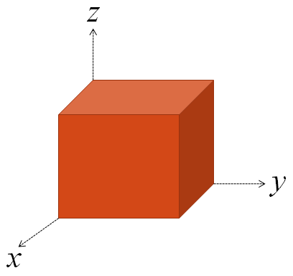
Ans.: (a) 0 (b) $-4N.m^{2}/C$ (c) 0 (d) zero in all the three cases

Problem 2: A point charge +q is a distance d/2 from a square surface of side d and is directly above the center of the square as shown. Find the electric flux through the square.
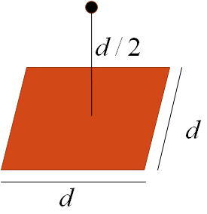
Ans.: $q/6ε_{0}$

Problem 3: An electron remains stationary in an electric field directed downward in the earth’s gravitational field. If the electric field is due to charge on two large parallel conducting plates, oppositely charged and separated by 2.3cm, what is the surface charge density, assumed to be uniform, on the plates?
Ans.: $σ=4.94×{10}^{-22}C/m^{2}$

Problem 4: Figure shows a point charge q = 126µC at the center of a spherical cavity of radius 3.66cm in a piece of metal. Use Gauss’ law to find the electric field (a) at point P1, halfway from the center to the surface, (b) at point P2.
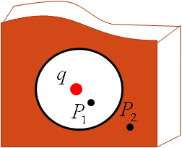
Ans.: $\left(a\right) 3.38×{10}^{6}\frac{N}{C}, \left(b\right) 0$

Problem 5: Two charged concentric thin spherical shells have radii of 10cm and 15cm. The charge on the inner shell is 40.6nC and that on the outer shell is 19.3nC. Find the electric field at (a) r = 12cm, (b) r = 22cm, and (c) r = 8.18cm from the center of the shells.
Ans.: $\left(a\right)2.54×{10}^{4}\frac{N}{C},\left(b\right)1.11×{10}^{4}\frac{N}{C},\left(c\right)0$

Problem 6: Two long charged concentric cylinders have radii of 3.22cm and 6.18cm. The surface charge density on the inner cylinder is 24.1µC/meter square and that on the outer cylinder is -18µC/meter square . Find the electric field at (a) r = 4.10cm, and (b) r = 8.2cm.
Ans.: $\left(a\right)2.14×{10}^{6}\frac{N}{C},\left(b\right)4.64×{10}^{5}\frac{N}{C}$
Problem 7: A cone with base radius R and height h is located on a horizontal table. A horizontal uniform field E penetrates the cone, as shown in Figure. Determine the electric flux that enters the left-hand side of the cone.

Ans.: $ERh$

Problem 8: A hollow conducting sphere is surrounded by a larger concentric spherical conducting shell. The inner sphere has charge -Q, and the outer shell has net charge +3Q.
The charges are in electrostatic equilibrium. Using Gauss’s law, find the electric field in the region (a) inside the sphere, (b) Between the sphere and shell, (c) within the shell and (d) outside the shell
Ans.: (a) E=0 (b) $E=kQ/r^{2}$ (c) $E=2kQ/r^{2}$

Problem 9: A solid insulating sphere of radius a carries a net positive charge 3Q , uniformly distributed throughout its volume. Concentric with this sphere is a conducting spherical shell with inner radius b and outer radius c, and having a net charge -Q, as shown in Figure.
(c) Find the electric field at r > c. (d) Find the electric field in the region with radius r where c >r > b. Find the electric field in the region b > r > a. (i) Find the electric field in the region r <a. ( j) Determine the charge on the inner surface of the conducting shell. (k) Determine the charge on the outer surface of the conducting shell. (l) Make a plot of the magnitude of the electric field versus r.
$$E=\frac{3(2qa^{2})}{2{πε_{0}x}^{4}}$$

Problem 10: A proton orbits with a speed v= 294Km/s just outside a charged sphere of radius r = 1.13cm. Find the charge on the sphere.

