Problem 1: A mass-spring system has mass 2.0kg, spring with constant 3.0N/m, and amplitude of vibration 0.10m. Calculate the angular frequency and frequency. Write expressions for the position, velocity, and acceleration as a function of time. Take t = 0 at the equilibrium position. Graph position, velocity, and acceleration as a function of time.
Problem 2: A 0.80kg mass hangs from a spring. When an additional 0.20kg mass is added the spring elongates another 3.0cm. What is the period of oscillation of the spring?

Problem 3: At time t = 0, an oscillating mass-spring system has displacement 10cm, velocity -12m/s, and acceleration -20m/s2. What is the (a) period of the system? (b) Phase angle?

Problem 4: Find the maximum velocity of a mass-spring system with mass 2.0kg, spring constant 0.80N /m, and amplitude of oscillation 0.36m.
Problem 5: Find the amplitude, angular frequency, and frequency for a mass-spring system with mass 2.0kg that is oscillating according to
$$x\left(t\right)=\left(2.0m\right)cos(6πt)$$
Write and graph the expressions for position, velocity, and acceleration. Finally, calculate the total energy of the system.
Problem 6: A 3.0kg mass-spring system executes simple harmonic motion according to
$$x\left(t\right)=\left(4.0cm\right)cos(\frac{π}{4}t-\frac{π}{6})$$
What is the total energy and the x position for equal division of the energy between kinetic and potential?
Problem 7: Two particles execute simple harmonic motion of the same amplitude and frequency along close parallel lines. They pass each other moving in opposite direction each time their displacement is half their amplitude. What is their phase difference?
Problem 8: A 0.20kg block traveling at 20m/ s slides into and sticks to a 0.80kg block resting on a frictionless surface and connected to a spring with force constant 80N/m. What is the angular frequency, frequency, and displacement of the oscillating system as a function of time? Also what fraction of the original energy in the moving block appears in the system?

Problem 9: Place a 3.0kg block at the top of a 3.4m high frictionless incline. At the bottom of the incline the block encounters a spring with a constant of 400 N/m on a horizontal surface. No energy is lost to friction. How far is the spring compressed?

Problem 10: Place a 2.5kg block at the top of a 4m high frictionless incline. A spring with a force constant of 300 N/m is placed at the bottom of the incline, as shown in Figure. Calculate the compression of the spring when the block slides down the plane.

Problem 11: At time t = 0, an oscillating mass-spring system has displacement 5cm, velocity 1.73m/s and acceleration -20m/s2. If amplitude of oscillation is 10cm, (a) Find the Phase angle (b) Write expressions for position, velocity, acceleration and sketch the graph.
Ans.:(a) –π/3 (b)$x=0.1cos⁡(20t-π/3)$, $v=-2sin⁡(20t-π/3)$,$a=-40cos⁡(20t-π/3)$
Graph for x(t) is shown below.(graph of cos20t is shifted right by π/3)
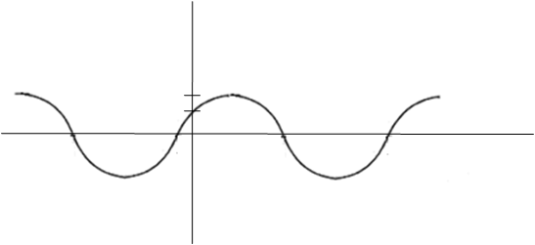
Problem 12: At time t = 0, an oscillating mass-spring system has displacement -5cm, velocity 1.73m/s and acceleration 20m/s2. If amplitude of oscillation is 10cm, (a) Find the Phase angle (b) Write expressions for position, velocity, acceleration and sketch the graph.
Ans.:(a) π/3 (b)$x=-0.1cos⁡(20t+π/3)$, $v=2sin⁡(20t+π/3)$,$a=40cos⁡(20t+π/3)$
Graph for x(t) is shown below.(graph of cos20t is first reflected about x-axis,-cos20t, then is shifted left by π/3)

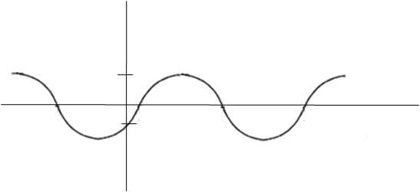

You can write alternate answer as

Ans.:(a) -2π/3 (b)$x=0.1cos⁡(20t-2π/3)$, $v=-2sin⁡(20t-2π/3)$,
$$a=-40cos⁡(20t-2π/3)$$

