
Department of Electrical Engineering

Faculty Member:____________________ Dated: ____________________

Course/Section:____________________ Semester: __________________

EE330- Digital Signal Processing
Lab #7 DFT SPECTRAL LEAKAGE

 |  | PLO4-CLO4 |  | PLO5-CLO5 | PLO8-CLO6 | PLO9-CLO7
Name | Reg. No | Viva / Quiz / Lab Performance | Analysis of data in Lab Report | Modern Tool Usage | Ethics and Safety | Individual and Team Work
 |  | 5 Marks | 5 Marks | 5 Marks | 5 Marks | 5 Marks

Page 1

Lab7: DFT SPECTRAL LEAKAGE, BLOCK CONVOLUTION USING DFT

Objectives

The objective in this lab is to explore basic spectral analysis using DFT and block convolution

DFT practical implementation and limitations.

Lab Instructions

- The students should perform and demonstrate each lab task separately for step-wise evaluation (please ensure that course instructor/lab engineer has signed each step after ascertaining its functional verification)
- Each group shall submit one lab report on LMS within 6 days after lab is conducted. Lab report submitted via email will not be graded.
. Students are however encouraged to practice on their own in spare time for enhancing their skills

Lab Report Instructions

All questions should be answered precisely to get maximum credit. Lab report must ensure following items:

Lab objectives

MATLAB/C codes

Results (graphs/tables) duly commented and discussed Conclusion

Page 2

1.1 Lab Tasks

1.1.1 Lab Task 1

1.1.1.1 DFT computation and Spectral leakage

- Generate a sinusoid of 0.1 second duration sampled at f_{s} = 44.1 KHz. Set the frequency of sinusoid to be f = 10*f_{s}/1024.

x₁ = cos(2*pi*f*t)

- Display the first 1024 samples of this sinusoid as a function of time in seconds.

- Compute the DFT of the signal x₁ using FFT of size N = 1024 (refer to help fft). Plot the magnitude spectrum as a function of ‘k’, the bin nu mber (use stem function). Explain the peaks obtained in different bins by linking them to the original sinusoid.

- Plot the magnitude spectrum again but now as a function of normalized (digital) frequency. For this purpose, define the frequency axis from - π to π (radians/sample) or -0.5 to 0.5 (cycles/sample). Recall the definition of this frequency axis from class notes.

- Redraw the same magnitude spectrum as a function of frequency in Hz and verify if you are able to identify the sinusoid that was input to the system. Is spectral leakage manifested in this case? Why/Why not?

- Generate two other sinusoids x₂ and x₃ with frequencies at 10.25 and 13.25 times 44100/1024 and display the first 1024 samples of each sinusoid. Compute the 1024 point DFT of x₂ and x₃, and display the magnitude spectra (as function of frequency in Hz) and try to identify their frequencies from the graphs. What is the change with respect to point

(5) above? Elaborate.

- Repeat the DFT evaluations done in part 5 and part 6, but using a 2048 point FFT. (Recall that applying a 2048 point FFT to a 1024 length data buffer has the effect of appending (2048-1024) zeros to the end of the data, which increases the number of points at which the spectrum is evaluated. Compare the resultant spectra with those obtained in part 5 and part6 and explain the differences.

The effect of spectral leakage can be reduced by applying a window function to the input sinusoid before performing the DFT. By default a rectangular window is applied when we truncate the sinusoid to the finite number of samples as in above examples. Using a window function that tapers of smoothly (rather than abruptly) at its ends results in reducing the effect of leakage although it cannot completely remove the leakage problem. The commonly used windows are shown below are:

Digital Signal Processing Page 3
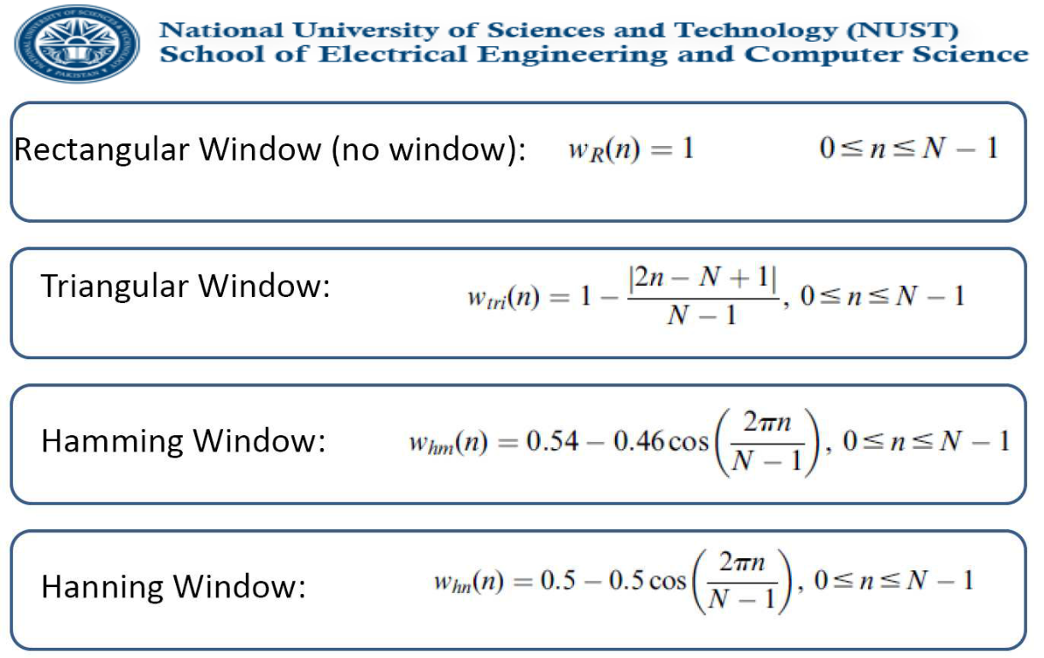

The plots of these windows with as a function of ‘ n’ are shown in the figure below.
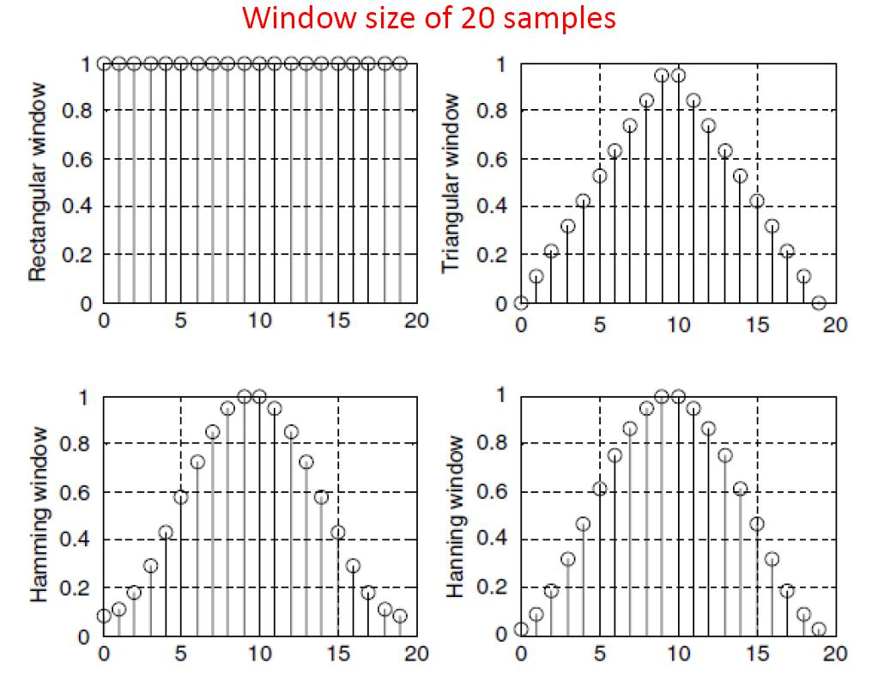

The properties of these windows can be better explained by displaying their corresponding

Fourier transforms as depicted in the figures below:

Digital Signal Processing Page 4
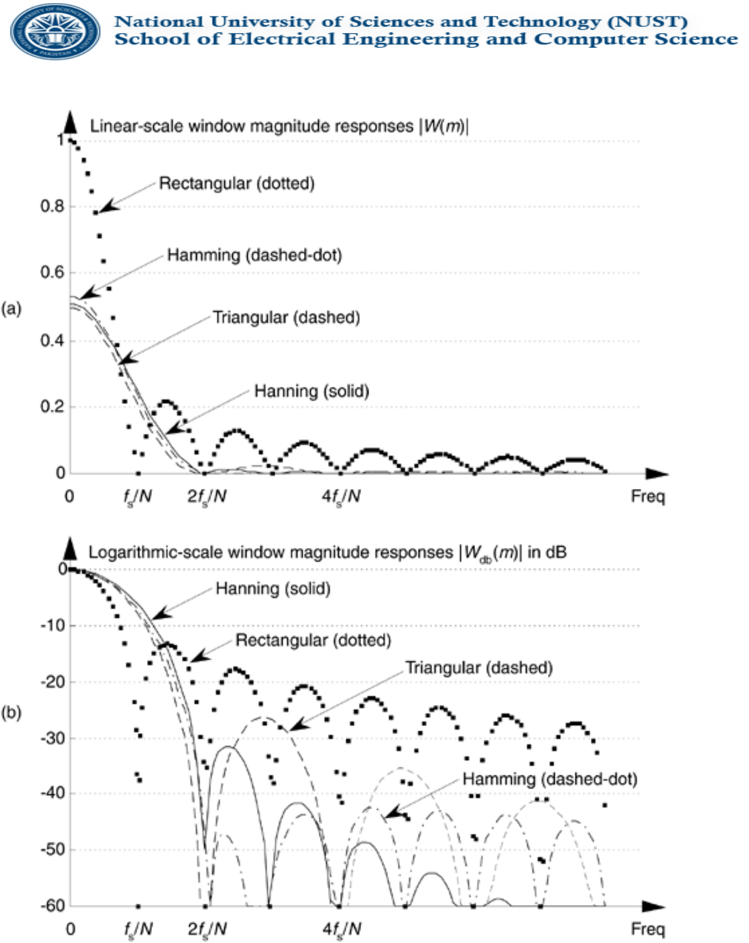

8. Construct a composite signal by adding up the sinusoids used in part 6 as follows:

xc = 50x₂ + 15 x₃

Plot the 1024 point spectrum of this composite signal for only positive frequencies (with frequency axis in Hz). Observe the spectrum to read the frequencies that were used at the input. Is it possible to clearly identify the frequencies from the background?

Digital Signal Processing Page 5

- Now create a new signal “ xcw” by applying a hamming window of length 1024 to the first 1024 samples of “xc” as:

xcw = xc (1:1024).*hamming(1024)’

Compute the 1024 point DFT of this new sequence and display the magnitude spectrum. Compare this spectrum with the one obtained in part (8) above and elaborate whether we obtain some improvement in identifying the sinusoids after pre-windowing.

- This part demonstrates the inverse DFT using the function ifft(). Generate a signal in the spectral domain by setting up a variable “ Xr” of length 1024 (corresponding to the number of FFT points) and initialize it to zero. Now the desired time domain signal is a sinusoid of frequency 1291.99 Hz sampled at 44.1 kHz. Set the appropriate bins by putting the value N/2 = 512 in them, note which bins to set should be determined from the given specifications above. Take the inverse DFT “ xr” of this signal “ Xr”. Plot the original spectrum as well as the obtained time domain signal “ xr”. Read out the frequency of the sinusoid from the time domain graph and compare with the one from the spectrum.

