Faculty Member:____________________ | Dated: ________________
Semester:_____________ | Section: ________________

EE313: ELECTRONIC CURCUIT DESIGN
Lab 11: OPERATIONAL AMPLIFIER WITH NEGATIVE FEEDBACK

S.no | Name | Reg. no. | Total/25
1
2
3
4

Experiment 11

INTRODUCTION

An operational ampliﬁer (op-amp) is an integrated circuit that ampliﬁes the difference between two input voltages and produces a single output. The op-amp is prevalent in analog electronics, and can be thought of as another electronic device, in much the same way as the bipolar or ﬁeld-effect transistor.

The term operational ampliﬁer comes from the original applications of the device in the early 1960s. Op-amps, in conjunction with resistors and capacitors, were used in analog computers to perform mathematical operations to solve differential and integral equations. The applications of op-amps have expanded signiﬁcantly since those early days.

From a signal point of view, the op-amp has two input terminals and one output terminal, as shown in the small-signal circuit symbol in Figure 7.1(a). also requires dc power, as do all transistor circuits, so that the transistors are biased in the active region. Also, most op-amps are biased with both a positive and a negative voltage supply, as indicated in Figure 7.1(b). The positive voltage is indicated by and the negative voltage by .

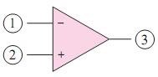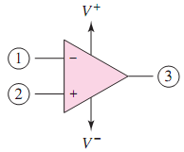
Figure 7.1(a) Small-signal op-amp symbol Figure 7.1(b) op-amp with positive and negative supply voltages

There are normally 20 to 30 transistors that make up an op-amp circuit. The typical IC op-amp has parameters that approach the ideal characteristics. For this reason, then, we can treat the op-amp as a “simple” electronic device, which means that it is quite easy to design a wide range of circuits using the IC op-amp.

IDEAL OP-AMP PARAMETERS

The ideal op-amp senses the difference between two input signals and ampliﬁes this difference to produce an output signal. The terminal voltage is the voltage at a terminal measured with respect to ground. The ideal op-amp equivalent circuit is shown in Figure 7.2.
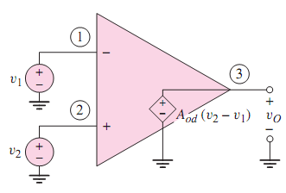
Figure 7.2 Ideal op-amp equivalent circuit

Ideally, the input resistance between terminals 1 and 2 is inﬁnite, which means that the input current at each terminal is zero. The output terminal of the ideal op-amp acts as the output of an ideal voltage source, meaning that the small-signal output resistance is zero. The parameter shown in the equivalent circuit is the open-loop differential voltage gain of the op-amp. In the ideal op-amp, the open-loop gain is very large and approaches infinity.

The output is out of phase with respect to and in phase with respect to . Terminal (1) then is the inverting input terminal, designated by the “-”notation, and terminal (2) is the noninverting input terminal, designated by the “+”notation.

Since the ideal op-amp responds only to the difference between the two input signals and , the ideal op-amp maintains a zero output signal for .When , there is what is called a common-mode input signal. For the ideal op-amp, the common-mode output signal is zero. This characteristic is referred to as common-mode rejection.

Because the device is biased with both positive and negative power supplies, most op-amps are direct-coupled devices (i.e., no coupling capacitors are used on the input). Therefore, the input voltages and shown in Figure 7.2 can be dc voltages, which produce the dc output voltage .

ANALYSIS METHOD

Usually, an op-amp is not used in the open-loop conﬁguration shown in Figure 7.2. Instead, feedback is added to close the loop between the output and the input. In negative feedback, the connection from the output goes to inverting terminal or terminal (1). This configuration produces stable circuits. In positive feedback the output is connected to noninverting terminal. Positive feedback can be used to produce oscillations. The ideal op-amp characteristics resulting from negative feedback are shown in Figure 7.3 and summarized below.

- The internal differential gain is considered to be inﬁnite.
- The differential input voltage () is assumed to be zero. If is very large and if the output voltage is ﬁnite, then the two input voltages must be nearly equal.
- The effective input resistance to the op-amp is assumed to be inﬁnite, so the two input currents, and , are essentially zero.
- The output resistance is assumed to be zero in the ideal case, so the output voltage is connected directly to the dependent voltage source, and the output voltage is independent of any load connected to the output.
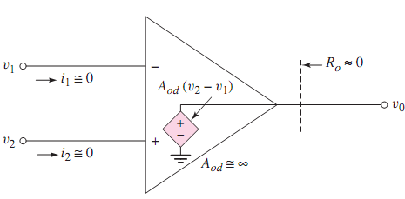
Figure 7.3 Parameters of ideal op-amp

PRACTICAL SPECIFICATIONS

Practical op-amps are not ideal, although their characteristics approach those of an ideal op-amp. Figure 7.4(a) is a more accurate equivalent circuit of an op-amp. Also included is a load resistance connected to the output terminal. This load resistance may actually represent another op-amp circuit connected to the output terminal.

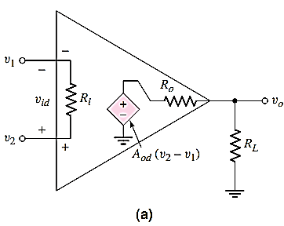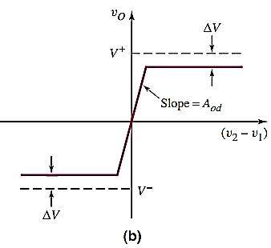
Figure 7.4 (a) Equivalent circuit of op-amp Figure 7.4(b) Simplified voltage transfer characteristics

OUTPUT VOLTAGE SWING

Since the op-amp is composed of transistors biased in the active region by the dc input voltages and , the output voltage is limited. When approaches , it will saturate, or be limited to a value nearly equal to , since it cannot go above the positive bias voltage. Similarly, when the output voltage approaches , it will saturate at a value nearly equal to . The output voltage is limited to , as shown in Figure 7.4 (b).

In older op-amp designs, such as the 741, the value of is between 1 and 2 V. However, in newer CMOS op-amp designs, the value of may be as low as 10 mV.
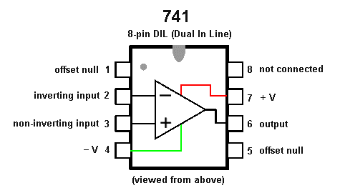

Figure 7.5 Pin-out diagram of a 741 op-amp

OBJECTIVES

In this experiment you will:

- Demonstrate the operation of non-inverting amplifier
- Verify voltage gain control by feedback resistors

EQUIPMENT AND MATERIALS

- DC power supply
- Function generator
- Digital multimeter
- Oscilloscope
- Breadboard
- Operational amplifier 741
- Resistors 75Ω, 1 kΩ [2], 15 kΩ

NONINVERTING AMPLIFIER

INTRODUCTION

The non-inverting voltage amplifier has the characteristics of an ideal voltage amplifier: exceptionally high input impedance and very low output impedance. Additionally, this amplifier, like any other based on a high-gain op-amp, has a voltage gain and stability that are dependent upon the external circuit resistors and independent of amplifier variations.
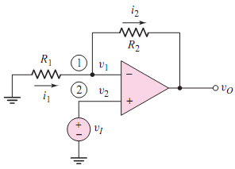
Figure 7.13 Non-inverting amplifier

The negative feedback forces the terminal voltages and to be essentially equal. Such a condition is referred to as virtual short. This condition exists since a change in will cause the output voltage to change in such a way that is forced to track . The virtual short means that the voltage difference between and is, for all practical purposes, zero. However, unlike a true short circuit, there is no current ﬂow directly from one terminal to the other.

The voltage gain of a noninverting amplifier is given by

A_{f} = 1/β = 1 + R₂ / R₁ (3)

In this experiment you will construct a series-parallel negative feedback op-amp non-inverting voltage amplifier circuit. You will verify and observe the effects of feedback resistors in setting the voltage gain, and you will demonstrate that negative feedback reduces the output resistance.

PART 1 IMPLEMENTATION

- Construct the circuit as shown in Figure 7.14 without the feedback network and measure the open loop. Set the generator to supply a 1-kHz sine wave at 200 mV peak-to-peak.
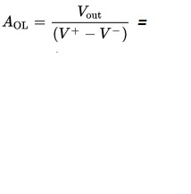

- Construct the circuit as shown in Figure 7.14

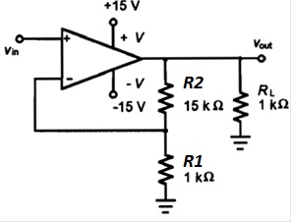
Figure 7.14 Circuit for non-inverting amplifier

- Apply DC power. Connect the function generator to v_{in}. Set the generator to supply a 1-kHz sine wave at 200 mV peak-to-peak. Using oscilloscope verify that output voltage v_{out} is in phase with the input voltage v_{in}

Phase shift =_____________________ degrees

With oscilloscope measure the peak-to-peak of v_{in} and v_{out} and record their values in Table 7.2.

- From your measured data, calculate the amplifier gain and record in Table 7.2.
- Your measured value of gain should agree with the calculated value, within resistance and equipment tolerances. If you find a greater deviation, recheck your measurements.
- Select a new value of R₂ to set the amplifier gain in the range of 6 to 25. Record the new value of R₂ in Table 7.2 with your predicted gain.
- Turn off AC and DC sources. Install the new R₂ resistance you selected. Reapply DC power and input signal. Repeat the gain measurements of steps 2 and 3. Record the peak-to-peak values of v_{in} and v_{out} in Table 7.2. Calculate the amplifier gain from measured values and record the result in Table 7.2.
- With both DC and AC sources off, install a 10 kΩ resistor for R₂. Reapply the DC power and input signal. Measure and record the peak-to-peak input and output voltage signal levels.

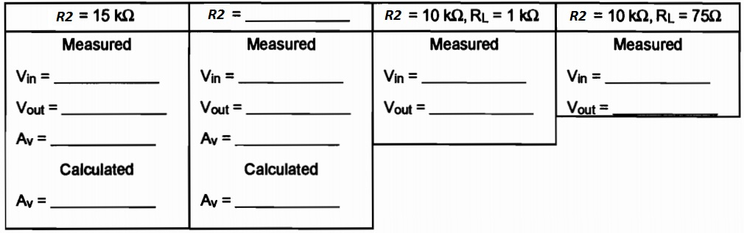

TABLE 7.2

PART 2 SIMULATION

- Create the circuit given in figure 7.14 in PSPice.
- Repeat the steps from implementation and record your results below.
Phase shift =_____________________ degrees

