Department of Electrical Engineering

Faculty Member: __________________ | Dated: ________________
Semester:_____________ | Section: ________________

EE313: ELECTRONIC CIRCUIT DESIGN

Lab 03: Cascode Amplifier

Name | Reg. No | Viva | Analysis of data in Lab Report | Modern Tool Usage | Ethics and Safety | Individual and Team Work
 |  | 5 Marks | 5 Marks | 5 Marks | 5 Marks | 5 Marks

Lab 03: Cascode Amplifier

Introduction
This lab provides an evaluation of the Cascode amplifier.
The cascode is a two-stage amplifier comprising a common emitter stage feeding into a common base stage. Compared to a single amplifier stage, this combination may have one or more of the following characteristics: output impedance, higher gain or higher bandwidth.
The cascode is often constructed from two transistors (BJTs or FETs), with one operating as a common emitter or common source and the other as a common base or common gate.

Ref Page 522-523 S&S 6th Ed.
Voltage Gain:
A= - ( ) [(II)
ǀ A= β β

Note for mosfet it is A
Output Impedance: 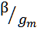
= ( 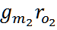) (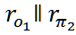) because 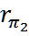
= 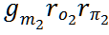 =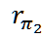
= 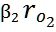

Note for mosfet it is A

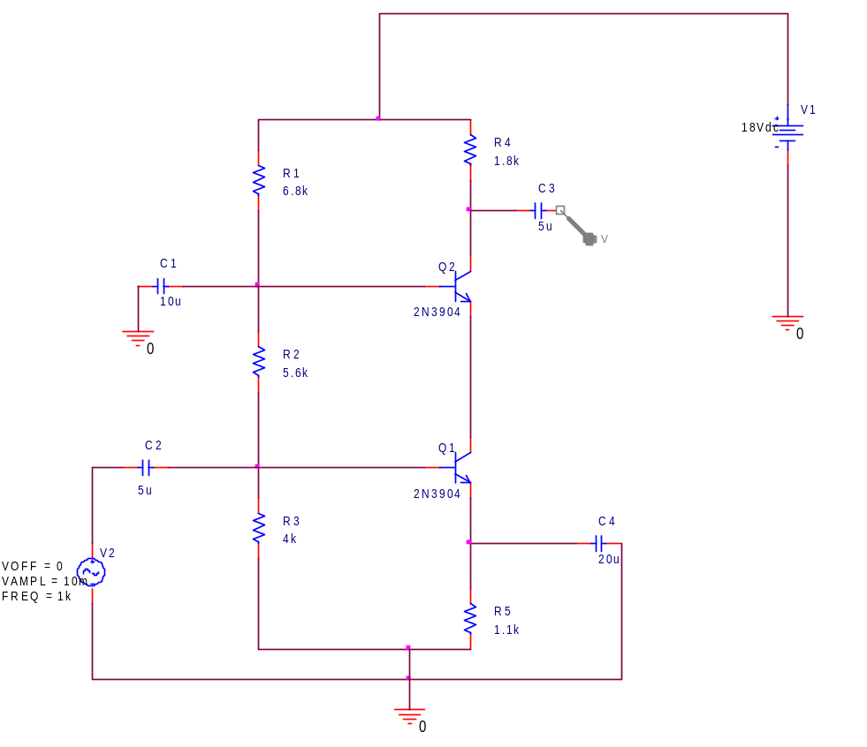
Fig. 1: Cascode Amplifier
Calculations
- Calculate the DC bias voltages and currents in the Cascode amplifier of Figure. 1

VB1 (calculated) =_______________ VB2 (calculated) =_______________

VC1 (calculated) =_______________ VC2 (calculated) =_______________

VE1 (calculated) =_______________ VE2 (calculated) =_______________

- Calculate the DC bias Emitter currents

IE1 (calculated) =_______________ IE2 (calculated) =_______________

Simualtion:

- Simulate the circuit in PSICE and measure the DC bias voltages

VB1 (measured) =_______________ VB2 (measured) =_______________

VC1 (measured) =_______________ VC2 (measured) =_______________

VE1 (measured) =_______________ VE2 (measured) =_______________

- Measure the values of emitter currents and dynamic resistances

IE1 (measured) =_______________ IE2 (measured) =_______________

Measure the AC Voltages Gain of each transistor stage

AV1 (calculated) =_______________ AV2 (calculated) =_______________

- Apply the input signal Vsig=10mV (p-p), Frequency = 1 KHz

Implementation:

Implement the circuit on breadboard. Observe the output waveform and make sure that no signal distortion occurs, if output is distorted or clipped, reduce input signal until it disappears. Measure

V_{i} (measured) =________________ V_{o1} (measured) =_________________
V_{o2} (measured) =_______________

- Calculate the measured voltage gains and sketch the waveforms for Vi, Vo1 and Vo2 in space below

AV1=V_{o1}/V_{i}=___________________ AV2=V_{o2}/V_{o1}=________________

AV=Vo2/Vi=_______________________
