Department of Electrical Engineering

Faculty Member:_____________ | Dated: ________________
Semester:___________________ | Section: ________________

EE-383-Instrumentation and Measurements

Experiment # 11
Ultrasonic Distance Sensor/Reflective Optical Sensor

 |  | PLO4/  CLO3 |  | PLO4/ CLO4 | PLO8/ CLO5 | PLO9/ CLO6
Name | Reg. No | Viva / Quiz / Lab Performance | Analysis of data in Lab Report | Modern Tool Usage | Ethics and Safety | Individual and Teamwork
 |  | 5 Marks | 5 Marks | 5 Marks | 5 Marks | 5 Marks

Lab no. 11

QNET Mechatronic Sensors

OBJECTIVE
In this lab, you will be introduced to QNET Mechatronics Sensor board; and you will learn:
- Ultrasonic Distance Sensor, its working principle , uses and application
- Reflective Optical Sensor, its working principle, uses and application.

Part (1): Ultrasonic Distance Sensor

Why Use Ultrasonic Sensors?
Ultrasonic distance sensors are popular non-contact distance measurement and object detection sensors. They are used in a variety of applications such as robotics, unmanned aerial vehicles (UAVs), obstacle detection, and liquid level measurement in water tanks. The signal conditioning circuitry integrated into the sensor converts the measured distance into a measurable signal, typically a voltage, which can be processed by a data acquisition system or microcontroller.
Ultrasonic Distance Sensor
An ultrasonic distance sensor uses sonar, which is a technique that uses sound propagation, to detect objects. Figure 1 shows an integrated ultrasonic distance sensor. The sensor consists of an ultrasonic transmitter, receiver, and signal conditioning circuitry.
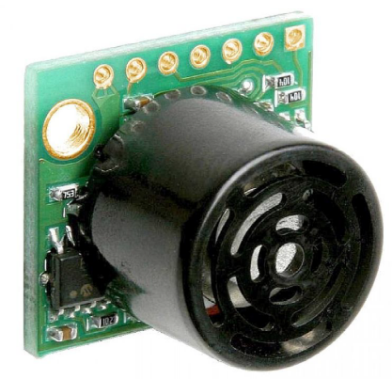
Figure 1: The MaxBotix ultrasonic distance sensor used in the QNET Mechatronic Sensors.

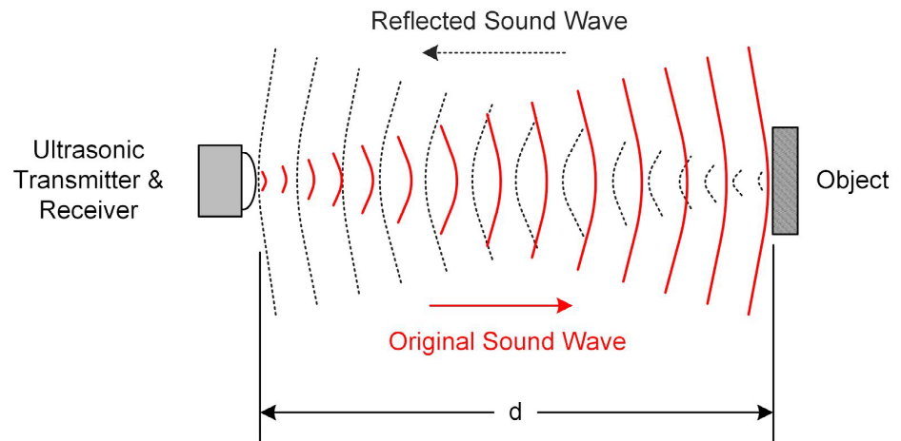
Figure 2: Sonar technique transmits and receives ultrasonic pings.
As illustrated in Figure 2, the transmitter generates a spherical cone-shaped ultrasonic pulse or ping which, when reflected off a nearby object, is picked up the receiver. The signal conditioning circuit measures the time it takes for the ultrasonic ping to travel to the object, bounce off, and be picked up by the receiver. Since sound waves travel at a constant speed (343 m/s in dry air at 20 °C), the speed of the transmitted and reflected ping will be the same, and hence the distance ( ) from the reflecting
object can be determined using Equation 1:
d=1/2(c.t)
where d is the distance between the sensor and the reflecting object, is the speed of sound, and is the time it takes for the transmitted ultrasonic ping to travel from the transmitter back to the receiver. Ultrasonic distance sensors typically generate several synchronized ultrasonic pings per second.
Ultrasonic distance sensors are ideal for long-range distance measurements as well as detecting large objects. The sensor mounted on the QNET Mechatronic Sensors board can measure objects ranging from 15.24 to 645.16 cm with a resolution of 2.54 cm. Prior to being measured by the data acquisition system, the signal generated by the sensor is amplified using the non-inverting amplifier.
In general, ultrasonic distance sensors are not suitable for close-range measurements and their resolution is relatively coarse. Furthermore, they may not detect soft objects such as clothing, blankets, and porous materials. Since the sonar technique relies on measuring reflected ultrasonic sound waves, ultrasonic distance sensors do not work in space.
Procedure
Mechatronic Sensors Lab Procedure
Ultrasonic Distance Sensor
The Virtual Instrument (VI) used to collect data from and calibrate the ultrasonic distance sensor is shown in Figure 1.
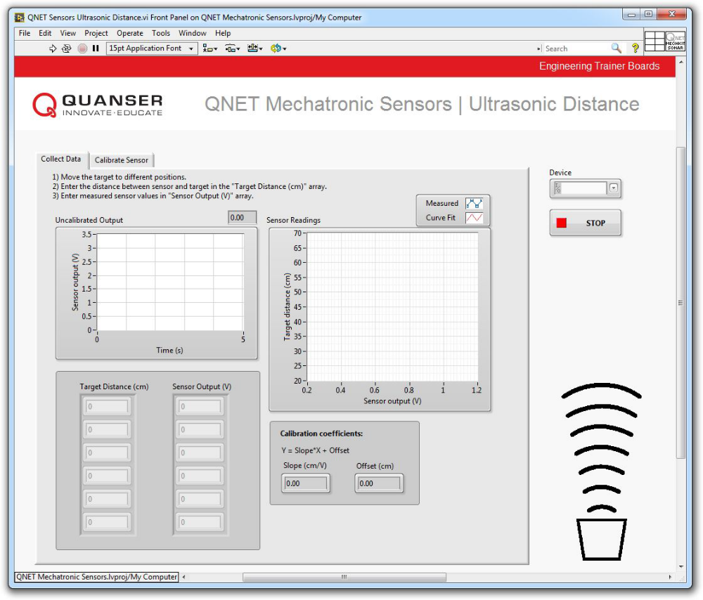
Figure 1: VI used to collect data from the ultrasonic distance sensor.
Collect Data
1. Prior to conducting this lab, use the NI ELVIS II prototyping board power switch to cycle the QNET Mechatronic Sensors power. The MaxBotix ultrasonic distance sensor performs a self-calibration on power-up to compensate for ambient temperature and humidity. Ensure that there are no objects close to the sensor while cycling the power. Best sensitivity is obtained when the sensor is clear for 35 cm during power-up.
2. Open QNET Mechatronic Sensors.lvproj .
3. From the Project Explorer window, open QNET Sensors Ultrasonic Distance.vi .
4. Click on the Collect Data tab.
5. From the Device drop-down menu, select the device name.
6. Run the VI.
7. Enter 20 in the Target Distance (cm) array.
8. Hold a sturdy cardboard 20 cm away from the sensor. Using the Uncalibrated Output waveform chart, read the corresponding sensor output and enter the value in the Sensor Output (V) array.
Note: Use a target that is at least 30 cm by 30 cm wide. Also, since the sensor generates a wide cone-shaped pulse, do not stand too close to the sensor while taking measurements. It will cause the sensor to detect your body which will interfere with your measurements. When measuring targets at longer distances, you will need to stand back and stretch out your arm while holding the target to get a valid measurement.
9. Continue taking measurements by moving the target in 10 cm intervals away from the sensor. Each time, enter the target distance and measured sensor outputs in the Target Distance (cm) and Sensor Output (V) arrays respectively.
Note: As the measured readings are entered, a linear curve is automatically generated to fit the data. The curve is shown in the Sensor Readings waveform graph. This curve represents the calibration curve of the sensor.
10. The slope and offset of the calibration curve are automatically calculated by the VI and displayed in the Slope (cm/V) and Offset (cm) indicators. Make a note of these values.
11. Record the collected data in Table 1.
12. Export a copy of the Sensor Readings graph. To do this, right-click on the graph and select Export |
Export Simplified Image .
13. Continue to the next section.

Target Distance (cm) | Sensor Output (V)
20
30
40
50
60
70

Table 1: Recorded sensor output.
Calibrate the Ultrasonic Distance Sensor
1. Click on the Calibrate Sensor tab to calibrate the output of the ultrasonic distance sensor in terms of linear displacement of the target (in cm).
2. Use the Slope (cm/V) and Offset (cm) numeric controls to enter the slope and offset values you obtained during the data collection step.
3. Test the accuracy of your calibration. To do this, place the target at different known positions within the calibrated range, and verify that the correct distance is displayed in the Calibrated Output waveform chart as well as the Distance (cm) slider indicator. Record the actual and measured distances in Table 2

Actual Distance (cm) | Measured Distance
20
30
40
50
60
70

Table 2: Actual versus measured target distances.
4. Using the Calibrated Output waveform chart, approximate the resolution of the sensor (in cm).Compare your result with the resolution of the sensor provided in the Concept Review .
Hint: Start by holding the target 20 cm away from the sensor. At a steady rate, slowly move the target away from the sensor and observe its response. The calibrated output of the sensor will have a step-like response. What is the smallest change in distance that it can detect?
5. If no further experiments are required, press the Stop button and power down the experiment.

Part (2): Reflective Optical Sensor

Reflective Optical Sensor
Why Use Optical Sensors?
Optical sensors convert light into a measurable electrical signal. They are typically made of semiconductor material and are used in a wide range of applications such as smartphones, assembly lines, machine automation, optical switching, and even edge detection in robots. An important usage of optical sensors is to create electrical isolation in electronic equipment and power transmission lines, where unwanted voltage surges are often caused by switching pulses and electrostatic discharge. The use of such sensors prevents voltage surges from affecting the system receiving the signal.
Reflective Optical Sensor
A typical reflective optical sensor is shown in Figure 1. It consists of a phototransistor and an infrared emitting diode (IRED). The emitting diode and detector are mounted side-by-side on parallel axes.
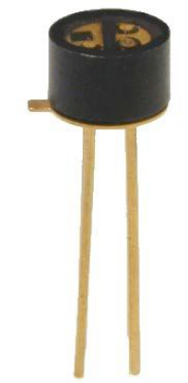

Figure 1: An OPB710 reflective optical sensor manufactured by TT Electronics.
To operate the sensor, a reflective surface, such as a retroreflective surface, is placed across from the sensor. The surface reflects the infrared light emitted by the IRED onto the phototransistor. The further the reflective surface is placed from the sensor, the less light is reflected onto the phototransistor. The sensor outputs a voltage that is proportional to the amount of reflected light.
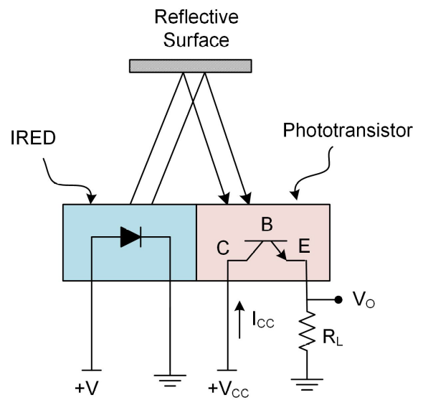

Figure 2: Schematic diagram of a reflective optical sensor.
Figure 2 schematically illustrates the operation of the sensor. When powered, the IRED emits infrared light, part of which is reflected by the reflective surface onto the phototransistor. The phototransistor is a light-sensitive transistor. It is different from a traditional transistor in that its base terminal has a transparent enclosure, allowing light to shine on it. The intensity of the reflected light onto the base terminal controls
the amount of current (I_{CC} ) that flows from the collector (C) to the emitter (E). Higher intensity light results in higher current flow and thus a larger output voltage (V_{O} ).
The load resistor (R_{L} ) can be selected such that the phototransistor operates in an “active mode”, meaning that the output voltage is proportional to the received light but limited to the common collector voltage (V_{CC} ). When the amount of light surpasses that level, the output voltage does not increase any further, in
which case the phototransistor is said to become saturated. To operate in an “active mode” the load resistor must be chosen such that V_{CC} > R _{L} x I_{CC} . When operated in “active mode”, a reflective optical sensor can be used as a short-range distance sensor.
The phototransistor can also be operated in a “switch mode”. That is, when the load resistor is chosen such that V_{CC} < R_{L} x I_{CC} , the phototransistor will act as an on/off switch. In “switch mode”, the sensor typically outputs either a value less than 0.8 V indicating an “off” state, or a value equaling V_{CC} indicating an “on” state.
A common problem with reflective optical sensors that are packaged with an IRED, is that ambient light affects their output. To minimize this problem, filtering material is added to the transparent enclosure of the sensor to filter out visible light.
Procedure
Reflective Optical Sensor
The Virtual Instrument (VI) used to collect and analyze data from the reflective optical sensor is shown in Figure 1.
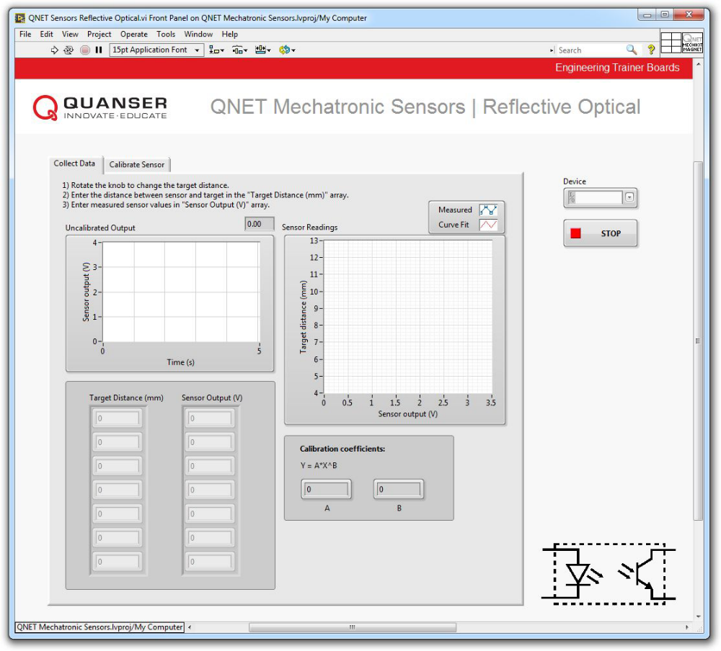

Figure 1: VI used to collect data from the reflective optical sensor.
Collect Data
1. Open QNET Mechatronic Sensors.lvproj .
2. From the Project Explorer window, open QNET Sensors Reflective Optical.vi .
3. Click on the Collect Data tab.
4. From the Device drop-down menu, select the device name.
5. Run the VI.
6. Gently turn the reflective optical sensor knob clockwise until it reaches its lower limit.
Note: At this position, the reflective target that is mounted on the bottom of the knob/screw assembly, will be at a distance of 5 mm from the reflective optical sensor. This will be your reference position.
7. Enter 5 in the Target Distance (mm) array.
8. Using the Uncalibrated Output waveform chart, read the corresponding sensor output and enter the value in the Sensor Output (V) array.
Note: Make sure your hand is away from the knob when reading the measured values.
9. Continue taking measurements by rotating the knob counterclockwise one rotation at a time. Enter the target distance and measured sensor outputs in the Target Distance (mm) and Sensor Output (V) arrays respectively.
Note : Each full revolution of the knob linearly moves the reflective target approximately 1.25 mm.
10. As the measured readings are entered, a one-term power series is automatically generated to fit the data. The curve is shown in the Sensor Readings waveform graph. This curve represents the calibration curve of the sensor.
11. The coefficients of the calibration curve are automatically calculated by the VI and displayed in the A and B indicators. Make a note of these values.
12. How well does the curve fit your data?
13. Record the collected data in Table 1.
14. Continue to the next section.

Target Distance  (mm) | Sensor Output  (V)
5.00
6.25
7.50
8.75
10.00
11.25
12.5

Table 1: Recorded sensor output.

Calibrate the Reflective Optical Sensor
1. Click on the Calibrate Sensor tab to calibrate the output of the reflective optical sensor in terms of linear displacement of the reflective target (in mm).
2. Use the A and B numeric controls to enter the power series coefficient values you obtained during the data collection step.
3. Test the accuracy of your calibration. To do this, move the target to different known positions within the calibrated range, and verify that the correct distance is displayed in the Calibrated Output waveform chart as well as the Distance (mm) slider indicator. Record the actual and measured distances in Table 2.

Actual Target Distance  (mm) | Measured Target Distance  (mm)
5.00
6.25
7.50
8.75
10.00
11.25
12.5

Table 2: Actual versus measured target distances.
4. A common problem with reflective optical sensors that are packaged with an IRED, is that ambient light affects their output. To observe this phenomenon, rotate the sensor’s knob in the counterclockwise direction until it reaches the highest position. Note the sensor value. Now partially obstruct ambient light by holding a notebook or your hand over the sensor assembly. How does blocking the ambient light affect the output of the sensor?
5. If no further experiments are required, press the Stop button and power down the experiment.

