

**NATIONAL UNIVERSITY OF SCIENCES AND TECHNOLOGY**

**Applied Physics (PHY-102)**

**Instructor: Muhammad Imran Malik**

**Lab 2: PASCAR With Mass**

**Class: BEE-12C**

**Dated: 5/11/2020**

**Group 2**

|  |  |
| --- | --- |
| **Name** | **Registration Number** |
| Muhammad Umer | 345834 |
| Saad Bakhtiar | 341150 |
| Tariq Umar | 334943 |

**ABSTRACT:**

The purpose of these experiments is to:

* Get familiar with PASCARs kinematics and dynamics
* Compare theoretical or ideal values with experimental ones
* Establish a rationale conclusion as to why such discrepancies arise
* Utilize Simple Harmonic Motion and the experiences of it on the PASCAR
* Verify Newton’s 2nd Law

**Equations:**

Equations that we will be using throughout the following four experiments are:

$$Average Velocity v_{avg}=D/T$$

$$Initial Instantaneous Velocity v_{o}= {2D}/T$$

$$Acceleration a= -{2D}/{T^{2}}$$

$$Time \left(through quadratic formula\right) t=d=v_{o}t+ \frac{1}{2}at^{2}$$

$$Acceleration \left(Upslope\right) a_{1}=-g\sin{θ}-μ_{r}\cos{θg}$$

$$Acceleration \left(Downslope\right) a_{2}=g\sin{θ}- μ_{r}\cos{θg}$$

$$Coefficient of Friction μ_{r}= -{{(a}_{1}+a_{2)}}/{2g}$$

$$Inclination θ= \sin^{-1}{({{ a}_{1}-a_{2}}/{2g})}$$

$$Spring Constant k= F/x$$

$$Time Period T=2π\sqrt{m/k}$$

$$a=\frac{F_{net}}{M_{total}}=(\frac{m}{M_{total}})g$$

**EXPERIMENT 1 (*Avg vs Instantaneous Velocities*)**

**Objective:**

In this experiment, we will use PASCAR to investigate and broaden our view on one dimensional accelerated motion. After calculations, we will be able to deduce if the acceleration remains constant or not.

**Equipment:**

* PASCAR
* Metric Tape
* Stopwatch

**Procedure:**

The car will be allowed to roll to a stop. The distance **D** covered and the total elapsed time **T** from launch to stop will be measured and recorded. Using the formulas aforementioned, we will calculate average velocity and acceleration. Theoretical values of time will be directly compared the measured or experimental values. From it, we can deduce if acceleration remains consistent or not.

$$Average Velocity v_{avg}=D/T$$

$$Initial Instantaneous Velocity v_{o}= {2D}/T$$

$$Acceleration a= -{2D}/{T^{2}}$$

$$Time \left(through quadratic formula\right) t=d=v_{o}t+ \frac{1}{2}at^{2}$$

**Data Analysis:**

d = 50 cm

**Table**

|  |  |  |  |  |  |  |  |
| --- | --- | --- | --- | --- | --- | --- | --- |
|  |  |  | **Experiment** |  |  | **Theory** |  |
| **Trial** | **t1**  **sec** | **T**  **sec** | **D**  **cm** | **Vo**  **cm/s** | **a**  **cm/s2** | **t1**  **sec** | **%Difference** |
| 1 | 0.83 | 2.55 | 90 | 70.59 | -27.68 | 0.853 | 2.69% |
| 2 | 0.82 | 2.58 | 90 | 69.77 | -27.04 | 0.861 | 4.76% |
| 3 | 0.84 | 2.61 | 90 | 68.97 | -26.42 | 0.872 | 3.67% |
| 4 | 0.81 | 2.52 | 90 | 71.42 | -28.34 | 0.844 | 4.03% |
| 5 | 0.83 | 2.56 | 90 | 70.31 | -27.46 | 0.853 | 2.7% |
| **Average** | **0.826** | **2.564** | **90** | **70.21** | **-27.38** | **0.854** | **3.27%** |

**Results and Calculations**

We now compare the Theoretical t with the Experimental t. As the %Difference between both these values is quite low, we can deduce that the acceleration remains consistent with the assumption.

*-------------------------------------------------------------------------------------------*

**EXPERIMENT 2 (*Coefficient of Friction*)**

**Objective:**

In this experiment, we shall launch PASCAR over an upslope and a downslope track. Utilizing the given formulas, we will calculate the coefficient of rolling friction and the inclination of the slope. We will need two separate sub-experiments to find the two values as it is not possible to calculate two values with a single equation.

**Equipment:**

* PASCAR
* Metric Tape
* Stopwatch

**Procedure:**

We will launch the car from a fixed position by giving the track a downward inclination first. Repeating this process several times, we could get an almost accurate reading of the acceleration. We shall call this ${ a}_{1}$**.** We will repeat this procedure but this time we’ll have an upslope. The acceleration calculated through this will be denoted by ${ a}_{2}$

$$Coefficient of Friction μ_{r}= -{{(a}_{1}+a_{2)}}/{2g}$$

$$Inclination θ= \sin^{-1}{({{ a}_{1}-a_{2}}/{2g})}$$

$$Acceleration a= {2D}/{T^{2}}$$

**Data Analysis:**

Coefficient of Rolling Friction = 0.00531

Floor Angle = 1.26°

**Table**

|  |  |  |  |  |  |  |
| --- | --- | --- | --- | --- | --- | --- |
|  |  | **UP** |  |  | **Down** |  |
| **Trial** | **d**  **cm** | **t**  **sec** | **a1**  **cm/s2** | **d**  **cm** | **t**  **sec** | **a2**  **cm/s2** |
| 1 | 45 | 2.34 | 16.43 | 60 | 2.10 | -27.21 |
| 2 | 44 | 2.29 | 16.78 | 60 | 2.08 | -27.73 |
| 3 | 46 | 2.37 | 16.38 | 60 | 2.14 | -26.20 |
| 4 | 47 | 2.38 | 16.60 | 60 | 2.12 | -26.70 |
| **Average** | **45.5** | **2.345** | **16.55** | **60** | **2.11** | **- 26.96** |

**Results and Calculations**

$$Acceleration \left(Upslope\right) a_{1}=-g\sin{θ}-μ_{r}\cos{θ}g$$

$$Acceleration \left(Downslope\right) a_{2}=g\sin{θ}- μ_{r}\cos{θ}g$$

**By adding:** (We choose inclination $θ$ ≃ 0 and hence cos $θ$ = 1)

$$a_{1}+a_{2}= -g\sin{θ}-μ_{r}\cos{θ}+g\sin{θ}- μ_{r}\cos{θ} \\ a_{1}+a_{2}= -μ_{r}\cos{θ}- μ_{r}\cos{θ}= -{2*μ}_{r}\cos{θ}$$

$μ_{r}=-(a_{1}+a_{2})/2g$**= $-\frac{16.55+\left(-26.96\right)}{1960}=0.00531$**

**By subtracting:**

$a_{1}-a_{2}= -g\sin{θ}-μ_{r}\cos{θ}-g\sin{θ}+ μ_{r}\cos{θ}$

$$a_{1}-a_{2}= -g\sin{θ}-μ_{r}\cos{θ}-g\sin{θ}+ μ_{r}\cos{θ}$$

$θ= \sin^{-1}\left(\frac{a_{1}-a_{2}}{2g}\right)= \sin^{-1}{(}\frac{16.55+26.96}{1960})=$ 1.26°

*-------------------------------------------------------------------------------------------*

**EXPERIMENT 3 *(Verification of Newton’s 2nd Law)***

**Objective:**

In this experiment, we will verify that a small mass **m** attached to the end of string, which rolls over a clamp, will have the same acceleration as the **PASCAR**.

**Equipment:**

* PASCAR
* Pulley and clamp
* Mass Set
* Stopwatch
* String
* Block

**Procedure:**

The PASCAR is set up on a track and balanced while having a string attached to it on one end. The other end of the string will be attached to a mass **m** and it will be observed that through what distance the car moves and in what time under the effect of that mass. After we have near accurate readings for the distance and time, we will calculate the acceleration. We will then compare the experimental value of **a** with the value calculated by the formula that Newton suggested; that is:

$$a=\frac{F_{net}}{M_{total}}=(\frac{m}{M_{total}})g$$

$$Acceleration a= {2D}/{T^{2}}$$

**Data Analysis:**

d = 100 cm

$M_{total}$ = 850 grams

**Table**

|  |  |  |  |  |  |
| --- | --- | --- | --- | --- | --- |
| **Trail** | **m**  **grams** | **Average time**  **sec** | **cm/s2** | **cm/s2** | **%Diff** |
| 1 | 10 | 4.36 | 10.52 | 11.53 | **8.76** |
| 2 | 30 | 2.51 | 31.74 | 34.59 | **8.24** |
| 3 | 50 | 1.95 | 52.59 | 57.64 | **8.77** |
| 4 | 100 | 1.38 | 105.01 | 115.29 | **8.92** |

**Results and Calculations**

1. $Acceleration a= {2D}/{T^{2}}$**= 2 (100) / (3.46)2 = 10.52 cm/s2**
2. **= 2 (100) / (3.46)2 = 31.74 cm/s2**
3. **= 2 (100) / (3.46)2 = 52.59 cm/s2**
4. **= 2 (100) / (3.46)2 = 105.0 cm/s2**

Comparing the experimental acceleration with theoretical values, we see that the % difference between them is quite low if we suppose that the losses are from friction. Hence, we can deduce that Newton’s 2nd Law is almost accurate and is valid.

*-------------------------------------------------------------------------------------------*

**EXPERIMENT 4: *(Simple Harmonic Motion)***

**Objective:**

The PASCAR has a spring plunger which can be utilized to produce consistent launch velocities. The collisions in it are relatively elastic.

**Equipment:**

* PASCAR
* Spring
* Mass Set
* Stopwatch

**Procedure:**

We connect either ends of the PASCAR with a spring and attach it with a string that, then, was near massless. The we start attaching incremental amounts of masses to then observe the change in position from the PASCAR’s balanced position. This gives us the Force exerted on the PASCAR as well as the displacement which we then can use to find the value of Spring Constant k. This enables us to further find the time periods and the effect of mass on it.

$$F= mg$$

$$Spring Constant k= F/x$$

$$Time Period T=2π\sqrt{m/k}$$

**Data Analysis:**

Spring Constant **k = 4.9 N/m**

Time Period (without addition mass) **T** = **1.42s**

Time Period (after adding mass) $T_{mass}$ **= 1.68s**

**Table**

|  |  |  |  |
| --- | --- | --- | --- |
| **Trial** | **Hanging mass**  **(Kg)** | **x**  **m** | **F= mg**  **N** |
| 1 | 0.01 | 0.02 | 0.098 |
| 2 | 0.03 | 0.06 | 0.294 |
| 3 | 0.05 | 0.1 | 0.49 |
| 4 | 0.1 | 0.2 | 0.98 |
| 5 | 0.2 | 0.4 | 1.96 |

F

**Graph**

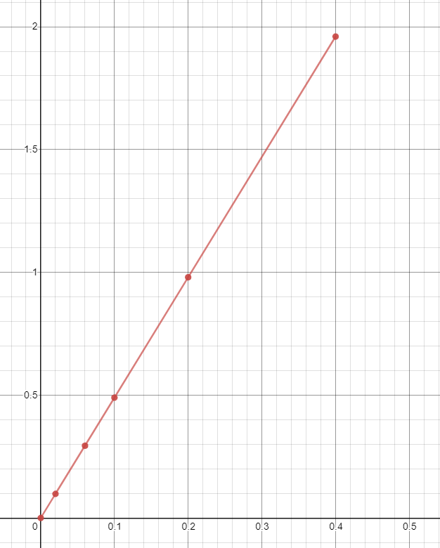

x

**Results and Calculations**

The slope of the graph gives us the value of **Spring Constant k** as **k = F/x.**

**k =** y2-y1 / x2-x1 = (0.49 – 0.294) / (0.1 – 0.06) **= 4.9N/m**

Now, we can use this value to calculate time period.

We divide time period into two categories; without and with additional mass.

* **Theoretical Value of T (without additional mass):**

$$T=2π\sqrt{\frac{m}{k}}$$

$$T=2π\sqrt{\frac{0.25}{4.9}}$$

$$T=1.42s$$

**Experimental Value of T (without additional mass):**

|  |  |  |  |
| --- | --- | --- | --- |
| **Trial** | **Time for 5 oscillations (T)**  **s** | **Time period**  **t = T/5** | **%Difference**  **Theoretical and Measured** |
| 1 | 6.82 | 1.36 | 4.2 |
| 2 | 6.77 | 1.35 | 4.9 |
| 3 | 6.89 | 1.38 | 2.8 |
| Average | 6.83 | **1.37** | 3.5 |

* **Theoretical Value of T (with additional mass):**

$$⋮m=250+100=0.35kg$$

$$T=2π\sqrt{\frac{m}{k}}$$

$$T=2π\sqrt{\frac{0.35}{4.9}}$$

$$T=1.68s$$

**Experimental Value of T (with additional mass):**

|  |  |  |  |
| --- | --- | --- | --- |
| **Trial** | **Time for 5 oscillations (T)**  **s** | **Time period**  **t = T/5** | **%Difference**  **Theoretical and Measured** |
| 1 | 8.05 | 1.61 | 4.17 |
| 2 | 7.82 | 1.56 | 7.14 |
| 3 | 7.92 | 1.58 | 5.9 |
| Average | 7.93 | **1.59** | 5.35 |

**Conclusion:**

After performing these experiments, I have come to know about the usage and advantages of using PASCAR. One key feature of using it is that track and its design offers extremely low friction and the ball-bearing provides smooth motion. We can also add mass over it to see effects of the individual mass to time period, motion, etc. We also deduced and verify the validity of Newton’s 2nd Law.

*-------------------------------------------------------------------------------------------*