

**NATIONAL UNIVERSITY OF SCIENCES AND TECHNOLOGY**

**Applied Physics (PHY-102)**

**Instructor: Muhammad Imran Malik**

**Lab 3: DC Electronics**

**Class: BEE-12C**

**Dated: 14/12/2020**

**Group 2**

|  |  |
| --- | --- |
| **Name** | **Registration Number** |
| Muhammad Umer | 345834 |
| Saad Bakhtiar | 341150 |
| Tariq Umar | 334943 |

**Assignment**

**Q1: Why do we connect a Voltmeter in parallel?**

We connect a Voltmeter in parallel with a desired component because components in parallel always experience the same potential difference and hence, makes it easy to measure the device’s voltage. If it were to be connected in series, it would give a faulty reading because the Resistance of Voltmeter is quite high and hence minimal current flows through it. An ideal Voltmeter has infinite resistance.

**Q2: Why do we connect an Ammeter in series?**

We connect an Ammeter in series with a component because current through each component in series remains the same. If it were to be connected in parallel, it would result in the damaging of Ammeter as the Shunt Resistance of Ammeter cannot withstand high currents.

**Circuit 1:**

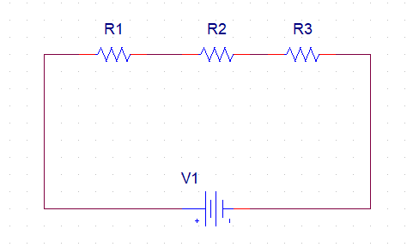

* **For (R1 = 4.7Ω, R2 =110Ω, R3 = 800Ω, & V=9V)**

**REQ**

In series, Equivalent Resistance is the sum of all resistances.

**REQ = R1 + R2 + R3**

**REQ = 914.7Ω**

**I = I1 = I2 = I3**

In series, current remains the same through each component.

We can calculate it by Ohm’s Law:

I = V/REQ = **9.84mA**

**V1:**

V1 = IR1 = **0.044V**

**V2:**

V2 = IR2 = **1.034V**

**V3:**

V3 = IR3 = **7.520V**

* **For (R1 =5.7Ω, R2 =600Ω, R3 =550Ω, & V=12V)**

**REQ**

In series, Equivalent Resistance is the sum of all resistances.

**REQ = R1 + R2 + R3**

**REQ = 1155.7Ω**

**I = I1 = I2 = I3**

In series, current remains the same through each component.

We can calculate it by Ohm’s Law:

I = V/REQ = **10.38mA**

**V1:**

V1 = IR1 = **0.059V**

**V2:**

V2 = IR2 = **6.228V**

**V3:**

V3 = IR3 = **5.709V**

* **For (R1 =6.8Ω, R2 =220Ω, R3 =320Ω, & V=9V)**

**REQ**

In series, eequivalent rresistance is the sum of all resistances.

**REQ = R1 + R2 + R3**

**REQ = 546.8Ω**

**I = I1 = I2 = I3**

In series, current remains the same through each component.

We can calculate it by Ohm’s Law:

I = V/REQ = **16.45mA**

**V1:**

V1 = IR1 = **0.1118V**

**V2:**

V2 = IR2 = **3.619V**

**V3:**

V3 = IR3 = **5.264V**

* **For (R1 =7.8Ω, R2 = 150Ω, R3 = 170Ω, & V=12V)**

**REQ**

In series, Equivalent Resistance is the sum of all resistances.

**REQ = R1 + R2 + R3**

**REQ = 327.8Ω**

**I = I1 = I2 = I3**

In series, current remains the same through each component.

We can calculate it by Ohm’s Law:

I = V/REQ = **36.6mA**

**V1:**

V1 = IR1 = **0.285V**

**V2:**

V2 = IR2 = **5.49V**

**V3:**

V3 = IR3 = **6.222V**

**Circuit 2:**

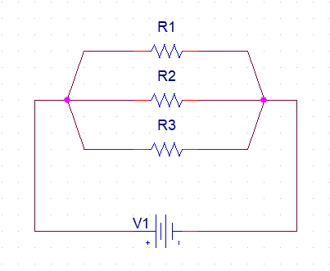

* **For (R1 = 4.7Ω, R2 =110Ω, R3 = 800Ω, & V=9V)**

**REQ**

In parallel, Equivalent Resistance is the reciprocal of sum of reciprocal all resistances.

**1/REQ = 1/R1 + 1/R2 + 1/R3**

**REQ = 4.482Ω**

**V = V1 = V2 = V3**

In parallel, voltage across each component is the same. Which, in this case, is the source.

V = **9V**

**I1:**

I1 = V/R1 = **1.914A**

**I2:**

I2 = V/R2 = **0.0818A**

**I3:**

I3 = V/R3 = **0.01125A**

* **For (R1 =5.7Ω, R2 =600Ω, R3 =550Ω, & V=12V)**

**REQ**

In parallel, Equivalent Resistance is the reciprocal of sum of reciprocal all resistances.

**1/REQ = 1/R1 + 1/R2 + 1/R3**

**REQ = 5.588Ω**

**V = V1 = V2 = V3**

In parallel, voltage across each component is the same. Which, in this case, is the source.

V = **12V**

**I1:**

I1 = V/R1 = **2.015A**

**I2:**

I2 = V/R2 = **0.02A**

**I3:**

I3 = V/R3 = **0.0218A**

* **For (R1 =6.8Ω, R2 =220Ω, R3 =320Ω, & V=9V)**

**REQ**

In parallel, Equivalent Resistance is the reciprocal of sum of reciprocal all resistances.

**1/REQ = 1/R1 + 1/R2 + 1/R3**

**REQ = 6.462Ω**

**V = V1 = V2 = V3**

In parallel, voltage across each component is the same. Which, in this case, is the source.

V = **9V**

**I1:**

I1 = V/R1 = **1.323A**

**I2:**

I2 = V/R2 = **0.0409A**

**I3:**

I3 = V/R3 = **0.0218A**

* **For (R1 =7.8Ω, R2 = 150Ω, R3 = 170Ω, & V=12V)**

**REQ**

In parallel, Equivalent Resistance is the reciprocal of sum of reciprocal all resistances.

**1/REQ = 1/R1 + 1/R2 + 1/R3**

**REQ = 7.1045Ω**

**V = V1 = V2 = V3**

In parallel, voltage across each component is the same. Which, in this case, is the source.

V = **12V**

**I1:**

I1 = V/R1 = **1.533A**

**I2:**

I2 = V/R2 = **0.08A**

**I3:**

I3 = V/R3 = **0.0706A**

**Circuit 3:**

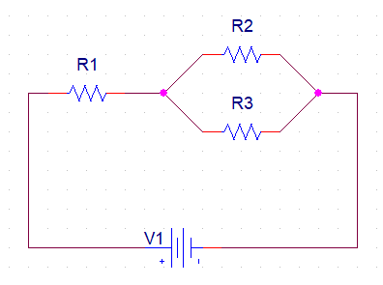

* **For (R1 = 4.7Ω, R2 =110Ω, R3 = 800Ω, & V=9V)**

**REQ**

In parallel, Equivalent Resistance is the reciprocal of sum of reciprocal all resistances.

**REQ = R1 + (1/R2 + 1/R3)-1**

**REQ = 101.4Ω**

**I**

Current flowing out from the source is;

I = V/REQ = **88.7mA**

This value flows through R1 and gets divided between R2 and R3.

**V1**

V1 = I (R1)= **0.417V**

**V2 = V3 = VP**

Since they are in parallel, they have the same potential difference.

**V – V1 = VP**

**VP = 8.583V**

**I1:**

I = V1 / R1 = **88.7mA**

**I2:**

I = VP / R2 = **78mA**

**I3:**

I = VP / R3 = **10.7mA**

* **For (R1 =5.7Ω, R2 =600Ω, R3 =550Ω, & V=12V)**

**REQ**

In parallel, Equivalent Resistance is the reciprocal of sum of reciprocal all resistances.

**REQ = R1 + (1/R2 + 1/R3)-1**

**REQ = 292.6Ω**

**I**

Current flowing out from the source is;

I = V/REQ = **40.8mA**

This value flows through R1 and gets divided between R2 and R3.

**V1**

V1 = I (R1)= **0.233V**

**V2 = V3 = VP**

Since they are in parallel, they have the same potential difference.

**V – V1 = VP**

**VP = 11.766V**

**I1:**

I = V1 / R1 = **40.8mA**

**I2:**

I = VP / R2 = **19.6mA**

**I3:**

I = VP / R3 = **21.3mA**

* **For (R1 =6.8Ω, R2 =220Ω, R3 =320Ω, & V=9V)**

**REQ**

In parallel, Equivalent Resistance is the reciprocal of sum of reciprocal all resistances.

**REQ = R1 + (1/R2 + 1/R3)-1**

**REQ = 137.1Ω**

**I**

Current flowing out from the source is;

I = V/REQ = **65.5mA**

This value flows through R1 and gets divided between R2 and R3.

**V1**

V1 = I (R1)= **0.446V**

**V2 = V3 = VP**

Since they are in parallel, they have the same potential difference.

**V – V1 = VP**

**VP = 8.553V**

**I1:**

I = V1 / R1 = **65.5mA**

**I2:**

I = VP / R2 = **38.8mA**

**I3:**

I = VP / R3 = **26.7mA**

* **For (R1 =7.8Ω, R2 = 150Ω, R3 = 170Ω, & V=12V)**

**REQ**

In parallel, Equivalent Resistance is the reciprocal of sum of reciprocal all resistances.

**REQ = R1 + (1/R2 + 1/R3)-1**

**REQ = 87.48Ω**

**I**

Current flowing out from the source is;

I = V/REQ = **137.1mA**

This value flows through R1 and gets divided between R2 and R3.

**V1**

V1 = I (R1)= **1.0699V**

**V2 = V3 = VP**

Since they are in parallel, they have the same potential difference.

**V – V1 = VP**

**VP = 10.93V**

**I1:**

I = V1 / R1 = **137.1mA**

**I2:**

I = VP / R2 = **72.8mA**

**I3:**

I = VP / R3 = **64.2mA**