

**NATIONAL UNIVERSITY OF SCIENCES AND TECHNOLOGY**

**Applied Physics (PHY-102)**

**Instructor: Muhammad Imran Malik**

**Lab 4: Gas Laws and Faraday’s Induction**

**Class: BEE-12C**

**Dated: 26/12/2020**

**Group 2**

|  |  |
| --- | --- |
| **Name** | **Registration Number** |
| Muhammad Umer | 345834 |
| Saad Bakhtiar | 341150 |
| Tariq Umar | 334943 |

**Assignment**

**Question 1:**

Why have we placed the base apparatus horizontally in Charles’s law experiment?

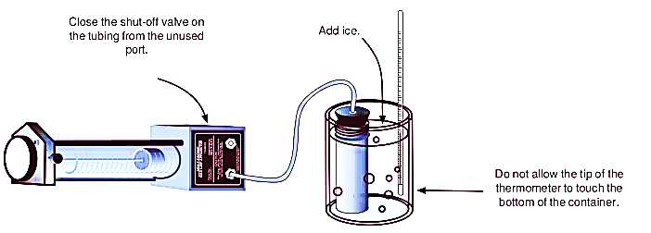

**Answer:**

To prove the the direct relation V ∝ T, we have to keep the pressure constant. We place the apparatus horizontally so as satisfy the aforementioned condition. Hence, in this way, there will be no change in pressure when the cylinder is connected to the base apparatus. Now, if we were to place the appartatus vertically, there will be a pressure change as a significant factor; gravity, now acts on it, and our results are no more accurate.

**Question 2:**

Define 3rd gas law; “Gay-Lussac’s Law”?

**Answer:**

This law states that;

**“The pressure exerted by a gas is proportional to the temperature of the gas when the mass is fixed and the volume is constant.”**

Mathematically, it is written as;

**P ∝ T or P/T=k**

Where;

* P is the pressure exerted by the gas
* T is the absolute temperature of the gas
* k is constant of proportionality

**Graph:**

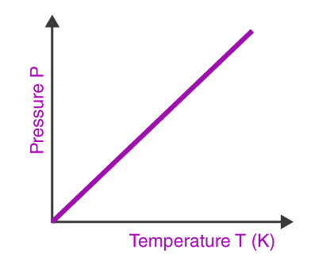

**Question 3:**

If B=327 Gauss, di=1.3cm, de=3.1cm, t1=5.934s, t2=6.234s, find the percentage error when experimental value of emf is 0.0104 V. Draw graph for v/t and energy dissipation without input data.

**Answer:**

Given data;

**B** = 327 *G* = 0.0327 *T*

**Di** = 1.3 cm and **Ri** = **Di / 2** = 0.65cm or 0.0065m

**De** = 3.1cm and **Re** = **De / 2 =** 1.55cm or 0.0155m

**T1**= 5.934s

**T2**= 6.234s

**N** = 200 turns

Calculations;

The theoretical value of emf can be calculated using;

$$∈ =NB\frac{∆A}{∆t}$$

Where;

$∆A$ is the average area

$∆t$ is the time difference

$$∆t=6.234-5.934=0.3 s$$

$$∆A=\frac{A_{i}+ A_{f}}{2}=\frac{πr_{i}^{2}+πr_{f}^{2}}{2}= \frac{1.327*{10}^{-4}+7.547*{10}^{-4}}{2}=4.437*{10}^{-4} m^{2}$$

Using these values in the equation;

$$∈ =200*0.0327*\frac{4.437*{10}^{-4}}{0.3}$$

$$∈ =0.00967 V$$

Percentage Error in $∈ =\frac{0.00967-0.0104}{0.00967}*100=7.55\%$

**Graphs:**

* **Energy Dissipation versus Time**

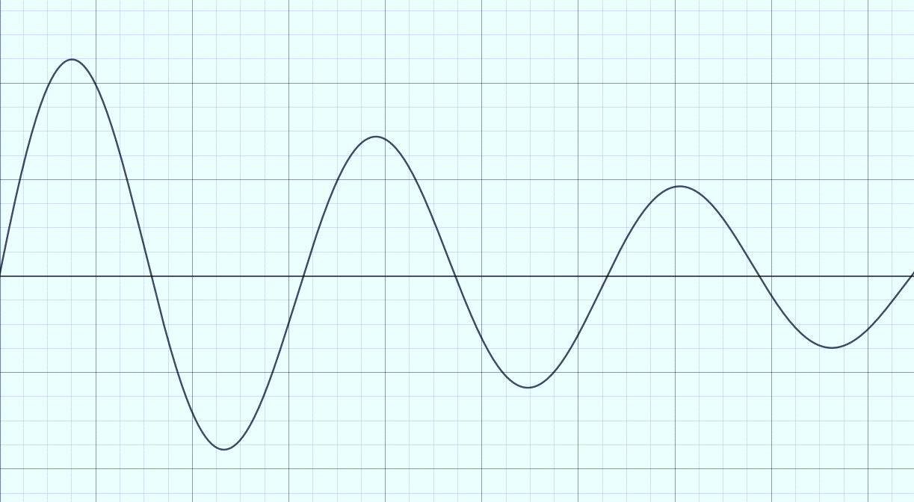

**Time (s)**

**Potential Energy**

* **Induced EMF versus Time**

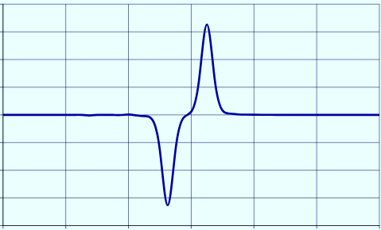

**Time (s)**

**Voltage (V)**