**Applied Physics BS 101**

**Rotation and Moment of Inertia**

**Problem 1:** Rigid rods of negligible mass lying along the *y* axis connect three particles (Fig.). If the system rotates about the *x* axis with an angular speed of 2.00 rad/s, find (a) the moment of inertia about the *x* axis (b) total rotational kinetic energy.





**Problem 2:** The four particles in Figure are connected by rigid rods of negligible mass. The origin is at the center of the rectangle. If the system rotates in the *xy* plane about the *z* axis with an angular speed of 6.00 rad/s, calculate (a) the moment of inertia of the system about the *z* axis and (b) the rotational kinetic energy of the system.





**Problem 3:** Two balls with masses *M* and *m* are connected by a rigid rod of length *L* and negligible mass as in Figure. (a) Find moment of inertia about an axis perpendicular to the rod as shown in figure. (b) Show that the system has the minimum moment of inertia when the axis passes through the center of mass, that is





$$I= µL^{2}, where µ=\frac{mM}{m+M}$$

**Problem 4:** Three identical thin rods, each of length *L* and mass *m,* are welded perpendicular to one another as shown inFigure. The assembly is rotated about an axisthat passes through the end of one rod and is parallelto another. Determine the moment of inertia of thisstructure.

$$Iz= mL^{2}/3,$$

$$Iy= m({L/2)}^{2},$$

$$Ix=\frac{mL^{2}}{12}+m({L/2)}^{2}=\frac{mL^{2}}{3}$$

$$I=\frac{mL^{2}}{3}+\frac{mL^{2}}{4}+\frac{mL^{2}}{3}=\frac{11mL^{2}}{12}$$



**Problem 5:** Many machines employ cams for various purposes, such as opening and closing valves. In Figure, the cam is a circular disk rotating on a shaft that does not pass through the center of the disk. In the manufacture of the cam, a uniform solid cylinder of radius *R* is first machined. Then an off-center hole of radius *R*/2 is drilled, parallel to the axis of the cylinder, and centered at a point a distance *R*/2 from the center of the cylinder. The cam, of mass *M*, is then slipped onto the circular shaft and welded into place. What is the kinetic energy of the cam when it is rotating with angular speed ω about the axis of the shaft?





**A little chat with Integration!**

**Problem 6: (A)** Try tocalculate the moment of inertia of a thin plate, in the shape of a right triangle, about an axis as shown in Figure (a)-(d). If *m* represents the mass of the triangle and dm mass of small mass element (strip), do the calculation for all four ways (a)-(d).

**(B)** If *I* represent the moment of inertia calculated in part (A), calculate the inertia *I*CM that represent the moment of inertia of the triangle about an axis through the center of mass and parallel to side *h*.

**(C):** Have you succeeded to calculate I in all four cases? If failed in any one of the parts, why?

**Note:** The center of mass of the triangle is two thirds of the way along the length *L*, from the corner toward the side of height *h*.

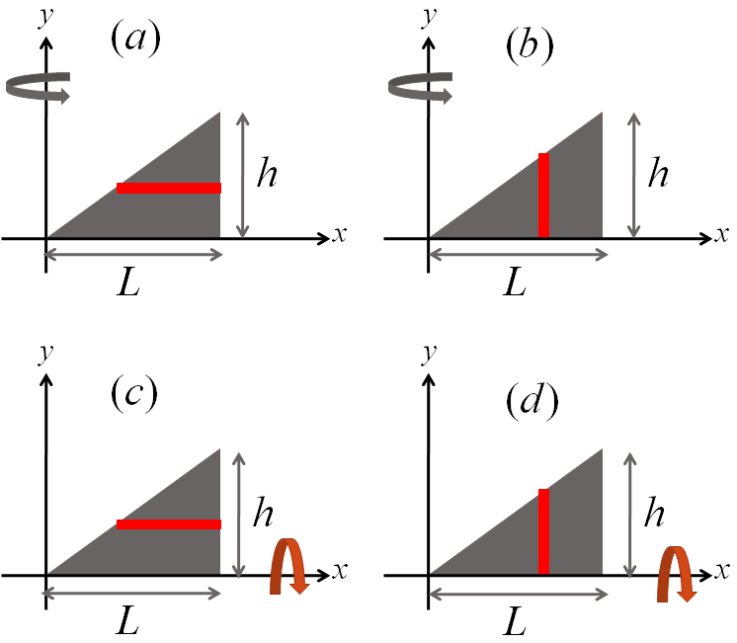

Answers

Problem 1: $\left(a\right)92Kgm^{2}, \left(b\right)184J$

Problem 2: $\left(a\right)143Kgm^{2}, \left(b\right)2570J$

Problem 3: $\left(a\right)I=Mx^{2}+m{(L-x)}^{2}$

Problem 4: $I=11ML^{2}/12$

Problem 5: $I=23MR^{2}ω^{2}/48$

Problem 6: $\frac{1}{2}mL^{2}$ *& $\frac{1}{2}mh^{2}$*  (b) $I=I_{cm}+m{\left(\frac{2L}{3}\right)}^{2}≫>I_{cm}=\frac{1}{2}mL^{2}-\frac{4}{9}mL^{2}=$