# Department of Electrical Engineering

**CS113: Introduction to Programming**

**Class: BEE12–C**

**Fall 2020**

**Lab 10: Nested Loops and Characters**

**Date: December 30, 2020**

**Time: Wednesday (9:00 – 12:00)**

# Instructor: Dr. Taha Ali

**Name:** Muhammad Umer

**CMS ID:** 345834

**Class:** BEE 12-C

**Lab Task**

1. Write a program that takes a character input from user and determines whether it’s an alphabet or not.
2. (Hollow Square of Asterisks) Write a program that inputs a variable *side* and prints a hollow square with the number of rows printed equal to *side*. For example, for a side = 5, your program should print the following:

*[Hint: Start with trying to print the square will all the stars. Then try to think of how*

*to add the spaces instead of the stars in the centre. This can easily be implemented*

*with if-else structures inside the inner loop.]*



1. Write a program that print the following shape using nested loop.

*[Hints: The outer loop will be used for rows. Two inner loops will be used. The first inner loop will adjust the spacing, while the other inner loop will print the “T” accordingly.]*

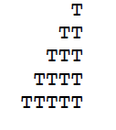

1. Write a program in C to display the pattern like a diamond.

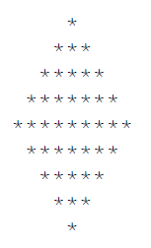

**Deliverables:**

Please include code and screenshots of all tasks and make sure to label them with TASK 1, TASK 2…, and so on.

Please insert your answers and the screenshot to a new file, add your name and section at the top of the word document, save it and upload to LMS at the end of the lab.

**Task 1:**

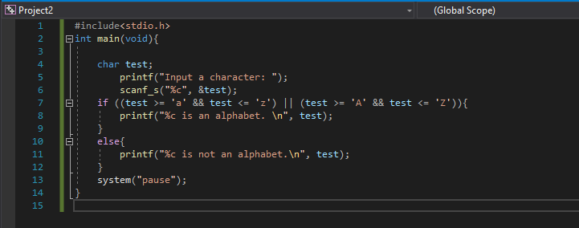

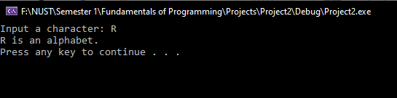

**Task 2:**

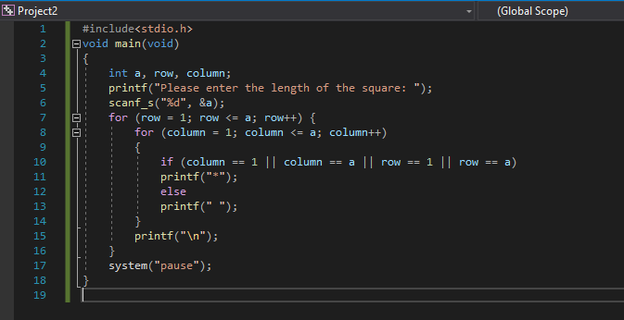

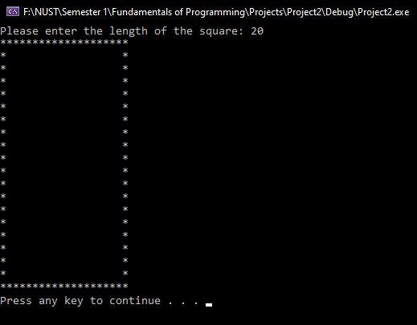

**Task 3:**

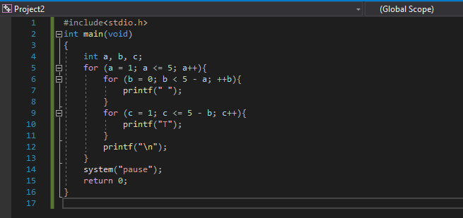

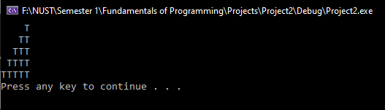

**Task 4:**



