# Department of Electrical Engineering

**CS113: Introduction to Programming**

**Class: BEE12–C**

**Fall 2020**

**Lab 13: Defining/Initializing C Arrays**

**Date: January 20th, 2020**

**Time: Wednesday (9:00 – 12:00)**

# Instructor: Dr. Taha Ali

**Name:** Muhammad Umer

**CMS ID:** 345834

**Class:** BEE 12-C

**Lab Task**

1. Write small programs with loops that perform each of the following single-subscripted array operations:

a) Initialize the 10 elements of integer array ***counts*** to zeros. Next, add 1 to each of the 10 elements of this array.

b) Read the 12 values of floating-point array ***monthlyTemperatures*** from the keyboard and display all the array elements in a column format.

c) Take random numbers in an array called ***checkEven*** from the keyboard and count how many elements are even.

1. Write a program to reverse a string of characters, i.e. take one word as input from the keyboard. Limit the word length to 100 characters (#define).

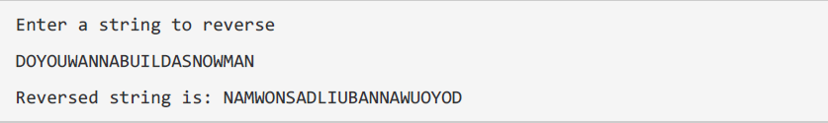

1. Write a program to take input in array of size 15 from user and sort this array in ascending or descending order depending upon user’s choice.

**Deliverables:**

Please include code and screenshots of all tasks and make sure to label them with TASK 1, TASK 2…, and so on.

Please insert your answers and the screenshot to a new file, add your name and section at the top of the word document, save it and upload to LMS at the end of the lab.

**Task 1: (a)**

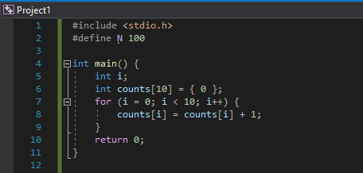

**Task 1: (b)**

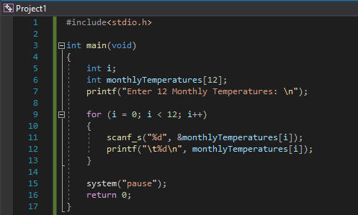

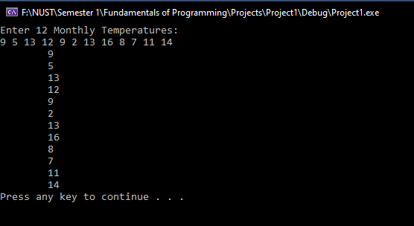

**Task 1: (c)**

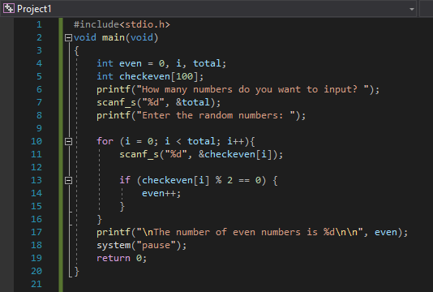

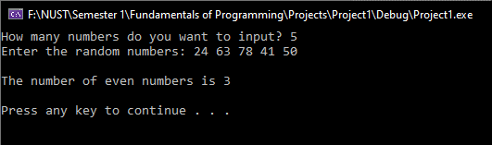

**Task 2:**

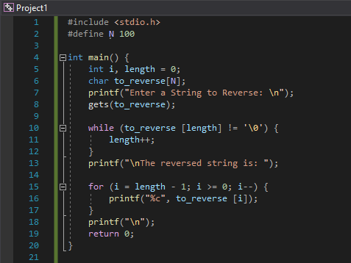

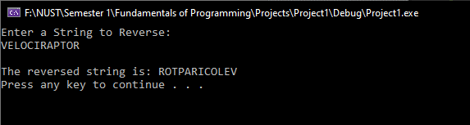

**Task 3:**

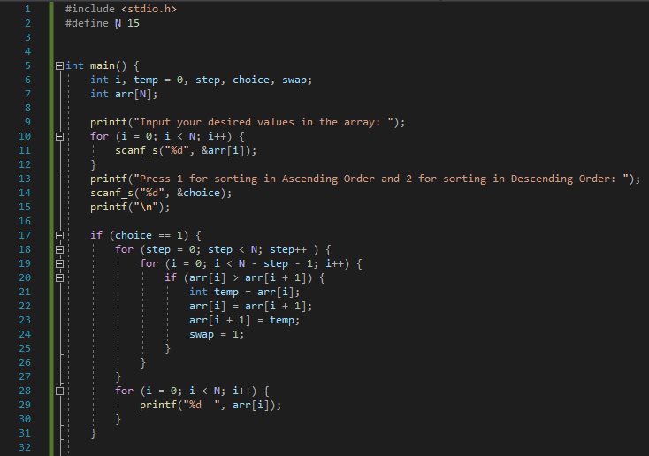

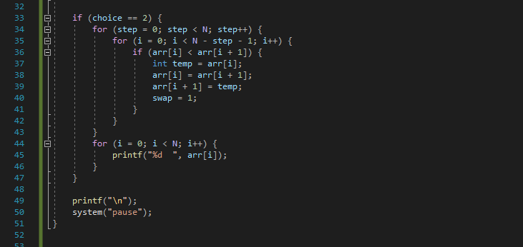

**Outputs:**



