# Department of Electrical Engineering

**CS113: Introduction to Programming**

**Class: BEE12–C**

**Fall 2020**

# Lab 4: Airthmetic Operations and Formatted output

**Date: November 18, 2020**

**Time: Wednesday (9:00 – 12:00)**

# Instructor: Dr. Taha Ali

**Name:** Muhammad Umer

**CMS ID:** 345834

**Class:** BEE 12-C

# Lab 4: Airthmetic Operations and formatted output

**Introduction**

In this lab, students will learn to use the standard input functions. They are introduced to scanf to take input from user and display formatted output using printf and performing basic arithmetic operations.

**Objectives**

After performing this lab students will be able to understand:

* The structured approach to C programming
* Use of standard library functions *scanf*
* Creating formatted output in a *printf* function

**Tools/Software Requirement**

* Visual Studio

**Lab Task**

Please complete the following tasks to complete this lab

1. Write a program that formats product information entered by user. The console should look like this when you run the program.

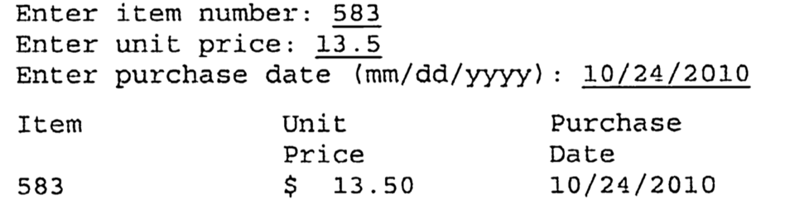

The item number and date should be left justified; the unit price should be right justified. Allow dollar amount upto $9999.99. Use tabs to line up the columns.

1. Write a program that asks the user to enter two numbers, obtains the two numbers from the user and prints the sum, product, difference, quotient and remainder of the two numbers. Sample output is as following:

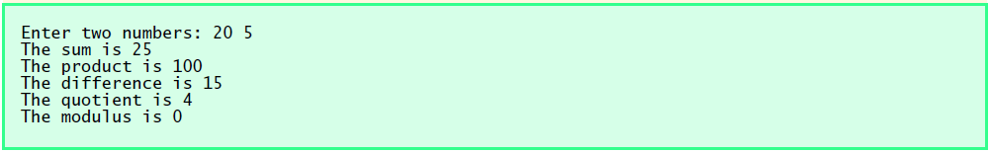

1. Write a program that inputs one five-digit number, generates its reverse and displays the reverse on screen. Copy your code in the submission file and take screenshot of your output.

**Deliverables:**

* 1. Please include code and screenshots of all tasks and make sure to label them with TASK 1, TASK 2…, and so on.

Please insert your answers and the screenshot to a **new file**, add your name and section at the top of the word document, save it and upload to LMS at the end of the lab.

**Task 1:**

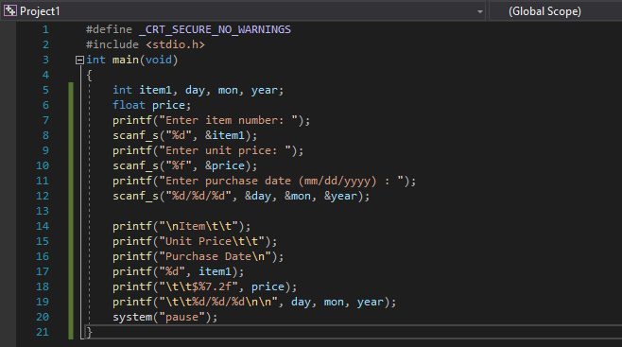

**Code**

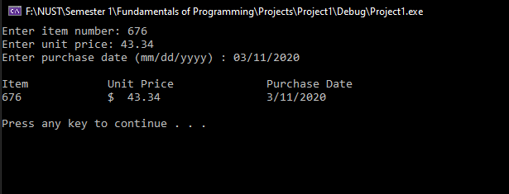

**Output**

**Task 2:**

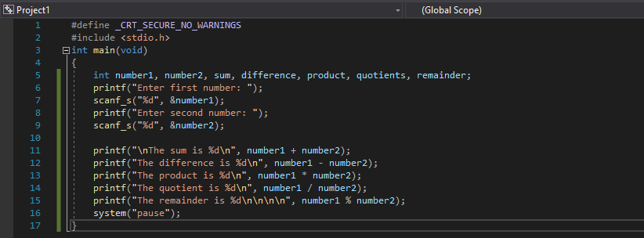

**Code**

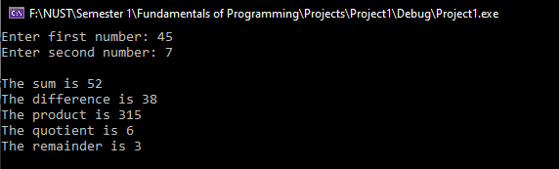

**Output**

**Task 3:**

