# Department of Electrical Engineering

**CS113: Introduction to Programming**

**Class: BEE12–C**

**Fall 2020**

# Lab 5: Airthmetic Operations and formatted output

**Date: November 25, 2020**

**Time: Wednesday (9:00 – 12:00)**

# Instructor: Dr. Taha Ali

**Name:** Muhammad Umer

**CMS ID:** 345834

**Class:** BEE 12-C

# 

# Lab 5: Airthmetic Operations and formatted output

**Introduction**

In this lab, students will learn to use the standard input functions. They are introduced to scanf to take input from user and display formatted output using printf and performing basic arithmetic operations.

**Objectives**

After performing this lab students will be able to understand:

* The structured approach to C programming
* Use of standard library functions *scanf*
* Creating formatted output in a *printf* function

**Tools/Software Requirement**

* Visual Studio

**Lab Task**

Please complete the following tasks to complete this lab

1. Using only the techniques you have learned so far, write a program that calculates the square and cube of the numbers from 0 to 10 and uses tabs to print the following table of values:

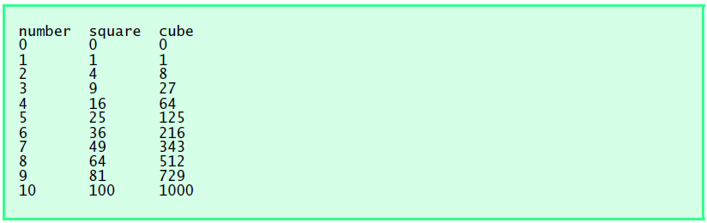

1. Write a program that assign values to two variables and then swap their values.
2. Write a program that inputs one four-digit number and calculates the sum of individual digits. Copy your code in the submission file and take screenshot of your output.
3. Write a program that asks user to enter a decimal number and convert the number into octal (base 8) number. Sample output is given below.

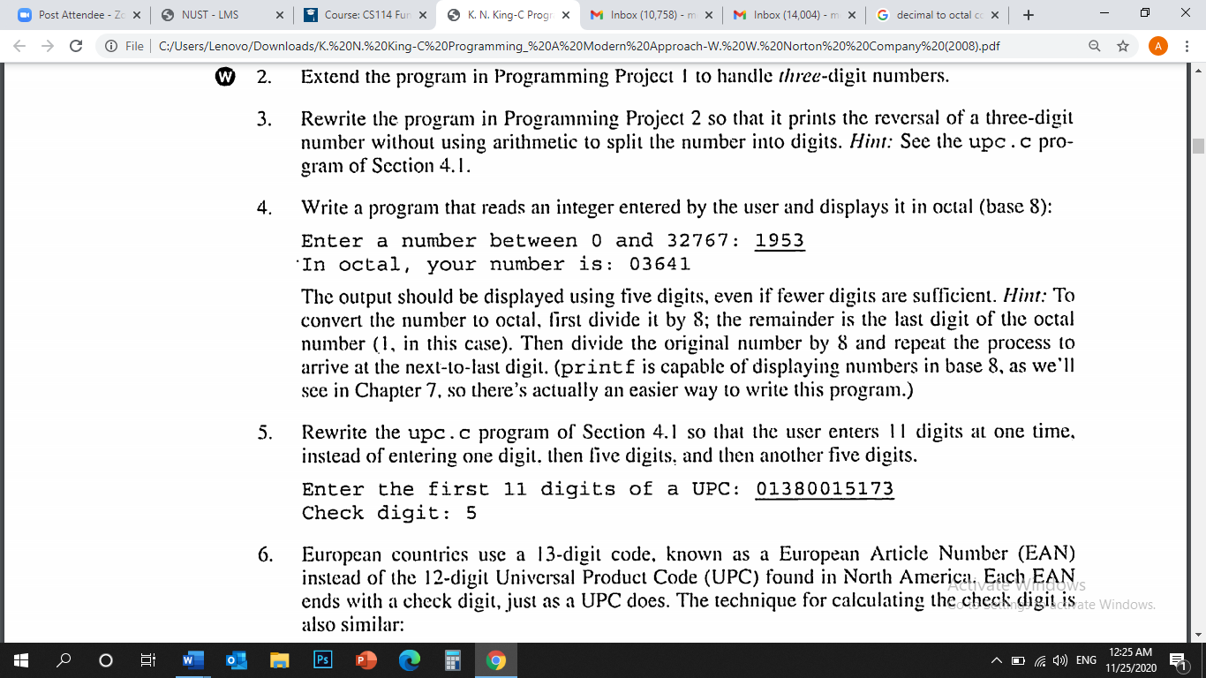

**Deliverables:**

* 1. Please include code and screenshots of all tasks and make sure to label them with TASK 1, TASK 2…, and so on.

Please insert your answers and the screenshot to a **new file**, add your name and section at the top of the word document, save it and upload to LMS at the end of the lab.

**Task 1:**

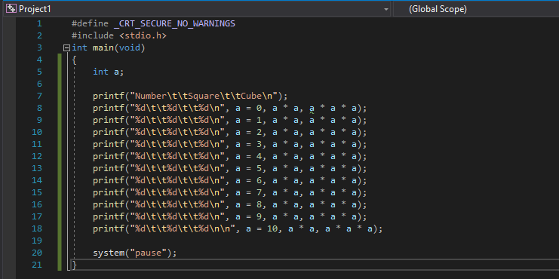

**Code**

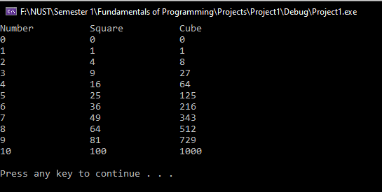

**Output**

**Task 2:**

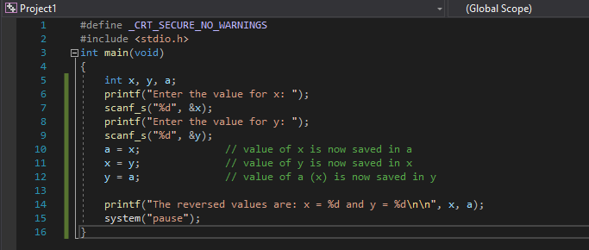

**Code**

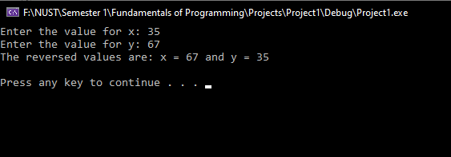

**Output**

**Task 3:**

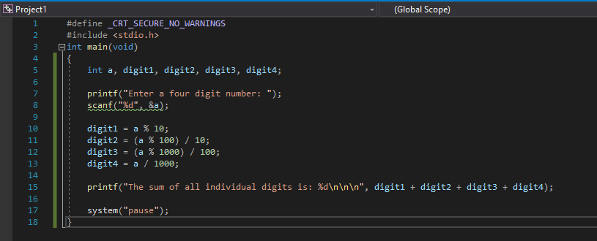

**Code**

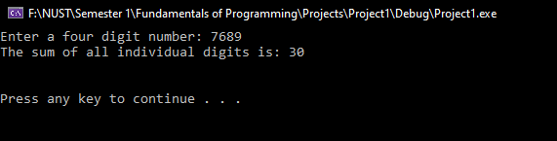

**Output**

**Task 4:**

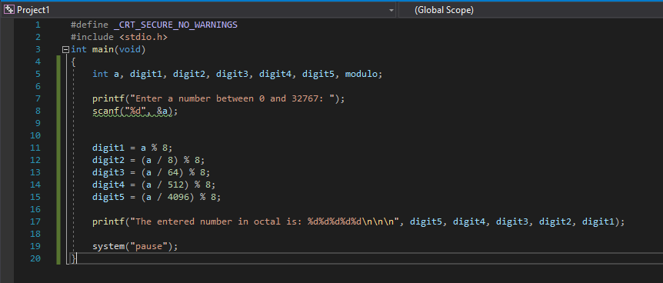

**Code**

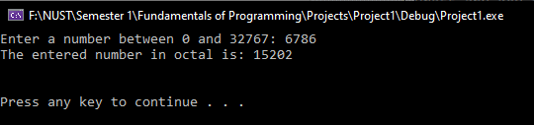

**Output**