# Department of Electrical Engineering

**CS113: Introduction to Programming**

**Class: BEE12–C**

**Fall 2020**

**Lab 6: Relational/Equality Operators and Simple If -else Statements**

**Date: November 25, 2020**

**Time: Wednesday (9:00 – 12:00)**

# Instructor: Dr. Taha Ali

**Name:** Muhammad Umer

**CMS ID:** 345834

**Class:** BEE 12-C

**Introduction**

In this lab, students will learn to use a combination of arithmetic operators and relational/equality

operator. They will also learn to use these combinations as conditions for simple if statements in

C.

**Objectives**

After performing this lab students will be able to understand:

• Use of if statements

• Use of arithmetic operators for mathematical analysis

• Use of relational and equality operators as conditional checks in simple if statements

**Tools/Software Requirement**

• Visual Studio

**Lab Task**

Please complete the following tasks to complete this lab

1. Write a program that reads in five integers and then determines and prints the largest and the

smallest integers in the group.

**Use only the single-selection form of the if statement**

2. Write a program that reads an integer and determines and prints whether it is odd or even.

3. A palindrome is a number or a text phrase that reads the same backwards as forwards. For example, each of the following five-digit integers are palindromes: 12321, 55555, 45554 and 11611. Write a program that reads in a five-digit integer and determines whether or not it is a

**palindrome**.

Enter a five-digit number: 18181

18181 is a **palindrome**

Enter a five-digit number: 16738

16738 is not a **palindrome**

**Deliverables:**

1. Please include code and screenshots of all tasks and make sure to label them with TASK 1, TASK

2…, and so on.

Please insert your answers and the screenshot to a **new file**, add your name and section at the top of the

word document, save it and upload to LMS at the end of the lab.

**Task 1:**

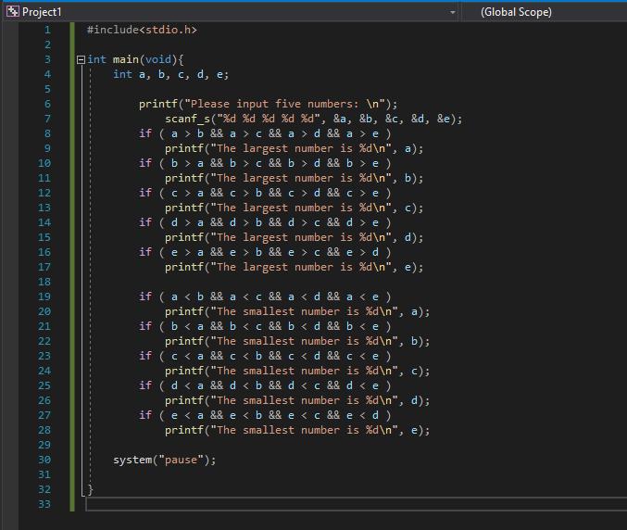

**Code**

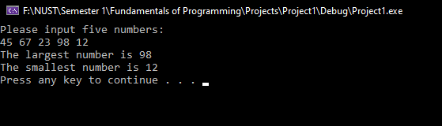

**Output**

**Task 2:**

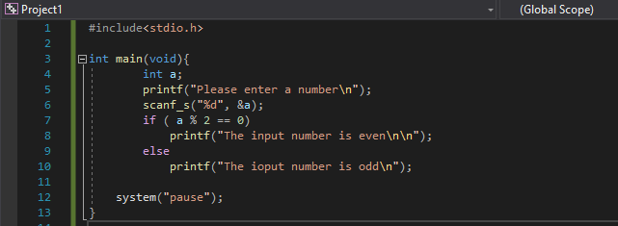

**Code**

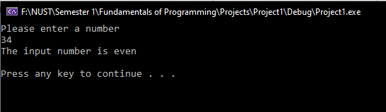

**Output**

**Task 3:**

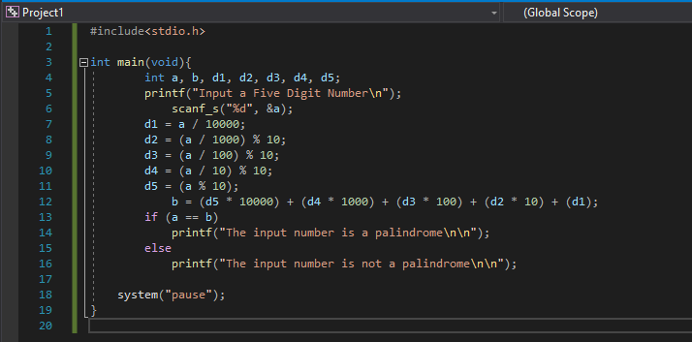

**Code**

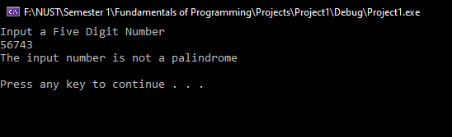

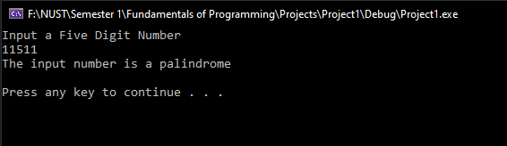

**Output**