# Department of Electrical Engineering

**CS113: Introduction to Programming**

**Class: BEE12–C**

**Fall 2020**

**Lab 7: If -else Statements and switch-case**

**Date: November 25, 2020**

**Time: Wednesday (9:00 – 12:00)**

# Instructor: Dr. Taha Ali

**Name:** Muhammad Umer

**CMS ID:** 345834

**Class:** BEE 12-C

**Introduction**

In this lab, students will learn to use a combination of arithmetic operators and relational/equality

operator. They will also learn to use these combinations as conditions for simple if statements in

C.

**Objectives**

After performing this lab students will be able to understand:

• Use of if statements

• Use of switch case

• Use of relational and equality operators as conditional checks in simple if statements

**Tools/Software Requirement**

• Visual Studio

**Lab Task**

Please complete the following tasks to complete this lab

1. Write a C program for an online bill payment system that pays both the electricity bill and

the gas bills. Assume it linked to a user’s bank account and the current amount in the user’s

bank is Rs. 12440. Your program should do the following:

1. Begin with a welcome message for the user telling him/her that they have entered the electricity and gas bill payment program
2. Ask user to enter amount of electricity bill to be paid
3. Then, ask user to enter amount of gas bill to be paid
4. If total combined bill is greater than Rs. 12440, inform user that total bill exceeds bank balance. Then ask the user if they would like to pay lesser of the two bills.
5. Ask them to enter 1 for yes and 2 for no.

If user enters 1, pay the lesser of the two bills and display the remaining bank balance

1. However, if total combined bill is less than Rs. 12440, tell user bills are paid and display remaining balance.
2. In all of the if-else scenarios ensure, that the program exits with the message “Thank you for using the electricity and gas bill payment program”

**2.** Write a C program that takes input from user for the marks in certain subject and then displays the grade of the subject according to following criteria.



**3.** Write a C program to build a calculator that performs addition, subtraction,

multiplication, division or average. The program should ask user to enter the desired

operation as well as the numbers. Use switch-case statement for this program.

**Deliverables:**

Please include code and screenshots of all tasks and make sure to label them with TASK 1, TASK 2…, and so on.

Please insert your answers and the screenshot to a **new file**, add your name and section at the top of the

word document, save it and upload to LMS at the end of the lab.

**Task 1:**

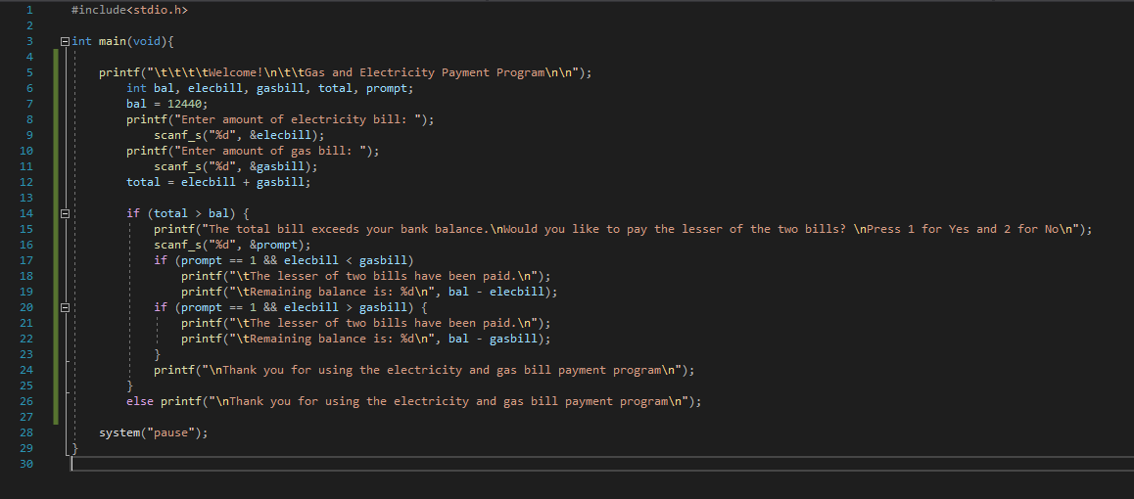

**Code**

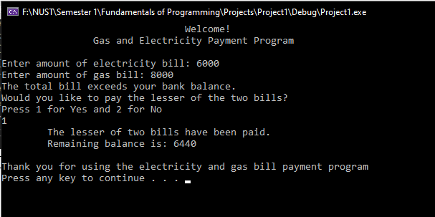

**Output**

**Task 2:**

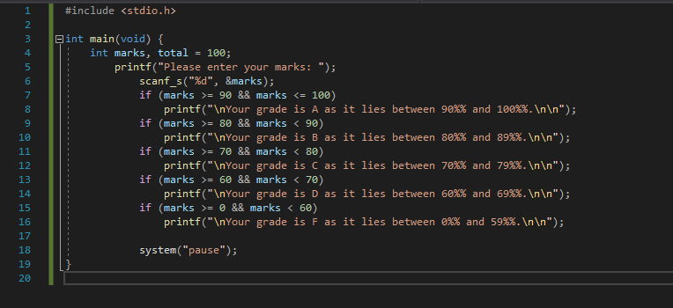

**Code**

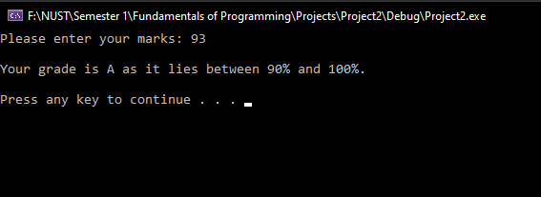

**Output**

**Task 3:**

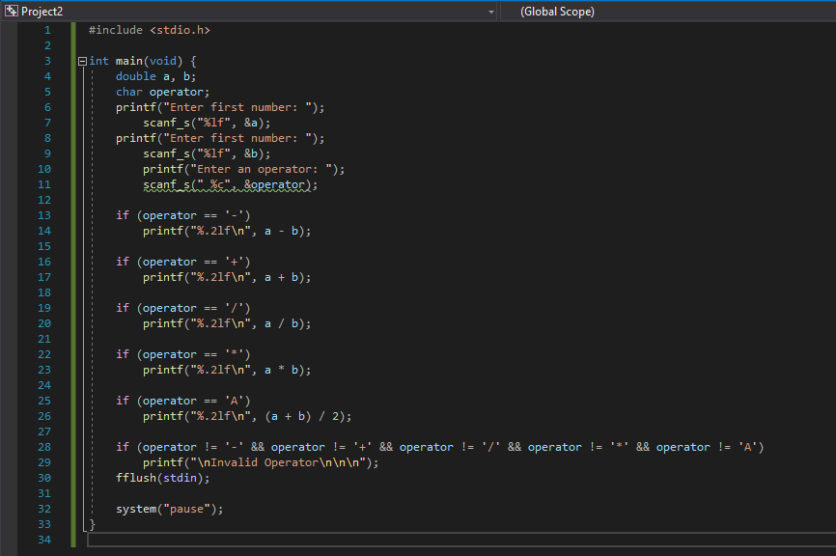

**Code**

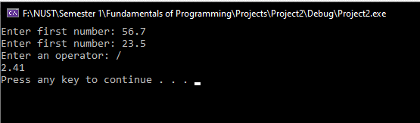

**Output**

**________________________________________________________________**