# Department of Electrical Engineering

**CS113: Introduction to Programming**

**Class: BEE12–C**

**Fall 2020**

**Lab 8: Switch statements and while loops**

**Date: December 16, 2020**

**Time: Wednesday (9:00 – 12:00)**

# Instructor: Dr. Taha Ali

**Name:** Muhammad Umer

**CMS ID:** 345834

**Class:** BEE 12-C

**Lab Tasks**

1. Write a C program to build a calculator that performs addition, subtraction, multiplication, division or average. The program should ask user to enter the desired operation as well as the numbers. Use switch-case statement for this program.
2. Write a program that asks the user about the number of values he/she wants to enter. Then enter the values as per the required number, calculate its sum and identify the smallest value among them. The sample output is as follow:

Enter the number of values to be input: 5

Enter the number: 20

Enter the number: 10

Enter the number: 50

Enter the number: 4

Enter the number: 65

The sum is: 149

The smallest value of entered numbers is 4

1. The factorial function is used frequently in probability problems. The factorial of a positive integer n (written n! and pronounced “n factorial”) is equal to the product of the positive integers from 1 to n. Write a function factorial that accepts an integer as parameter and returns its factorial. Using the factorial function, write a program that evaluates the factorials of the integers from 1 to 5. Print the results in tabular format as following.



1. Write a C program to input an alphabet and check whether it is vowel or consonant using switch case. C program to check vowel or consonant using switch case. Logic to check vowel or consonant using switch case.

**Deliverables:**

**Task 1:**

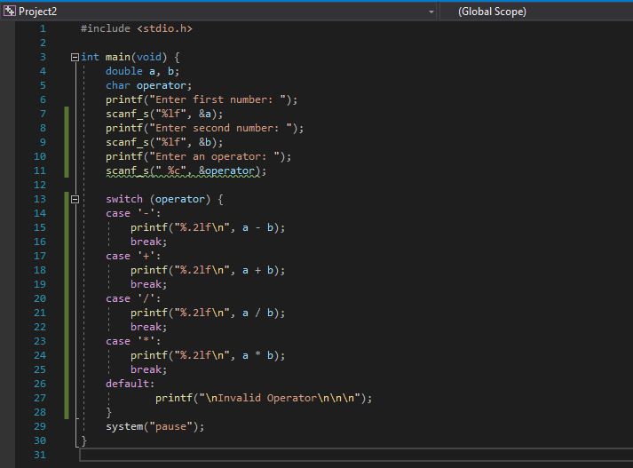

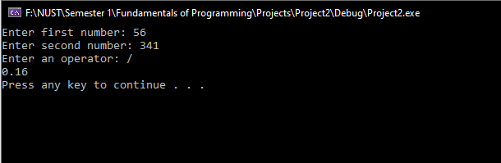

**Task 2:**

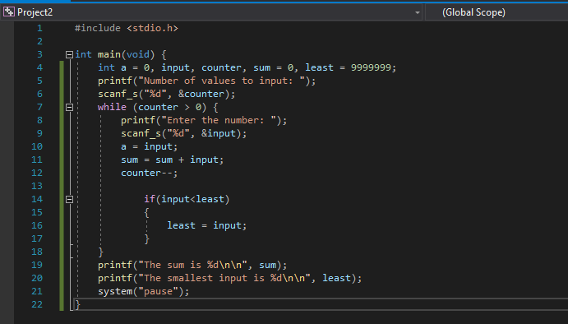

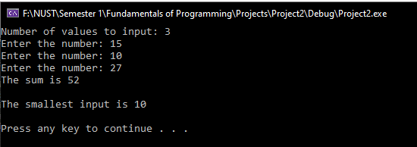

**Task 3:**

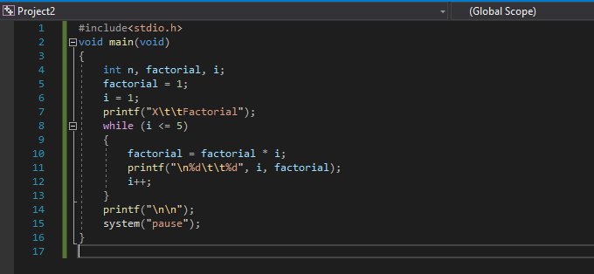

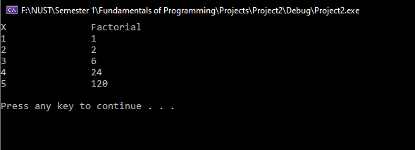

**Task 4:**



