# Department of Electrical Engineering

**CS113: Introduction to Programming**

**Class: BEE12–C**

**Fall 2020**

**Lab 9: While and For Loops**

**Date: December 23, 2020**

**Time: Wednesday (9:00 – 12:00)**

# Instructor: Dr. Taha Ali

**Name:** Muhammad Umer

**CMS ID:** 345834

**Class:** BEE 12-C

**Lab Task**

1. Write a program that plays an incredibly stupid number-guessing game. The user will try to guess the secret number until they get it right. That means it will keep looping as long as the guess is different from the secret number. You must store the secret number in a variable, and use that variable throughout. The secret number itself must not appear in the program at all, except in the one line where you store it into a variable. Sample output is as following:

I have chosen a number between 1 and 10. Try to guess it.

Your guess: 5

That is incorrect. Guess again.

Your guess: 4

That is incorrect. Guess again.

Your guess: 8

That is incorrect. Guess again.

Your guess: 6

That's right! You guessed it.

1. The greatest common divisor (GCD) of two integers is the largest integer that evenly divides each of the two numbers. Write function god that returns the greatest common divisor of two integers.

Use the god function in your program to determine the GCD of the numbers in the sample output:



1. An integer is said to be prime if it is divisible only by 1 and itself. For example, 2, 3, 5 and 7 are prime, but 4, 6, 8 and 9 are not.

a) Write a function that determines if a number is prime.

b) Use this function in a program that determines and prints all the prime numbers between 1 and 10,000.



1. Write a program in C to display the n terms of even natural number and their sum.

(Use for loop)

**Sample Output**

Input number of terms: 5

*Expected Output:*

The even numbers are :2 4 6 8 10

The Sum of even Natural Number up to 5 terms: 30

**Deliverables:**

1. Please include code and screenshots of all tasks and make sure to label them with TASK 1, TASK

2…, and so on.

Please insert your answers and the screenshot to a **new file**, add your name and section at the top of the

word document, save it and upload to LMS at the end of the lab.

**Task 1:**

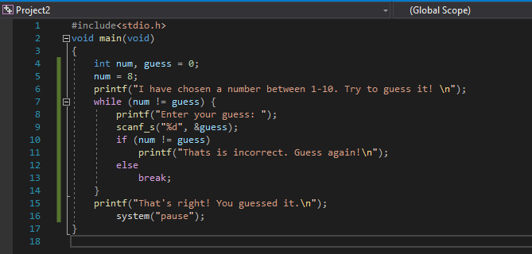

**Code**

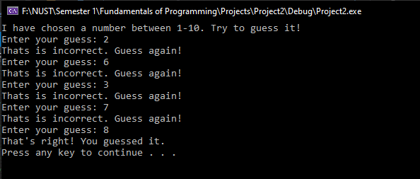

**Output**

**Task 2:**

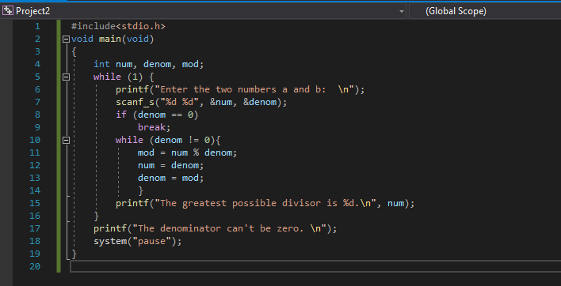

**Code**

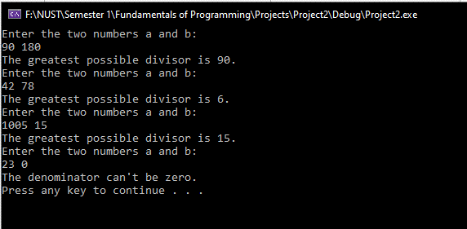

**Output**

**Task 3:**

**A:**

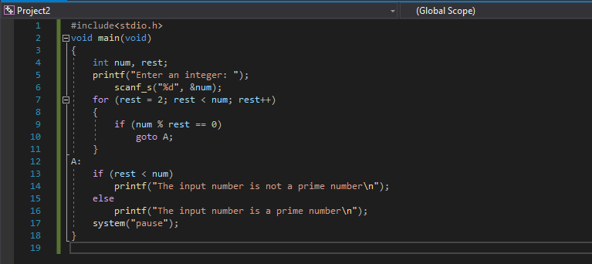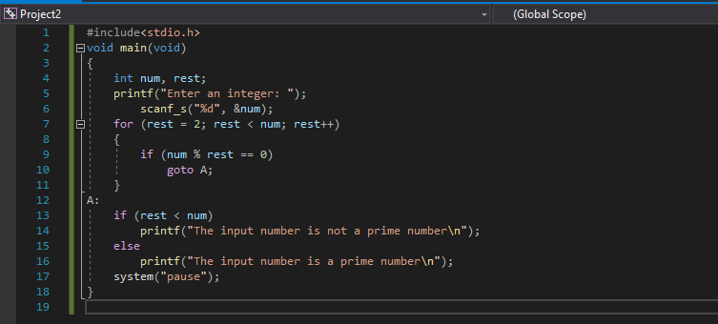

**Code**

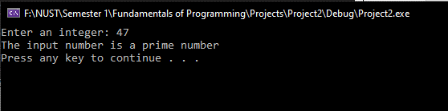

**Output**

**B:**

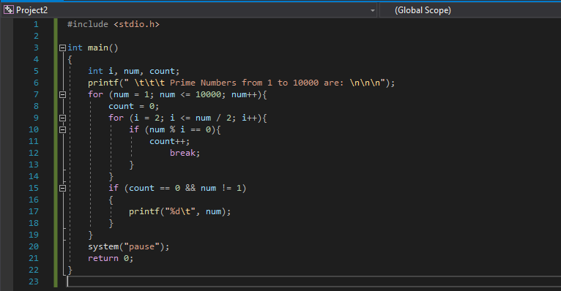

**Code**

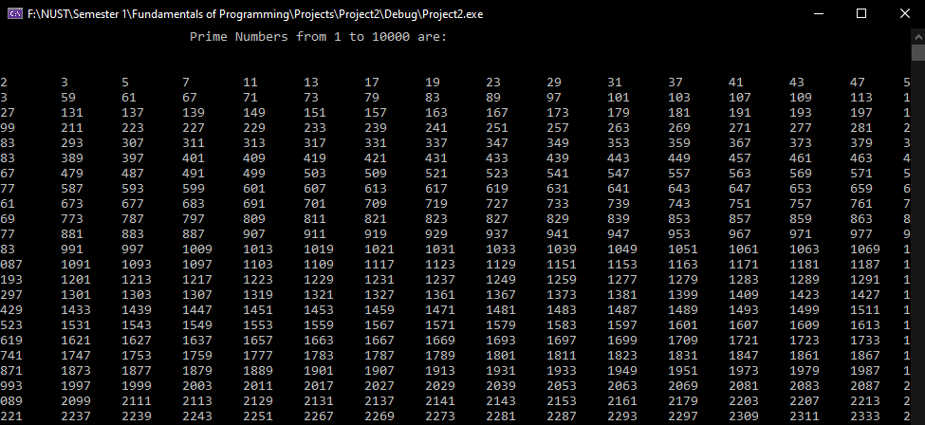

**Output**

**Task 4:**

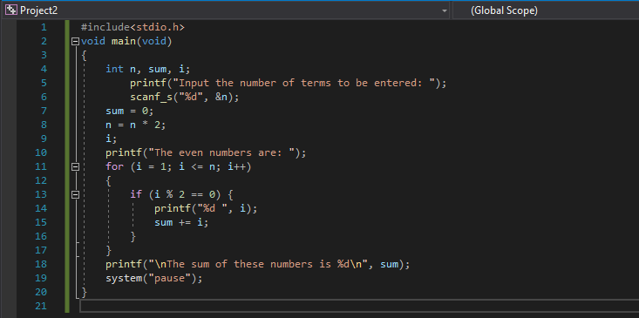

**Code**

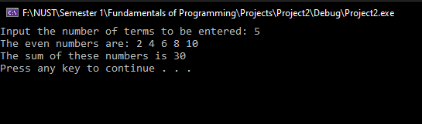

**Output**