# Department of Electrical Engineering

**CS113: Introduction to Programming**

**Class: BEE12–C**

**Fall 2020**

**Lab 11: Introduction to LEGO Mindstorms and Virtual Robotics Toolkit**

**Date**: January 6th, 2021

**Time**: Wednesday (9:00 – 12:00)

# Instructor: Dr. Taha Ali

**Name:** Muhammad Umer

**CMS ID:** 345834

**Class:** BEE 12-C

**Lab Task**

**Task 1:**

Write a programme in LEGO Mindstorms EV3 to blink the lights that uses bricks status light block and a wait block to set the light on the brick to blink orange until 5 sec has passed.

* **Code:**

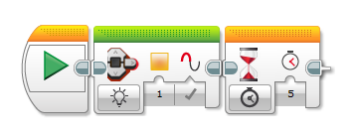

We perform this task by using a **Brick Status Light** block and a **Wait** block that defines the duration of how long the brick blinks for.

**Task 2:**

Configure LEGO Mindstorms EV3 such that to move the robot straight until the colour sensor detects the tape colour you are using.

* **Code:**

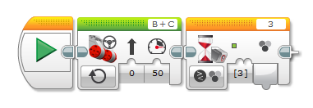

Through this code, the Intelligent Brick will move straight until it encounters a tape of green colour.

**Task 3:**

Revise Task 2 and add a steering block to the end and set the mode to the “OFF”.

* **Code:**

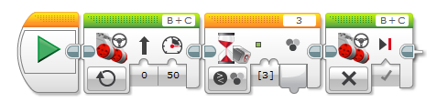

Since it is set to “**Off**” state, it does not contribute to the program. Also, after running the simulation, we can conclude that it has **no effect** on the simulation.

**Task 4:**

Revise Task 2 by using ultrasonic sensor.

* **Code:**

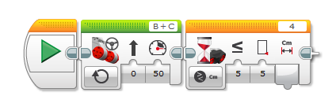

Ultrasonic Sensor are optimal for programs related to **distances**. Through this code, the Intelligent Brick runs straight until it encounters an object within a vicinity of 5cm.

**_____________________________________________________________________**