# Department of Electrical Engineering

**CS113: Introduction to Programming**

**Class: BEE12–C**

**Fall 2020**

**Lab 12: Loops in LEGO Mindstorms and Virtual Robotics Toolkit**

**Date**: January 13th, 2021

**Time**: Wednesday (9:00 – 12:00)

# Instructor: Dr. Taha Ali

**Name:** Muhammad Umer

**CMS ID:** 345834

**Class:** BEE 12-C

**Lab 2 Tasks**

**Task 1:**

Write a program that makes a robot drive forward by repeating three different sounds until the colour sensor detects the colour tape you are using.

* **Code:**

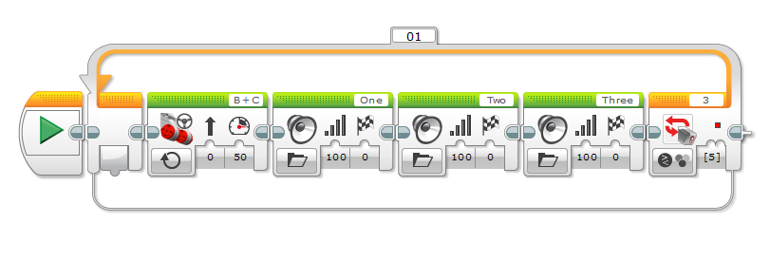

*This is a pretty simple code which relies on a single colour sensor. The transfer of flow in this code can be described in the following words:*

As long as the colour sensor does not detect the colour Red, make the Bot go straight indefinitely with 50 Power, then play the sound One, Two and Three consecutively.

**Task 2:**

Write a Code for following a line using one light sensor (Hint: Using switch and loop block).

* **Code:**

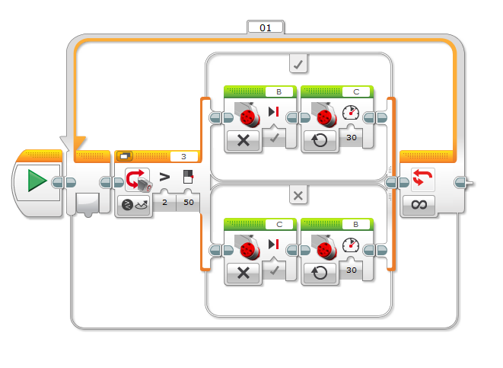

*A switch block inside of an infinitely recurring loop can help us make a code that keeps the Bot consistently on a black line in an EV3 Maze Environment. Here, B is the Left Motor and C is the Right Motor. The flow of this code can be expressed as:*

If the Intensity of Reflected Light is greater than 50, then make the B Motor stop and keep the C Motor running, this makes the Bot go right. If the initial condition is false, then the C Motor stops while the B Motor keeps running. This makes the Bot go left. Since, white light has intensity > 50 while black light has < 50 intensity, the condition of the Loops keeps becoming True and False. In this way, the Bot keeps moving left and right and thus, keeps on following the Black line.

**Task 3:**

Write a code for following a line using two light sensors (Hint: Using 3 switch blocks and 1 loop block).

* **Code:**

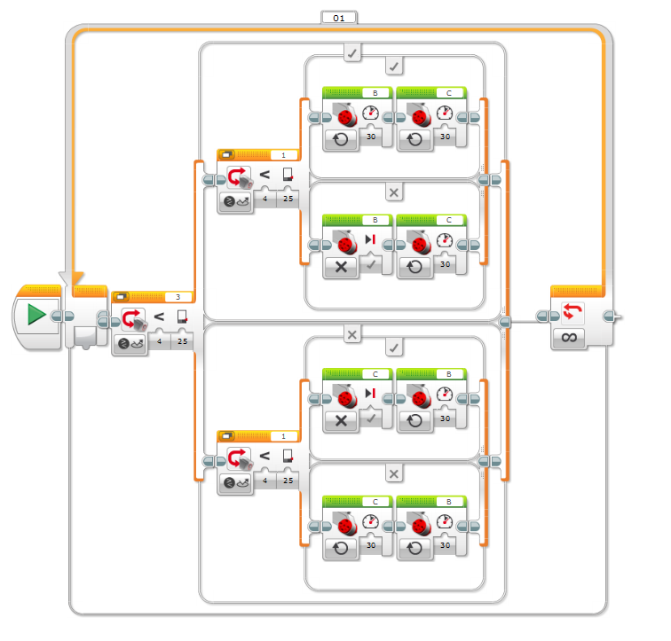

*This code works in a samiliar fashion to the one in Task 2. However, since we are using two sensors, we use multiple switch statements. The Left Sensor is on Port 3 and the Right Sensor is on Port 1. The Left Motor is connected to C and Right Motor is at B. The flow of the execution in this program can be put into the following words;*

*It is divided into two parts:*

* If the intensity of light reflected into the left sensor is < 25, then check if the intensity of the right sensor is < 25. If it is True, let the both motors run. If it is false, put the right motor at hold and let left motor continue to run. This turns our Bot right.
* If the intensity of light reflected into the left sensor is > 25, then check if the intensity of the right sensor is < 25. If it is True, put the left motor at hold and let right motor continue to run. If it is false, let the both motors run. This turns our Bot left.

*In this way, our Bot stays on track and follows the Black Line quite accurately.*

**_____________________________________________________________________**