**Department of Electrical Engineering**

**Faculty Member:**  **Sir Mansoor Shaukat Dated: 21/12/2020 **

**Semester: 1st Section: BEE-12C **

**EE-111: Linear Circuit Analysis**

**Lab 10: Verification of Maximum Power Transfer Theorem**

|  |  |  |  |  |
| --- | --- | --- | --- | --- |
| **PLO4/CLO4** | | **PLO5/CLO5** | **PLO8/CLO6** | **PLO9/CLO7** |
| **Name** | **Reg. No** | **Viva /Quiz / Lab Performance**  **5 marks** | **Analysis of data in Lab Report**  **5 marks** | **Modern Tool Usage**  **5 marks** | **Ethics and Safety**  **5 marks** | **Individual and Team Work**  **5 marks** |
| **Muhammad Umer** | **345834** |  |  |  |  |  |
| **Saad Bakhtiar** | **341150** |  |  |  |  |  |
|  |  |  |  |  |  |  |
|  |  |  |  |  |  |  |

**Lab 10: Verification of Maximum Power Transfer Theorem**

**Introduction:**

Conduction of this lab enables and provides students to prove that the Power of the Load component is maximum when it equals Thevenin Equivalent.

**Objectives**

After performing this lab, students should be able to:

* Find the Thevenin Equivalent of a complex circuit.
* Use the DMM as a ammeter and voltmeter to measure the various currents and voltages.
* Explain deviations in results in case these are encountered during the experiment.
* Prove that maximum power transfer (50%) is when RTH = RLOAD
* Further strengthen their base concepts.

**Conduct of Lab**

1. The students are required to work in groups of three to four; each student must attempt to understand and use the laboratoy set-up and conduct at least one or two parts of the requirement experimentation. The lab attendents and Teaching Assistants will be available to assit the students.
2. In case some aspect of the lab experiment is not understood the students are advised to seek help from the teacher, the lab attendent or the assigned Teaching Assistant (TA).

**Lab Equipment**

The following equipment would be used in this experiment:

* Test bench
* The Multimeter
* The Power Supply
* Digital Multimeter

**Circuit analysis for maximum power transfer**

The maximum power transfer theorem states that a load resistance will abstract maximum power from the network when the load resistance is equal to the internal resistance. For maximum power transfer Load resistance RL= RTH,Where RTH equivalent resistance of the remaining circuit.

**Maximum power = PMAX =V2/RL where V is the DC supply voltage**



R1 = 1K, R2 = 10k, R3 = 2k. Find the value of RL.

**Task**

Theoretically, **RTH = 2.909kΩ**

**Equivalent Circuit**

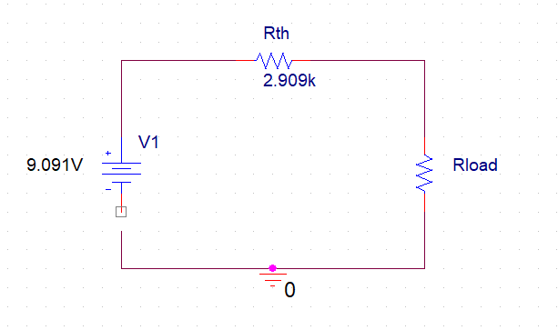

We take values of RL close to RTH in order to prove that the maximum power is when the load equals the Thevenin’s equivalent.

**Table**

|  |  |  |  |  |
| --- | --- | --- | --- | --- |
| **S. No** | **RL** | **VL** | **IL** | **P = VL X IL** |
| **1** | 2.87k | 4.51482V | 1.57311mA | 7.10230849mW |
| **2** | 2.88k | 4.52272V | 1.57039mA | 7.102434261mW |
| **3** | 2.89k | 4.53059V | 1.56768mA | 7.102515331mW |
| **4** | 2.90k | 4.53844V | 1.56498mA | 7.102567831mW |
| **5** | 2.909k | 4.54549V | 1.562564mA | 7.102619036mW |
| **6** | 2.92k | 4.55406V | 1.55961mA | 7.102557517mW |
| **7** | 2.93k | 4.56184V | 1.556944mA | 7.102529417mW |

**Graph**

P

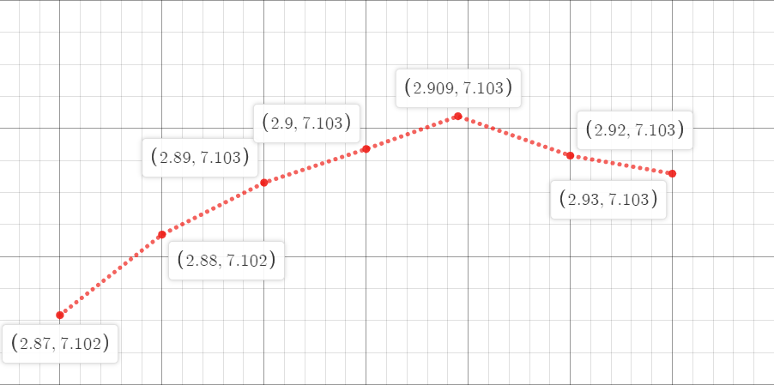

R

Hence, we can derive from the table as well as graph that maximum power (50%) is reached when the Resistance of Load equals the value of Thevenin Equivalent.

**Conclusion:**

After performing this lab, I can firmly state that I am able to prove that maximum power transfer, half, occurs when the value of Load Resistance is equal to the Norton/Thevenin Equivalent. I am also able to use our previously learned concepts to derive a simple equivalent circuit of a former complex circuit.

**___________________________________________________________________**