**Department of Electrical Engineering**

**Faculty Member:**  **Sir Mansoor Shaukat Dated: 06/01/2021 **

**Semester: 1st Section: BEE-12C **

**EE-111: Linear Circuit Analysis**

**Lab 11: RC Circuits**

|  |  |  |  |  |
| --- | --- | --- | --- | --- |
| **PLO4/CLO4** | | **PLO5/CLO5** | **PLO8/CLO6** | **PLO9/CLO7** |
| **Name** | **Reg. No** | **Viva /Quiz / Lab Performance**  **5 marks** | **Analysis of data in Lab Report**  **5 marks** | **Modern Tool Usage**  **5 marks** | **Ethics and Safety**  **5 marks** | **Individual and Team Work**  **5 marks** |
| **Muhammad Umer** | **345834** |  |  |  |  |  |
| **Saad Bakhtiar** | **341150** |  |  |  |  |  |
|  |  |  |  |  |  |  |
|  |  |  |  |  |  |  |

**Introduction**

In this lab, we will be looking at RC circuits and specifically, the graphs of charging and discharging capacitor. We will also learn how to observe and read the graphs and to calculate Tau from a simulated cursor.

**Objectives**

After performing this lab, students will be able to:

* Further strengthen their concepts on Transients
* Calculate time constant from tracing charge/discharge graph
* Differ between simulated and calculated values
* Set up a Capacitive circuit on breadboard

**Equipment**

Following equiment are necessary to perform this lab:

* Capacitors
* Resistors
* DMM
* Function Generation
* Oscilloscope
* Simulation Software

**Conduct of Lab**

The students are required to work in groups of three to four; each student must attempt to understand and use the laboratoy set-up and conduct at least one or two parts of the requirement experimentation. The lab attendents and Lab Engineer will be available to assit the students.

In case some aspect of the lab experiment is not understood the students are advised to seek help from the teacher, the lab attendent or the assigned Lab Engineer (LE).

**τ and T1/2**

*T1/2 = (ln2) τ, so τ = T1/2 /ln2 = T1/2 / (0.693)*

**Voltages (VR and VC)**

V_R(t)=I(t) R =V_s e^{-t/(RC)} V_c(t)=V_s-V_R(t)=V_s (1- e^{-t/(RC)})

**Lab Experiments:**

**Task 1**

**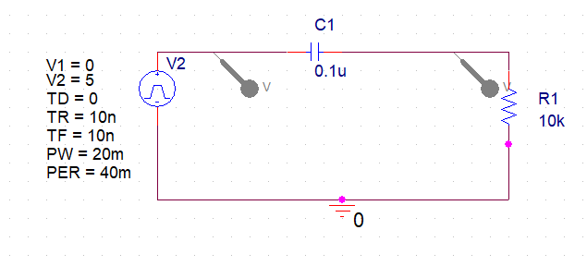Figure 1**

Assemble the circuit shown in Figure 1 on the breadboard.

With values R= 10kΩ, C= 0.1µF and *f*= 25Hz, observe the waveform when the output is taken across the capacitor.

*You will use the function generator to provide a square wave a.c voltage of 5V peak and the oscilloscope to measure the output.*

* Amplitudes:

**Measure the amplitude of VR =** 5V

**Measure the amplitude of VC =** 5V

* Calculate and measure τ and T1/2:

**T1/2 (Simulated)** = 696.629 μs

**τ (Simulated)** = 1.005 x 10-3

**τ (Calculated)** = 1 x 10-3

* For f = 25Hz, calculate:

**ω** = 2πf = **50π**

**R** = ZR = **10k**

**XC** = ZC = 1/jωC = 1/50π\*0.1μ = **63.661kΩ**

**R+J (- XC)** = ZR + ZC = 10k + 63.661k = **73.661kΩ**

**Insert the waveform you observed on the oscilloscope on the graph given.**

* Graph

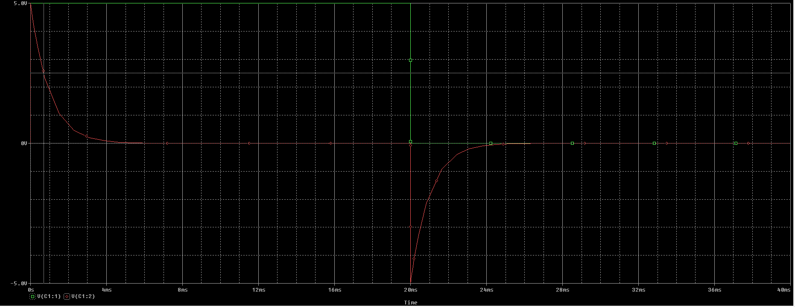

**Task 2**

Solve the RC circuit, now with, R= 10kΩ, C= 0.5µF and *f*= 50Hz.

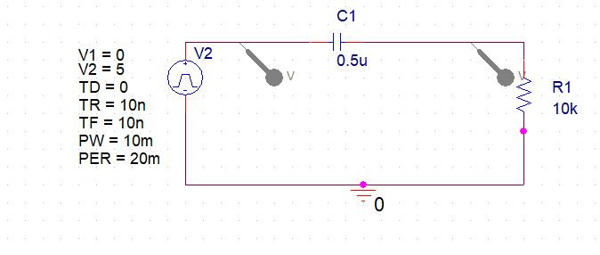

Figure 2

* Amplitudes:

**Measure the amplitude of VR =** 5V

**Measure the amplitude of VC =** 5V

* Calculate and measure τ and T1/2:

**T1/2 (Simulated)** = 3.4607 ms

**τ (Simulated)** = 4.9927 x 10-3

**τ (Calculated)** = 5 x 10-3

* For f = 50Hz, calculate:

**ω** = 2πf = **100π**

**R** = ZR = **10k**

**XC** = ZC = 1/jωC = 1/100π\*0.5μ = **6.3661kΩ**

**R+J (- XC)** = ZR + ZC = 10k + 63.661k = **16.3661kΩ**

**Insert the waveform you observed on the oscilloscope on the graph given.**

* Graph

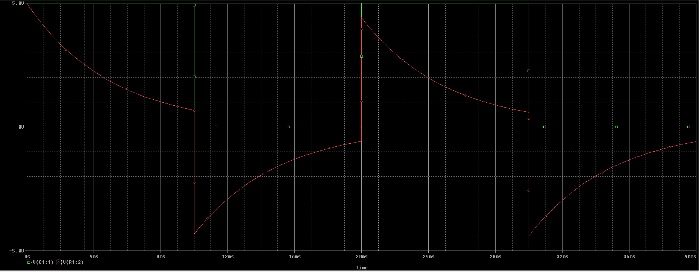

**Q1: Explain what is the difference between simulated and calculated values.**

Inherently, there is no difference in the simulated and calculated values. However, the means through which we obtain these values are different i.e, we get the Simulated value of **Tau (τ)** by dividing the Half Life of discharging curve with ln(2) whereas we calculate the theoretical value of **Tau (τ)** by multiplying equivalent Resistance with the equivalent Capacitance.

**Q2: What is the effect of capacitor values on charging and discharging cycles?**

The Time Constant is directly proportional to the value of both Capacitor and Resistor. Hence, upon increasing or decreasing the Capacitance, the time constant increases or decreases. A larger time constant results in a faster charging and discharging and vice versa.

Mathematically,

$$C∝ τ ∝\frac{1}{Time of Charge/Discharge}$$

**Conclusion:**

After performing this lab, I can definitively say that I am able to observe, read and solve the simulated graphs of RC circuits. I have learnt the direct effect of time constant on such a graph and have also further strengthened my base concepts.

**\_\_\_\_\_\_\_\_\_\_\_\_\_\_\_\_\_\_\_\_\_\_\_\_\_\_\_\_\_\_\_\_\_\_\_\_\_\_\_\_\_\_\_\_\_\_\_\_\_\_\_\_\_\_\_\_\_\_\_\_\_\_\_\_\_\_\_\_\_\_\_\_\_\_\_\_\_\_**