**Department of Electrical Engineering**

**Faculty Member:**  **Sir Mansoor Shaukat Dated: 06/01/2021 **

**Semester: 1st Section: BEE-12C **

**EE-111: Linear Circuit Analysis**

**Lab 12: RL Circuits**

|  |  |  |  |  |
| --- | --- | --- | --- | --- |
| **PLO4/CLO4** | | **PLO5/CLO5** | **PLO8/CLO6** | **PLO9/CLO7** |
| **Name** | **Reg. No** | **Viva /Quiz / Lab Performance**  **5 marks** | **Analysis of data in Lab Report**  **5 marks** | **Modern Tool Usage**  **5 marks** | **Ethics and Safety**  **5 marks** | **Individual and Team Work**  **5 marks** |
| **Muhammad Umer** | **345834** |  |  |  |  |  |
| **Saad Bakhtiar** | **341150** |  |  |  |  |  |
|  |  |  |  |  |  |  |
|  |  |  |  |  |  |  |

**Introduction**

In this lab, we will be looking at RC circuits and specifically, the graphs the voltage across Inductor. We will also learn how to observe and read the graphs and to calculate Tau from a simulated cursor.

**Objectives**

After performing this lab, students will be able to:

* Further strengthen their concepts on Transients
* Calculate time constant from tracing charge/discharge graph
* Differ between simulated and calculated values
* Set up an Inductive circuit on breadboard

**Equipment**

Following equiment are necessary to perform this lab:

* Inductor
* Resistors
* DMM
* Function Generation
* Oscilloscope
* Simulation Software

**Conduct of Lab**

The students are required to work in groups of three to four; each student must attempt to understand and use the laboratory set-up and conduct at least one or two parts of the requirement experimentation. The lab attendants and Lab Engineer will be available to assist the students.

In case some aspect of the lab experiment is not understood the students are advised to seek help from the teacher, the lab attendant or the assigned Lab Engineer (LE).

**τ and T1/2**

*T1/2 = (ln2) τ, so τ = T1/2 /ln2 = T1/2 / (0.693)*

**Voltages (VR and VC)**

*VR(t) = I(t)R = VS * e-(t*R/L) VL(t) = VS - VR(t) = VS (1- e-(t/L))*

**Lab Experiment**

**Task 1**



Figure 1

Assemble the circuit shown in Figure 1 on the breadboard.

With values R= 1kΩ, L=300mH and f=500Hz, observe the waveform when the output is taken across the capacitor.

*You will use the function generator to provide a square wave arc voltage of 10V p, and the oscilloscope to measure the output. (To see the discharging cycle, change the frequency to 5KHz)*

* Calculate and measure τ and T1/2:

**T1/2 (Simulated)** = 209.483 μs

**τ (Simulated)** = 3.022 x 10-4

**τ (Calculated)** = 3 x 10-4

* For f = 500Hz, calculate:

**ω** = 2πf = **100π**

**R** = ZR = **1kΩ**

**XL** = ZL = ωL = 100π*300 x 10-3 = **30π**

**R+J (XL)** = ZR + ZL = 1k + 94.247 = **1094.247Ω**

**Insert the waveform you observed on the oscilloscope on the graph given.**

* Graph

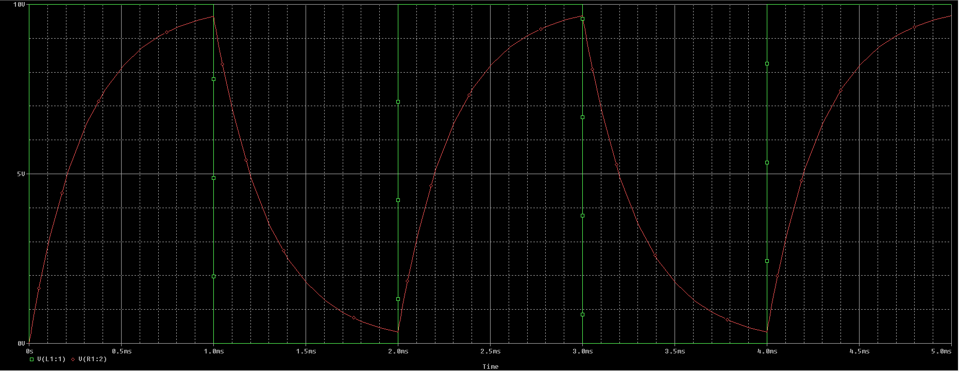

**Conclusion:**

After performing this lab, I can definitively say that I am able to observe, read and solve the simulated graphs of RL circuits. I have learnt the direct effect of time constant on such a graph and have also further strengthened my base concepts.

**___________________________________________________________________**