**Department of Electrical Engineering**

**Faculty Member:**  **Sir Mansoor Shaukat Dated: 22/10/2020 s**

**Semester: 1st Section: BEE-12C **

**EE-111: Linear Circuit Analysis**

**Lab1: INTRODUCTION TO BASIC LABORATORY EQUIPMENT**

|  |  |  |  |  |
| --- | --- | --- | --- | --- |
| **PLO4/CLO4** | | **PLO5/CLO5** | **PLO8/CLO6** | **PLO9/CLO7** |
| **Name** | **Reg. No** | **Viva /Quiz / Lab Performance**  **5 marks** | **Analysis of data in the Lab Report**  **5 marks** | **Modern Tool Usage**  **5 marks** | **Ethics and Safety**  **5 marks** | **Individual and Team Work**  **5 marks** |
| **Muhammad Umer** | **345834** |  |  |  |  |  |
| **Saad Bakhtiar** | **341150** |  |  |  |  |  |
|  |  |  |  |  |  |  |
|  |  |  |  |  |  |  |

**Lab1: INTRODUCTION TO BASIC LABORATORY EQUIPMENT**

**Introduction:**

As the students enter a new phase of their lives and strive to become Electrical Engineers, it is of utmost importance to acquaint them with basic Electronic equipment such as breadboard, resistors, power supply, and Multimeter. This lab expounds students on the procedures of using such equipment while also educating them on Lab ethics.

**Objective:**

The set-specific targets of this lab for the students are:

* Understanding the connections inside the breadboard
* Assembling and operating simple circuits
* Using the Multimeter to measure Resistance of a resistor, Voltage and Current across or through a component respectively.
* Using the Power Supply and jumper wires to run the circuit and also adjust the Voltage as per task assigned.

**Equipment:**

Following equipment is necessary for this Lab:

* Multimeter (DMM)
* Breadboard
* Resistors
* Jumper Wires
* Power Supply

**Tasks:**

**Setting up the Circuit**

Setting up the resistors on the breadboard in series (such that they share one common node). Connecting jumper wires to the opposite ends of resistors. Supplying power to the circuit by connection potential probes to unpaired end of jumper wires. Adjusting the Voltage to 10 Volts by using the Knob. Using Multimeter as a Voltmeter or Ammeter to calculate Voltage and Current respectively. Filling the given Table with the measured and calculated values.

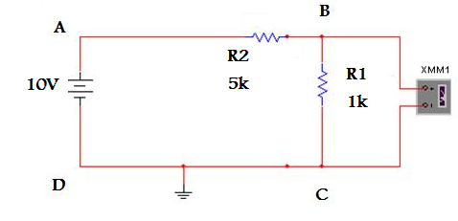

**4.7k**

**Answers**

**Q1**. Connect the DMM as a voltmeter to measure the voltage in the circuit as shown in the configuration below. Here the voltmeter is shown connected across points B and C. To measure the voltage across a different set of points you will have to disconnect the voltmeter and connect it between the desired points. Fill in the required results in Table 1.

|  |  |  |  |  |
| --- | --- | --- | --- | --- |
| **SNo** | **Value** | **Calculated** | **Measured** | **Difference** |
| 1 | Voltage A-B | 8.245V | 8.208V | 0.037V |
| 2 | Voltage C-D | 0V | 0V | 0V |
| 3 | Voltage D-A | -10V | -10V | 0V |
| 4 | Voltage A-D | 10V | 10V | 0V |
| 5 | Current A-D | 1.754mA | 1.7406mA | 0.0134mA |
| 6 | Current D-A | -1.754mA | -1.7406mA | -0.0134mA |

**TABLE 1**

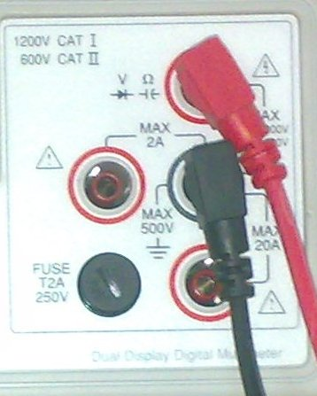

**Q2**. Consider your DMM and the picture given above. What is the range of voltage and current that the DMM can measure?

Range­­ of V: Red probe must be connected to the top-right port and can measure up to 1000 Volts.  
Range of I: Red probe must be connected to either the left or bottom-right port and measure current up to 2 Amps and 20 Amps respectively.

**Q3**. Comment on any variations observed between the measured and the calculated values of the voltages and currents.  
The difference in the calculated and measured value is because components in calculations and simulations are always ideal; they don’t have any tolerance resistance. Unlike theoretical circuits, real circuit components can never be ideal. They always possess some tolerance resistance and thus calculated values are higher than the experimental values.

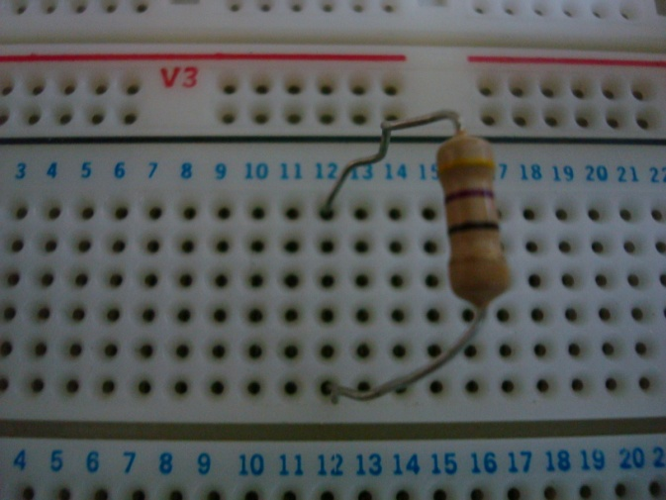 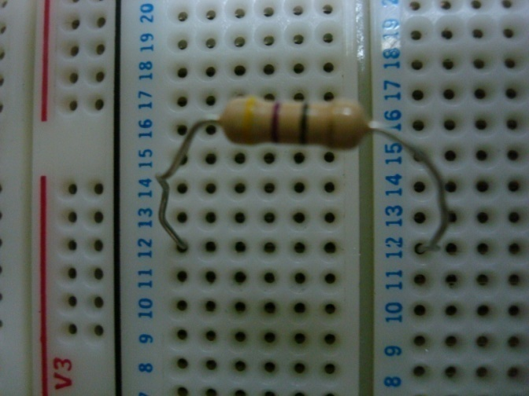

**Figure B**

**Figure A**

**Q4**. Consider Figure A and B above. Utilizing what you have learned in this lab and in-class about nodes, explain in which configuration the resistor is short or active. Explain.  
The resistor is short in Figure A because both of its ends are connected to a single node and the current chooses the path of least resistance. Whereas, the resistor is active in Figure B because it is connected to sides that are isolated by the gap in the middle of the breadboard and hence, are two nodes.

**Conclusion**

After performing this lab, I have become accustomed to the procedures necessary to operate Lab equipment such as the DMM and Power Supply. I also came to know about the connections that exist within the breadboard and what the horizontal and vertical bands represent, how to connect resistors in series and parallel, wiring up a basic circuit, and preeminently, the Lab ethics.