**Department of Electrical Engineering**

**Faculty Member:**  **Sir Mansoor Shaukat Dated: 26/10/2020**

**Semester: 1st Section: BEE-12C **

**EE-111: Linear Circuit Analysis**

**Lab 2: INTRODUCTION TO MULTISIM**

|  |  |  |  |  |
| --- | --- | --- | --- | --- |
| **PLO4/CLO4** | | **PLO5/CLO5** | **PLO8/CLO6** | **PLO9/CLO7** |
| **Name** | **Reg. No** | **Viva /Quiz / Lab Performance**  **5 marks** | **Analysis of data in Lab Report**  **5 marks** | **Modern Tool Usage**  **5 marks** | **Ethics and Safety**  **5 marks** | **Individual and Team Work**  **5 marks** |
| **Muhammad Umer** | **345834** |  |  |  |  |  |
| **Saad Bakhtiar** | **341150** |  |  |  |  |  |
|  |  |  |  |  |  |  |
|  |  |  |  |  |  |  |

**Lab1: INTRODUCTION TO BASIC LABORATORY EQUIPMENT**

1. **Introduction**

We’re living in the age where research and development is sped up. One simply doesn’t have enough time anymore to solve circuits by hand, taking a handful of time which could’ve been utilized as breathing space or being more productive. Thus, as an answer to the needs, Multisim was developed. It has since then saved a considerable amount of time of Engineers all over the world.

1. **Objective**

After performing this lab, students will be able to:

* Learn how to use the interface of Multisim
* Create complex circuits
* Join a Multimeter as an Ammeter, Voltmeter or Ohmmeter
* Further understanding and practicality of Breadboard

1. **Some guidelines:**

Use the multi users’ guide for this lab; some basic pointers are listed below:

* Double click the Multisim icon, the program is launched and a MULTISIM window appears on the screen.
* On the extreme left is the component toolbar. Place the cursor on each of the buttons to read the stated nomenclature and familiarize with what is available where. For this lab you may only need the top two buttons which display sources and basic passive components when cursor is placed over them.
* Click on New and start a new circuit window.
* Now look at the left side on component toolbar. Top most button on the menu is the DC power symbol. You select a dc power supply can click on it and then take the cursor to Circuit window (the major white part in the window). Click again and the DC power symbol will be pasted on the circuit window.
* Next click on Resistor symbol and view another pull down menu. Top most buttons on the menu is the resistor symbol l. You can click on it and then take the cursor to Circuit window (the major white part in the window). Click again and the resistor symbol finds a place in the circuit window. Use the mouse to connect the elements displayed in the circuit window together in a logical manner.
* Now set up the circuits that are given in figure-1 and figure-2 one by one.
* On the extreme right side is the Instruments toolbar. Top most button displays multimeter. Place it in the circuit window.
* Connect the multimeter in various parts of the two circuits and measure various required currents and voltages.
* Continue further experimentation and exploration till end of class time.

1. **Tasks**

Our goal is to make the circuit on paper, Multisim and Breadboard and then calculating the **theoretical, simulated and measured** values respectively.

**Theoretical Values**

We first draw the circuit on paper, apply Kirchoff’s Circuit Laws to find the theoretical values and fill the table out.

|  |  |  |
| --- | --- | --- |
| **No. of Observations** | **Component** | **Theoretical Values** |
| 1 | VR1 | 7 |
| 2 | VR2 | 2 |
| 3 | VR3 | 2 |
| 4 | VR4 | 5 |
| 5 | VR5 | 1 |
| 6 | VR6 | 1 |
| 7 | IR1 | 7mA |
| 8 | IR2 | 2mA |
| 7 | IR3 | 2mA |
| 8 | IR4 | 5mA |
| 9 | IR5 | 1mA |
| 10 | IR6 | 1mA |

**Simulated Values**

Next, we make the circuit on Multisim and calculate the Simulated Values.

To calculate the Voltage across the components, we connect the Multimeter in Multisim in Parallel as follows:

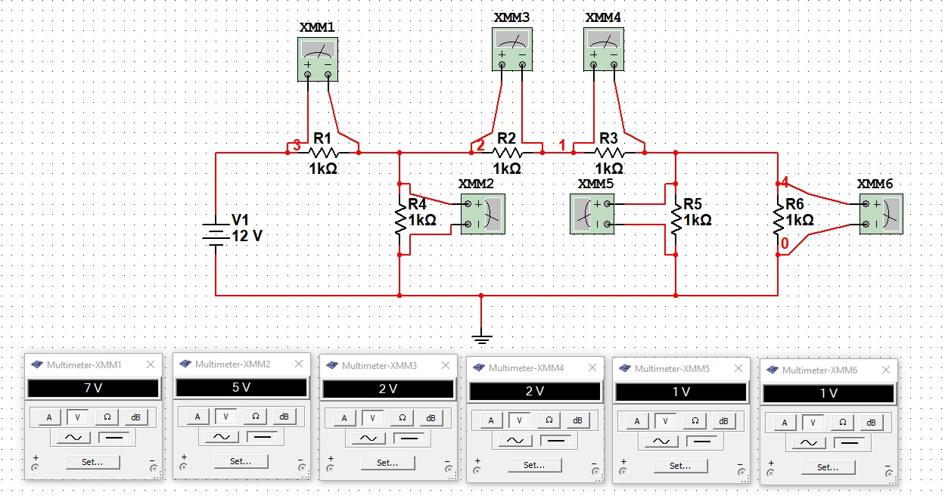

|  |  |  |
| --- | --- | --- |
| **No. of Observations** | **Component** | **Simulated Values** |
| 1 | VR1 | 7 |
| 2 | VR2 | 2 |
| 3 | VR3 | 2 |
| 4 | VR4 | 5 |
| 5 | VR5 | 1 |
| 6 | VR6 | 1 |

After that, we connect the Multimeter in Multisim in Series with the components to find the current through them.

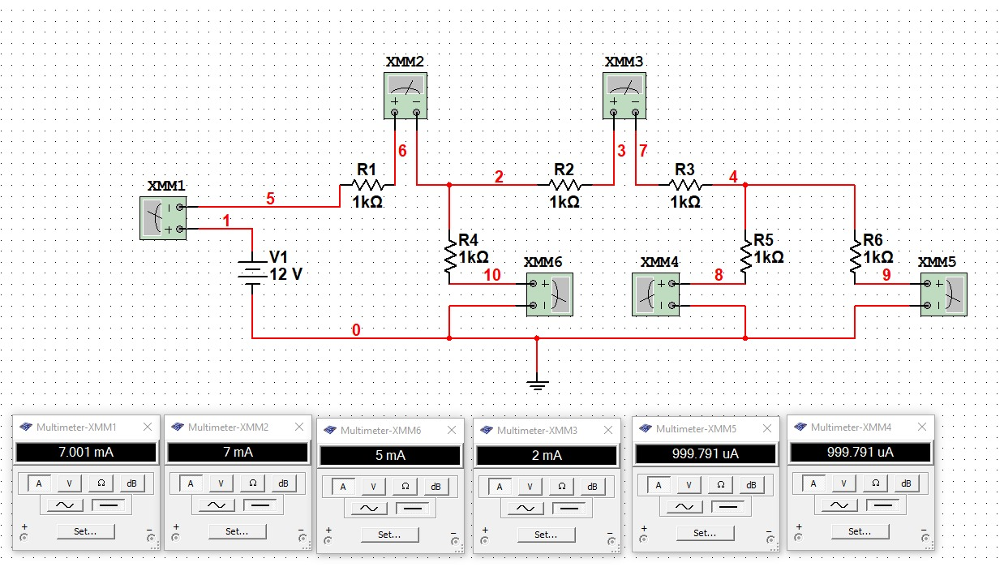

|  |  |  |
| --- | --- | --- |
| 7 | IR1 | 7mA |
| 8 | IR2 | 2mA |
| 7 | IR3 | 2mA |
| 8 | IR4 | 5mA |
| 9 | IR5 | 1mA |
| 10 | IR6 | 1mA |

Lastly, we implement the circuit on Breadboard and calculate the Measured value.

**Measured Values**

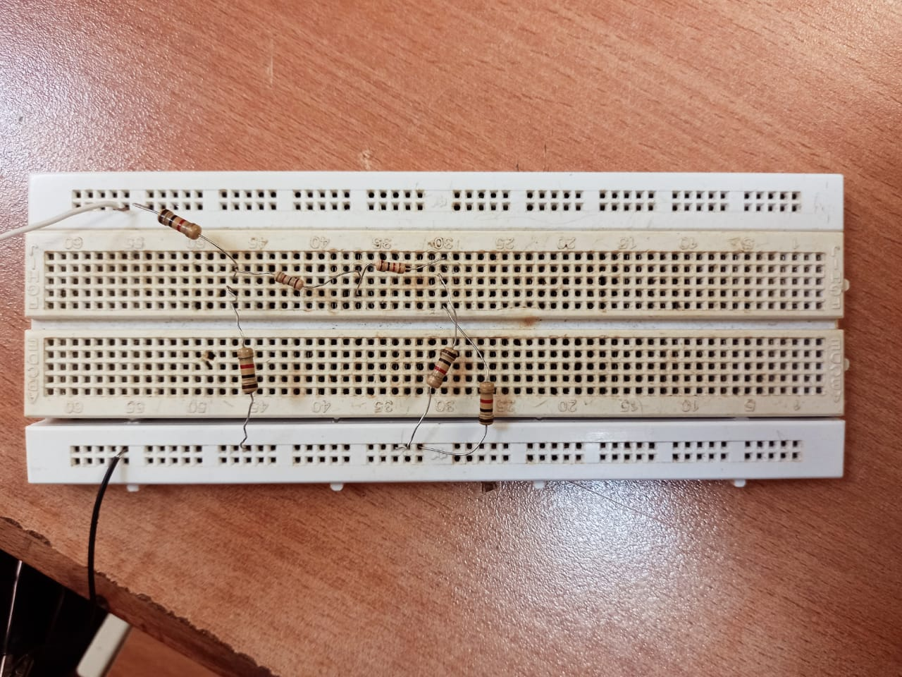

|  |  |  |
| --- | --- | --- |
| **No. of Observations** | **Component** | **Measured Values** |
| 1 | VR1 | 6.959 |
| 2 | VR2 | 1.98 |
| 3 | VR3 | 1.98 |
| 4 | VR4 | 4.98 |
| 5 | VR5 | 1.006 |
| 6 | VR6 | 1.006 |
| 7 | IR1 | 6.93mA |
| 8 | IR2 | 1.93mA |
| 7 | IR3 | 1.93mA |
| 8 | IR4 | 4.69mA |
| 9 | IR5 | 0.96mA |
| 10 | IR6 | 0.96mA |

**Questions**

**Q1. Is there any difference in simulated, calculated and measured values?**

There isn’t any difference between the simulated and calculate values per se, however the means through which they are obtained are completely different. Whereas, the measured value is different from both simulated and calculated because there exists a tolerance resistance in every real component (non-ideal).

**Q2. Why the values of IR5 and IR6 are same?**

The current through IR5 and IR6 is the same because their resistor values are same and since current gets divided in parallel, being exactly the same, it gets divided evenly.

**Q3. Why the values of IR2 and IR3 are same?**

The current through IR2 and IR3 is same because they are connected in series, and in a combination of resistor in series, the current through them is equal.

1. **Conclusion**

After performing this lab, I can say that on a firm stance that Multisim is an indispensible tool for Engineers. It helps them not only in making practical implementations but also expands their knowledge on different types of components whilst wholly removing any imbiguity and makes the foundation of their concepts stronger. .