**Faculty Member:**  **Sir Mansoor Shaukat Dated: 9/11/2020 **

**Semester: 1st Section: BEE-12C **

**EE-111: Linear Circuit Analysis**

**Lab 4: Introduction to PSpice**

|  |  |  |  |  |
| --- | --- | --- | --- | --- |
| **PLO4/CLO4** | | **PLO5/CLO5** | **PLO8/CLO6** | **PLO9/CLO7** |
| **Name** | **Reg. No** | **Viva /Quiz / Lab Performance**  **5 marks** | **Analysis of data in Lab Report**  **5 marks** | **Modern Tool Usage**  **5 marks** | **Ethics and Safety**  **5 marks** | **Individual and Team Work**  **5 marks** |
| **Muhammad Umer** | **345834** |  |  |  |  |  |
| **Saad Bakhtiar** | **341150** |  |  |  |  |  |
|  |  |  |  |  |  |  |
|  |  |  |  |  |  |  |

**Lab 4: Introduction to PSpice**

**Introduction:**

PSpice, like Multisim, offers an easy way to get simulated values of a circuit. One advantage of PSpice over other simulation softwares is that you do not need to connect a virtual multimeter across branches, in lieu, it gives us all the nodal voltages, power and currents through an element by itself.

**Objective:**

After performing this lab, students will be able to:

* Learn to set up and implement circuits on Pspice
* Further strengthen their concepts of circuit analysis

**Equipment:**

* Breadboard
* Resistors
* DMM
* Power Source

**Conduct of Lab**

The students are required to work in groups of three to four; each student must attempt to understand and use the laboratoy set-up and conduct at least one or two parts of the requirement experimentation. The lab engineer will be available to assit the students.

In case some aspect of the lab experiment is not understood the students are advised to seek help from the teacher, the lab attendent or the assigned Lab Engineer.

**Tasks:**

We have to implement the following circuit on both breadboard and a simulation software and then compare the theoretical and measured results.

Any discrepancy in the results is due to the fact that every practical circuit element has a tolerance of its own.

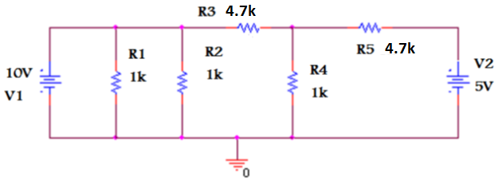

**Base Circuit**

**Theoretical Calculations (On paper)**

|  |  |  |
| --- | --- | --- |
| **No. of Observations** | **Values** | **Theoretical Values** |
| 1 | VR1 | 10V |
| 2 | VR2 | 10V |
| 3 | VR3 | 2.24V |
| 4 | VR4 | 7.6V |
| 5 | VR5 | 5V |
| 6 | IR1 | 10mA |
| 7 | IR2 | 10mA |
| 8 | IR3 | 1.651mA |
| 9 | IR4 | 2.24mA |
| 10 | IR5 | 587.5uA |

**Measured Values (On breadboard)**

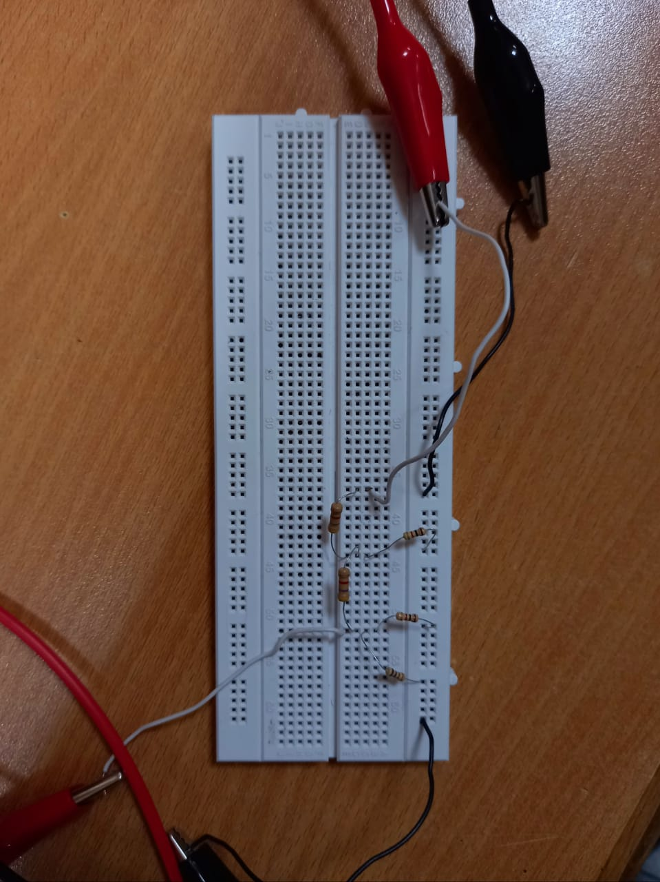

**Implemented Circuit**

|  |  |  |
| --- | --- | --- |
| **No. of Observations** | **Values** | **Measured Values** |
| 1 | VR1 | 9.93V |
| 2 | VR2 | 9.93V |
| 3 | VR3 | 7.728V |
| 4 | VR4 | 2.20V |
| 5 | VR5 | 2.70V |
| 6 | IR1 | 9.89mA |
| 7 | IR2 | 9.8mA |
| 8 | IR3 | 1.61mA |
| 9 | IR4 | 2.129mA |
| 10 | IR5 | 488uA |

**Simulated Values**

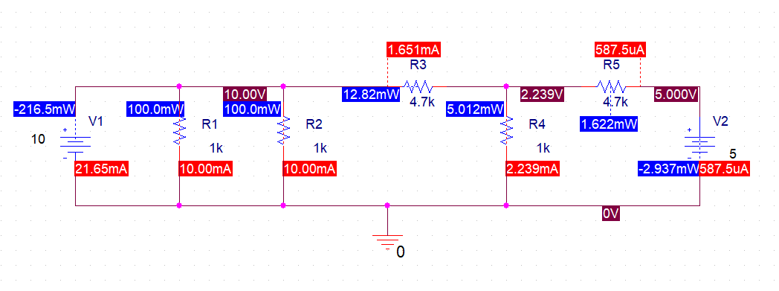

|  |  |  |
| --- | --- | --- |
| **No. of Observations** | **Values** | **Simulated Values** |
| 1 | VR1 | 10V |
| 2 | VR2 | 10V |
| 3 | VR3 | 7.761V |
| 4 | VR4 | 2.239V |
| 5 | VR5 | 5V |
| 6 | IR1 | 10.00mA |
| 7 | IR2 | 10.00mA |
| 8 | IR3 | 1.651mA |
| 9 | IR4 | 2.239mA |
| 10 | IR5 | 587.5uA |

**Conclusion:**

After conduction of this lab, we have learnt how to setup and create a project on PSpice, run a simulation and find the values of Voltage across and through current respectively. We also can find the power of the circuit element and that their sum is equal to zero.