**Department of Electrical Engineering**

**Faculty Member:**  **Sir Mansoor Shaukat Dated: 26/10/2020**

**Semester: 1st Section: BEE-12C **

**EE-111: Linear Circuit Analysis**

**Lab 5: Introduction to Nodal Analysis**

|  |  |  |  |  |
| --- | --- | --- | --- | --- |
| **PLO4/CLO4** | | **PLO5/CLO5** | **PLO8/CLO6** | **PLO9/CLO7** |
| **Name** | **Reg. No** | **Viva /Quiz / Lab Performance**  **5 marks** | **Analysis of data in Lab Report**  **5 marks** | **Modern Tool Usage**  **5 marks** | **Ethics and Safety**  **5 marks** | **Individual and Team Work**  **5 marks** |
| **Muhammad Umer** | **345834** |  |  |  |  |  |
| **Saad Bakhtiar** | **341150** |  |  |  |  |  |
|  |  |  |  |  |  |  |
|  |  |  |  |  |  |  |

**Lab 5: INTRODUCTION TO NODAL ANALYSIS**

**Introduction**

Nodal Analysis provides us with a simple method to find all the node voltages and in turn, the current through them with simple calculations. It also strengthens the base concepts of students and is essential to any electrical engineer.

**Objectives**

After performing this lab, students will be able to:

* Calculate the current and voltage through and across any element.
* Explain deviations in results in case these are encountered during the experiment.

**Conduct of Lab**

The students are required to work in groups of three to four; each student must attempt to understand and use the laboratoy set-up and conduct at least one or two parts of the requirement experimentation. The lab attendents and Teaching Assistants will be available to assit the students.

In case some aspect of the lab experiment is not understood the students are advised to seek help from the teacher, the lab attendent or the assigned Teaching Assistant (TA).

**Lab Equipment**

Equipment necessary to perform this experiment:

* PSpice
* The Power Supply
* Digital Multimeter

1. **Circuit for Analysis by Nodal Analysis Method.**
   1. For the circuit given below use NODAL ANALYSIS to measure and calculate all the currents and voltages for each circuit element.

The first step is to calculate the values of currents ,to accomplish do the following.

* + 1. Measure all the currents and voltages.
    2. Caluculate the power delivered /absorbed by each circuit element.
    3. Write thefinal set of equations necessary to calculate the currents.
    4. Fill in TABLE **1a** & **1b**.

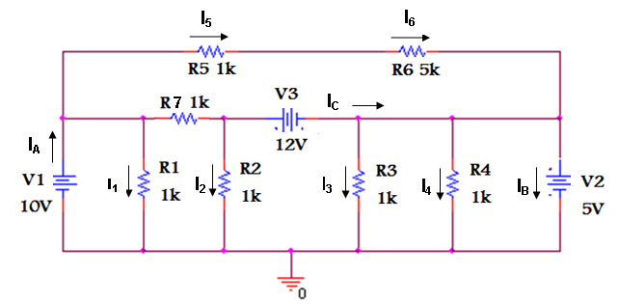

**CAUTION**

**DO NOT SWITCH ON POWER TILL YOU HAVE GOTTEN YOUR CIRCUIT CHECKED BY YOUR TEACHER /LAB ATTENDANT / TA**

**FIGURE 1**

**R6 = 4.7kΩ**

**THEORETICAL CALCULATIONS:**

|  |  |  |  |  |
| --- | --- | --- | --- | --- |
| **S.NO** | **ELEMENT** | **VOLTAGE** | **CURRENT** | **POWER ABSORBED/DELIVERED** |
| **CALCULATED** | **CALCULATED** |
| 1 | V1 | 10V | 3.877mA | -38.77mW |
| 2 | R1 | 10V | 10mA | 100mW |
| 3 | R2 | 17V | 17mA | 289mW |
| 4 | R3 | 5V | 5mA | 25mW |
| 5 | R4 | 5V | 5mA | 25mW |
| 6 | R5 | 0.877V | 0.8772mA | 769.5uW |
| 7 | R6 | 4.122V | 0.8772mA | 3.617mW |
| 8 | R7 | 7V | 7mA | 49mW |
| 9 | V2 | 5V | 33.12mA | -165.6mW |
| 10 | V3 | 12V | 24mA | -288mW |

TABLE 1a

* 1. Now simulate the above circuit in PSpice and record the values of voltages and currents in the table below and find out the percentage deviation in the measured and simulated values.
  2. By using the printscreen option save the simulation in a folder on the desktop.

**Simulations**

**Voltage**

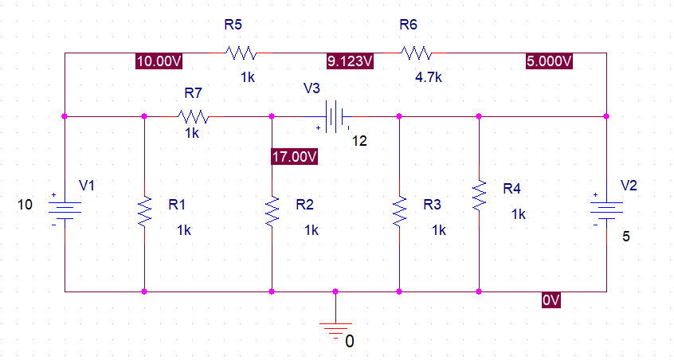

**Current**

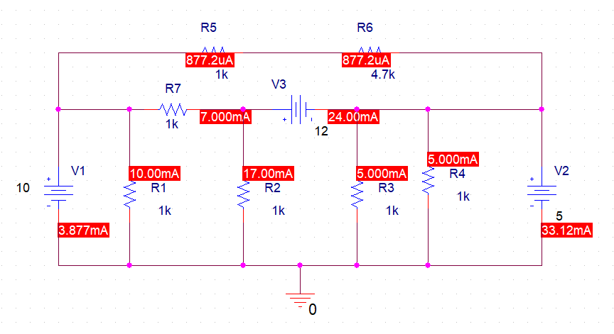

**Power**

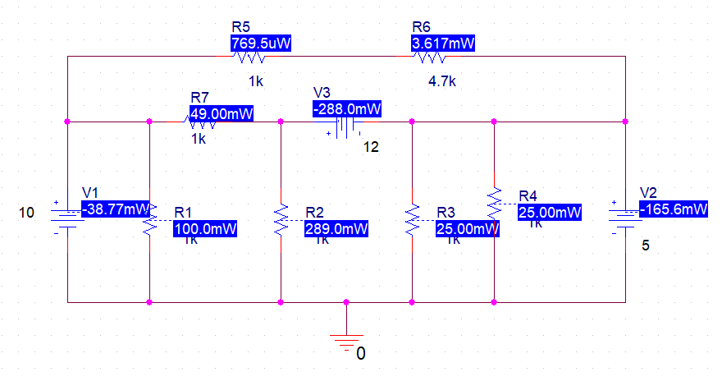

|  |  |  |  |  |
| --- | --- | --- | --- | --- |
| **S.NO** | **ELEMENT** | **VOLTAGE** | **CURRENT** | **POWER ABSORBED/DELIVERED** |
| **SIMULATED** | **SIMULATED** |
| 1 | V1 | 10V | 3.877mA | -38.77mW |
| 2 | R1 | 10V | 10mA | 100mW |
| 3 | R2 | 17V | 17mA | 289mW |
| 4 | R3 | 5V | 5mA | 25mW |
| 5 | R4 | 5V | 5mA | 25mW |
| 6 | R5 | 0.877V | 0.8772mA | 769.5uW |
| 7 | R6 | 4.122V | 0.8772mA | 3.617mW |
| 8 | R7 | 7V | 7mA | 49mW |
| 9 | V2 | 5V | 33.12mA | -165.6mW |
| 10 | V3 | 12V | 24mA | -288mW |

TABLE 1b

**Considering the time, it took to measure the values of voltage and current across the elements, and the time it took to perform nodal analysis on paper, would you agree that nodal analysis is an effective circuit analysis technique? Explain**

For beginners who have just started using a simulation software, nodal analysis proves to be more worthwhile. However, once you get the hang of PSpice, you can effectively make a circuit and get all node voltages without any problem. So, I personally will have to disagree, Simulation Softwares are more effective than nodal analysis because you save the energy to do any needless effort. One similarity between the forementioned solutions is that they both are extremely essential in an engineer’s life.

**Conclusion:**

After conduction of this lab, I can firmly say that I’ve learned how to implement a common ground between two or more voltage sources on a breadboard. I’ve also learnt the procedure to calculate the nodal voltages that help us solve a circuit completely and the method to simulate a circuit on PSpice.