**Department of Electrical Engineering**

**Faculty Member:**  **Sir Mansoor Shaukat Dated: 23/11/2020 **

**Semester: 1st Section: BEE-12C **

**EE-111: Linear Circuit Analysis**

**Lab 6: Introduction to Mesh Analysis**

|  |  |  |  |  |
| --- | --- | --- | --- | --- |
| **PLO4/CLO4** | | **PLO5/CLO5** | **PLO8/CLO6** | **PLO9/CLO7** |
| **Name** | **Reg. No** | **Viva /Quiz / Lab Performance**  **5 marks** | **Analysis of data in Lab Report**  **5 marks** | **Modern Tool Usage**  **5 marks** | **Ethics and Safety**  **5 marks** | **Individual and Team Work**  **5 marks** |
| **Muhammad Umer** | **345834** |  |  |  |  |  |
| **Saad Bakhtiar** | **341150** |  |  |  |  |  |
|  |  |  |  |  |  |  |
|  |  |  |  |  |  |  |

**Lab 6: INTRODUCTION TO MESH ANALYSIS**

**Introduction**

Mesh analysis, like nodal analysis, is another useful method in analysis of a circuit. One key difference between them is that mesh analysis gives us the current flowing through a mesh while nodal analysis gives us the node voltage. Needless to say, both are essential to analysing a circuit by hand.

**Objectives**

After performing this lab, students will be able to:

* Create a simulation on PSpice using multiple resistors and sources
* Further strengthen their base circuit concepts
* Identify the current flowing through a mesh

**Conduct of Lab**

The students are required to work in groups of three to four; each student must attempt to understand and use the laboratoy set-up and conduct at least one or two parts of the requirement experimentation. The lab attendents and Teaching Assistants will be available to assit the students.

In case some aspect of the lab experiment is not understood the students are advised to seek help from the teacher, the lab attendent or the assigned Teaching Assistant (TA).

**Lab Equipment**

The following equipment would be used in this experiment:

* PSpice

**LAB EXPERIMENT**

1. **Circuit for Analysis by MESH Analysis Method.**
   1. For the circuit given below use MESH ANALYSIS to measure and calculate all the currents and voltages for each circuit element.

The first step is to calculate the values of currents ,to accomplish do the following.

* + 1. Measure all the currents and voltages.
    2. Caluculate the power delivered /absorbed by each circuit element (use calculated values).
    3. Write the final set of equations necessary to calculate the currents.
    4. Fill in TABLE **1a** & **1b**.
  1. Now simulate the above circuit in PSpice and record the values of voltages and currents in the table below and find out the percentage deviation in the measured and simulated values.
  2. By using the printscreen option save the simulation in a folder on the desktop.

**I5**

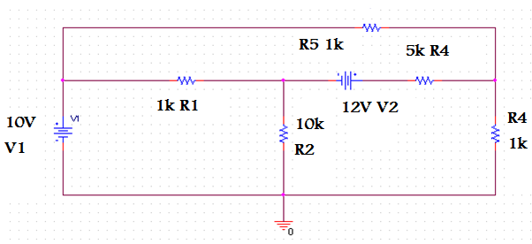

**I3**

**I2**

**I4**

**IA**

**I1**

**M 3**

**M 2**

**M 1**

**Simulations:**

**Voltage**

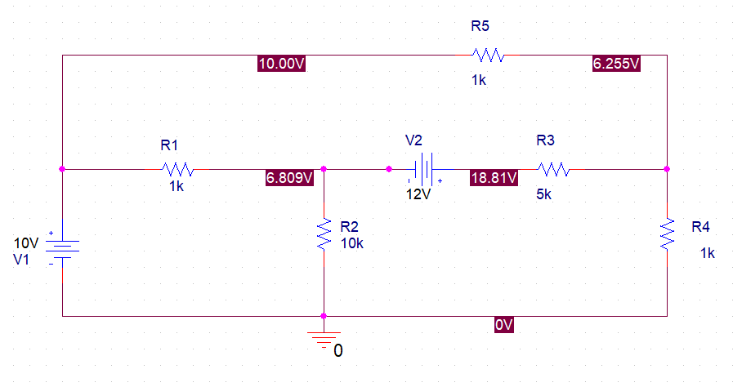

**Current**

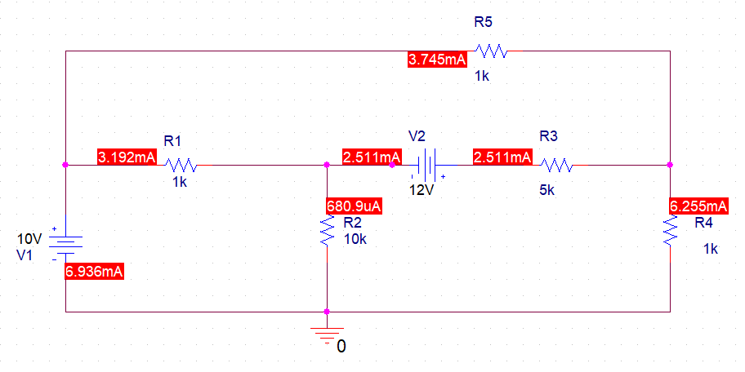

**Power**

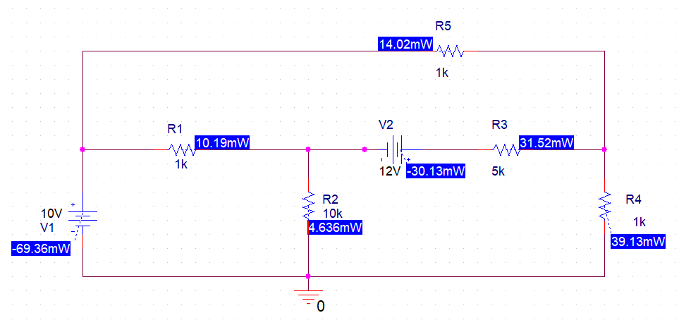

**THEORETICAL AND SIMULATED CALCULATIONS:**

|  |  |  |  |  |  |  |
| --- | --- | --- | --- | --- | --- | --- |
| **S.NO** | **ELEMENT** | **VOLTAGE** | | **CURRENT** | | **POWER ABSORBED/**  **DELIVERED** |
| **CALCULATED** | **SIMULATED** | **CALCULATED** | **SIMULATED** |
| 1 | V1 | 10V | 10V | 6.936mA | 6.93mA | -69.36mW |
| 2 | R1 | 3.192V | 3.19V | 3.192mA | 3.19mA | 10.19mW |
| 3 | R2 | 6.809V | 6.810V | 680.9uA | 680.9uA | 4.636mW |
| 4 | R3 | 12.55V | 12.55V | 2.511mA | 2.511mA | 31.52mW |
| 5 | R4 | 6.255 | 6.255 | 6.255mA | 6.255mA | 39.13mW |
| 6 | R5 | 3.745V | 3.745V | 3.745mA | 3.745mA | 14.02mW |
| 7 | V2 | 12V | 12V | 2.511mA | 2.51mA | -30.13mW |

**Explain any discrepancies between the calculated and simulated values.**

The simulated value given by PSpice is always up to three decimal places, while the person solving a circuit isn’t bound by any set of instruction. Hence, the user may round the calculated values by himself which causes such discrepancies to arise. Albeit it is to be noted that the Calculated and Simulated values are the same per definition; neither of them implement the concept of tolerance.

1. **Circuit For Analysis using *MESH* Concept..**
   1. For the circuit given below use **MESH CONCEPT** calculate all the currents and voltages for each circuit element.

Set up the circuit give below and do the following:

* + 1. Measure all the currents and voltages.
    2. Caluculate the power delivered /absorbed by each circuit element.
    3. Fill in TABLE **2a** & **2b**.
  1. Now simulate the above circuit in PSpice and record the values of voltages and currents in the table below and find out the percentage deviation in the measured and simulated values.
  2. By using the printscreen option save the simulation in a folder on the desktop.

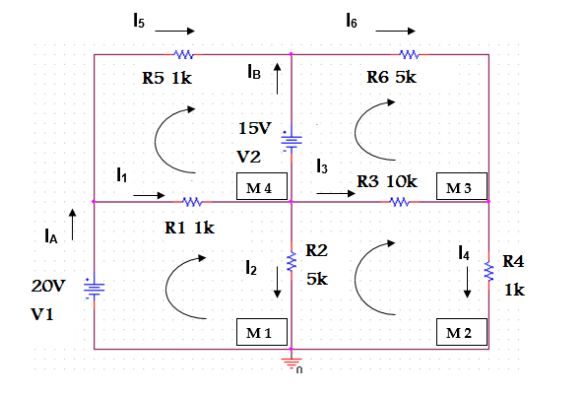

**Simulation:**

**Voltage**

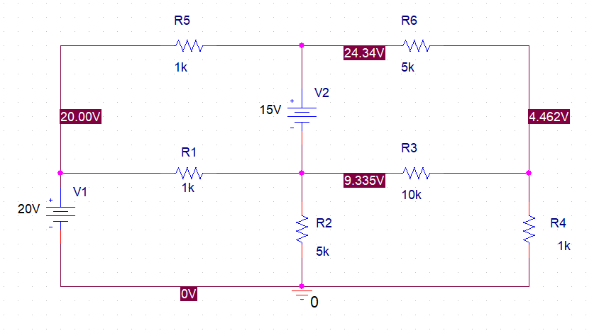

**Current**

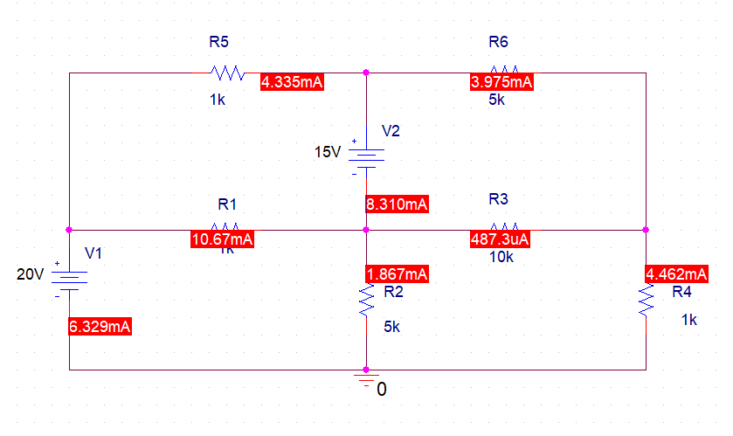

**Power**

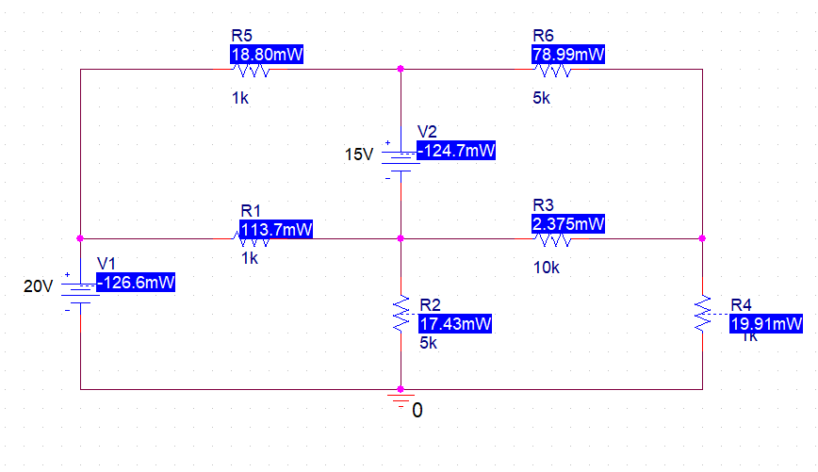

**THEORETICAL CALCULATIONS:**

|  |  |  |  |  |  |  |
| --- | --- | --- | --- | --- | --- | --- |
| **S.NO** | **ELEMENT** | **VOLTAGE** | | **CURRENT** | | **POWER ABSORBED/**  **DELIVERED** |
| **CALCULATED** | **SIMULATED** | **CALCULATED** | **SIMULATED** |
| 1 | V1 | 20V | 20V | 6.329mA | 6.329mA | -126.6mW |
| 2 | R1 | 10.665V | 10.665V | 10.67mA | 10.67mA | 113.7mW |
| 3 | R2 | 9.335V | 9.335V | 1.867mA | 1.867mA | 17.43mW |
| 4 | R3 | 4.873V | 4.873V | 487.3uA | 487.3uA | 2.375mW |
| 5 | R4 | 4.462V | 4.462V | 4.462mA | 4.462mA | 19.91mW |
| 6 | R5 | 4.340V | 4.340V | 4.335mA | 4.335mA | 18.80mW |
| 7 | R6 | 19.878V | 19.878V | 3.975mA | 3.975mA | 78.99mW |
| 8 | V2 | 15V | 15V | 8.310mA | 8.310mA | -124.7mW |

**Explain any discrepancies between the calculated and simulated values.**The simulated value given by PSpice is always up to three decimal places, while the person solving a circuit isn’t bound by any set of instruction. Hence, the user may round the calculated values by himself which causes such discrepancies to arise. Albeit it is to be noted that the Calculated and Simulated values are the same per definition; neither of them implement the concept of tolerance.

**3. Considering the time it took to measure the values of voltage and current across the elements, and the time it took to perform mesh analysis on paper, would you agree that mesh analysis is an effective circuit analysis technique? Explain**

For beginners who have just started using a simulation software, mesh analysis proves to be more worthwhile. However, once you get the hang of PSpice, you can effectively make a circuit and get all the currents in a mesh without any problem. So, I personally will have to disagree, Simulation Softwares are more effective than analysis techniques because you save the energy to do any needless effort. One similarity between the forementioned solutions is that they both are extremely essential in an engineer’s life.

**4. Compare and explain the differences between Nodal and Mesh Analysis. Can the circuits shown above be solved by the nodal analysis method? Explain the cases in which mesh analysis should be used instead of nodal analysis.**

Yes, the forementioned circuits can be solved by nodal analysis as well. One may prefer to use nodal analysis in which the number of meshes is greater than the number of nodes. The circuits in this experiment have either equal number or less number of meshes than loops. Hence, we prefer to use mesh analysis technique in both of them.

**5. Please explain briefly what you have learned in this lab and any difficulties you encountered**

I have learnt how to identify meshes and the current flowing through them. Moreover, I further strengthened my fundamental concepts as well as implementing a circuit on PSpice. I did not encounter any difficulties while performing this experiment.