**Department of Electrical Engineering**

**Faculty Member:**  **Sir Mansoor Shaukat Dated: 30/11/2020 **

**Semester: 1st Section: BEE-12C **

**EE-111: Linear Circuit Analysis**

**Lab 7: THEVENIN’S EQUIVALENT CIRCUIT**

|  |  |  |  |  |
| --- | --- | --- | --- | --- |
| **PLO4/CLO4** | | **PLO5/CLO5** | **PLO8/CLO6** | **PLO9/CLO7** |
| **Name** | **Reg. No** | **Viva /Quiz / Lab Performance**  **5 marks** | **Analysis of data in Lab Report**  **5 marks** | **Modern Tool Usage**  **5 marks** | **Ethics and Safety**  **5 marks** | **Individual and Team Work**  **5 marks** |
| **Muhammad Umer** | **345834** |  |  |  |  |  |
| **Saad Bakhtiar** | **341150** |  |  |  |  |  |
|  |  |  |  |  |  |  |
|  |  |  |  |  |  |  |

**Lab 7: THEVENIN’S EQUIVALENT CIRCUIT**

**Introduction**

In this experiment, we learn how to replace a complex circuit with many branches and components with a single Voltage source and a Resistor in series with a Load that may vary in values.

**Objectives**

After performing this lab, students will be able to:

* Replace a Complex Circuit with its Thevenin Equivalent
* Be able to utilize the Equivalent Circuit to find the power of a Variable Resistor
* Further strengthen the base concepts

**Conduct of Lab**

The students are required to work in groups of three to four; each student must attempt to understand and use the laboratoy set-up and conduct at least one or two parts of the requirement experimentation.

The lab attendents and Teaching Assistants will be available to assit the students.In case some aspect of the lab experiment is not understood the students are advised to seek help from the teacher, the lab attendent or the assigned Teaching Assistant (TA).

**Equipment:**

* Breadboard
* Multimeter
* Resistor
* Source
* PSpice or any Simulation Software

**Theoretical Calculations**

* 1. Calculate the Thevenin equivalent for the following circuit also labelled as Figure 1.

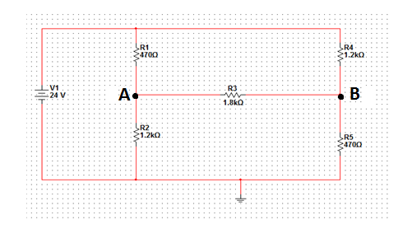

**Figure 1**

**CALCULATIONS FOR VOC**

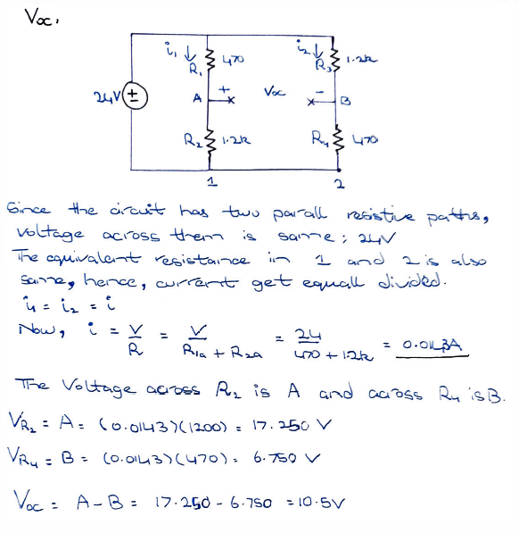

**CALCULATIONS FOR RTH**

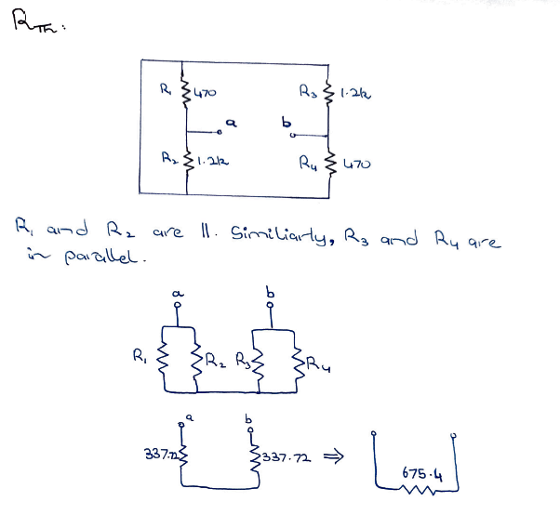

**Measured Values**

* + 1. Measure the open circuit voltage VOC at points A & B by replacing the load resistance RL with an open circuit.

**VOC = 9.943V**

* + 1. Measure the Thevenin equivalent resistance RTH looking from the points A & B by replacing RL with a open circuit and short circuiting the voltage source VDC.

**RTH = 656.4Ω**

* + 1. Put the load resistance RL in its place and find out the voltage VL across it. Calculate power absorbed by the load resistance RL using the formula

**PL = VL2 / RL**

**PL1=** ( 7.274 )2 / 1.8k = **29.38 mW**

* + 1. Simulate the following circuit on PSpice and record the voltage across the points A & B.

**Base Circuit**

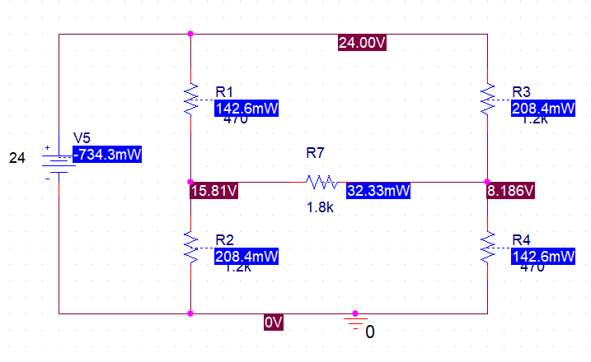

**Equivalent Circuit**

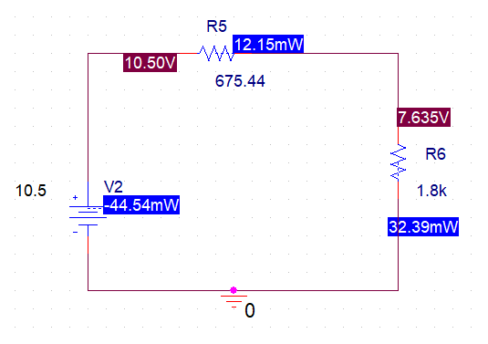

**ii)** Measure voltage VL across RL and find out the power absorbed by load resistor.

**PL2** = ( 7.286 )2 / 1.8k = **29.4 mW**

**Q1: Are the values of PL1 and PL2 same? Explain your answer.**

As the values are very near, we can consider them to be the same. Hence, we conclude that the Thevenin Equivalent circuit is a definitive alternative for a complex circuit. One advantage of Thevenin Equivalent is that it is far easier to replace the Load and find the Power of it.

**Table**

|  |  |  |  |
| --- | --- | --- | --- |
| **ELEMENT** | **VOLTAGE** | | |
| **CALCULATED** | **SIMULATED** | **MEASURED** |
| **VOC** | 10.5V | 10.5V | 9.943V |
| **RTH** | 675.4 Ω | 675.44 Ω | 656.4Ω |
| **PL** | 32.36mW | 32.33mW | 29.4 mW |

**Conclusion:**

After performing this lab, I can affirm that I am able to convert a complex circuit with multiple sources and components to its equivalent Thevenin Equivalent. I also verified that the effect of the complex circuit is the same as that of a Voltage Source and a Resistor in Series through comparing Powers.