**Department of Electrical Engineering**

**Faculty Member:**  **Sir Mansoor Shaukat Dated: 30/11/2020 **

**Semester: 1st Section: BEE-12C **

**EE-111: Linear Circuit Analysis**

**Lab 8: Norton Equivalent Circuit**

|  |  |  |  |  |
| --- | --- | --- | --- | --- |
| **PLO4/CLO4** | | **PLO5/CLO5** | **PLO8/CLO6** | **PLO9/CLO7** |
| **Name** | **Reg. No** | **Viva /Quiz / Lab Performance**  **5 marks** | **Analysis of data in Lab Report**  **5 marks** | **Modern Tool Usage**  **5 marks** | **Ethics and Safety**  **5 marks** | **Individual and Team Work**  **5 marks** |
| **Muhammad Umer** | **345834** |  |  |  |  |  |
| **Saad Bakhtiar** | **341150** |  |  |  |  |  |
|  |  |  |  |  |  |  |
|  |  |  |  |  |  |  |

**Lab 8: NORTON’S EQUIVALENT CIRCUIT**

**Introduction**

In this experiment, we shall learn how to find the Norton Equivalent of a complex circuit. Norton’s Circuit, like Thevenin’s Circuit, allows us to connect a variable resistor and find the power and other aspects of it without applying other techniques to the base circuit itself. It is generally a current source in parallel with a resistor which is the alternative form of some complex circuit connected to a load.

**Objectives**

After performing this lab, students will be able to:

* Covert a complex circuit to Current Source-Resistor form
* Use the DMM to find voltage across and current through different components in a circuit
* Further strengthen their base circuit analysis concepts

**Conduct of Lab**

The students are required to work in groups of three to four; each student must attempt to understand and use the laboratoy set-up and conduct at least one or two parts of the requirement experimentation.

The lab attendents and Teaching Assistants will be available to assit the students.In case some aspect of the lab experiment is not understood the students are advised to seek help from the teacher, the lab attendent or the assigned Teaching Assistant (TA).

**Lab Equipment**

The following equipment would be used in this experiment:

* Breadboard
* The Multimeter
* The Power Supply
* Multimeter
* Circuit components

**Task # 1**

1. **Circuit for Analysis by : NORTON’S EQUIVALENT.**
   1. Calculate the : Norton’s Equivalent for the circuit given in figure 1 theoretically.

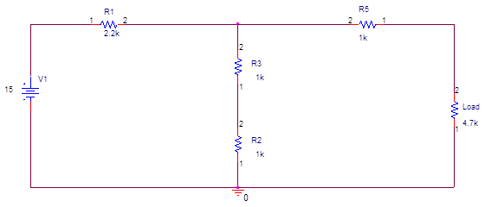

**FIGURE-1**

**CALCULATIONS FOR VOC**

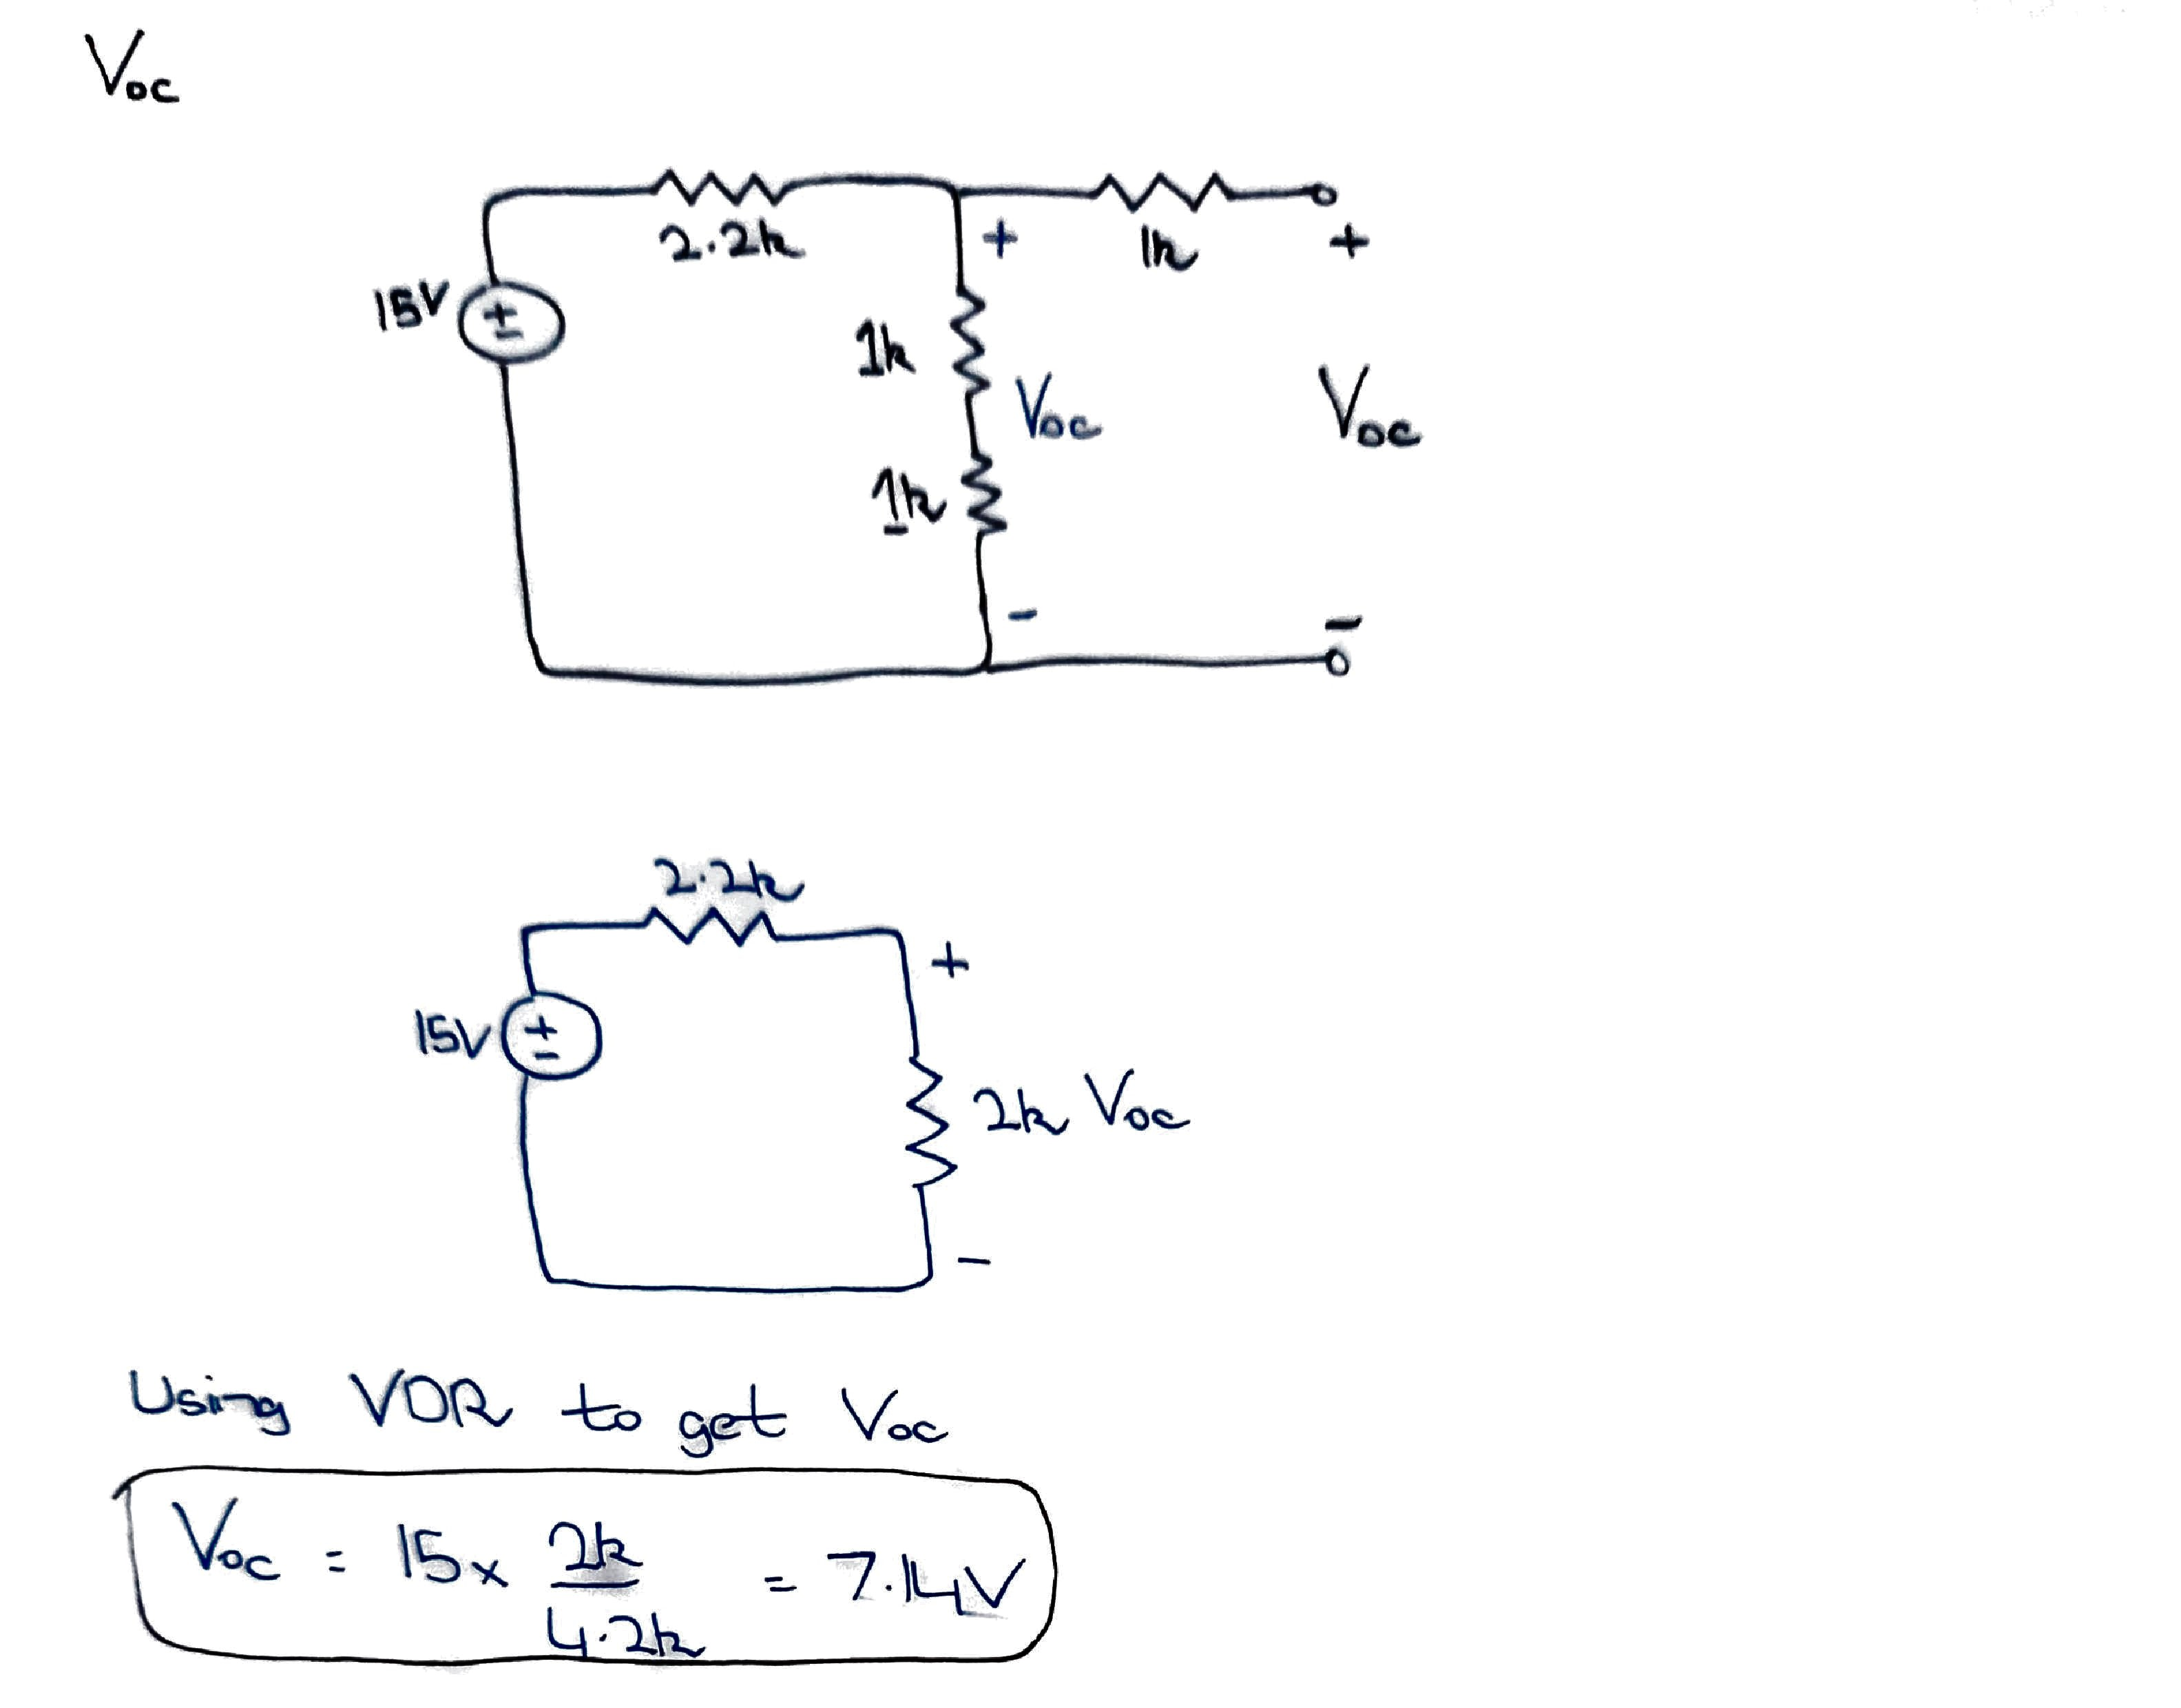

**CALCULATIONS FOR ISC**

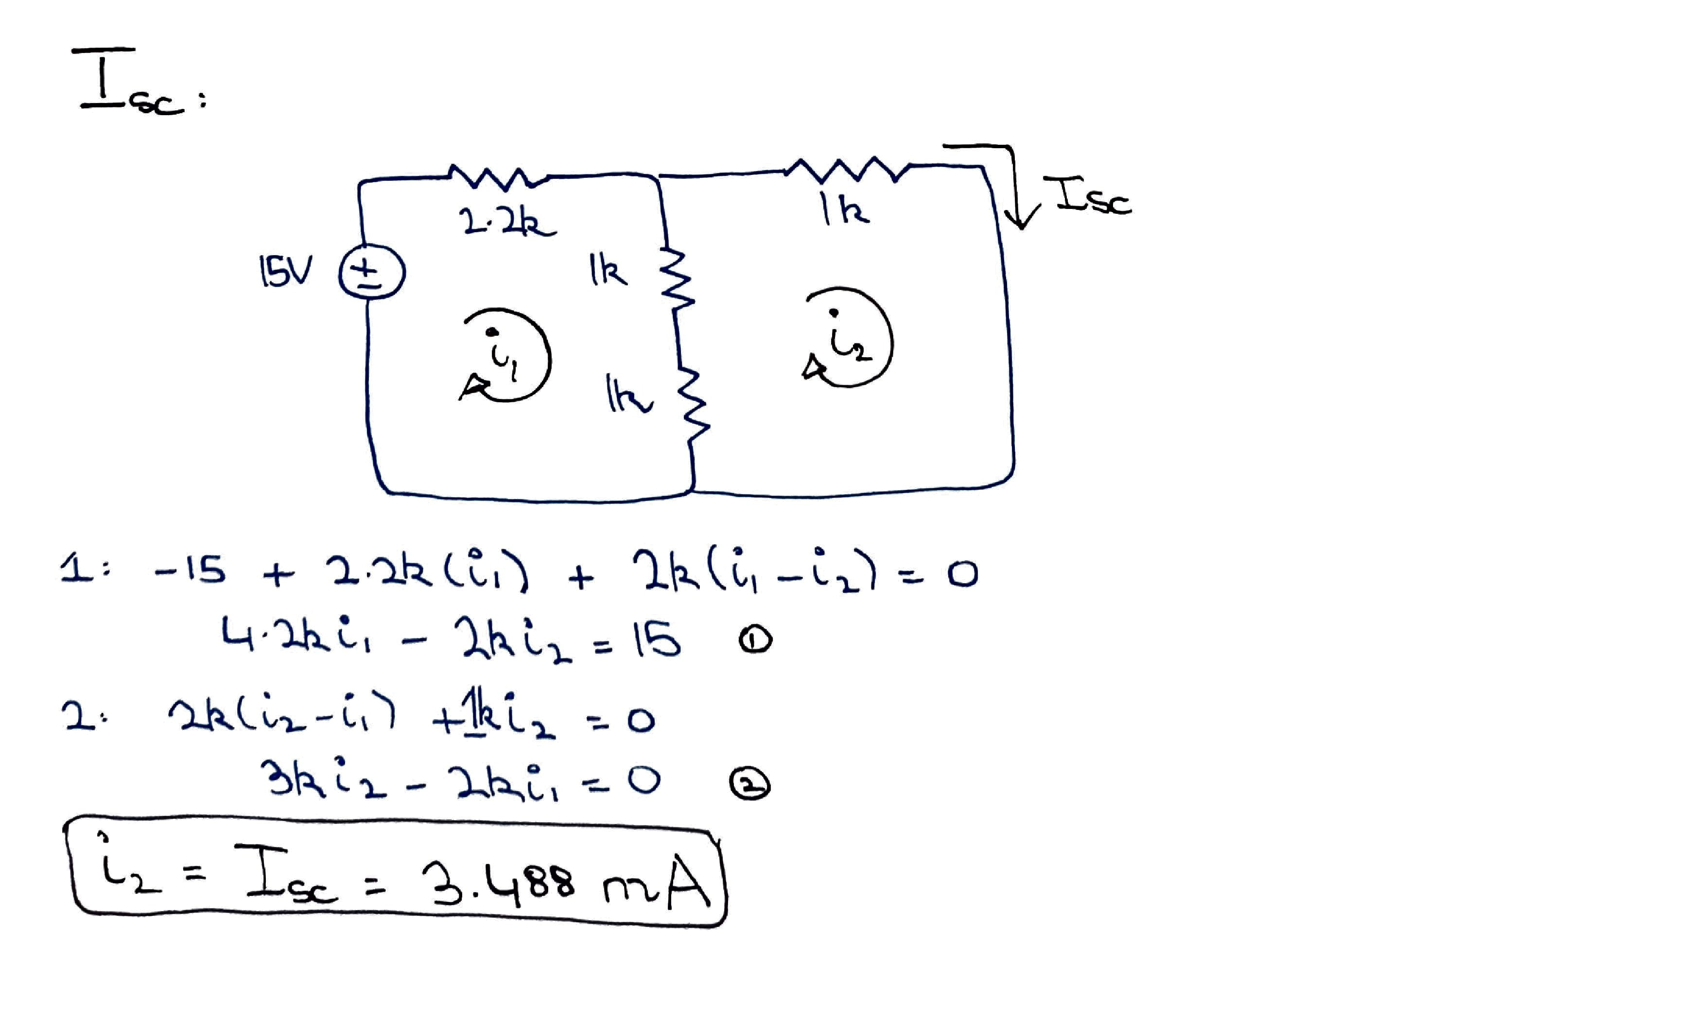

**CALCULATIONS FOR RN**

RN = VOS / ISC

RN = 7.14V / 3.488mA

**RN = 2.047kΩ**

* 1. Set up the circuit given in Figure 1 find the NORTON’S EQUIVALENT at Points A & B.
     1. Measure the open circuit voltage VOC at points A & B

**VOC = 6.96V**

* + 1. Measure the short circuit current ISC

**Isc = 3.3759mA**

* + 1. Measure the equivalent resistance looking from the points A & B.

**RN = 2.0589kΩ**

* + 1. Simulate the following circuit on PSpice and record the current through the points A & B. Save your simulation profile.

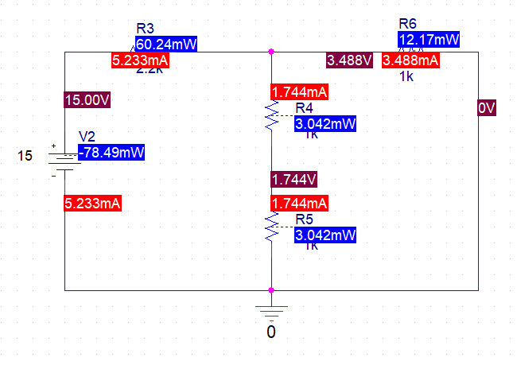

* + 1. Simulate the Norton’s equivalent circuit you have obtained and compare your simulated values with your calculated values.

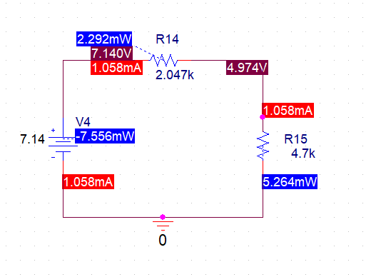

**Simulated for VOC**

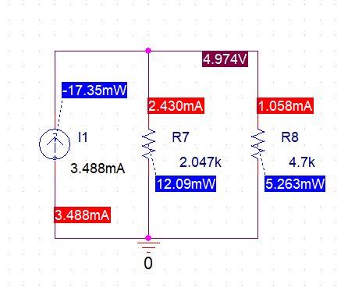

**Simulated for ISC**

|  |  |  |  |  |  |  |
| --- | --- | --- | --- | --- | --- | --- |
| **ELEMENT** | **VOLTAGE** | | **CURRENT** | | **Power** | |
| **SIMULATED** | **CALCULATED** | **SIMULATED** | **CALCULATED** | **SIMULATED** | **CALCULATED** |
| **VOC** | 7.14V | 7.14V | 1.058mA | 1.058mA | -7.55mW | -7.556mW |
| **ISC** | 4.974V | 4.974V | 3.488mA | 3.488mA | -17.35mW | -17.35mW |
| **RN** | 4.974V | 4.974V | 2.430mA | 2.430mA | 12.09mW | 12.09mW |
| **RL** | 4.974V | 4.974V | 1.058mA | 1.058mA | 5.263mW | 5.263mW |

**TABLE 1**

**Conclusion:**

After performing this lab, I can affirm that I am able to convert a complex circuit into a single current source in parallel with an equivalent Resistor. We also verified the equivalent circuit through means of power that the power of load remains same in both a complex circuit and in its respective equivalent circuit.

**_____________________________________________________________________________**