**Department of Electrical Engineering**

**Faculty Member:**  **Sir Mansoor Shaukat Dated: 14/11/2020 **

**Semester: 1st Section: BEE-12C **

**EE-111: Linear Circuit Analysis**

**Lab 9: Operation of Oscilloscope and Function Generator**

|  |  |  |  |  |
| --- | --- | --- | --- | --- |
| **PLO4/CLO4** | | **PLO5/CLO5** | **PLO8/CLO6** | **PLO9/CLO7** |
| **Name** | **Reg. No** | **Viva /Quiz / Lab Performance**  **5 marks** | **Analysis of data in Lab Report**  **5 marks** | **Modern Tool Usage**  **5 marks** | **Ethics and Safety**  **5 marks** | **Individual and Team Work**  **5 marks** |
| **Muhammad Umer** | **345834** |  |  |  |  |  |
| **Saad Bakhtiar** | **341150** |  |  |  |  |  |
|  |  |  |  |  |  |  |
|  |  |  |  |  |  |  |

**Objective:**

To familiarize students with AC source and the working of oscilloscope. We also explore the effects of changing the horizontal and vertical sensitivty on the Frequency and Voltage.

**Equipment:**

* Digital Oscilloscope
* Digital multimeter
* Powersupply
* Function generator

**RESUME OF THEORY**

The oscilloscope is most important available to the practicing technican or engineer .It permitss the visual display of a signal that can reveal a range of information regarding the operating characteristics of a circuit or system that is not available with a standard multimeter.

At first glance the instrument may appear complex and difficult to master.Be assured , however,that once the function of each section of the oscilloscope is explained and understood and the system is used throughout a set of experiments, your expertise with this important tool will develop quite rapidly.

In addition to the disply of a signal, it can be used to measure the average value, rmsvalue, frequency and period of a sinusoidal or nonsinsousodial signal. The screen is divided in to centimeter division in the vertical and horizontal directions .

The verticical sensitivity is provided(or set)volts /cm, whie the horzontal scale is provided(or set)in t time (s/cm).If a particular signal occupies 6 vertical centimeters and the vertical sensitivity is 5mV/cm, the magnitude of the signal can be determined from the following equation:

**Signal Voltage (Unknown)= Voltage Sensitivity (V/cm) X Deflection (cm)**

**Horizontal Sensitivity**

Figure 3 shows the HORIZONTAL controls: MENU knob, POSITION and SCALE knobs of horizontal system. Following the exercise to familiarize with the Buttons, knobs, and status bar.

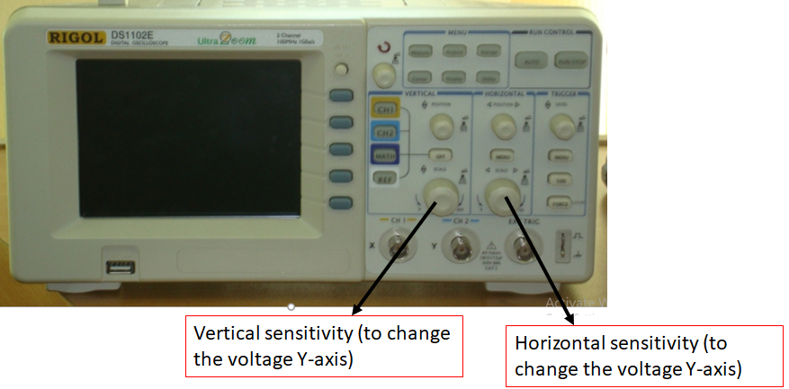

**Figure**

1. Determine the period of the 100Hz sinusoidal waveform using the equation T=1/f.

**(Calculate) T=** 10ms

1. Set horizontal sensitivity of the oscilloscope to 2ms/cm by rotating the SCALE knob of the digital oscilloscope. Using the results of part c calculates and divisions required to properly displaying one full cycle of the 100Hz signal.

**(Calculate) Number of divisions =** 5

The horizontal POSITION knob moves displayed signal horizontally on waveform window.

1. Change the horizontal sensitivity of the oscilloscope to 5ms/cm by rotating SCALE knob without touching any of the function generators. Using the results of part d how many horizontal divisions will now be required to display one full cycle of the 100Hz signal.

(**Calculate) Number of divisions =** 2

1. Change the horizontal sensitivity of the oscilloscope to 1ms/cm by rotating SCALE knob without touching any of the controls of the function generator. Using the results of part d, how many horizontal divisions will now be required to display one full cycle of the 100Hzsignal?

**(Calculate) Number of divisions =** 10

1. What was the effect on the appearance of the sinusoidal waveform as horizontal sensitivity was horizontal sensitivity was changed from 1ms/cm to 5ms/cm?

**As we increase the horizontal sensitivity from 1ms/cm to 5ms/cm, the waveform compresses horizontally; in other words, the number of divisions become lesser.**

Did the frequency of the signal on the screen change with each horizontal sensitivity? What conclusion can draw from the results?

**The frequency of the signal does not change with change in horizontal sensitivity. Only the number of division alter and but multiplied with the sensitivity scale, it gives frequency which, remains the same.**

1. Give a sinusoidal wave from on the screen. Review the procedure to determine the frequency of the pattern. In other words, develop a sequence of steps calculate the frequency.

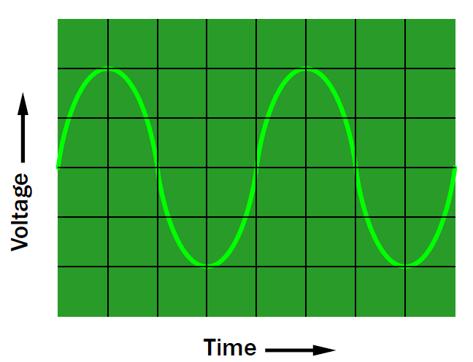

**Steps:**

1. We find the number of divisions of the sinusoidal wave of a single cycle.
2. We then multiply the calculated number of divisions with the sensitivity scale of the oscilloscope.
3. This gives us the Time Period of the Waveform.
4. From f = 1/T, we finally calculate the frequency of the waveform.

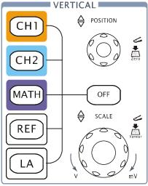

**Vertical Sensitivity**

Figure 4 shows the VERTICAL controls, CH1, CH2, MATH, REF, and OFF buttons and vertical POSITION, SCALE knobs. Following the exercise of the buttons, knobs, and the status bar to be familiar with the vertical parameters’ settings.

Set the vertical sensitivity of the scope to1V/cm by rotating the SCALE knob and adjust the amplitude control of the function generator to establish 4 V peak to peak (p-p) Sinusoidal waveform on the screen.

1. Do not touch the control of the control of function generator but return the sensitivity of the scope to 1v/cm and change the vertical sensitivity to 2V/cm by rotating the SCALE knob. Using the sensitivity calculate the peak-to-peak value of the sinusoidal waveform on the screen by first counting the number if the vertical division between peak values and multiplying by the sensitivity.

**(Calculate) Peak-to Peak value = 4**

Change the vertical sensitivity of the oscilloscope to 0.5V/cm by rotating the SCALE knob and repeat **Part (a)**.

**(Calculate) Peak-to Peak value = 4**

Did the peak-to peak value of the sinusoidal waveform change with the change in vertical sensitivity? What conclusion can you draw from the results?

**No, the Peak to Peak value of Voltage remains the same, however, the number of vertical division changes. This is because the the input voltage remains the same, and we only alter the scale of a measuring intrsument.**

What was the effect on the appearance of sinusoidal waveform as the vertical sensitivity was changed from 2V/cm to 0.5V/cm?

**As we decrease the vertical sensitivity from 2V/cm to 0.5V/cm, the waveform stretches vertically; in other words, the number of divisions become higher.**

Did the peak-to peak amplitude of the signal change with each vertical sensitivity? What conclusion can you draw from the results?

**No, the peak amplitude does not alter with a change in the setting of the vertical sensitivity.**

**Problems**

* **Give V=20 sin 2000t, Determine?**

1. ω = **2000 rad/s**
2. f = **318.3 1/s**
3. T = **3.14 ms**
4. Peak value = **20V**
5. Peak-to-peak value = **40V**
6. Effective value = **14.14V**
7. DC level = **0V**

* **Given V=8 sin 2π 4000t, determine.**

1. ω = **2π * 4000 rad/s**
2. f = **4000 1/s**
3. T = **0.25 ms**
4. Peak value = **8V**
5. Peak-to-peak value = **16V**
6. Effective value = **5.65V**
7. DC level = **0**

* **Given VRMS=1.2V, and a frequency of 400Hz, determine the mathematical expression for the sinusoidal voltage as a function of time.**

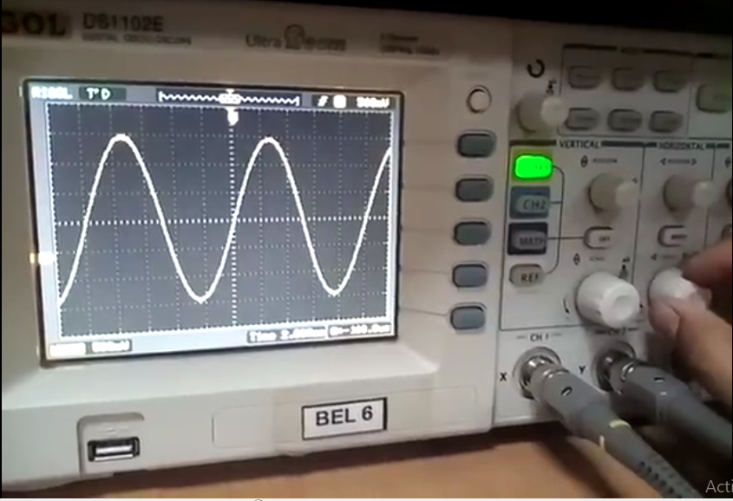

**V (Peak) =** VRMS * (2)1/2 **= 1.697V**

**ω =** 2π * f **= 800π**

The expressional of Sinusoidal Voltage as function of time, thus, is;

**V = 1.697 * sin (800π t)**

____________________________________________________________________________