Intercultural Communication: A Comparative Report

Assignment # 2

Submitted to: Dr. Ayesha Khurshid

Class: BEE 12C

Date: 25/04/2021

Group Members

|  |  |
| --- | --- |
| Name | CMS ID |
| Muhammad Ahmed Mohsin | **333060** |
| Muhammad Umer | **345834** |
| Saad Bakhtiar | **341150** |
| Tariq Umar | **334943** |

Introduction

When a group of people belonging from different cultures work in a community or a company there comes a need of when they want to interact with each other. However, due to the culture barrier it becomes very difficult for them to communicate with each other. The Intercultural communication is the verbal and non-verbal communication or interaction between the people from different cultural backgrounds. It is important to know your colleagues, their culture and their traditions so that there is an effective conversation knowing their background and area of interest. Here comes an important thing that when a foreign person interacts with us their maybe some things that are very offended in one's culture. Since we will be discussing about the cultures and traditions of Pakistan, USA, and South Korea their comes many barriers which we should keep in our mind and avoid while working in the same company. In the American culture pork is allowed to eat however on the contrary you may not find any such kind of meat in Pakistan. Our report summarizes some of these facts which are very important to know for people from such countries while working in same environment.

Hofstede Cultural Dimensions

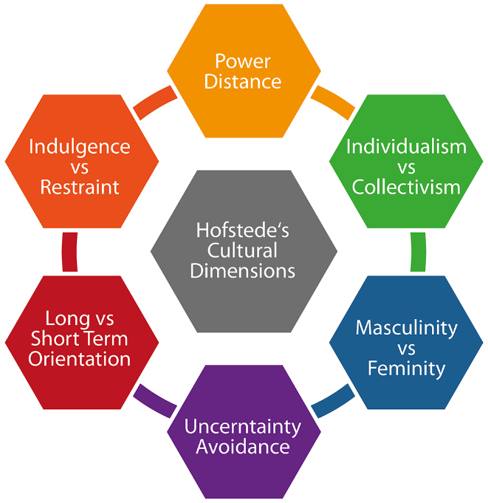

**Hofstede's 6 Cultural Dimensions**

We shall be comparing South Korea, Pakistan and United States of America through the Hofstede’s Model of Cultural Dimensions.

Following figure states the estimated rating each country scored on each dimension:

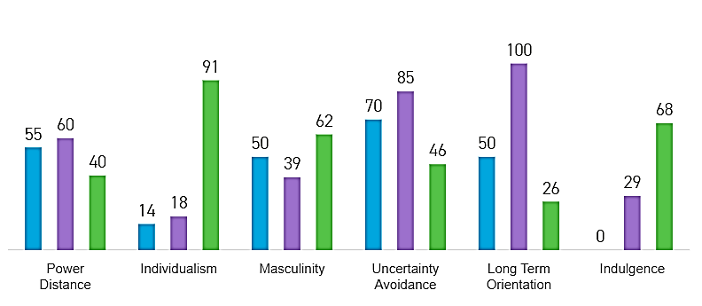

Keeping these values into account, we compare our selected three countries highlighting the similarities and differences.

Comparison

# Power Distance

This term describes that how the people belonging to the same culture view power relationships and how the less powerful and less authoritative members accept the difference in unequal distribution of power and acknowledge this fact. Those individuals expressing high power distance are considered as influential people and differential figures of the society. On the other hand, the people with low power distance only participate in questioning the decision of the authority.

This power distance influences the way of communication in different cultures. The more the people acknowledge this power distance the more the they develop communication gap between themselves.

# Observations

We can infer the following details from the Hofstede’s comparison bar chart:

## Pakistan

The second in line is Pakistan. Well according to a research paper, Mediterranean Journal of Social Sciences, it shows that although the overall score of Pakistan is 55 which in indeterminate in nature. The difference in power distance within the provinces is quite evident and KPK has the highest score. It is also obvious from the cultural brought up that the actions maintain and believe in a power hierarchy and they accept their definite place in it and also their cultural brought up is in a way that they maintain a communication gap between each other.

## South Korea

Among our three selected countries South Korea faces the most power distance effect. This shows that the people of South Korea live in a high-power distance and because of this they accept the reality of power. They believe in a definite place in the hierarchy of power. They tend to maintain some distance while communicating and be more formal and precise. Working in a business environment they will tend to follow orders because of their cultural brought up. (This all discussion is relative to other two countries and not absolute in nature.) The power distance is though most evident in business setting in south Korea.

## United States of America

US having a score of 40 implies that it a flat system as compared to Pakistan and South Korea. They have the thinking of ***‘liberty and justice for all’***. There is equality between the people, and the structure of their organization. The Americans are straight forward in expressing what they want to say. Hierarchy is established for convenience. But superiors are always accessible, and all decisions are taken after a formal discussion. The power is not centralized. This can be observed as an overall trait in USA, but power distance is still there which gives it the score of 40.

*The scores of these countries are almost the same, meaning Power Distribution to some extent is the same in these countries on family level as well as organizational level.*

# Individualism

Individualism is actually defined as the cultural syndrome which focuses on **I** rather that **we**. In this type of cultural and ethnic society people are more leaned towards **“I”**. They are concerned about their own family members and do not pay heed to the needs of other people. In the individualistic cultures the people are autonomous and sovereign. On the other hand, the collectivism means that the families live together and stretch arms to help each other in return of loyalty.

# Observations

We can infer the following details from the Hofstede’s comparison bar chart:

## Pakistan

With the least score of 14, Pakistan is considered as the country with collectivism cultural influence. The people of Pakistan live as families and these families extend out in long chains and thus creating a sense of harmony in the environment. The data obtained from collectivism vs individualism shows that Punjab, Sindh and KPK have a string collective Background while Baluchistan stays low in these scores.

This actually affects how the people of Pakistan communicate in their business and domestic chores. They often tend to develop brotherly relations with each other and are more likely to express feelings and help out each other. This is good for bringing harmony in business point of view where the teams can bring out their maximum output. On the other hand, being too frank in communication may lead to miss judgement.

## South Korea

The next in line is South Korea with a pretty less score of 18. This collective culture has proven to be very fruitful for South Korea against the Pandemic COVID 19’. This country has actually become an example to the world of how its millennia old Confucian values have helped them contain the spread of this pandemic. Due to the collective aspect of the culture they also help out each other and have a good communication and understanding with each other’s. For example, in South Korea **woo-rig (family, company)** is the most spoken word. There is a ***‘we mindset’***, where members of the society not only work for the progress of only themselves but for everyone they know. In such societies, offence leads to shame and humility. In the Organizations, where people form collective society work, an element of favouritism can also be seen.

## United States of America

Placing third in this category is the United States of America with a very high score of 91. This shows that America is predominantly an individualistic culture which the Americans in their own terminology call as the “**personal space**”. The people look after themselves and their immediate families only. They have an ***‘I mindset’***. They do not rely (much) on anyone for support. Americans do very well in interacting or doing business with new people. It can also be seen that in American organizations hiring, decisions and promotion are all done on merit and seeing the potential of the candidate.

This actually concurs with the **American dream** which relates than any individual with hard work can rise to the top. One of the many outcomes of this individualism is that fewer indirect codes of communication are shared between the individuals so direct communication always prevail which decreases miss judgement in any case.

*Thus, from this index it is seen that the culture of Pakistan and South Korea in terms of individualism is approximately the same while for America it is completely opposite.*

# Masculinity

Masculinity in cultural sense means that winners and those people at the top are appreciated. A high score in this dimension means that in society everyone is competitive, where success is defined by having distinction and being the best at something. Femininity is the opposite of it. In femininity caring for other and quality of life is considered as success rather than standing out of the crowd.

# Observations

We can infer the following details from the Hofstede’s comparison bar chart:

## Pakistan

The score of Pakistan in this field is 50 which is pretty moderate. A uniformity between provincial level is also observed while studying for masculinity in Pakistan. In Pakistan being a winner is appreciated in the society but the success in not totally dependent on it. People care about the hard work of others even if they don’t succeed. This moderate level of masculinity also open doors in communication where people can interact with the high achievers more comfortably and open doors of opportunity between them.

## South Korea

The score of South Korea in this regard was very low of about 39. This means that the South Korean culture is predominantly feminine in nature. The women in feminine countries have the same modest and same caring values as men. South Korea and other feminine countries show a gap between men and female values. There is less aggressive competition among men and women for achieving success. It aspires a caring working place for both men and women to work together and less focus in achieving targets.

## United States of America

The highest score in this case is of America I-e 62. Americans maintain a higher level of competition between individuals as compared to Pakistan and South Korea. Education is more oriented in achieving success and achievement targets are defined for students. From a young age the Americans are introduced to aggressive competition in various fields. While this has many negative impacts on mental health causing depression and anxiety it also creates a sense of can-do attitude.

*From this index we can conclude that the culture of the rural areas of Pakistan resembles with South Korean Culture, while the culture in urban areas have more similarities towards the American Culture.*

# Uncertainty Avoidance

Uncertainty avoidance actually refers to the fact that how the individuals of the society cope with anxiety to minimize uncertainty and high uncertainty avoidance index follows conventional behaviors and standard approaches where as low scoring countries are actually comfortable with uncertainty.

# Observations

We can infer the following details from the Hofstede’s comparison bar chart:

## Pakistan

Pakistan scored 70 in this index. It means that in Pakistan there is a high preference for avoiding uncertainties. Countries with high Avoidance of uncertainty, have rigid behaviour and beliefs. Innovation is resisted, people follow norms without trying new things. The individuals want assurance or security agreements before doing anything.

## South Korea

South Korea scores 85 in this domain which is a pretty high score. This actually indicates a societies low level of tolerance for uncertainty and to put up maximum efforts and define such rules to control all the outputs and results. In order to minimize uncertainty strict rules and uncertainty policies are adopted and full efforts are made for their proper implementation. Mostly such kind of societies are resilient to charges and do not accept change readily.

## United States of America

The United states of America scored very less in uncertainty avoidance index. In the United states short term orientation is very evident in domestic and business life. Americans have been very well known to seek instant life. Americans is actually a mentality of living in the moment. The Americans are considered uncertainty accepting. This actually reflects that America gives room for new inventions and products. In United states rules are very important but are not always to be followed. They adapt new ideas and decision into their experiences. This also creates a persuasive culture inclined on spending rather than saving money.

*Thus, from this index we can see that the culture of Pakistan and South Korea are somehow the same where the American culture is quite different.*

# Long Term Orientation

By long term orientation we mean a society that is more focused on the future. They are willing to delay the short-term pragmatic results for a secure future in the long run. Low score in this dimension means society does not make any long-term plans for the future but rather focuses on short term. On the other hand, a high score indicate that the country is far-sighted. They prepare proper plans for the future keeping in view the current trends, rather than getting any short-term profit.

# Observations

We can infer the following details from the Hofstede’s comparison bar chart:

## Pakistan

***Pakistan*** has a moderate score of ***50*** in this index,indicating that both type of culture can be seen short term oriented as well as long term. As in KPK long term plans are made, while in Punjab people are more focused on living the moment.

## South Korea

***South Korea*** scored a perfect score of ***100***, indicating that they prefer making long term plans which will benefit their country or organizations for a long time, rather than getting a quick profit.The South Korean community is focused on a secure future and the **KOREAN ELCTRIC POWER COMPANY** is an excellent example for this. They have been so successful that they are now producing and saving electricity for the future as well.

## United States of America

***USA*** has the lowest score of ***26***, which indicates that their organization and people strive to get quick results, for which they have short-term plans. These people are oriented in *“****living in the movement****”* and thus it is actually evident from the fact that American are believed to make rushed dealings. The idiom “time is money” has become their personally trait.

*In this index the three countries are very different from each other, as Pakistan is on an intermediate level, South Korea have a very high score while America has a very low score. Thus, during communication or working in an organization of these countries, one has to keep in mind the culture and what is expected from him.*

# Indulgence

Indulgent society is the one in which the individuals have a weaker control over their desires. They basically allow free gratification of human desires. A low score in this index means strong control called **‘restraint’**. While a high score means weak control called **‘indulgence’**.

# Observations

We can infer the following details from the Hofstede’s comparison bar chart:

## Pakistan

The last in this domain is Pakistan with zero score. Thus, Pakistani culture is a highly restrained culture. Religion plays a huge factor for this, as ***95%*** of Pakistanis are Muslim their religion has restricted them from many immoral things. In a restraint society, the people spend most of their time working or praying and keep themselves away from indulgence as they believe in the life here after and prepare themselves for it. For example, their exists strong class consciousness among Pakistani people and this directly affects their dealings and chores. *People live, drive, eat, wear and communicate according to classes*.

## South Korea

***South Korea*** scored ***26***, indicating that it is restraint society as well, but some element of indulgence can also be found. Restraint cultures generally have a smaller number of happy people and happy also they have low importance of having friends or leisure time. They have strictly prescribed gender roles and also in such societies **freedom of speech** is not of primary concern. Just like in the Pakistani culture, the South Korean also do not spend their time in leisure activities as they are discredited. Freedom of speech is not considered an issue as well.

## United States of America

The United States of America actually scored the most in this domain with a score of 68. American culture can be considered a dominating indulgent culture. Such societies basically allow the individuals to direct their behavior and thoughts themselves. The people of United states behave in accordance with basic human drives. This can be attributed to the liberty of individuals and because of that ***Drug Addiction*** is very high in US.

*Thus, in this index as well the culture of Pakistan and South Korea have some common traits while the American culture is completely different.*

Potential Hindrances in Multinational Project

So far, we’ve been comparing cultural differences among three countries; Pakistan, United States and South Korea, through Hofstede's cultural dimension model. Now we shall hypothesize or rather, simulate a situation where individuals of the aforementioned countries get grouped in a multinational project. It is of no surprise that the said countries are very different from each other, more so considering that each is placed far from each other geographically.

Such a situation is bound to have high probability of miscommunication occurring among the individuals. Keeping the differences in their cultures in mind, we shall state and briefly explain possible troubles that may arise in this environment.

## Language

The first and foremost, perhaps the most obvious, hindrance in a multinational firm is due to the primary language of communication in the precinct. English, from an international perspective, is the most used language to communicate in business dealings. Even if one does speak elementary English, unless they’re well versed with components such as metaphors, slangs, similes and phrases, there is a high chance of miscommunication.

In our particular simulated environment, an individual originating from South Korea or Pakistan is very likely to not keep up with the pacing of an American. This causes a decline in the overall efficiency of the team as the former may ask the latter to repeat themselves on multiple occasions, which in turn, demotivates their morale.

## Accent

An extension to the language barrier, is the different layers of understanding to a particular accent. Some accents such as that of Irish and Geordie are hard to understand from a native English speaker’s perspective as well. American people generally do not have that thick of an accent and neither do Pakistanis. South Koreas on the other hand, while not having a particular accent, tend to cut short some words; do not fully pronounce the letter at the very end of some words. Most common of them being ‘t’ as in the end of ‘that’.

## Extent of Detail

The extent to which each individual shares their work detail in this environment varies heavily. South Koreans are generally not the talkative type among their less, much less to foreigners. Whereas stereotypically, Americans pose to be a complete opposite of Koreans in this aspect. Pakistanis, in this case, stand somewhat neutral. A Pakistani individual adapts to a specific condition relatively faster when faced with such a situation; gets along with other’s culture rather than retaining their own cultural heritage.

Hence, when there is either excess or shortage of detail, miscommunication may occur. Excess in detailing a particular task may impose the listener to think that said task holds higher importance than it actually does. On the other hand, lack of detail may result in a completely different product than what was actually desired.

## Lack of Mutual Understanding

The aforementioned differences between the three countries also reflect upon the management, behavioural and communication style of respective cultures. This, in turn, imposes a barrier to smooth communication and these come from the fact that the lifestyle of an individual is, without a doubt, going to affect their attitude and approach to their workplace environment.

Apart from having varying focus on profits, different cultural backgrounds lead to having different expectations to work itself. It also influences the way people perceive and alter the core purpose of their firms; the vision of the said firm. Such a lack of mutual understanding gives rise to multiple communication problems and on the extreme cases, may strike up an argument as a by-product of having different outlook to a specific task.

## Different Reactive Approach to Accidents

Accidents usually have a direct relation to the use of formal and informal communication system in a systematic workplace. Formal communication, in a business environment, usually implies talking directly to one’s superiors for an appropriate work-related reason. Informal system, on the other hand, is talking to surrounding peers about any general topic. Different cultures utilize either one and both of them are feasible. However, when talking in regards to a multinational firm, both systems should be utilized. It is to be taken into account that formal communication is both inefficient and often time-consuming as everything has to go through a series of processes.

Countries with low rating on uncertainty avoidance are generally more tolerant to accidents. Amongst the chosen three, an American is more likely to overlook an accident and take reactive measures to mitigate the effect of the accident. The rest, instead of being flexible, usually report to their direct superiors about the particular incident. The US employees utilize both formal and informal communication system; talk about it to both their superiors and amongst themselves as well. In a way, it is also taking a risk to some extent to solve the immediate accident. Different opinions and attitudes on the procedure to resolve the damages by an accident in a multinational firm, gives rise to differences and disagreements, ultimately hindering communication.

## Time Difference

One of the biggest hindrances to communication in a multinational firm is due to the difference in time zones. United States of America being located in the far west whilst Pakistan and South Korea being more in the South causes there to be almost a 12-hour difference between these two groups. The effect of such a difference is that the individual in America may not get a response on the same day as was asked, which may obstruct him from doing any further work.

On the bright side, some well-established organizations turn this fact into their own favour. This is done by devising an ordered and structured plan such that the waiting delay is reduced to the very minimum. An example can be put front from our three chosen countries albeit on a much smaller scale; suppose a 3D model has to be built from scratch. The South Korean individual draws the general model and describes the general mechanics behind the object and gets done for the day, as soon as he is off-time from his work, the American is up and ready to implement the model how he perceives it on, say, a particular rendering software. Turning this into a constant cycle of flow of work is both efficient and results in minimal disruptions to the project at hand.

## Religious Differences

Religious is a very delicate and sensitive matter varying in intensity over different cultures. Such an aspect is directly related to the ‘long term orientation’ dimension of the Hofstede’s model. It is described in terms of “***how every society has to maintain some links with its own past while dealing with the challenges of the present and future***, and societies prioritise these two existential goals differently.” (Hofstede, 1997)

Countries that score high on this dimension tend to take a pragmatic approach to a certain task while those that score low, tend to be conservative and hone their traditions. Christianity and Muslims being the prevalent religions in United States of America and Pakistan respectively, view societal alterations with suspicions. South Korea scoring the highest in this case imply that the concept of God and the notion of one and almighty is alien to them.

Under such circumstances, religious discussions, if they may arise, tend to do more harm than any good. Such a conversation, on the extreme case, may end up with one being disrespectful and intolerable to other’s beliefs, ultimately ruining an ethical and safe work environment. It also gives rise to intolerance and disharmony among the individuals and if not dealt with immediately, decreases the overall morale exponentially.

Survey

# Results

We, as a group, conducted a rather short survey among our fellow classmates upon the general barriers and experiences with cross-cultural communication. We received 53 responses, collectively, yielding the following bar charts;

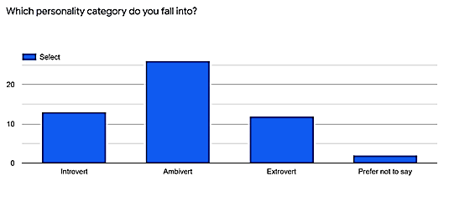

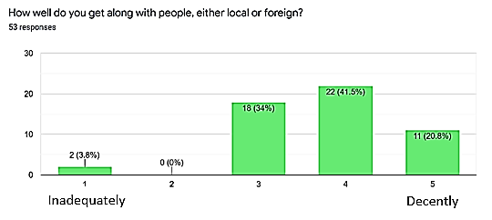

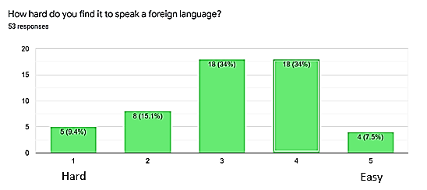

Apart from these polls, we also asked them to describe their first experience communicating with a foreign individual and then faced hindrances while doing so. Despite most speaking foreign languages adequately, within 3-5 range on the above chart, 74% of the responses had faced difficulties in communicating; With the highest occurring hindrances in this interaction being related to **accent** and **nervousness.** Lastly, as one would expect, introverts had faced the most difficulties in their communication varying on a broad range - from nervousness to thoughts being all over the place.

Conclusion

In the study made we have come to a conclusion. Each nation has its own cultures and traditions. We are sometimes compelled to work with people from different nations for a specific job or project. In the above writing we have compared the behaviour and nature of the people of Pakistan, USA and South Korea. Each country has its own capabilities, characteristics and nature. While working in a safe environment it becomes easier for the other if he/she is familiar with others interests. We have seen that the people belonging from Pakistan and South Korea very less adopt the individualism while on the other hand we see that in USA people are more independent and its percentage of individualism is 91%! While if we talk about the power distance South Korea and Pakistan are way ahead of USA in this regard. Therefore, by comparing these stats we are able to give comfort to the foreigners according to their personalities that are reflected by their cultures.