**Department of Electrical Engineering**

**Faculty Member:**  **Kiran Liaqat Dated: 05/08/2021 **

**Semester: 2nd Section: BEE-12C **

**EE-211: Electric Network Analysis**

**Lab 10: Use of MATLAB for s-Domain Analysis**

|  |  |  |  |  |
| --- | --- | --- | --- | --- |
| **PLO4/CLO4** | | **PLO5/CLO5** | **PLO8/CLO6** | **PLO9/CLO7** |
| **Name** | **Reg. No** | **Viva /Quiz / Lab Performance**  **5 marks** | **Analysis of data in Lab Report**  **5 marks** | **Modern Tool Usage**  **5 marks** | **Ethics and Safety**  **5 marks** | **Individual and Team Work**  **5 marks** |
| **Muhammad Umer** | **345834** |  |  |  |  |  |
| **Saad Bakhtiar** | **341150** |  |  |  |  |  |
|  |  |  |  |  |  |  |
|  |  |  |  |  |  |  |

**Introduction:**

MATLAB is undoubtedly a very powerful tool for performing numerous tasks such as solving linear systems, signal processing, simulations, etc. A significant advantage of MATLAB over other alternatives is that it is relatively easy to learn and errors are easy to fix. Scripts are also optimized when performing heavy operations and thus, it is a must have software for an engineer.

**Objective:**

After performing this lab, students will be able to perform the following operations in MATLAB:

1. *Polynomial Input in s-Domain*
2. *Finding Roots of Polynomial of any Order*
3. *Finding Partial Fractions of an s-Domain Expression having N(s)/D(S) Form*
4. *Finding Laplace Transform of Time Domain Function*
5. *Finding Inverse Laplace Transform of s-Domain Functions*
6. *Circuit Analysis in s-Domain Using MATLAB*

**Equipment:**

1. MATLAB

**Conduct of Lab**

The students are required to work in groups of three to four; each student must attempt to understand and use the laboratory set-up and conduct at least one or two parts of the requirement experimentation. The lab attendants and Lab Engineer will be available to assist the students.

In case some aspect of the lab experiment is not understood the students are advised to seek help from the teacher, the lab attendant or the assigned Lab Engineer (LE).

# Task # 1

Let 𝑭(𝒔) = **𝟓𝒔𝟒 + 𝟑𝒔𝟑 + 𝟏𝟎𝒔𝟐 + 𝟐𝟓𝒔 + 𝟐𝟎** 𝒂𝒏𝒅 **𝑮(𝒕) = 𝒕𝟓 − 𝒕𝟑 + 𝒕𝟐 − 𝟏𝟗.**

Define F(s) and G(t) in MATLAB (You may use Fs instead of F(s) in MATLAB).

Find vector forms of both expressions.

Like if you have: Fs= s^2+2*s+3 and its vector form is [1 2 3]

**Code**

**syms s t**

**Fs = 5*s^4 + 3*s^3 + 10*s^2 + 25*s + 20;**

**Gt = t^5 - t^3 + t^2 -19;**

**Fs_vec = sym2poly(Fs);**

**Gt_vec = sym2poly(Gt);**

**Fs_vec**

**Gt_vec**

**Output**

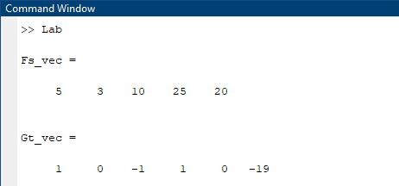

1. What is the difference between poly2sym and poly2str functions in MATLAB?

**Answer:** *poly2str* requires the passage of a string symbol in its syntax, i.e. **‘s’** and displays the output of a character string polynomial whereas *poly2sym* can display output without any sort of symbol, albeit the default symbol is ‘**x’**,while also providing the alternative to input a ***var*** in the syntax, i.e.[***p***](https://www.mathworks.com/help/symbolic/poly2sym.html#buns1kb-p)***= poly2sym(***[***c***](https://www.mathworks.com/help/symbolic/poly2sym.html#buns1kb-c)***,*** [***var***](https://www.mathworks.com/help/symbolic/poly2sym.html#buns1kb-var)***).*** Intrinsically, both convert an input vector form of an expression into an expression polynomial with different syntax.

# Task # 2

Find the roots of the two polynomials given at task number 1.

**Code**

**syms s t**

**Fs = 5*s^4 + 3*s^3 + 10*s^2 + 25*s + 20;**

**Gt = t^5 - t^3 + t^2 -19;**

**Fs_vec = sym2poly(Fs);**

**Gt_vec = sym2poly(Gt);**

**Root_Fs = roots(Fs_vec);**

**Root_Gt = roots(Gt_vec);**

**Root_Fs**

**Root_Gt**

**Output**

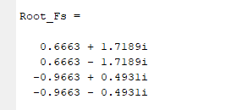 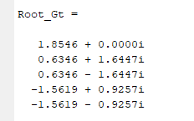

# Task # 3

1. Define and display polynomial in x domain which have following roots:

**X1 = 2, 4, -5, -7, -13**

*Find polynomial in vector form and then convert this vector into X domain expression.*

1. Define the polynomial generated at (a) and find roots using MATLAB. Compare with the roots given as input at (a) with the roots found at (b).

**Code**

**syms x;**

**X = [2, 4, -5, -7, -13];**

**Fx_vec = poly(X);**

**Fx_vec**

**Fx = poly2sym(Fx_vec, x);**

**Fx**

**root_Fx = roots(Fx_vec);**

**root_Fx**

**Output**

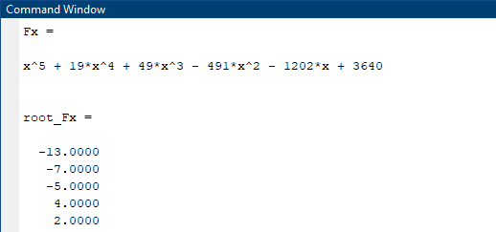

# Task # 4

1. **Define** two polynomials (of your own choice) order 2 and 3 respectively and find the product of the two polynomials, and then find roots of a final polynomial expression.

Write the following TFs in factored form using MATLAB.

**F= (5s2 + 2s + 5) / (5s4 + 2s3 + 5s2)**

1. Find its factors and simplified forms.

**Code**

**a)**

**syms s;**

**A = 5*s^3 + 7*s^2 + 8*s + 27;**

**B = s^2 + 23*s + 11;**

**product = expand(A*B);**

**product**

**product_vec = sym2poly(product);**

**root_p = roots(product_vec);**

**root_p**

**b)**

**syms s;**

**A = 5*s^2 + 2*s+5;**

**B = 5*s^4 + 2*s^3 + 5*s^2;**

**D_AB = A/B;**

**factors_AB = factor(D_AB);**

**factors_AB**

**pretty(factors_AB)**

**Output**

**a) b)**

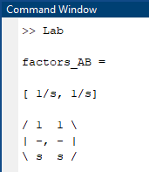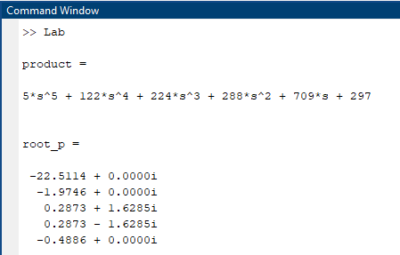

**Conclusion:**

After performing this lab, we have become familiar with:

* Using MATLAB for s-Domain circuit analysis
* Determining roots of polynomials
* Converting polynomials to their vectorial form and vice versa
* Determining product of two polynomials
* Making an output visually appealing