**Department of Electrical Engineering**

**Faculty Member:**  **Kiran Liaqat Dated: 29/05/2021 **

**Semester: 2nd Section: BEE-12C **

**EE-211: Electric Network Analysis**

**Lab 11: Using MATLAB for s-Domain Functions**

|  |  |  |  |  |
| --- | --- | --- | --- | --- |
| **PLO4/CLO4** | | **PLO5/CLO5** | **PLO8/CLO6** | **PLO9/CLO7** |
| **Name** | **Reg. No** | **Viva /Quiz / Lab Performance**  **5 marks** | **Analysis of data in Lab Report**  **5 marks** | **Modern Tool Usage**  **5 marks** | **Ethics and Safety**  **5 marks** | **Individual and Team Work**  **5 marks** |
| **Muhammad Umer** | **345834** |  |  |  |  |  |
| **Saad Bakhtiar** | **341150** |  |  |  |  |  |
|  |  |  |  |  |  |  |
|  |  |  |  |  |  |  |

**Introduction:**

MATLAB is undoubtedly a very powerful tool for performing numerous tasks such as solving linear systems, signal processing, simulations, etc. A significant advantage of MATLAB over other alternatives is that it is relatively easy to learn and errors are easy to fix. Scripts are also optimized when performing heavy operations and thus, it is a must have software for an engineer.

**Objective:**

After performing this lab, students will be able to perform the following operations in MATLAB:

1. *Polynomial Input in s-Domain*
2. *Finding Roots of Polynomial of any Order*
3. *Finding Partial Fractions of an s-Domain Expression having N(s)/D(S) Form*
4. *Finding Laplace Transform of Time Domain Function*
5. *Finding Inverse Laplace Transform of s-Domain Functions*
6. *Circuit Analysis in s-Domain Using MATLAB*

**Equipment:**

1. MATLAB

**Conduct of Lab**

The students are required to work in groups of three to four; each student must attempt to understand and use the laboratory set-up and conduct at least one or two parts of the requirement experimentation. The lab attendants and Lab Engineer will be available to assist the students.

In case some aspect of the lab experiment is not understood the students are advised to seek help from the teacher, the lab attendant or the assigned Lab Engineer (LE).

# Task # 1

Let numerator N(s) of a transfer function be:

𝑵(𝒔) = 𝒔𝟐 + 𝟑𝒔 + 𝟐

And the denominator be:

𝑫(𝒔) = 𝒔(𝒔𝟑 − 𝟔𝒔𝟐 + 𝟓𝒔 + 𝟏𝟓)

*Define a transfer function $H\left(s\right)=\frac{N\left(s\right)}{D\left(s\right)}$ then find partial fractions of the H(s) using MATLAB.*

**Code:**

**syms s;**

**N(s) = s^2 + 3*s + 2;**

**D(s) = s*(s^3 - 6*s^2 + 5*s + 15);**

**[r,p,k] = residue(sym2poly(N(s)), sym2poly(D(s)))**

**Output:**

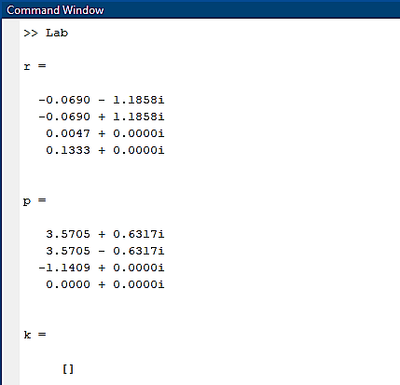

Which translates to:

**H(s) = $\frac{-0.0690 – 1.1858i}{s-\left(3.5705 + 0.6317i\right)}+\frac{-0.0690 + 1.1858i}{s-\left(3.5705 – 0.6317i\right)}+\frac{ 0.0047 + 0.0000i}{s-\left(-1.1409 + 0.0000i\right)}+\frac{0.1333 + 0.0000i}{s-\left(0.0000 + 0.0000i\right)}$**

# Task # 2

**a)** Take Laplace and then inverse Laplace transforms of the following functions:



**b)** Find the partial fraction expression as well as the inverse Laplace transform of the following functions:

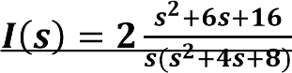 **and** 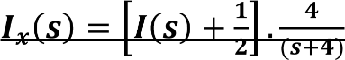

**Code for a)**

**syms a s w t;**

**Fa = t^3;**

**Fa_L = laplace(Fa);**

**display(Fa_L)**

**Fa_I = ilaplace(Fa_L);**

**display(Fa_I)**

**Fb = sin(w*t);**

**Fb_L = laplace(Fb);**

**display(Fb_L)**

**Fb_I = ilaplace(Fb_L);**

**display(Fb_I)**

**Fc = 1/(t+a);**

**Fc_L = laplace(Fc);**

**display(Fc_L)**

**Fc_I = ilaplace(Fc_L);**

**display(Fc_I)**

**Fd = 1/(t^2 + a^2);**

**Fd_L = laplace(Fd);**

**display(Fd_L)**

**Fd_I = ilaplace(Fd_L);**

**display(Fd_I)**

**Fe = cos(w*t);**

**Fe_L = laplace(Fe);**

**display(Fe_L)**

**Fe_I = ilaplace(Fe_L);**

**display(Fe_I)**

**Output**

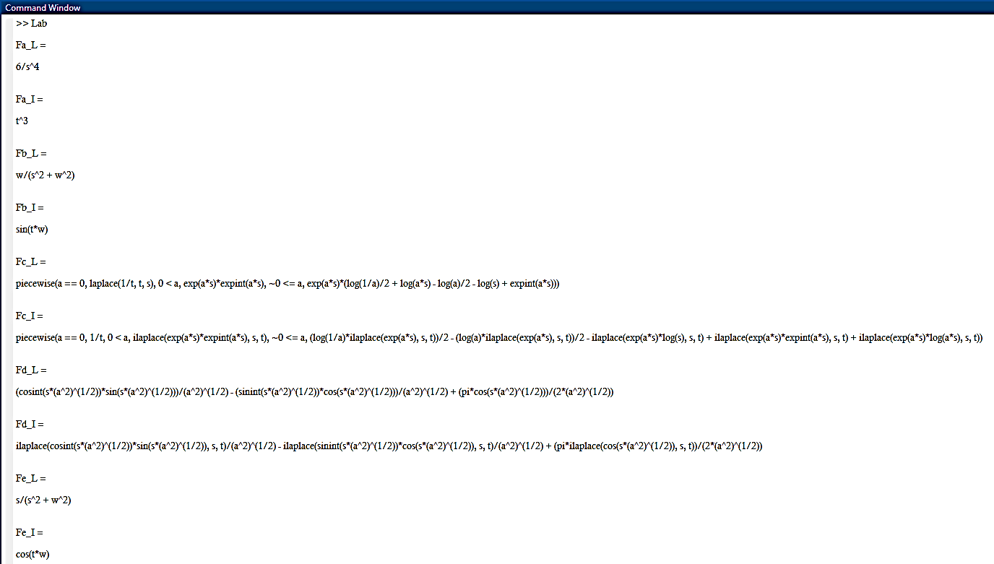

**Code for b)**

**syms a s w t I;**

**I = (2*(s^2 + 6*s + 16)) / s*(s^2 + 4*s + 8);**

**NI = 2*(s^2 + 6*s + 16);**

**DI = s*(s^2 + 4*s + 8);**

**[coeffI, rootsI, kI] = residue(sym2poly(NI), sym2poly(DI))**

**ilaplace(I)**

**Ix = (8*s^4 + 80*s^3+ 384*s^2 + 898*s + 1024)/(s^2+4*s);**

**NIx = (8*s^4 + 80*s^3+ 384*s^2 + 898*s + 1024);**

**DIx = (s^2+4*s);**

**[coeffIx, rootsIx, kIx] = residue(sym2poly(NIx), sym2poly(DIx))**

**ilaplace(Ix)**

**Output:**

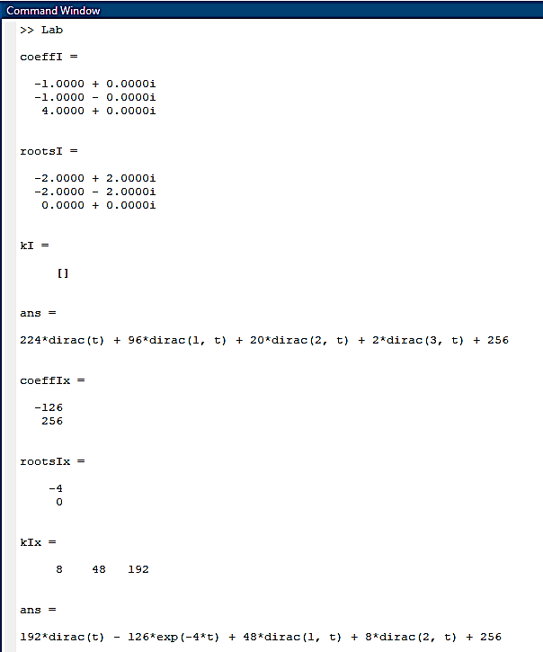

**Partial Fraction I** = $\frac{-1.0000 + 0.0000i}{s-\left(-2.0000 + 2.0000i\right)}+\frac{-1.0000 - 0.0000i}{s-\left(-2.0000 - 2.0000i\right)}+\frac{ 4.0000 + 0.0000i}{s-\left(0.0000 + 0.0000i\right)}$

**Partial Fraction IX =**

***c)*** *What is the Laplace transform of unit step? Find MATLAB command?*

**Code:**

**syms s;**

**H = heaviside(t);**

**laplace(H)**

**Output:**

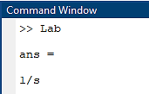

***Heaviside*** is the function used to represent the unit step function. *It returns 0 when the* ***s < 0,*** *1/2 when* ***s = 0*** *and 1 when* ***s > 0.***

# Task # 3

Draw the s-domain equivalent of the following circuit, and then find two mesh currents in s-domain. You may use MATLAB to simplify the s-domain expressions. Then find the two-time domain currents.

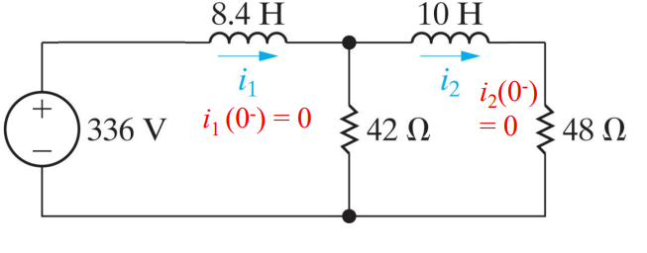

**Solution:**

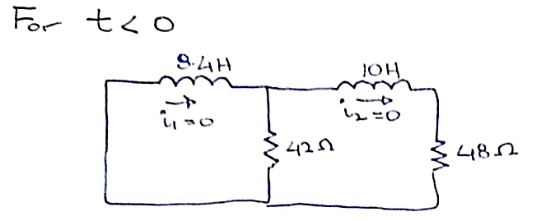

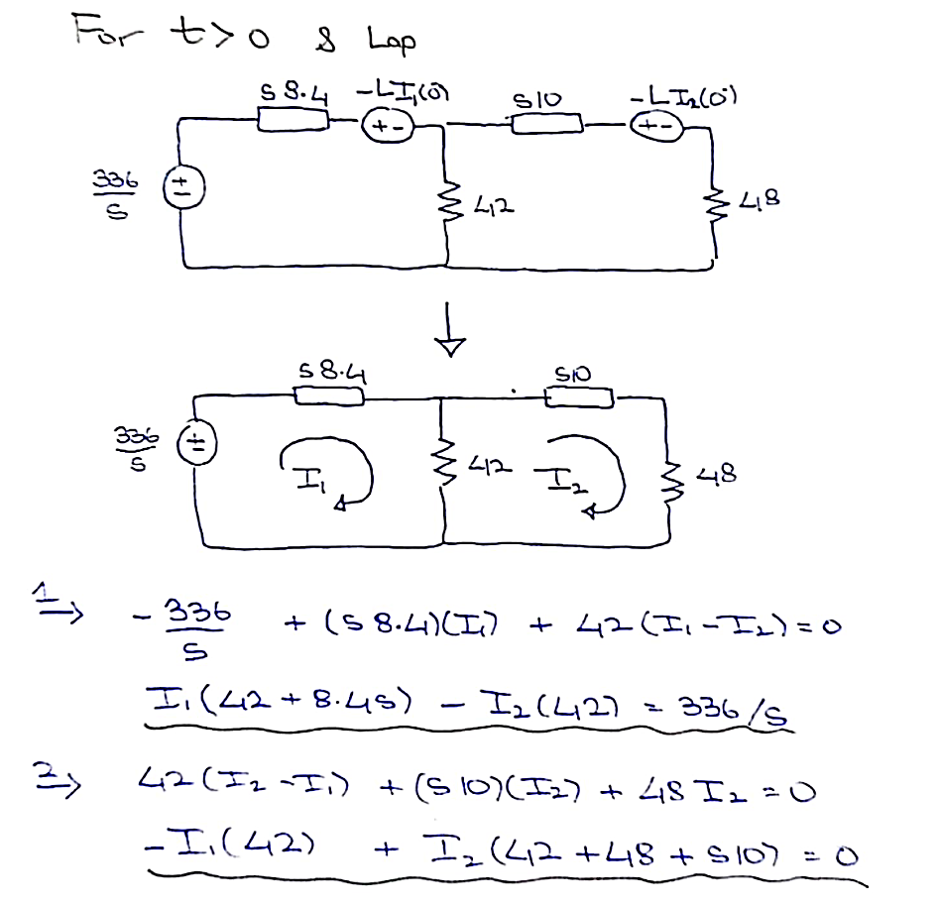

*Solving these set of equations through MATLAB:*

**Code:**

**syms s t I1 I2;**

**eqn1 = I1*(42 + 8.4*s) - I2*(42) == 336/s;**

**eqn2 = -I1*(42) + I2*(42 + 48 + s*10) == 0;**

**[I1, I2] = solve(eqn1, eqn2, I1, I2)**

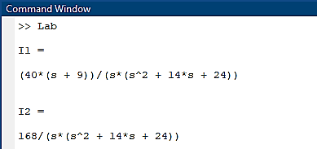

Converting these back into the domain shall then give us the solution for **I1 and I2** in time-domain:

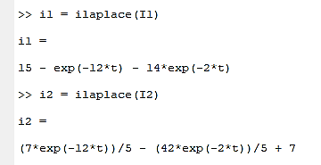

**Conclusion:**

After performing this lab, we have become familiar with:

* Using MATLAB for s-Domain circuit analysis
* Determining roots of polynomials
* Converting polynomials to their vectorial form and vice versa
* Determining product of two polynomials
* Making an output visually appealing