**Department of Electrical Engineering**

**Faculty Member:**  **Kiran Liaqat Dated: 30/05/2021 **

**Semester: 2nd Section: BEE-12C **

**EE-211: Electric Network Analysis**

**Lab 12:** Implementation of a Tune Resonant Circuit and Basic Low and High Pass Filters in PSpice

|  |  |  |  |  |
| --- | --- | --- | --- | --- |
| **PLO4/CLO4** | | **PLO5/CLO5** | **PLO8/CLO6** | **PLO9/CLO7** |
| **Name** | **Reg. No** | **Viva /Quiz / Lab Performance**  **5 marks** | **Analysis of data in Lab Report**  **5 marks** | **Modern Tool Usage**  **5 marks** | **Ethics and Safety**  **5 marks** | **Individual and Team Work**  **5 marks** |
| **Muhammad Umer** | **345834** |  |  |  |  |  |
| **Saad Bakhtiar** | **341150** |  |  |  |  |  |
|  |  |  |  |  |  |  |
|  |  |  |  |  |  |  |

**Introduction**

PSpice offers a ton of ways to get simulated values of a circuit and with ease. One advantage of While it offers the analysis of simple linear circuits, we can also utilize it to build us a semi-logarithmic simulation of RLC circuits, be they in Series/Parallel Resonance or filter circuits. Students especially can learn a lot about circuits by modifying values in a circuit and correlate it to their respective graphs.

**Objective**

* Get familiar with filter circuits
* Further strengthen their concepts of circuit analysis
* Implement resonant circuits in PSpice and their respective analysis
* Build semi-logarithmic simulation profiles in PSpice

**Software**

1. PSpice
2. ORCAD Capture Lite

**Conduct of Lab**

The students are required to work in groups of three to four; each student must attempt to understand and use the laboratory set-up and conduct at least one or two parts of the requirement experimentation. The lab attendants and Lab Engineer will be available to assist the students.

In case some aspect of the lab experiment is not understood the students are advised to seek help from the teacher, the lab attendant or the assigned Lab Engineer (LE).

**Introduction of Filters**

In electronic circuits systems it is often helpful to separate a specific range of frequencies from the total spectrum. A filter is a type of circuit that passes a specific range of frequencies while rejecting other frequencies. A passive filter consists of passive circuit elements, such as capacitors, inductors and resistors.

In this lab, we shall look over some simple tasks pertaining to the aforementioned circuits:

# Task # 1

Simulate following circuit and find Resonant Cyclic Frequency and Quality Factor theoretically and from the frequency response curve obtained in PSpice.

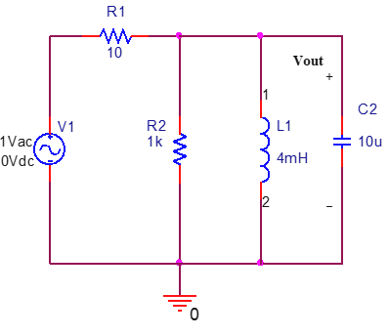

Fill in the following table and show it to the instructor or the Lab Engineer. Also attach the snapshot of Frequency Response Curve with your Lab Report.

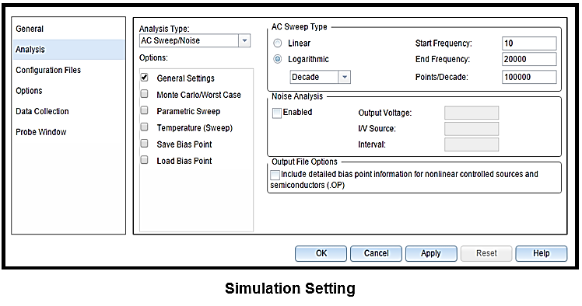

**Simulation**

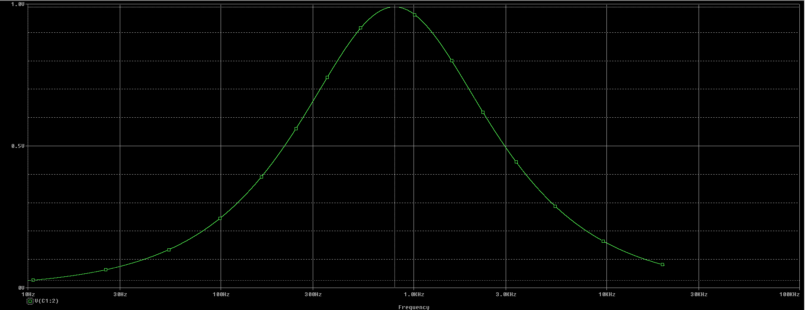

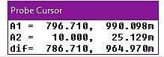

**Resonant Frequency**

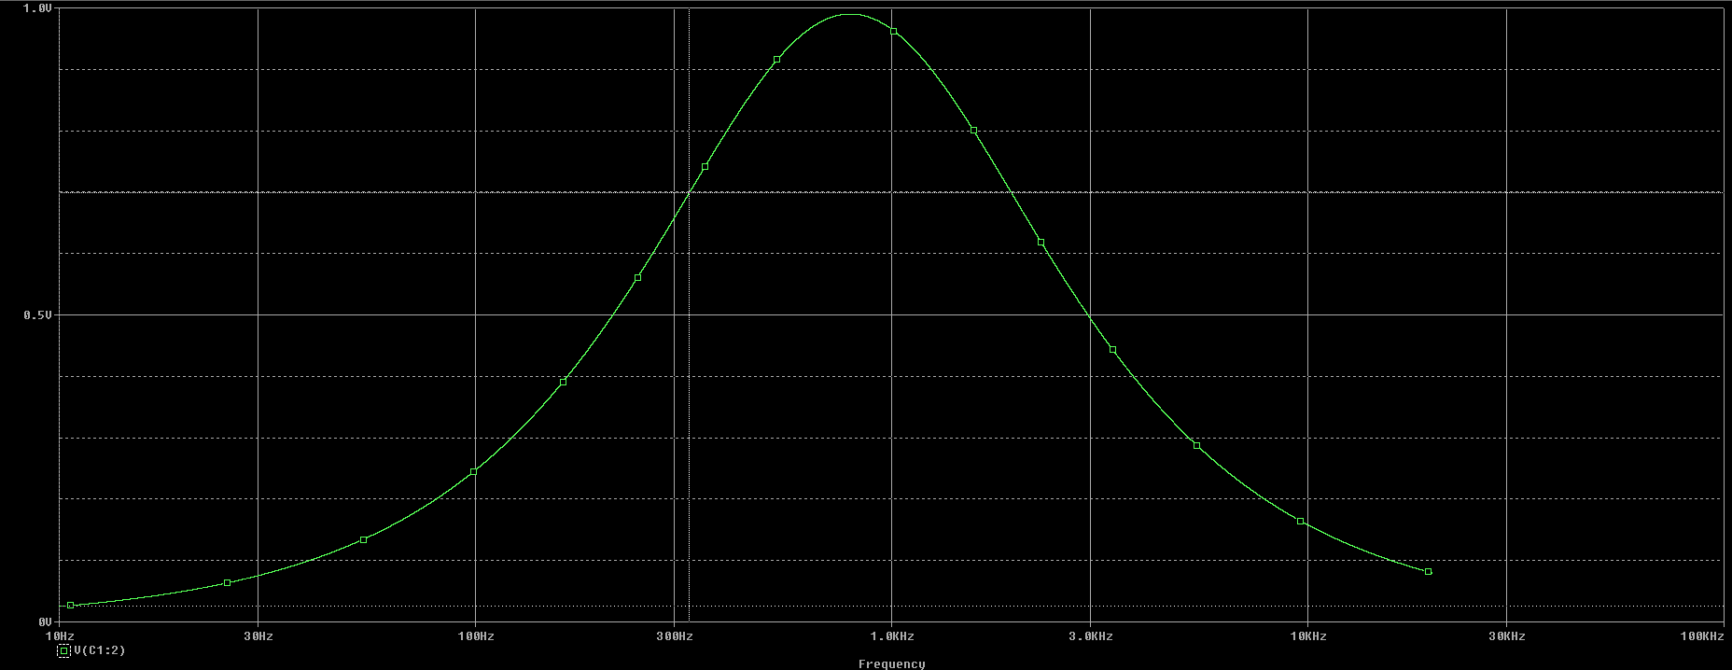

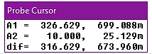

**Lower Frequency**

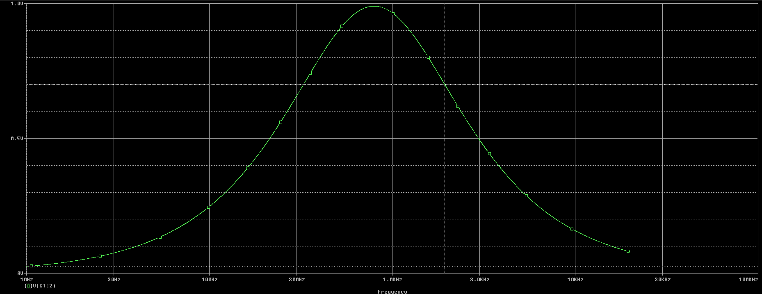

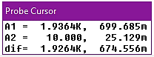

**Higher Frequency**

|  |  |  |
| --- | --- | --- |
| **Parameter** | **Theoretical** | **From PSpice Frequency Response** |
| Resonant Frequency | 795.774 Hz | 796.710 Hz |
| Quality Factor | 0.4950 | 0.4949 |

# Task # 2 (Low-Pass Filter)

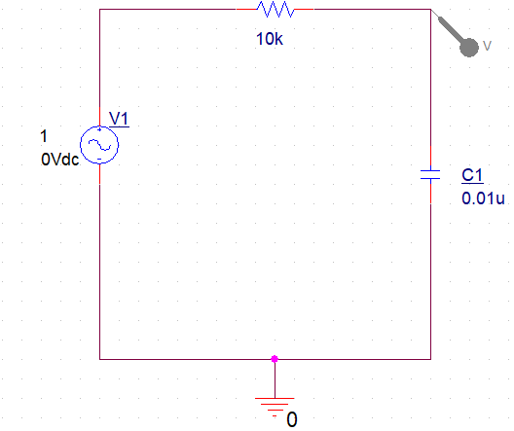

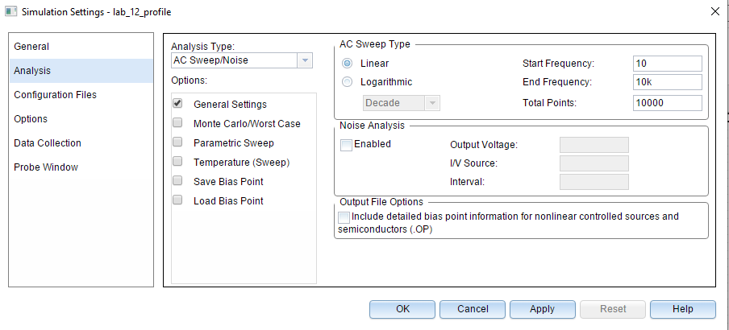

* Graph the results of VOUT vs. frequency
* Use the graph to find the cut-off frequency
* Calculate the cut-off frequency and compare

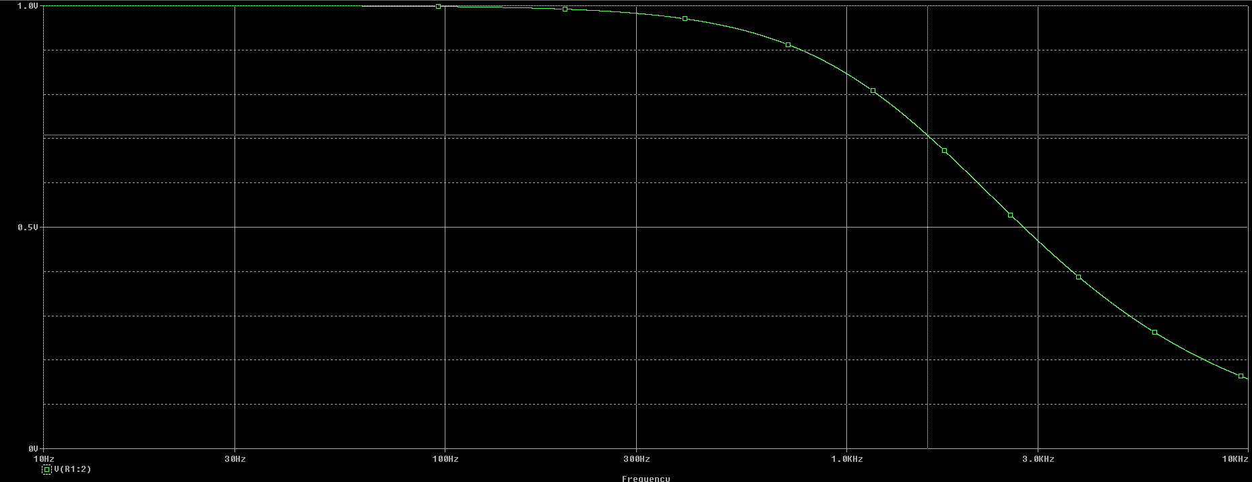

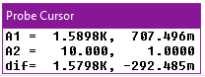

Cut-off Frequency

Theoretical Cut-off frequency = $\frac{1}{2πRC}=\frac{1}{2π \left(10*{10}^{3}\right)*(0.01*{10}^{-6})}=1591.549 Hz$

**Q. What would happen to the value of fc if the value of the capacitor C for the low-pass filter is increased?**

Ans**.** Using a capacitor of high capacitance results in a significant drop in the cut-off frequency; when a 1 uC is used instead of 0.01 uC, the value of fc ­drops from 1.6 kHz to only 21 Hz.

**Q. What would happen to the value of fc if the input voltage is increased?**

Ans**.** The value of voltage has no effect on the cut-off frequency as it is reached at 0.707*VPEAK at the same value as the one used with a lower voltage.

# Task # 3 (High-Pass Filter)

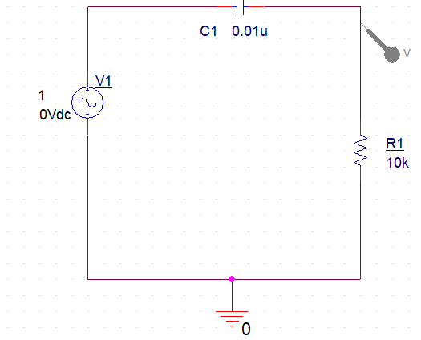



* Graph the results of VOUT vs. frequency
* Use the graph to find the cut-off frequency
* Calculate the cut-off frequency and compare

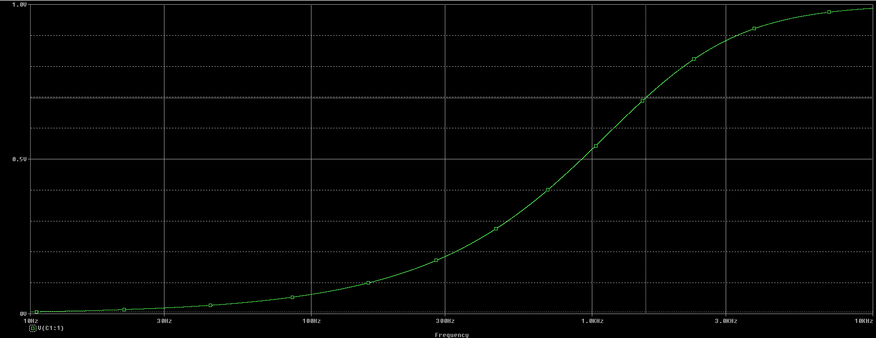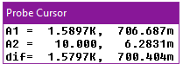

Theoretical Cut-off frequency = $\frac{1}{2πRC}=\frac{1}{2π \left(10*{10}^{3}\right)*(0.01*{10}^{-6})}=1591.549 Hz$

Q. **What would happen to the value of fc if the value of the capacitor C for the high-pass filter is increased?**

Ans. Using a capacitor of high capacitance results in a significant drop in the cut-off frequency; when a 1 uC is used instead of 0.01 uC, the value of fc ­drops from 1.6 kHz to only 16 Hz.

Q. **What would happen to the value of fc if the input voltage is increased?**

Ans. The value of voltage has no effect on the cut-off frequency as it is reached at 0.707*VPEAK at the same value as the one used with a lower voltage.

**Conclusion:**

After performing this lab, we have become familiar with:

* Implementing a semi-logarithmic simulation profile in PSpice
* Resonant circuits and their respective simulations
* Passive filter circuits and their respective simulations
* Effects of altering values of different components across a filter circuit