**Department of Electrical Engineering**

**Faculty Member:**  **Kiran Liaqat Dated: 3/03/2021 **

**Semester: 2nd Section: BEE-12C **

**EE-211: Electric Network Analysis**

**Lab 1: Introduction to MATLAB**

|  |  |  |  |  |
| --- | --- | --- | --- | --- |
| **PLO4/CLO4** | | **PLO5/CLO5** | **PLO8/CLO6** | **PLO9/CLO7** |
| **Name** | **Reg. No** | **Viva /Quiz / Lab Performance**  **5 marks** | **Analysis of data in Lab Report**  **5 marks** | **Modern Tool Usage**  **5 marks** | **Ethics and Safety**  **5 marks** | **Individual and Team Work**  **5 marks** |
| **Muhammad Umer** | **345834** |  |  |  |  |  |
| **Saad Bakhtiar** | **341150** |  |  |  |  |  |
|  |  |  |  |  |  |  |
|  |  |  |  |  |  |  |
|  |  |  |  |  |  |  |

**Introduction:**

MATLAB is undoubtedly a very powerful tool for performing numerous tasks such as solving linear systems, signal processing, simulations, etc. A significant advantage of MATLAB over other alternatives is that it is relatively easy to learn and errors are easy to fix. Scripts are also optimized when performing heavy operations and thus, it is a must have software for an engineer.

**Objectives:**

After performing this lab, students will be able to:

* Perform basic tasks on MATLAB
* Get used to the interface of MATLAB
* Do basic matrix manipulation
* Plot different graphs and use specifiers

**Software Used:**

* MATLAB

**Conduct of Lab**

The students are required to work in groups of three to four; each student must attempt to understand and use the laboratoy set-up and conduct at least one or two parts of the requirement experimentation. The lab engineer will be available to assit the students.

In case some aspect of the lab experiment is not understood the students are advised to seek help from the teacher, the lab attendent or the assigned Lab Engineer.

**Tasks:**

To implement plots of various different functions and use the interface and specifiers to edit different aspects of the said plot.

* **Sin(x) and Cos(x)**

**Script**:

x = 0:0.01:2*pi;

y = sin (x);

z = cos (x);

plot(x,y,'-r');

hold on;

plot(x,z,'-b');

hold off;

title('Graph of Sin and Cos from 0 to 2 pi');

xlabel('X Axis','fontsize',12);

ylabel('Y Axis','fontsize',12);

legend('sin(x)','cos(x)');

grid on;

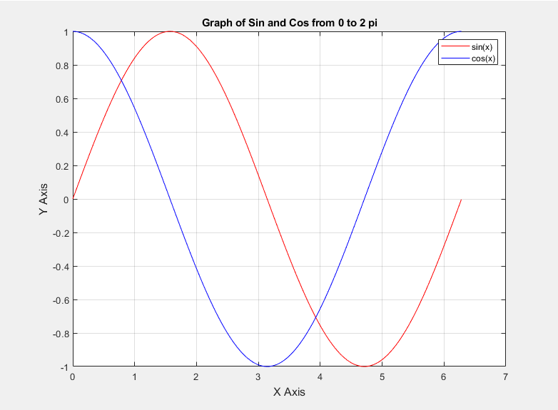

* **Log(x)**

**Script**:

x = 0:0.1:100;

y = log(x);

plot(x,y,'--c');

title('Graph of Log(x)');

xlabel('X Axis','fontsize',12);

ylabel('Y Axis','fontsize',12);

grid on;

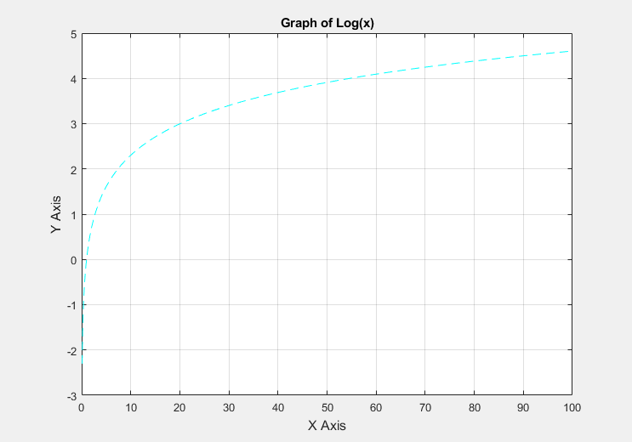

* **Sinc(t/2)**

**Script**:

clearvars;

clc

t = -20:0.001:20;

y = (sin(pi.*t/2))./(pi.*(t/2));

plot(t,y,'-r');

title('Graph of sinc');

xlabel('Time','fontsize',12);

ylabel('Sinc of t/2','fontsize',12);

grid on;

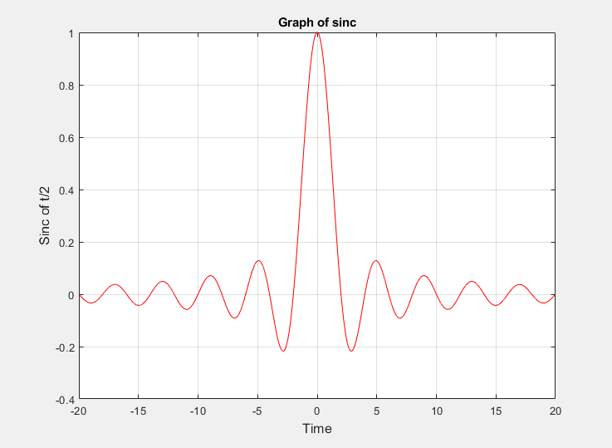

* **Linspace**

**Script**:

clearvars;

clc

x = linspace(-10,10,200);

y = sin(4*x)./exp(.1*x);

plot(x,y)

axis([-10 10 0 inf])

title('Graph');

xlabel('X Axis','fontsize',12);

ylabel('Y Axis','fontsize',12);

grid on;

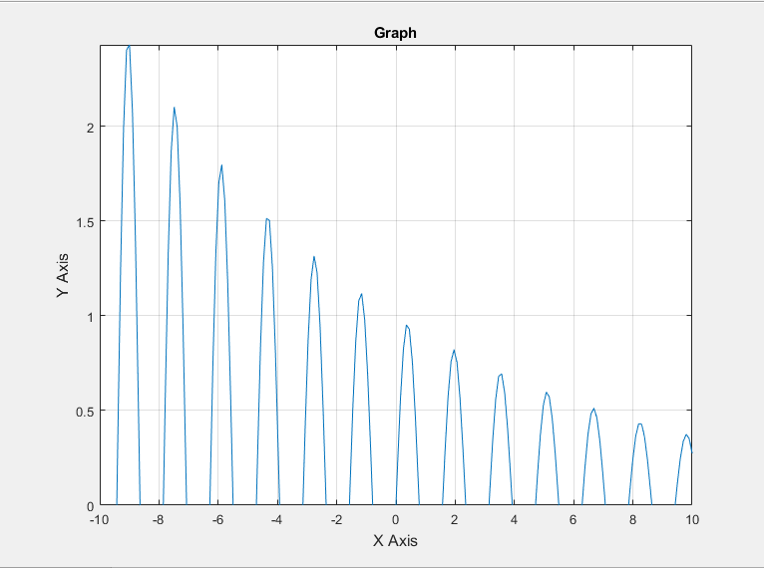

* **X4 and X5**

**Script**:

x=-5:0.01:5;

y=x.^4;

z=x.^5;

plot(x,y,'--b');

hold on

plot(x,z,'.-r');

hold off

title('x^4 & x^5','fontsize',12);

xlabel('X Axis','fontsize',12);

ylabel('Y Axis','fontsize',12);

axis([-7 7 -15 15]);

legend('X^4','X^5');

grid on;

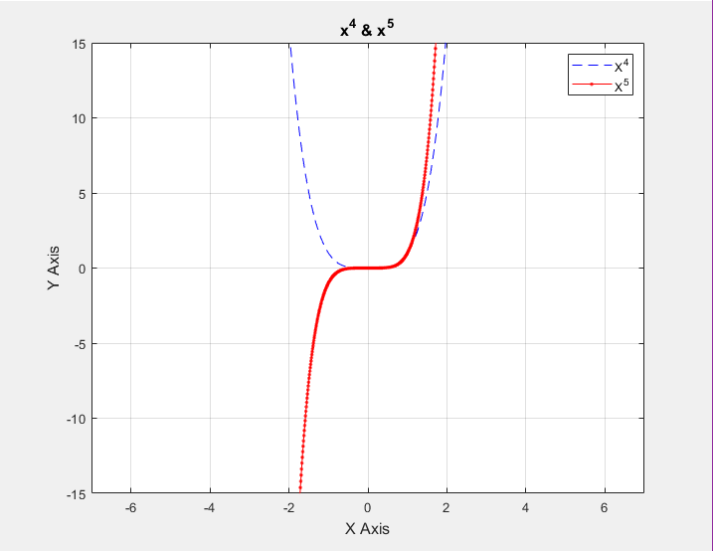

* **Conclusion:**

After performing this lab, I can firmly say that MATLAB is an extremely efficient tool for not just plotting graphs, but acting as both a programming language and a calculator. It is both optimized and easy to learn and a must have tool for engineers specifically.