**Department of Electrical Engineering**

**Faculty Member:**  **Kiran Liaqat Dated: 14/03/2021 **

**Semester: 2nd Section: BEE-12C **

**EE-211: Electric Network Analysis**

**Lab 3: Sinusoidal Response Analysis and Simulation**

|  |  |  |  |  |
| --- | --- | --- | --- | --- |
| **PLO4/CLO4** | | **PLO5/CLO5** | **PLO8/CLO6** | **PLO9/CLO7** |
| **Name** | **Reg. No** | **Viva /Quiz / Lab Performance**  **5 marks** | **Analysis of data in Lab Report**  **5 marks** | **Modern Tool Usage**  **5 marks** | **Ethics and Safety**  **5 marks** | **Individual and Team Work**  **5 marks** |
| **Muhammad Umer** | **345834** |  |  |  |  |  |
| **Saad Bakhtiar** | **341150** |  |  |  |  |  |
|  |  |  |  |  |  |  |
|  |  |  |  |  |  |  |

**Introduction:**

In this lab, we will be simulating and generating Sinusoidal functions and using respective equipment to observe their affects. We will also learn how to observe/analyze graphs on Oscilloscope and use tracking cursor to find the (x, y) values of a generated function.

**Objective:**

After performing this experiment, students will be able to:

* Analyze Sinusoidal Graphs
* Set up inductive/capacitive circuit and observe their graphs using the Oscilloscope
* Further strengthen their concepts on Transients

**Equipment:**

* Digital Oscilloscope
* Digital Function generator
* Circuit Board Set Up
* Resistor, Capacitor and Inductor

**Software:**

* PSpice

**Conduct of Lab**

The students are required to work in groups of three to four; each student must attempt to understand and use the laboratory set-up and conduct at least one or two parts of the requirement experimentation. The lab attendants and Lab Engineer will be available to assist the students.

In case some aspect of the lab experiment is not understood the students are advised to seek help from the teacher, the lab attendant or the assigned Lab Engineer (LE).

***Analysis of RL circuit to Sinusoidal Response***

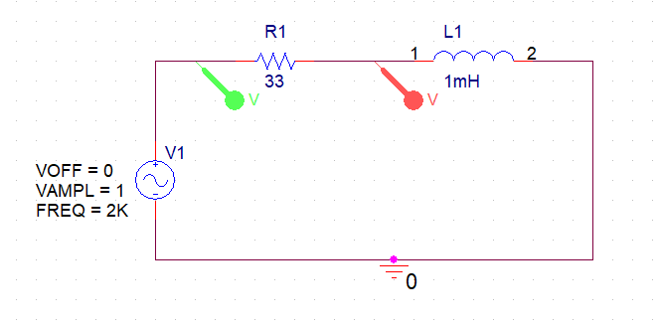

## Insights:

* The inductor voltage leads the source voltage
* Inductance causes a phase shift between voltage and current that depends on the relative values of the resistance and the inductive reactance
* The phase angle is the phase difference between the total current and the source voltage
* Impedance magnitude: Z = √ R2+ X2
* Phase angle: θ = tan-1(XL/R)

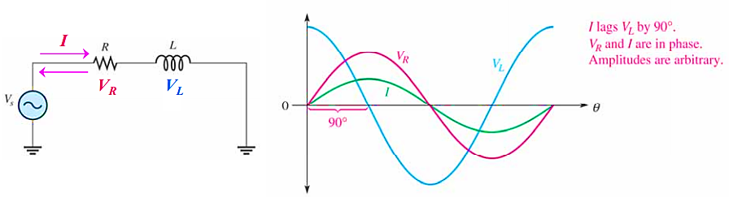

## Theoretical Work:

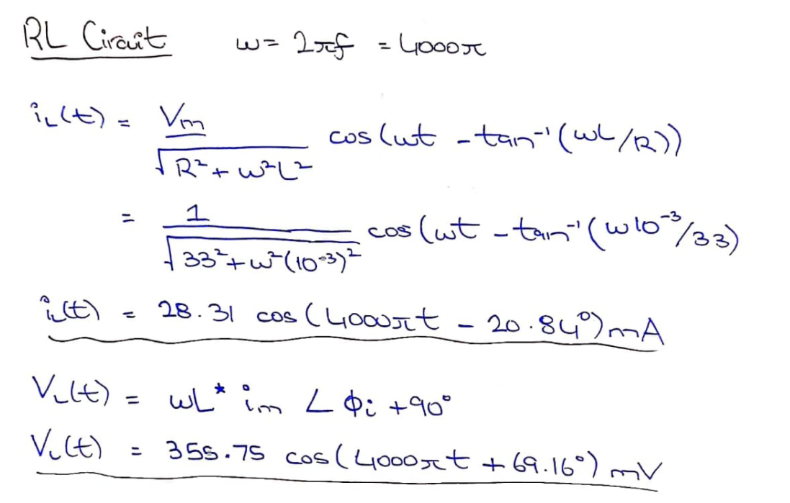

* ***VL*(t) = 355.75 cos (4000πt + 69.160) mV**
* ***IL* (t) = 28.31 cos (4000πt + -20.840) mA**
* Phase angle of ***VL*** is **69.160** and **VM L** is **355.75 mV**
* Phase angle of ***IL*** is **-20.84** and **IM** is **28.31 mA**

**Simulation:**

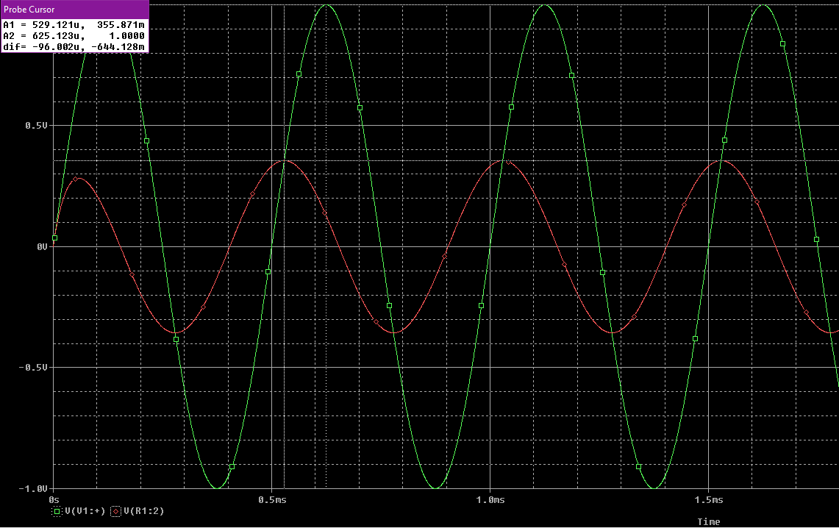

* Phase angle of ***VL*** is **0**
* Value of **VM 1** is **1 V**
* Value of **VM L** is **355.868 mV**
* Phase angle of ***IL*** is
* Value of ***IM*** is **28.3** **Ma**

**Oscilloscope Display:**

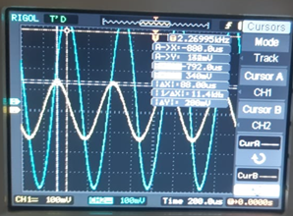

***Analysis of RC circuit to Sinusoidal Response***

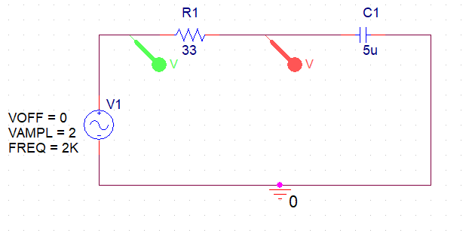

## Insight:

* The capacitor voltage lags the source voltage
* Capacitance causes a phase shift between voltage and current that depends on the relative values of the resistance and the capacitive reactance
* Phase angle: θ = tan-1(XC/R)

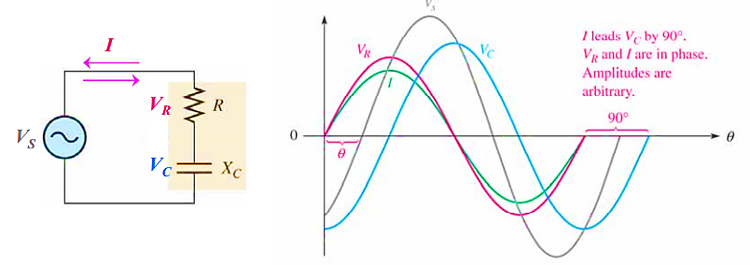

## Theoretical Work:

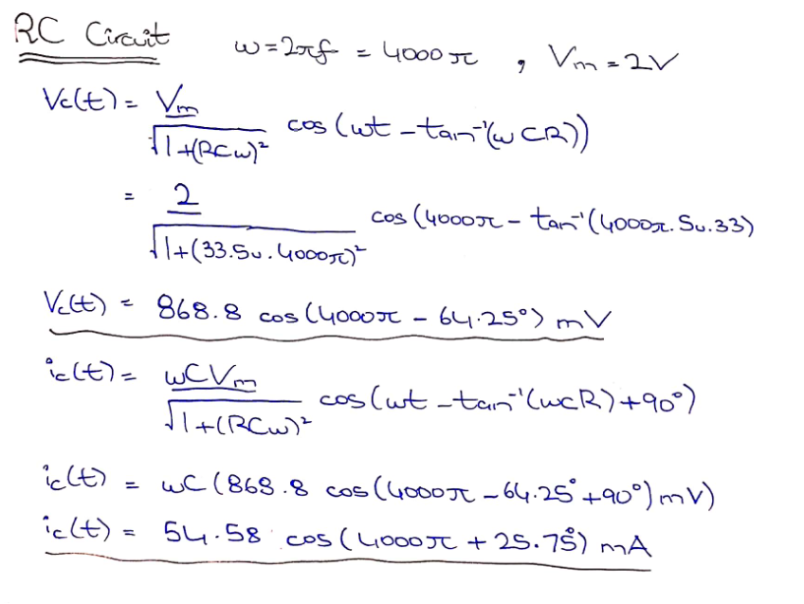

* ***VC*(t) = 868.8 cos (4000πt – 64.250) mV**
* ***IC* (t) = 54.58 cos (4000πt + 25.750) mA**
* Phase angle of ***VC*** is **-64.250** and **VM C** is **868.8 mV**
* Phase angle of ***IC*** is **25.750** and **IM** is **54.58 mA**

**Simulation:**

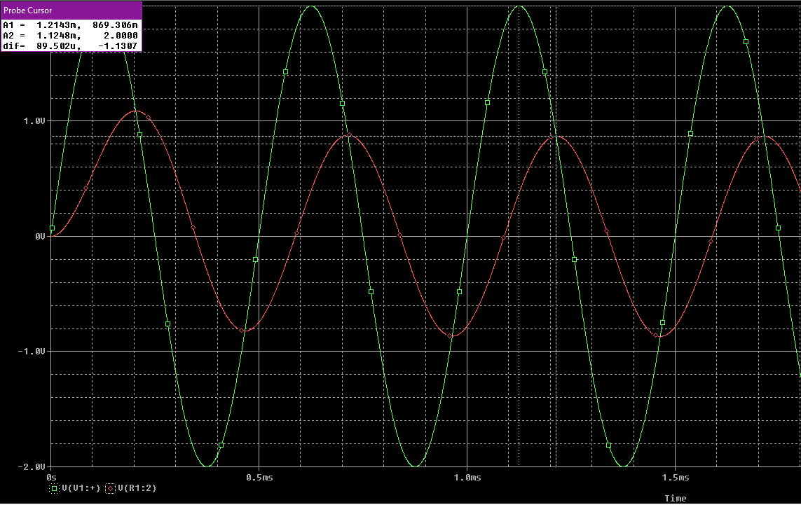

* Phase angle of ***VC*** is **0**
* Value of **VM 1** is **2 V**
* Value of **VM C** is **867.3 mV**
* Phase angle of ***IL*** is
* Value of ***IM*** is **54.6** **mA**

**Oscilloscope Display:**

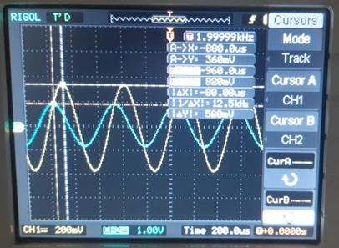

**Conclusion:**

After performing this lab, we have learnt;

* Analyzing sinusoidal waveforms of RL/RC circuits
* Set up capacitive/inductive circuits on breadboard through means of Function Generator and analyzed through Oscilloscope