**Department of Electrical Engineering**

**Faculty Member:**  **Kiran Liaqat Dated: 24/03/2021 **

**Semester: 2nd Section: BEE-12C **

**EE-211: Electric Network Analysis**

**Lab 4: Phasors and Phase Shift Circuits**

|  |  |  |  |  |
| --- | --- | --- | --- | --- |
| **PLO4/CLO4** | | **PLO5/CLO5** | **PLO8/CLO6** | **PLO9/CLO7** |
| **Name** | **Reg. No** | **Viva /Quiz / Lab Performance**  **5 marks** | **Analysis of data in Lab Report**  **5 marks** | **Modern Tool Usage**  **5 marks** | **Ethics and Safety**  **5 marks** | **Individual and Team Work**  **5 marks** |
| **Muhammad Umer** | **345834** |  |  |  |  |  |
| **Saad Bakhtiar** | **341150** |  |  |  |  |  |
|  |  |  |  |  |  |  |
|  |  |  |  |  |  |  |

**Introduction:**

Solving AC circuits through the basic circuit analysis can be tedious and often time-consuming. Being engineers, we thrive to achieve the maximum possible efficiency, and that is where Phasor comes into the play. By expressing a circuit into its respective Phasor form, and then solving it by means of familiar techniques saves us a lot of time and is relatively easy to do.

**Objective:**

After performing this lab, students will be able to:

* Solve Sinusoidal AC circuits through Phasor Alteration
* Understand phase shifts
* Implement the circuit on breadboard
* Observe +ive and -ive Phase for Reactive Circuits

**Equipment:**

* Digital Oscilloscope
* Digital Function generator
* Breadboard
* Resistor, Capacitor and Inductor

**Software:**

* PSpice

**Conduct of Lab**

The students are required to work in groups of three to four; each student must attempt to understand and use the laboratory set-up and conduct at least one or two parts of the requirement experimentation. The lab attendants and Lab Engineer will be available to assist the students.

In case some aspect of the lab experiment is not understood the students are advised to seek help from the teacher, the lab attendant or the assigned Lab Engineer (LE).

# Task # 1

**Phase Shifter using RC combination**

Assemble the series RC circuit with the following circuit element values:



**C = 0.027 μ F**

**R = 10 k Ω**

**Vs(t) = VMcos(ωt)**

**VM = 5 V** (VP-P = 10V)

**Theoretical**

**Formulation:**

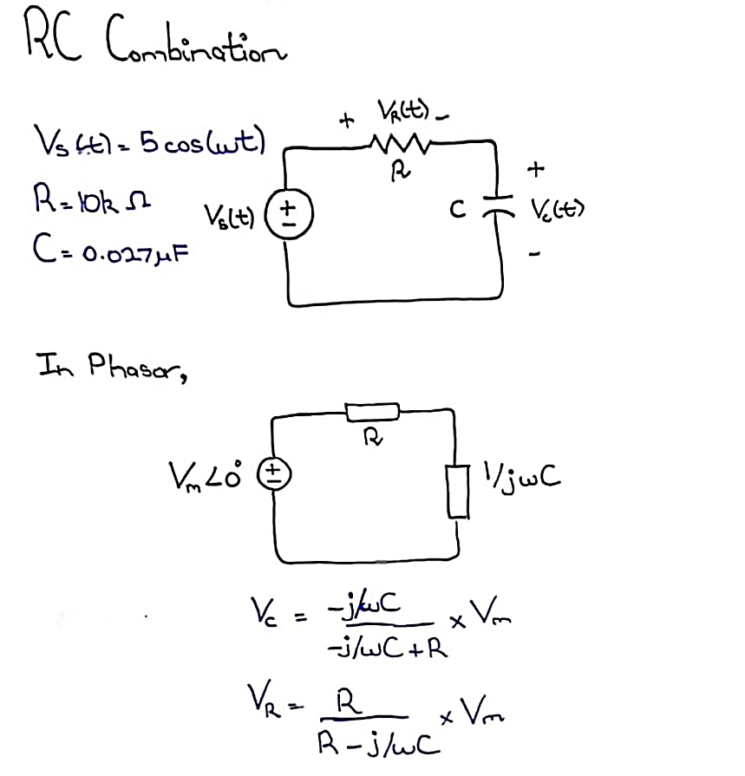

**Solution:**

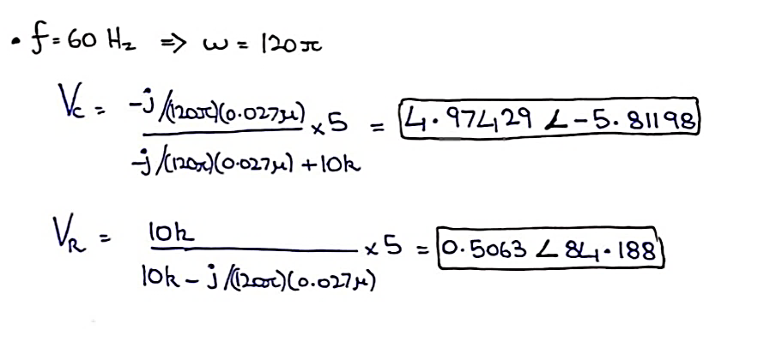

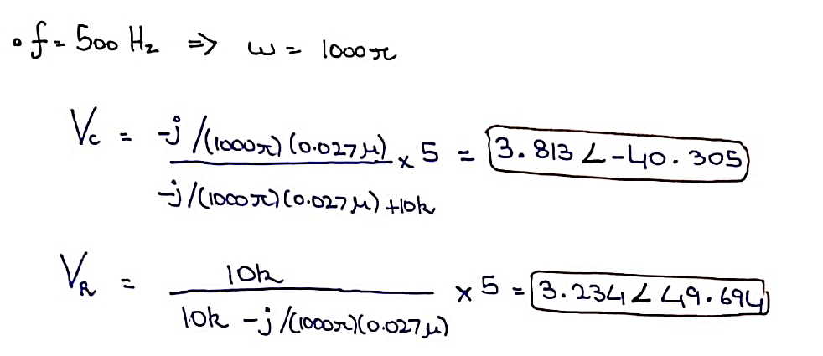

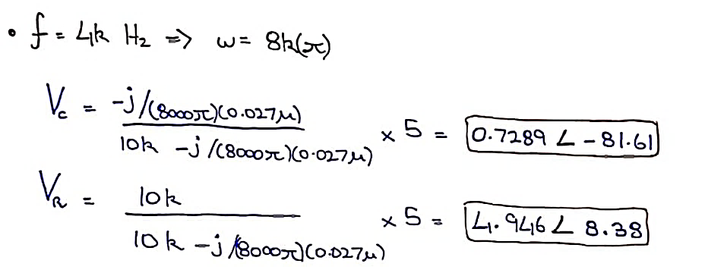

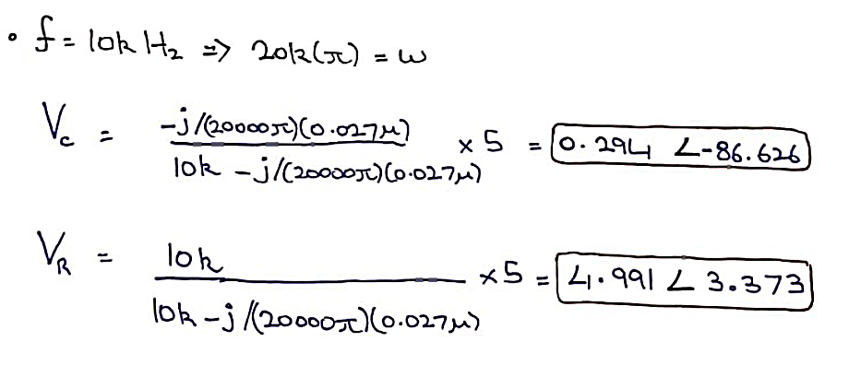

**Simulations**

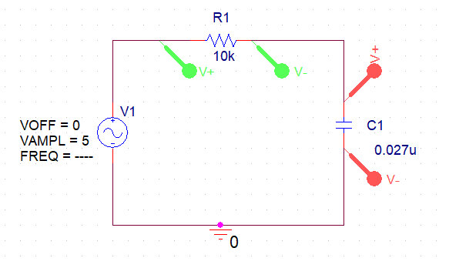

We vary and observe the effects of changing the frequency in this RC circuit

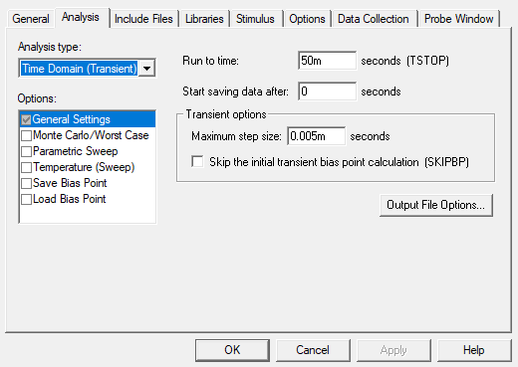

**Profiles:**

|  |  |  |  |
| --- | --- | --- | --- |
| **Frequency (Hz)** | **Run to Time (s)** | **Maximum Step Size (s)** | **Start Saving Data After(s)** |
| 60 | 50m | 0.005m | 0 |
| 500 | 10m | 0.005m | 0 |
| 4K | 2m | 0.005m | 0 |
| 10k | 0.2m | 0.005m | 0 |

Changing the frequency of the source and the respective simulation setting, we simulate and attach the said simulations;

**f = 60 Hz**

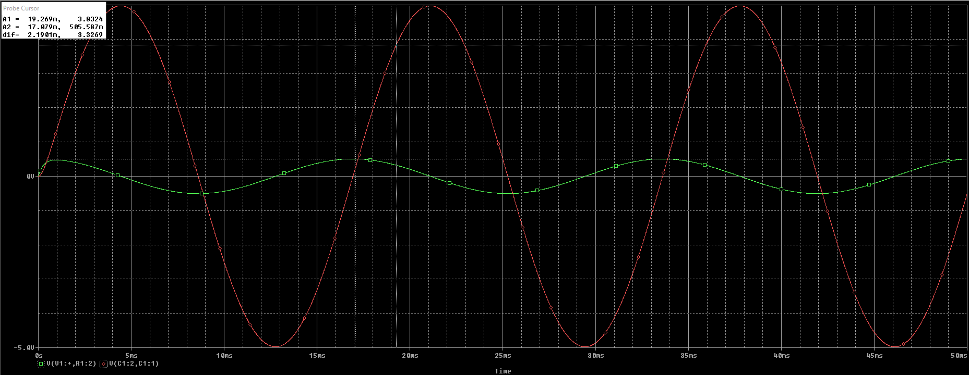

**f = 500 Hz**

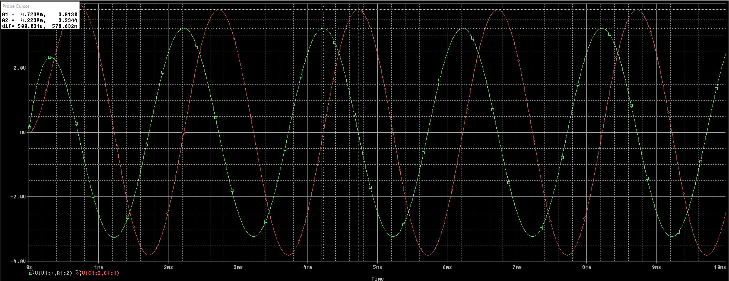

**f = 4k Hz**

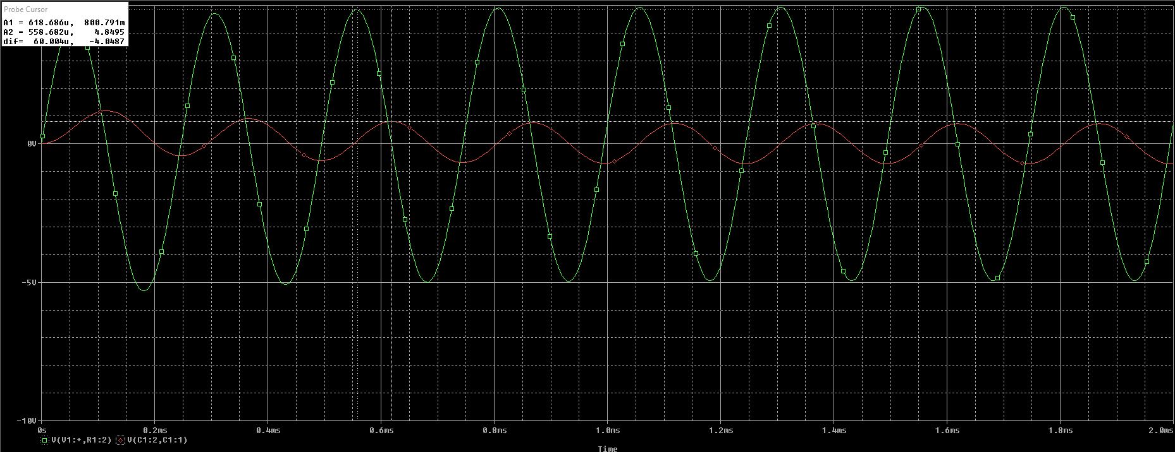

**f = 10k Hz**

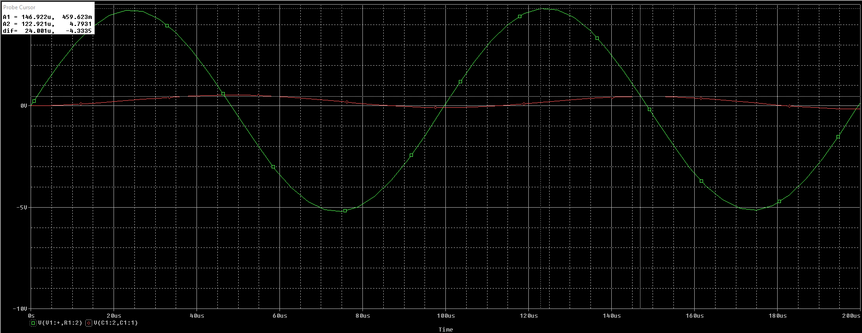

**Table**

|  |  |  |  |  |  |  |  |  |
| --- | --- | --- | --- | --- | --- | --- | --- | --- |
| **Frequency**  **(Hz)** | **Magnitude** | | | | **Phase** | | | |
| VR(t) | | VC(t) | | VR(t) | | VC(t) | |
| Simulated | Calculated | Simulated | Calculated | Simulated | Calculated | Simulated | Calculated |
| **60** | 0.506V | 0.506V | 4.973V | 4.974V | 84.24° | 84.19° | -5.82° | -5.81° |
| **500** | 3.233V | 3.234V | 3.814V | 3.813V | 49.81° | 49.69° | -40.45° | -40.30° |
| **4k** | 4.946V | 4.946V | 0.730V | 0.729V | 8.39° | 8.38° | -81.61° | -81.60° |
| **10k** | 4.991V | 4.991V | 0.294V | 0.294V | 3.38° | 3.37° | -86.26° | -86.27° |

# Task # 2

**Phase Shifter using RL combination**

Assemble the series RC circuit with the following circuit element values:

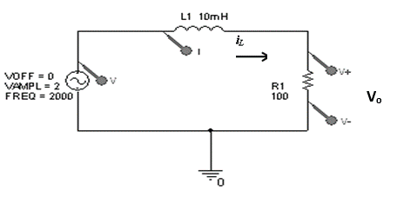

**L = 10 m H**

**R = 100 Ω**

**Vs(t) = VMcos(ωt)**

**VM = 2 V** (VP-P = 4V)

**Theoretical**

**Formulation:**

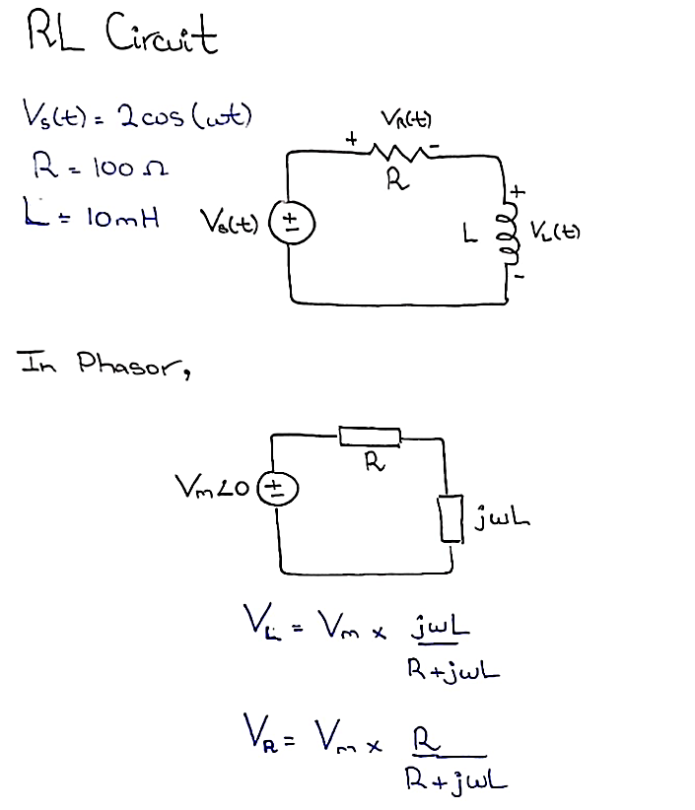

**Solution:**

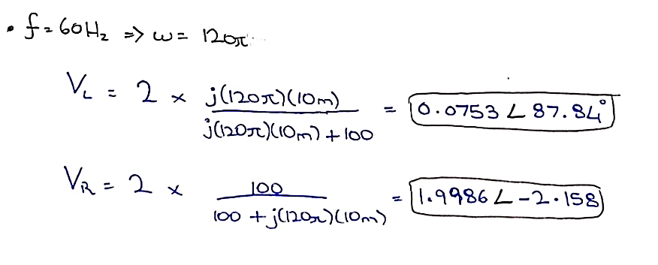

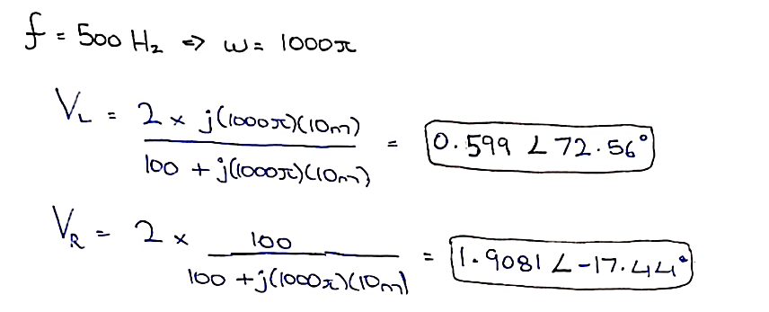

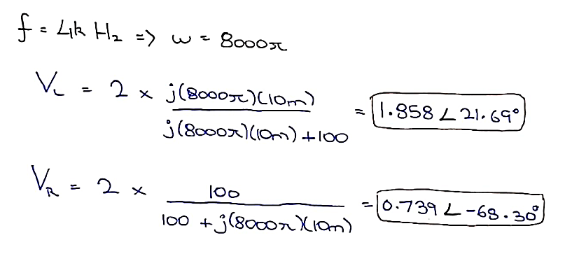

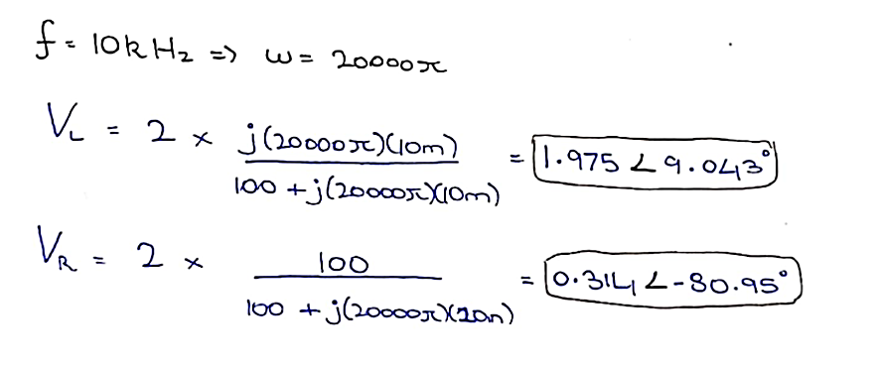

**Simulations**

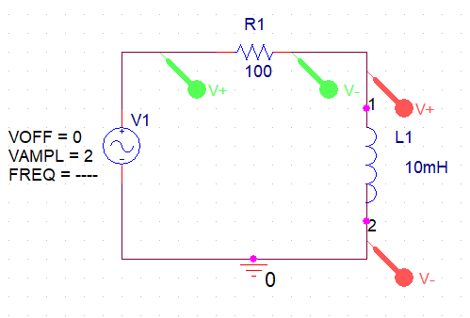

We vary and observe the effects of changing the frequency in this RC circuit



**Profiles:**

|  |  |  |  |
| --- | --- | --- | --- |
| **Frequency (Hz)** | **Run to Time (s)** | **Maximum Step Size (s)** | **Start Saving Data After(s)** |
| 60 | 50m | 0.005m | 0 |
| 500 | 10m | 0.005m | 0 |
| 4K | 2m | 0.005m | 0 |
| 10k | 0.2m | 0.005m | 0 |

Changing the frequency of the source and the respective simulation setting, we simulate and attach the said simulations;

**f = 60 Hz**

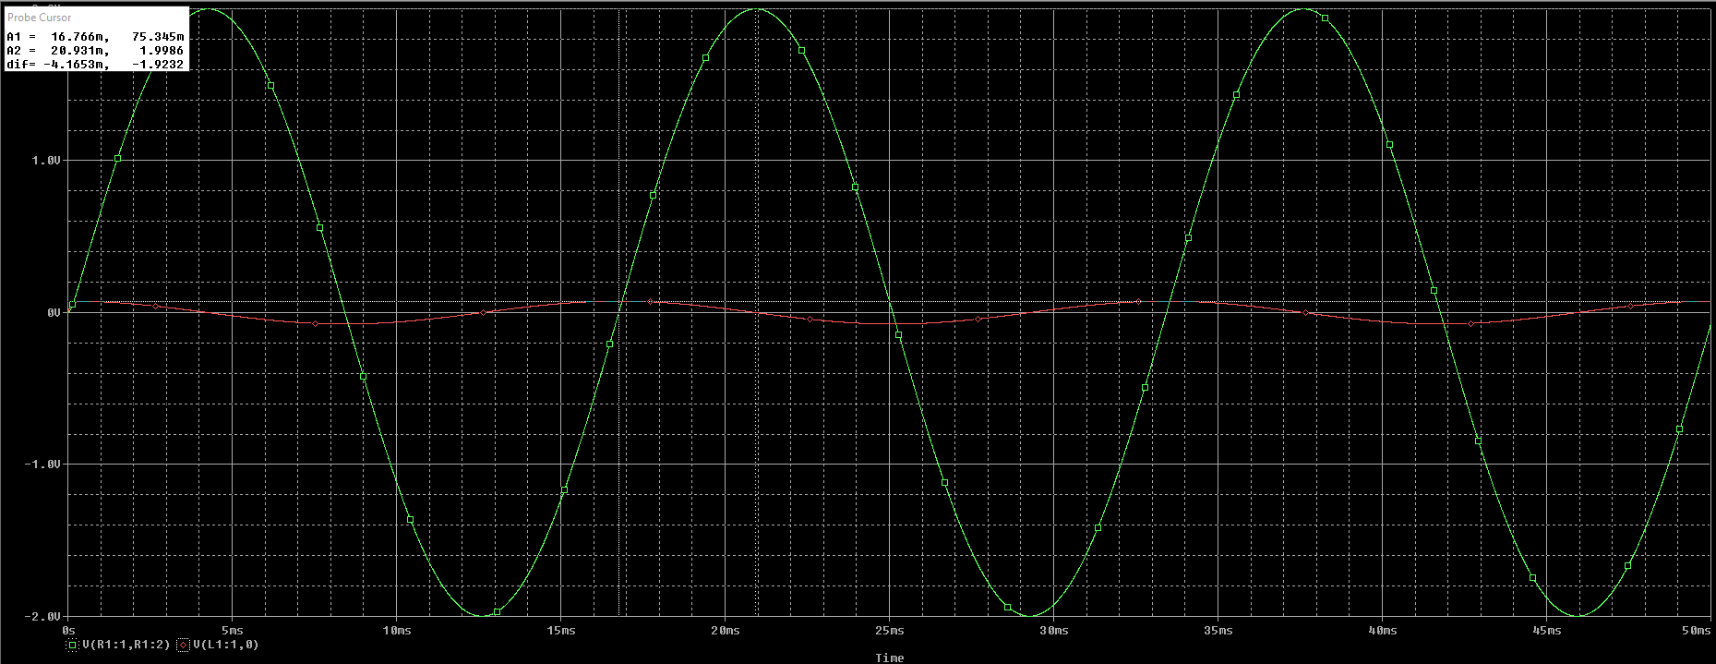

**f = 500 Hz**

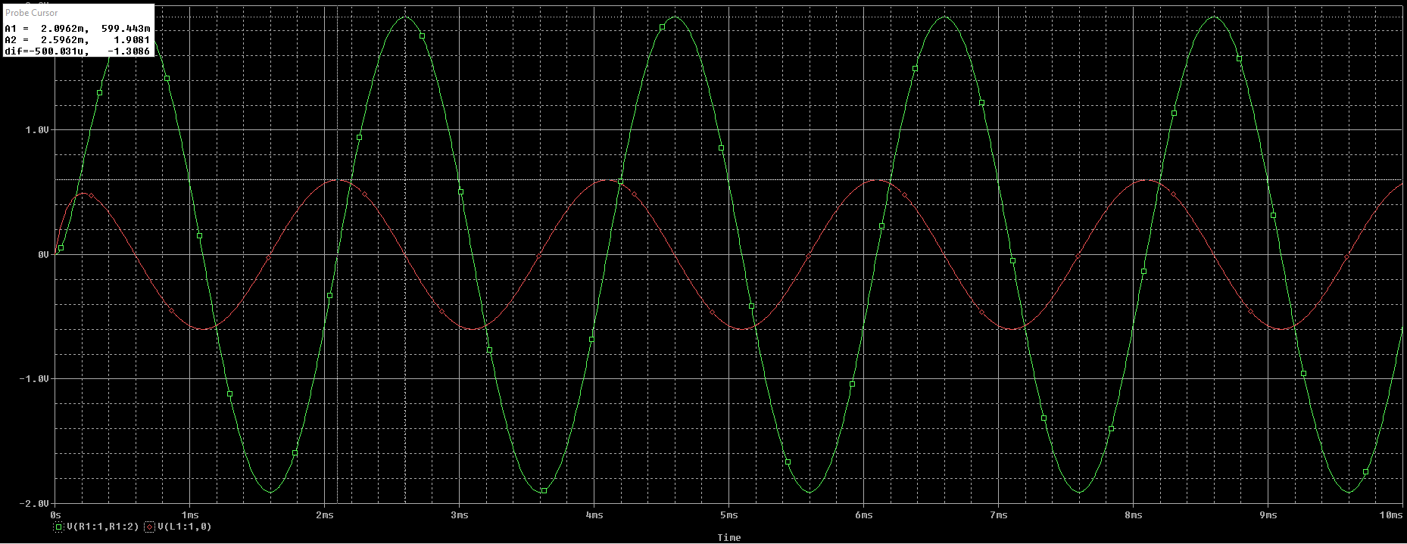

**f = 4k Hz**

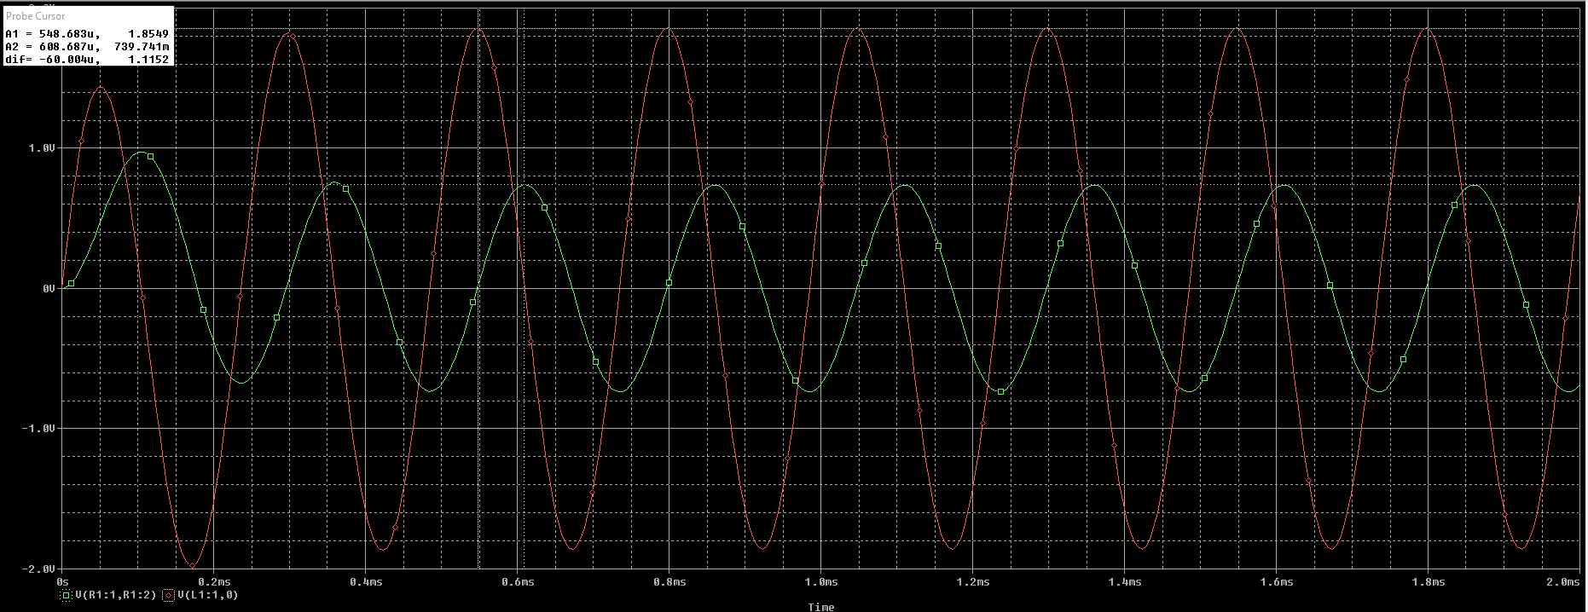

**f = 10k Hz**

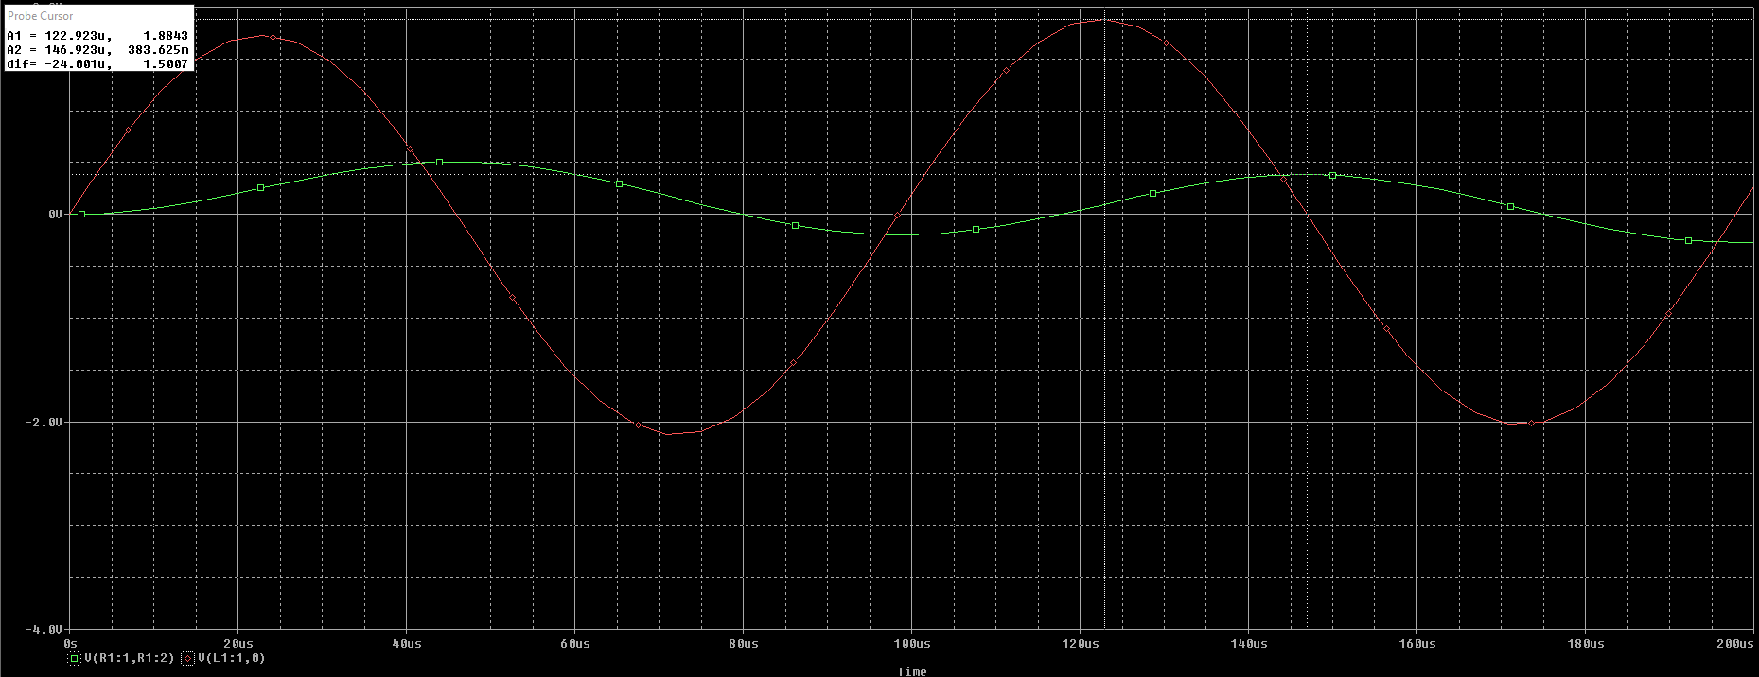

**Table**

|  |  |  |  |  |  |  |  |  |
| --- | --- | --- | --- | --- | --- | --- | --- | --- |
| **Frequency**  **(Hz)** | **Magnitude** | | | | **Phase** | | | |
| VR(t) | | VL(t) | | VR(t) | | VL(t) | |
| Simulated | Calculated | Simulated | Calculated | Simulated | Calculated | Simulated | Calculated |
| **60** | 1.998V | 1.998V | 0.075V | 0.075V | -2.217° | -2.158° | 87.78° | 87.84° |
| **500** | 1.908V | 1.908V | 0.599V | 0.599V | -17.48° | -17.44° | 72.52° | 72.56° |
| **4k** | 0.739V | 0.739V | 1.824V | 1.824V | -68.24° | -68.31° | 21.76° | 21.69° |
| **10k** | 0.314V | 0.314V | 1.885V | 1.885V | -80.85° | -80.95° | 9.151° | 9.043° |

**Conclusion:**

After performing this lab, we have learnt;

* Solving AC circuits through Phasor
* Set up capacitive/inductive circuits on breadboard through means of Function Generator and analyzed through Oscilloscope
* Simulate the circuit on PSpice and find the Phase Difference through predetermined formulae