**Department of Electrical Engineering**

**Faculty Member:**  **Kiran Liaqat Dated: 24/03/2021 **

**Semester: 2nd Section: BEE-12C **

**EE-211: Electric Network Analysis**

**Lab 5: Application of Phase Shift Circuits**

|  |  |  |  |  |
| --- | --- | --- | --- | --- |
| **PLO4/CLO4** | | **PLO5/CLO5** | **PLO8/CLO6** | **PLO9/CLO7** |
| **Name** | **Reg. No** | **Viva /Quiz / Lab Performance**  **5 marks** | **Analysis of data in Lab Report**  **5 marks** | **Modern Tool Usage**  **5 marks** | **Ethics and Safety**  **5 marks** | **Individual and Team Work**  **5 marks** |
| **Muhammad Umer** | **345834** |  |  |  |  |  |
| **Saad Bakhtiar** | **341150** |  |  |  |  |  |
|  |  |  |  |  |  |  |
|  |  |  |  |  |  |  |

**Introduction:**

Solving AC circuits through the basic circuit analysis can be tedious and often time-consuming. Being engineers, we thrive to achieve the maximum possible efficiency, and that is where Phasor comes into the play. By expressing a circuit into its respective Phasor form, and then solving it by means of familiar techniques saves us a lot of time and is relatively easy to do.

**Objective:**

After performing this lab, students will be able to:

* Solve Sinusoidal AC circuits through Phasor Alteration
* Understand phase shifts
* Implement the circuit on breadboard
* Observe +ive and -ive Phase for Reactive Circuits

**Equipment:**

* Digital Oscilloscope
* Digital Function generator
* Breadboard
* Resistor, Capacitor and Inductor

**Software:**

* PSpice

**Conduct of Lab**

The students are required to work in groups of three to four; each student must attempt to understand and use the laboratory set-up and conduct at least one or two parts of the requirement experimentation. The lab attendants and Lab Engineer will be available to assist the students.

In case some aspect of the lab experiment is not understood the students are advised to seek help from the teacher, the lab attendant or the assigned Lab Engineer (LE).

# Task (Ball Generation Circuit)

* **Assemble the phase shift circuit using the following circuit values:**

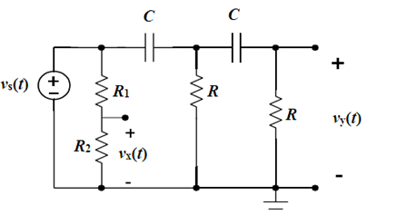

C = 0.1 u F

R1 = 2.2 k Ω

R = 4.7 k Ω

R2 =?

f =?

Vs(t) =2VP

**Theoretical**

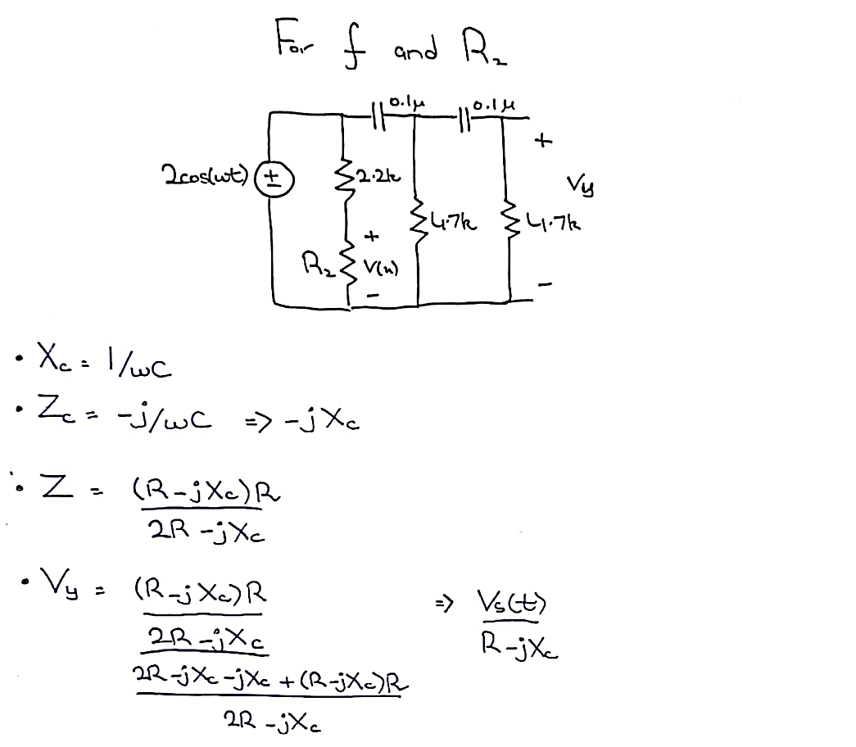

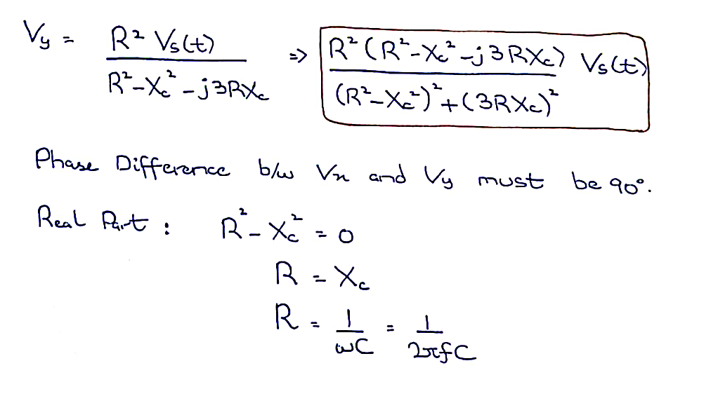

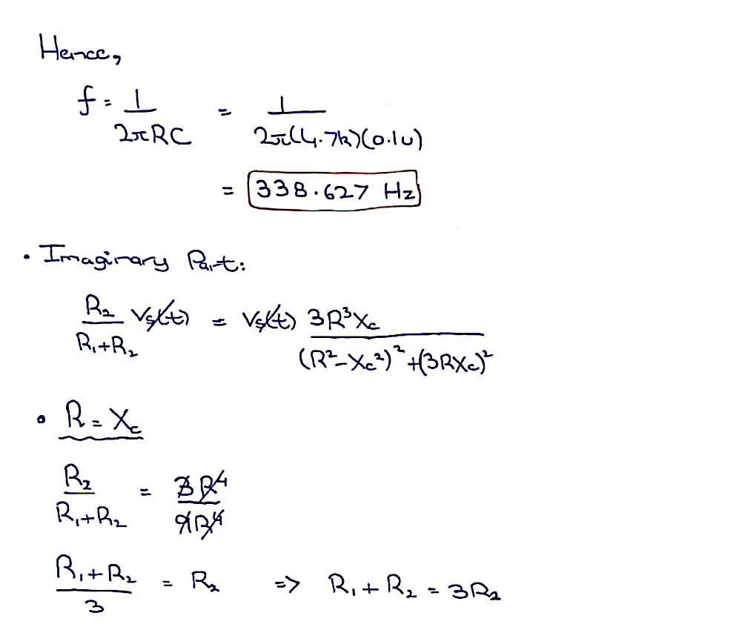

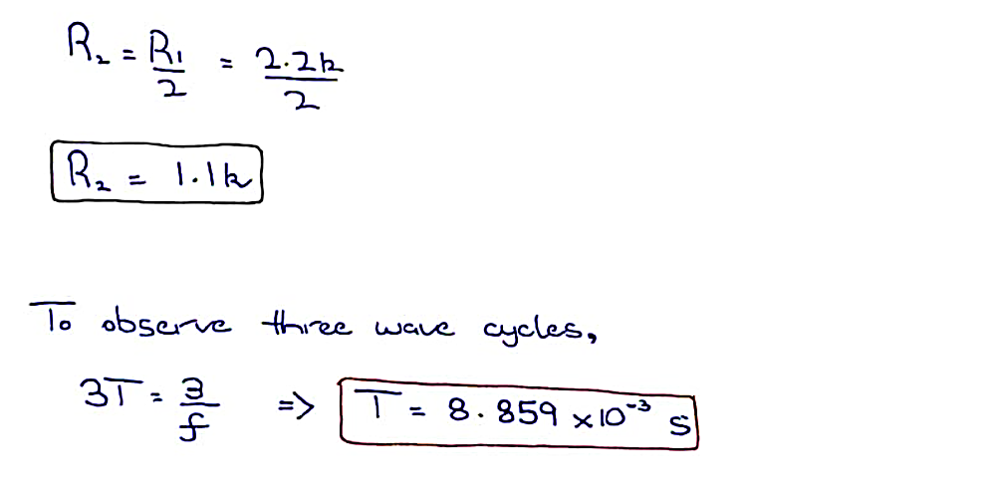

**Simulation**

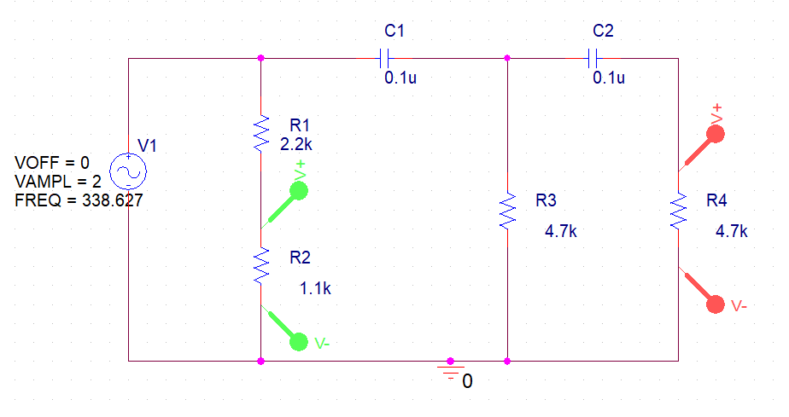

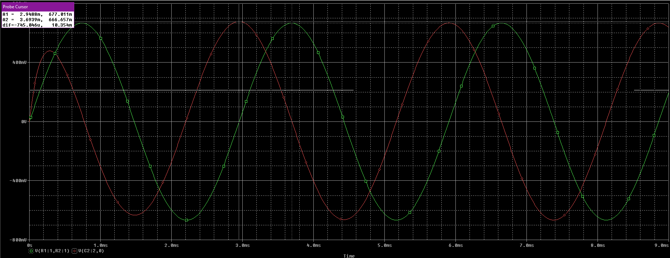



$Phase θ=360*f*∆t=360*338.627*745.046μ=90.82°$

**Hence, the Phase difference between VX and VY is 90 $°$.**

* **Questions:**

Adjust the frequency ω and resistor R2 to obtain a circle on the oscilloscope.

* ω = **2127.656 rad/s** Theoretical, **2127.66 rad/s**  Experimental (Simulated)
* R2 = **1.1 k Ω** Theoretical, **1.1 k Ω** Experimental (Simulated)

***R2 is actually a potentiometer.***

* Explain what happens to the scope figure, if either condition in part **a)** is violated.

When either condition in part **a)** i.e., either the phase angle is not 90 $°$ or the amplitude of VX and VY is not the same, the figure becomes more of an ellipse with the intesity directly to proportional to the difference in the values. If the amplitude of VX is higher than VY, then the figure is horizontally eliptical and vice versa.

**Conclusion:**

After performing this lab, we have learnt;

* Solving AC circuits through Phasor
* Setting up a ball generation circuit and observe the effects on the “ball” with the change in Amplitude and Phase Difference
* Set up the circuit on PSpice and find the phase difference from the simulation through time difference