**Department of Electrical Engineering**

**Faculty Member:**  **Kiran Liaqat Dated: 7/04/2021 **

**Semester: 2nd Section: BEE-12C **

**EE-211: Electric Network Analysis**

**Lab 6: Inductive Phase Shift and Reactive Power**

|  |  |  |  |  |
| --- | --- | --- | --- | --- |
| **PLO4/CLO4** | | **PLO5/CLO5** | **PLO8/CLO6** | **PLO9/CLO7** |
| **Name** | **Reg. No** | **Viva /Quiz / Lab Performance**  **5 marks** | **Analysis of data in Lab Report**  **5 marks** | **Modern Tool Usage**  **5 marks** | **Ethics and Safety**  **5 marks** | **Individual and Team Work**  **5 marks** |
| **Muhammad Umer** | **345834** |  |  |  |  |  |
| **Saad Bakhtiar** | **341150** |  |  |  |  |  |
|  |  |  |  |  |  |  |
|  |  |  |  |  |  |  |

**Introduction:**

Three phase power supplied is both efficient and less costly. All of our modern-day appliances run on such a system and particularly to observe the phase shifts and reactive power; an induction motor. In this lab, we observe the validity of Ohm’s Law to such reactive circuits through means of using a three-phase power supply and a workstation. We also implement the circuit on a Simulation software; LVSIM.

**Objective:**

After performing this lab, students will be able to:

* Determining Inductive Reactance through Voltage and Current
* Understand phase shifts
* Get familiar with LVSIM
* Prove the validity of Ohm’s law for Reactive Circuits

**Equipment:**

* Three Phase Power Supply
* Induction Motor
* Data Acquisition Interface
* Banana Cables

**Software:**

* LVSIM-EMS

**Conduct of Lab**

The students are required to work in groups of three to four; each student must attempt to understand and use the laboratory set-up and conduct at least one or two parts of the requirement experimentation. The lab attendants and Lab Engineer will be available to assist the students.

In case some aspect of the lab experiment is not understood the students are advised to seek help from the teacher, the lab attendant or the assigned Lab Engineer (LE).

# Task

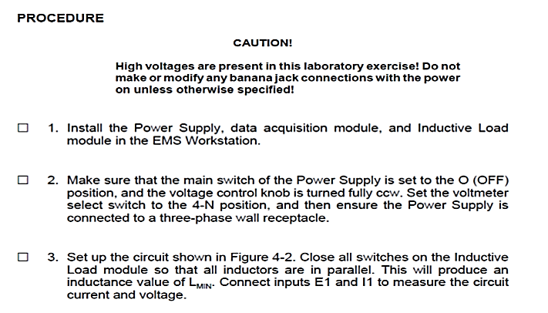

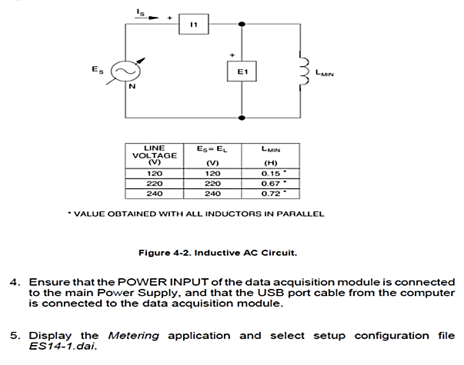

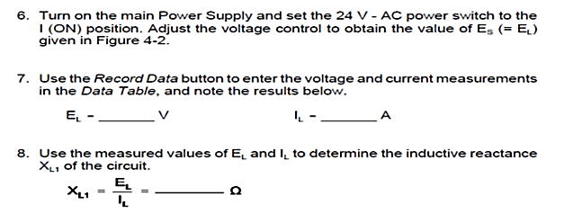

23.75V

0.020A

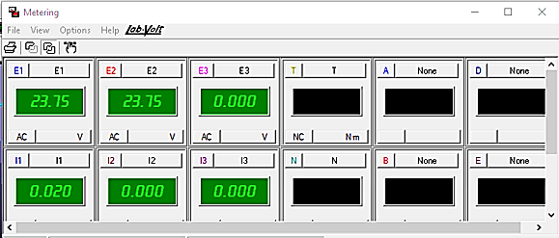

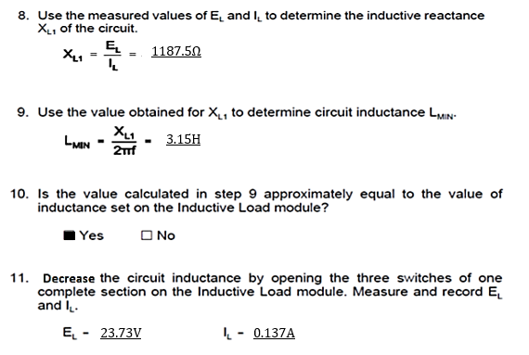

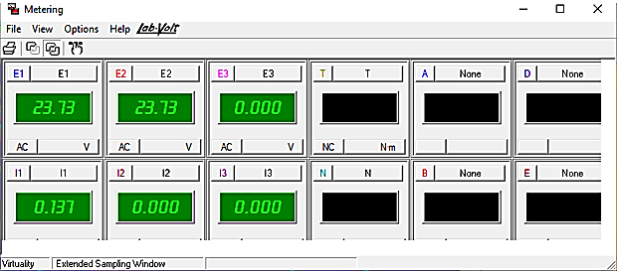

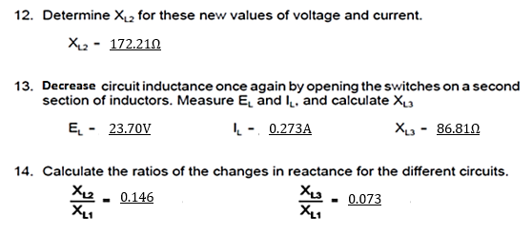

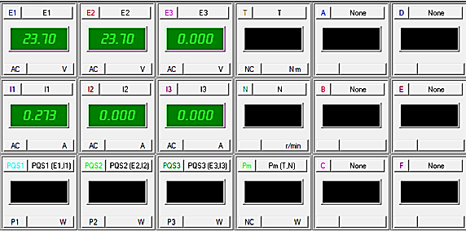

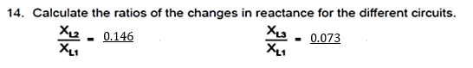

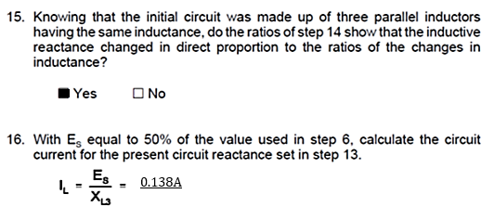

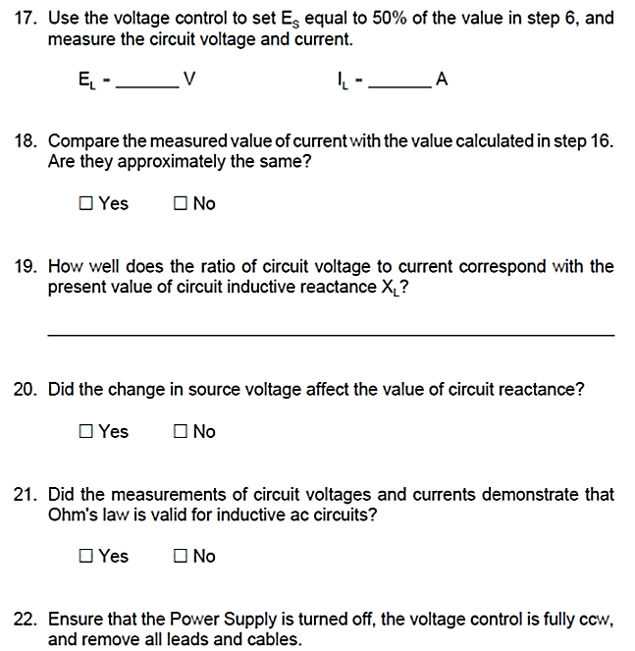

0.144A

12.47V

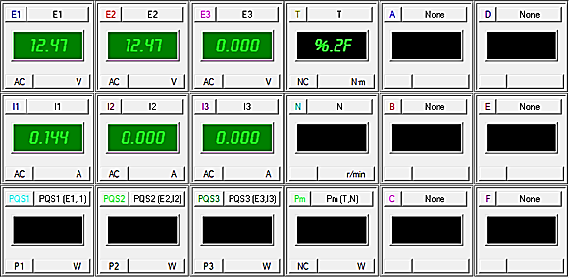

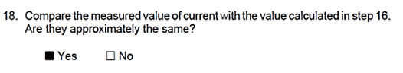

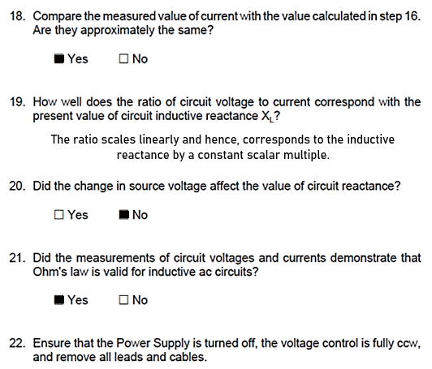

**Conclusion:**

After performing this lab, we have proved that Ohm’s Law indeed holds for AC and Inductive Circuits specifically as observed from the simulations. We’ve learned how to use three phase power supply along with respective motors with the help of Banana-Plug wires. We also familiarized ourselves with LVSIM – Electromechanical Simulator and verified the readings of the Voltmeter and Ammeter.