**Department of Electrical Engineering**

**Faculty Member:**  **Kiran Liaqat Dated: 14/04/2021 **

**Semester: 2nd Section: BEE-12C **

**EE-211: Electric Network Analysis**

**Lab 7: Capacitive Phase Shift and Reactive Power**

|  |  |  |  |  |
| --- | --- | --- | --- | --- |
| **PLO4/CLO4** | | **PLO5/CLO5** | **PLO8/CLO6** | **PLO9/CLO7** |
| **Name** | **Reg. No** | **Viva /Quiz / Lab Performance**  **5 marks** | **Analysis of data in Lab Report**  **5 marks** | **Modern Tool Usage**  **5 marks** | **Ethics and Safety**  **5 marks** | **Individual and Team Work**  **5 marks** |
| **Muhammad Umer** | **345834** |  |  |  |  |  |
| **Saad Bakhtiar** | **341150** |  |  |  |  |  |
|  |  |  |  |  |  |  |
|  |  |  |  |  |  |  |

**Introduction:**

Three phase power supplied is both efficient and less costly. All of our modern-day appliances run on such a system and particularly to observe the phase shifts and reactive power; a capacitive circuit. In this lab, we observe the validity of Ohm’s Law to such reactive circuits through means of using a three-phase power supply and a workstation. We also implement the circuit on a Simulation software; LVSIM.

**Objective:**

After performing this lab, students will be able to:

* Determining Inductive Reactance through Voltage and Current
* Understand phase shifts
* Get familiar with LVSIM
* Prove the validity of Ohm’s law for Reactive Circuits

**Equipment:**

* Three Phase Power Supply
* Induction Motor
* Data Acquisition Interface
* Banana Cables

**Software:**

* LVSIM-EMS

**Conduct of Lab**

The students are required to work in groups of three to four; each student must attempt to understand and use the laboratory set-up and conduct at least one or two parts of the requirement experimentation. The lab attendants and Lab Engineer will be available to assist the students.

In case some aspect of the lab experiment is not understood the students are advised to seek help from the teacher, the lab attendant or the assigned Lab Engineer (LE).

# Task

1. Install the Power Supply, data acquisition module, and Capacitive Load module in the EMS Workstation.

2. Make sure that the main switch of the Power Supply is set to the O (OFF) position, and the voltage control knob is turned fully ccw. Ensure the Power Supply is connected to a three-phase wall receptacle.

3. Set up the circuit shown in Figure 3-9, and connect inputs E1 and I1 to measure the circuit voltage and current. Set the Capacitive Load module for the value of CMAX given in Figure 3-9.

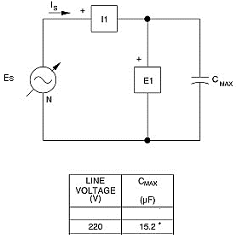

**Figure 3-9. Capacitive Phase Shift and Reactive Power in an AC Circuit**

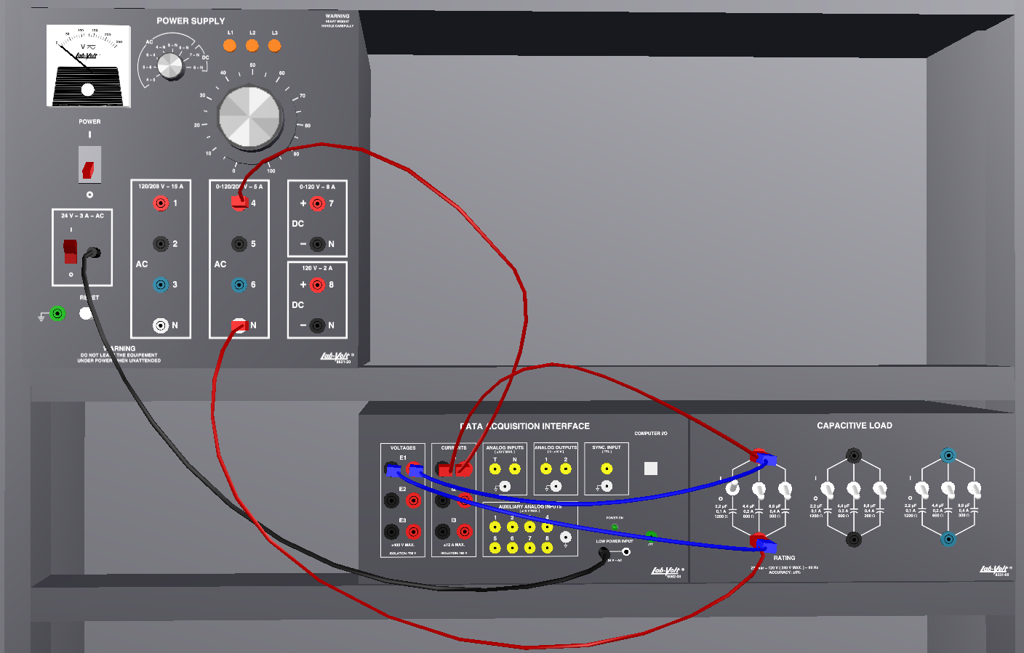

4. Ensure that the POWER INPUT of the data acquisition module is connected to the main Power Supply, and that the USB port cable from the computer is connected to the data acquisition module. Display the Metering application. Select setup configuration file **ES13-4.dai** for the exercise.

5. Turn on the main Power Supply and set the **24 V - AC** power switch to the I (ON) position. Turn on only one capacitor 2.2µF.

6. Note the rms values of the voltage and current, and the apparent power (S) displayed by the meters.

**ES = 23.76V IS = 0.02A S (PQS1) = 0.468VA**

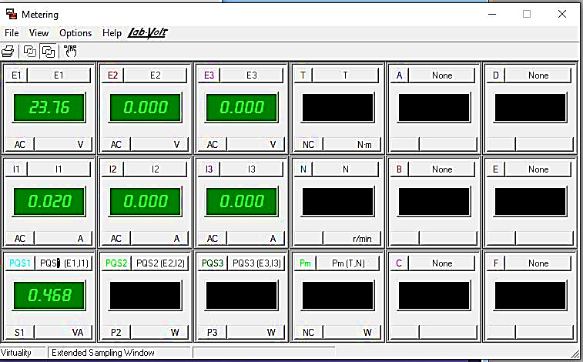

7. Is the apparent power equal to the product of the rms values of voltage and current?

**Yes** No

8. Click on the Oscilloscope button and display **E1, I1,** and **P1** on **CH1, CH2**, and CH3. Ensure that the time base control is adjusted to show at least two/one complete cycles of the sine waves.

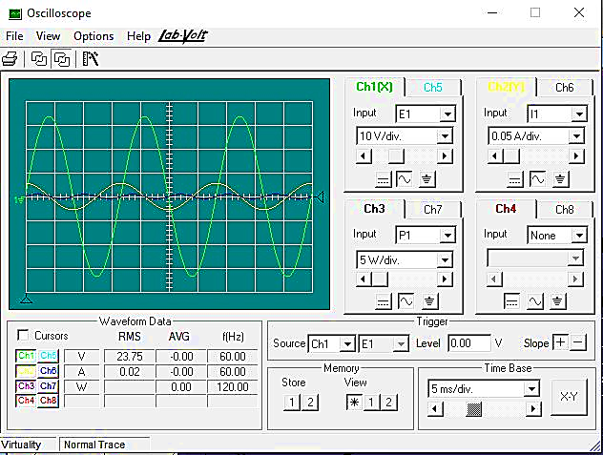

9. Compare the current waveform with the voltage waveform. Are they both sine waves at the same frequency?

**Yes** No

10. What is the phase shift between the voltage and current?

Phase shift = **-79.27o**

11. Does step 10 confirm that the current leads the voltage by about 90O?

**Yes** No

12 Does the current waveform attain its maximum when the voltage is going through zero amplitude, and become zero when the voltage is going through its maximum?

**Yes** No

13. Determine the period and frequency of the instantaneous power waveform?

**T = 8.3ms f =**

14. How does the frequency of the instantaneous power waveform compare with that of the AC source?

**The frequency of the instantaneous power (waveform) is, ideally*, twice* the frequency of AC source.**

15. Does the instantaneous power waveform show that the areas of positive and negative power are approximately equal?

**Yes** No

16. Calculate the apparent power (S) by multiplying of the rms values of the current and voltage displayed on the oscilloscope and compare it with the active power P [average (AVG) power value of P1 given in the waveform data box of the Oscilloscope screen].

Apparent power (S) = **ES x IS = 0.475VA**

Active power (P) **= 0W**

17. Do the results of step 16 confirm that the apparent power and the active power are different, due to the presence of reactive power (Q) in the circuit?

**Yes** No

18. What is the total active power consumed by the circuit?

**PACTIVE = 0W**

19. Is the instantaneous power zero when the current or the voltage is zero?

**Yes** No

20. Change the circuit capacitance by opening the three switches on one section of the Capacitive Load module.

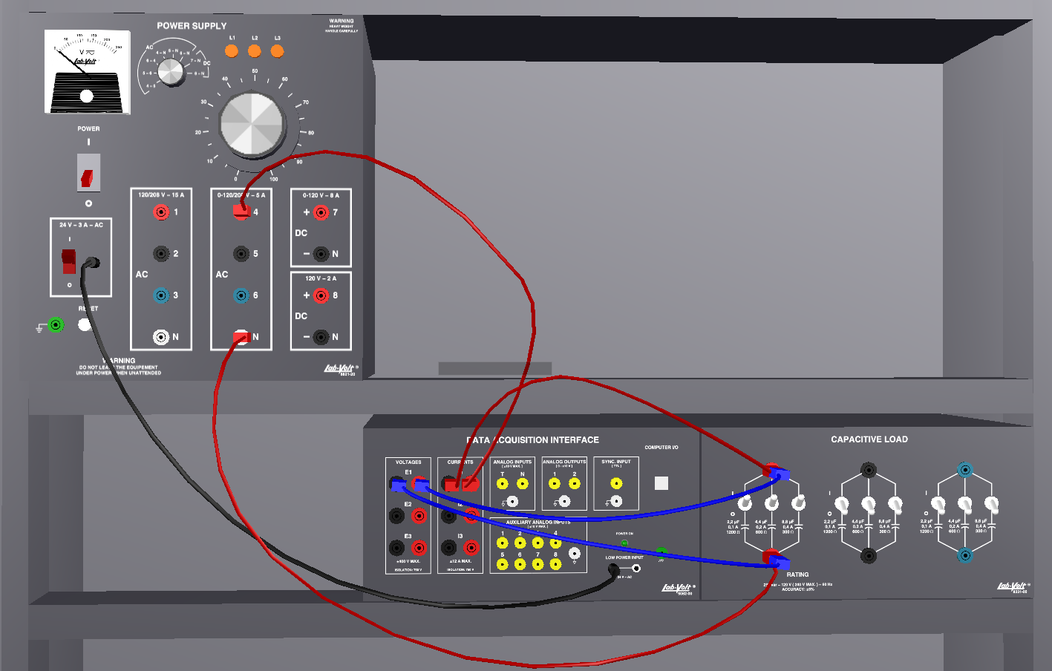

21. What effect does the change in capacitive reactance produce on the circuit current, voltage and reactive power?

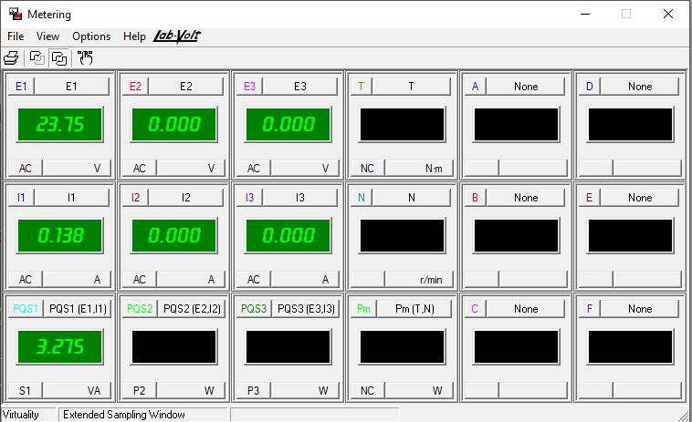

22. Did the phase shift between the current and voltage change?

Yes **No**

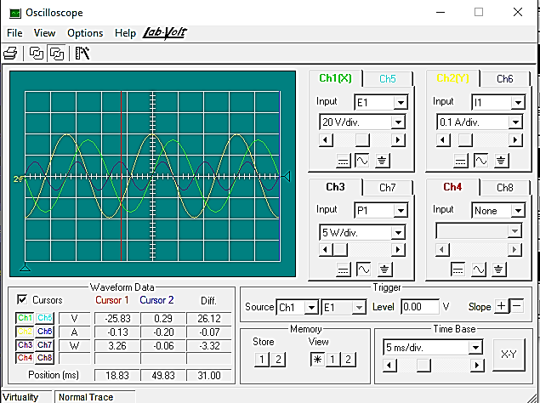

23. Why is the instantaneous power waveform different in amplitude?

**Instantaneous power is calculated through the formula:**

**P = VRMS x IRMS cos ()**

**Hence, when the current increases, the instantaneous power also increases.**

24. Ensure that the Power Supply is turned off, the voltage control is fully CCW, and remove all leads and cables.

**Conclusion**

You determined capacitive phase shift in an ac circuit using measurements of the current and voltage waveforms. You examined the instantaneous power waveform and saw that there was no active power dissipated in the capacitive circuit. Finally, observation of the circuit waveforms allowed you to confirm the theoretical behaviour of the circuit current and voltage.