**Department of Electrical Engineering**

**Faculty Member:**  **Kiran Liaqat Dated: 24/04/2021 **

**Semester: 2nd Section: BEE-12C **

**EE-211: Electric Network Analysis**

**Lab 8: Power in AC Circuits**

|  |  |  |  |  |
| --- | --- | --- | --- | --- |
| **PLO4/CLO4** | | **PLO5/CLO5** | **PLO8/CLO6** | **PLO9/CLO7** |
| **Name** | **Reg. No** | **Viva /Quiz / Lab Performance**  **5 marks** | **Analysis of data in Lab Report**  **5 marks** | **Modern Tool Usage**  **5 marks** | **Ethics and Safety**  **5 marks** | **Individual and Team Work**  **5 marks** |
| **Muhammad Umer** | **345834** |  |  |  |  |  |
| **Saad Bakhtiar** | **341150** |  |  |  |  |  |
|  |  |  |  |  |  |  |
|  |  |  |  |  |  |  |

**Introduction:**

Three phase power supplied is both efficient and less costly. All of our modern-day appliances run on such a system and particularly to observe the phase shifts and reactive power. In ac circuits, apparent power is always greater than active power when the load contains reactance, because reactive power must be supplied by the source. The reactive power may be inductive or capacitive, but in most electromechanical deceives it will be inductive because of the inductance of the coils in transformers and motors.

**Objective:**

After performing this lab, students will be able to:

* Determining Inductive Reactance through Voltage and Current
* Understand phase shifts
* Get familiar with LVSIM
* Prove the validity of Ohm’s law for Reactive Circuits

**Equipment:**

* Three Phase Power Supply
* Induction Motor
* Data Acquisition Interface
* Banana Cables

**Software:**

* LVSIM-EMS

**Conduct of Lab**

The students are required to work in groups of three to four; each student must attempt to understand and use the laboratory set-up and conduct at least one or two parts of the requirement experimentation. The lab attendants and Lab Engineer will be available to assist the students.

In case some aspect of the lab experiment is not understood the students are advised to seek help from the teacher, the lab attendant or the assigned Lab Engineer (LE).

# Task

1. Install the Power Supply, Data Acquisition Interface, Resistive Load, Inductive Load, and Capacitive Load Modules in the EMS work stations.
2. Make sure that the main switch of the power supply is set to **O** (Off), position, and the voltage control knob is turned fully ccw. Set the voltmeter select switch to the 4-N position, and the ensure the power supply is connected to a 3 Phase wall receptacle.

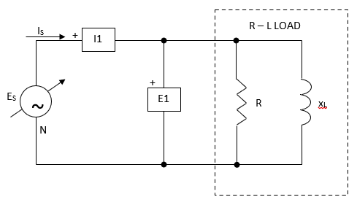

|  |  |  |  |
| --- | --- | --- | --- |
| LINE VOLTAGE  (V) | ES  (V) | R  (Ω) | XL  (Ω) |
| 120 | 120 | 100 | 100 |
| 220 | 220 | 367 | 367 |
| 240 | 240 | 400 | 400 |

**Figure 5-5. RL Load to Simulate an AC Motor**

1. Setup the current shown in Figure 5-5. The RL section of the circuit simulates the load of a single-phase AC motor. Connect all 3 sections of the resistive and inductive load modules in parallel and set R and XL to the values given. Connect I1 and E1 is shown to measure the circuit current and voltage.

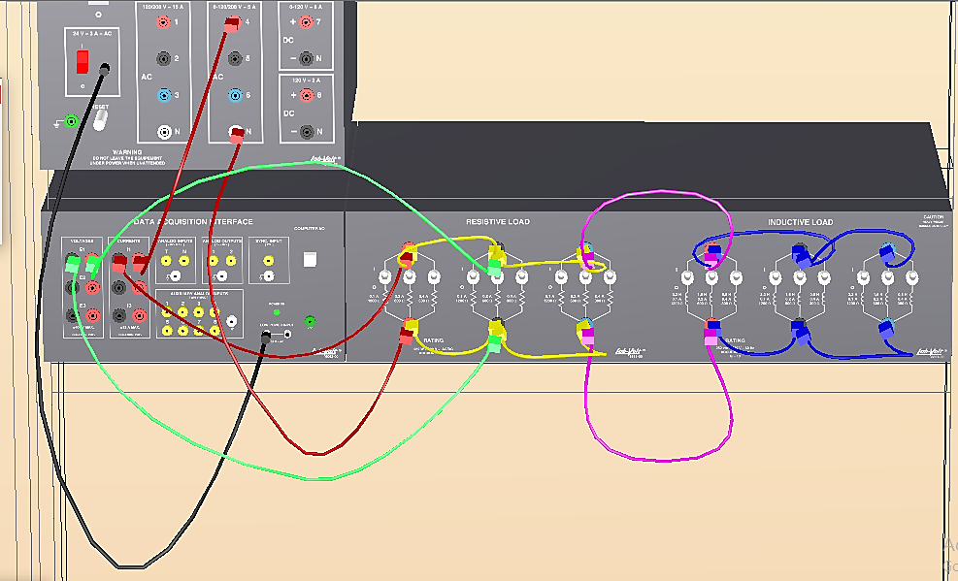

1. Ensure that the DAI LOW POWER INPUT is connected to the main power supply and the USB Port cable from the computer is connected to the DAI.
2. Display the metering application and select setup configuration file ES15-1.dai.
3. Turn on the power supply and set the 24 V-AC power switches to the I (ON) position. Adjust the voltage control to obtain the value of ES given in figure 5-5.

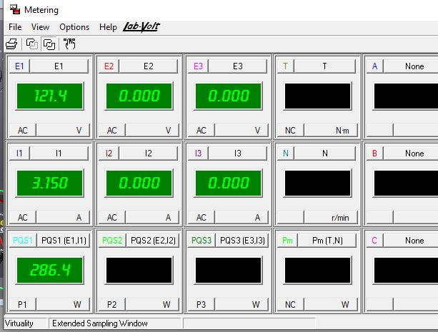

1. Measure the load voltage and current, and the active power consumed by the circuit. Note the results, and then turn off the power.

E = **121.4 V** I = **3.15 A** P = **286.4 W**

1. Use the measured values of E and I to determine the apparent power supplied to the load.

S = E x I = **382.41 VA**

1. Determine the power factor cos φ, and the reactive power Q.

cos φ = $\frac{P}{S}$ **= 0.749 $Q= \sqrt{S^{2}- P^{2}}$ = 253.4 VAR**

1. Do the values calculated in step 9 demonstrate a low power factor and a notable amount of reactive power for the simulated motor load?

**Yes** No

1. Modify the RL circuit by adding capacitive reactance in parallel with the load as shown in Figure 5-6. Ensure that all sections of the Capacitive Load module are connected in parallel, and that all the switch on the module are open.
2. Turn on the power and add capacitance to the circuit by closing the first switch in each section one after the other, then the middle switches, and finally the third switch in each section, until all switches have been closed.

At each new value of capacitance, click the record data button to record the line current measurement in the data table.

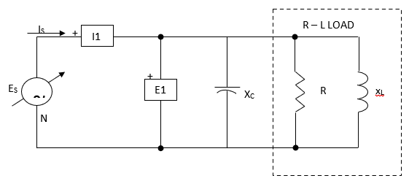

|  |  |  |  |
| --- | --- | --- | --- |
| LINE VOLTAGE  (V) | ES  (V) | R  (Ω) | XL  (Ω) |
| 120 | 120 | 100 | 100 |
| 220 | 220 | 367 | 367 |
| 240 | 240 | 400 | 400 |

**Figure 5-6. Power Factor Correction by Adding Capacitive Reactance**

1. After all data values have been recorded, display the graph window, select l1 as the Y-axis parameter, and make sure the line graph format and the linear scale are selected. Observe the line current variation curve. Does the line current increase, decrease, or stay the same as more and more capacitance is added to the circuit?

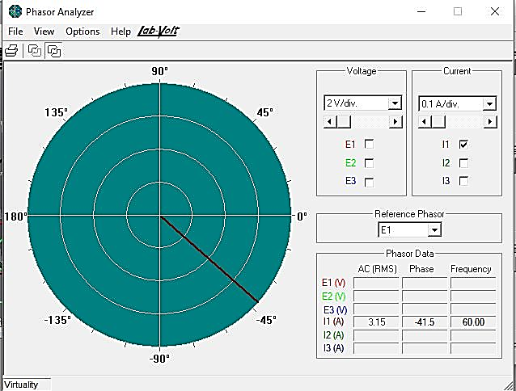

1. Is there a point at which the line current stops decreasing, and then starts to increase again when more capacitance is added?

Yes **No**

1. Carefully adjust the switches on the capacitive load module to obtain minimum line current, while readjusting the voltage control as necessary to maintain the exact value of Es given in the table. Use the settings on the module to determine the value of capacitive reactance that produces minimum line current.

$X_{C}= \frac{1}{2πfC}$ = **57.44 Ω**

***Note:*** *You will have notice that the line current is minimum when the capacitive reactance equals the inductive reactance. The negative reactive power then cancels the positive reactive power, and line current is minimized.*

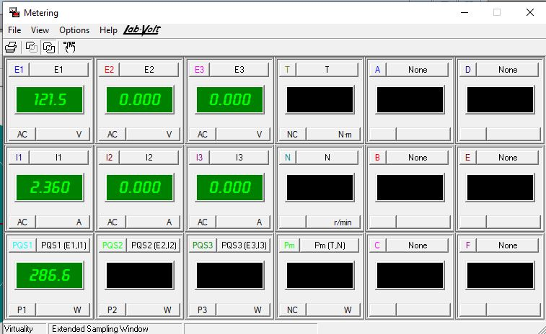

1. With XC adjusted for minimum line current, record the value of E, IMIN and the active power on PQS1.

E = **121.5 V** IMIN = **2.36 A** P1 = **286.6 W**

1. Determine the apparent power S.

S = E x IMIN = **286.74 VA**

1. Calculate the power factor cos φ, and the reactive power Ω.

cos φ = $\frac{P1}{S}$ = **0.995 $Q= \sqrt{S^{2}- {P1}^{2}}$** = **8.96 VARS**

1. Has the reactive power consumed by the circuit decreased between step 9 and step 18?

**Yes** No

1. Has the line current been reduced by a significant amount with the addition of capacitance?

**Yes**  No

1. Is the active power consumed by the RL load approximately the same with and without capacitance?

**Yes** No

1. Ensure that the Power Supply is turned off, the voltage control is full CCW, and remove all leads and cables.

**Conclusion**

You determined the active, relative and apparent power for an inductive, load, and were able to observe the effect produced by adding capacitance in parallel with the load. You saw how the power factor can be improved with the addition of capacitance, and you were able to demonstrate that line current can be reduced without affecting the amount of active power consumed by the load.