# Department of Electrical Engineering

**CS212**

**Object Oriented Programming**



# Lab 10: Polymorphism

**Class**: BEE - 12C

**Date**: December 7th, 2021

**Time**: Monday (1400 – 1700)

**Name**: Muhammad Umer

**CMS ID**: 345834

**Tools**

* Microsoft Visual Studio 2013

**Lab Tasks**

Given the following:

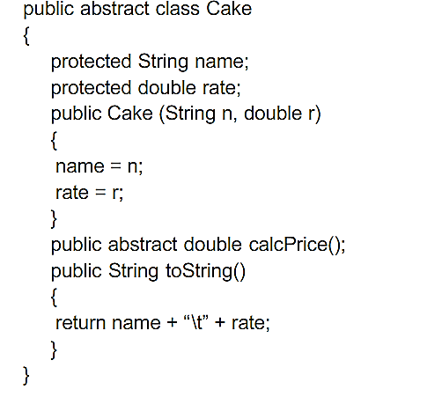

1. Based on class Cake and the following table, define TWO subclasses named as orderCake and readymadeCake

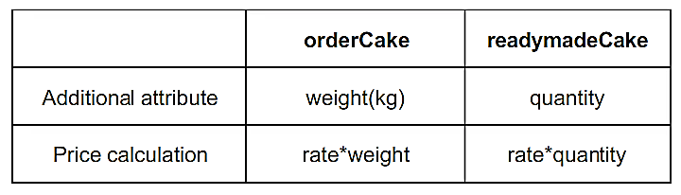

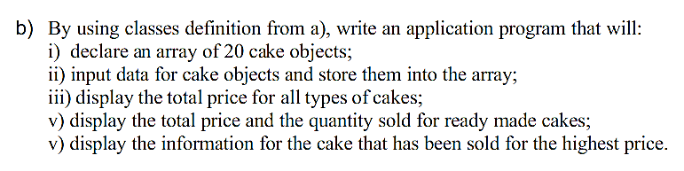

**Code**

// Inclusion of Libraries

#include <iostream>

#include <string>

using namespace std;

// Base Class Body

class Cake {

protected:

    string name;

    double rate;

public:

    double price;

    Cake(){

        name = "Cake";

        rate = 0.01;

    }

    Cake(string n, double r){

        name = n;

        rate = r;

    }

    // Pure Virtual Function

    virtual double calcPrice() = 0;

    void getData(){

        cout << "\tInput the Name of Cake: ";

        cin.ignore();

        getline(cin, name);

        cout << "\tInput Rate: ";

        cin >> rate;

    }

    string toString(){

        return name + "\t" + to_string(rate);

    }

};

// Dervied Class for Ordered Cakes

class orderCake : public Cake {

protected:

    double weight;

public:

    orderCake(){

        weight = 5.00;

    }

    orderCake(double w){

        weight = w;

    }

    double calcPrice(){

        price = weight * rate;

        return price;

    }

};

// Derived Class for Ready Made Cakes

class readymadeCake : public Cake {

protected:

    int quantity;

public:

    readymadeCake(){

        quantity = 1;

    }

    readymadeCake(int q){

        quantity = q;

    }

    double calcPrice(){

        price = quantity * rate;

        return price;

    }

};

int main() {

    Cake *c[20];

    double weight, temp_price;

    int quantity;

    char choice;

    cout << "\t\tInput Data for Cakes!\n";

    // Loop to iterate over the base class array

    for (int i = 0; i < 20; i++){

        cout << "Input your choice: Order or Readymade?\n";

        cin >> choice;

        if (choice == 'o')

        {

            cout << "\tInput Weight: ";

            cin >> weight;

            // Dynamically assign derived class object to

            // the base class array's index

            c[i] = new orderCake(weight);

            c[i]->getData();

            temp_price = c[i]->calcPrice();

            cout << "\nPrice of Cake: " << temp_price << " $" << "\n\n";

        }

        if (choice == 'r')

        {

            cout << "\tInput Quantity: ";

            cin >> quantity;

            // Dynamically assign derived class object to

            // the base class array's index

            c[i] = new readymadeCake(quantity);

            c[i]->getData();

            temp_price = c[i]->calcPrice();

            cout << "\nPrice of Cake: " << temp_price << " $" << "\n\n";

        }

    }

    // Block to calculate the total price of all cakes

    double tp = 0;

    for (int i = 0; i < 20; i++){

        tp += c[i]->calcPrice();

    }

    cout << "\nTotal Price of All Cakes: " << tp << " $" << endl;

    // Block to find the information about

    // the highest valued cake

    int rt_index = 1;

    for (rt_index = 1; rt_index < 20; ++rt_index)

    {

       if(c[0]->price < c[rt_index]->price)

       {

           c[0]->price = c[rt_index]->price;

       }

    }

    --rt_index;

    string hi_info;

    hi_info = c[rt_index]->toString();

    // Printing information about highest priced cake

    cout << "\n\tCake Sold at the Highest Price\n";

    cout << "Name and Rate: " << hi_info << endl;

    cout << "Price: " << c[rt_index]->price << " $" << endl;

    return 0;

}

**Terminal Output**

Input Data for Cakes!

Input your choice: Order or Readymade?

o

        Input Weight: 1

        Input the Name of Cake: A

        Input Rate: 0.1

Price of Cake: 0.1 $

Input your choice: Order or Readymade?

r

        Input Quantity: 1

        Input the Name of Cake: B

        Input Rate: 0.2

Price of Cake: 0.2 $

Input your choice: Order or Readymade?

o

        Input Weight: 2

        Input the Name of Cake: C

        Input Rate: 0.3

Price of Cake: 0.6 $

Input your choice: Order or Readymade?

r

        Input Quantity: 3

        Input the Name of Cake: D

        Input Rate: 0.6

Price of Cake: 1.8 $

Input your choice: Order or Readymade?

o

        Input Weight: 4

        Input the Name of Cake: E

        Input Rate: 0.9

Price of Cake: 3.6 $

Input your choice: Order or Readymade?

o

        Input Weight: 5

        Input the Name of Cake: F

        Input Rate: 0.12

Price of Cake: 0.6 $

Input your choice: Order or Readymade?

r

        Input Quantity: 8

        Input the Name of Cake: G

        Input Rate: 0.3

Price of Cake: 2.4 $

Input your choice: Order or Readymade?

o

        Input Weight: 3

        Input the Name of Cake: H

        Input Rate: 0.15

Price of Cake: 0.45 $

Input your choice: Order or Readymade?

r

        Input Quantity: 6

        Input the Name of Cake: I

        Input Rate: 0.9

Price of Cake: 5.4 $

Input your choice: Order or Readymade?

r

        Input Quantity: 2

        Input the Name of Cake: J

        Input Rate: 0.98

Price of Cake: 1.96 $

Input your choice: Order or Readymade?

r

        Input Quantity: 3

        Input the Name of Cake: K

        Input Rate: 0.2

Price of Cake: 0.6 $

Input your choice: Order or Readymade?

o

        Input Weight: 5

        Input the Name of Cake: L

        Input Rate: 1.03

Price of Cake: 5.15 $

Input your choice: Order or Readymade?

o

        Input Weight: 2

        Input the Name of Cake: M

        Input Rate: 1.08

Price of Cake: 2.16 $

Input your choice: Order or Readymade?

r

        Input Quantity: 4

        Input the Name of Cake: N

        Input Rate: 1.23

Price of Cake: 4.92 $

Input your choice: Order or Readymade?

r

        Input Quantity: 7

        Input the Name of Cake: T

        Input Rate: 4.32

Price of Cake: 30.24 $

Total Price of All Cakes: 114.23 $

Cake Sold at the Highest Price

Name and Rate: T        4.320000

Price: 30.24 $