# Department of Electrical Engineering

**CS212**

**Object Oriented Programming**



# Lab 9: Polymorphism

**Class**: BEE - 12C

**Date**: November 22th, 2021

**Time**: Monday (1400 – 1700)

**Name**: Muhammad Umer

**CMS ID**: 345834

**Tools**

* Microsoft Visual Studio 2013

**Lab Tasks**

Create an abstract person class with pure virtual functions getData() . The student and professor classes add new data items to the base class. The student class contains a variable gpa of type float, which represents the student’s grade point average (GPA). The professor class contains a variable numPubs, of type int, which represents the number of scholarly publications the professor has published.

The test program should let the user enter number of student and teacher names. For students, the program also asks for the GPA, and for professors it asks for the number of publications. When the user is finished, the program prints out the names of all the students and professors with their relevant information.

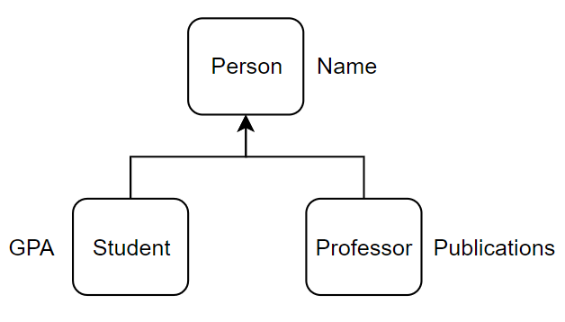

**Code**

#include <iostream>

#include <string>

using namespace std;

class Person {

public:

    string name;

    virtual void getData() = 0;

    void getName() {

        cout << "\nEnter a name: ";

        getline(cin, name);

    }

};

class Professor : public Person {

public:

    int numPubs;

    void getData()

    {

        cout << "Enter Number of Publications of the Professor: ";

        cin >> numPubs;

    }

};

class Student : public Person {

public:

    float GPA;

    void getData()

    {

        cout << "Enter GPA of the Student: ";

        cin >> GPA;

    }

};

int main() {

    Professor prof;

    Student stud;

    int n_student = 0, n_professor = 0, n = 0;

    cout << "Enter the number of Students: ";

    cin >> n_student;

    string st_name[n_student];

    float st_gpa[n_student];

    string prof_name[n_student];

    int prof_pubs[n_student];

    for (int i = 0; i < n_student; i++){

        cin.ignore();

        stud.getName();

        stud.getData();

        st_gpa[i] = stud.GPA;

        st_name[i] = stud.name;

    }

    cout << "__________________________________\n\n";

    cout << "Enter the number of Professors: ";

    cin >> n_professor;

    for (int i = 0; i < n_professor; i++){

        cin.ignore();

        prof.getName();

        prof.getData();

        prof_pubs[i] = prof.numPubs;

        prof_name[i] = prof.name;

    }

    cout << "_____________________________\n";

    cout << "\nInformation of Students";

    for (int x = 0; x < n_student; x++)

    {

        cout << "\nName of Student: " << st_name[x];

        cout << "\nGPA of Student: " << st_gpa[x];

    }

    cout << "\n\nInformation of Professors";

    for (int y = 0; y < n_professor; y++)

    {

        cout << "\nName of Professor: " << prof_name[y];

        cout << "\nPublications of Professor: " << prof_pubs[y];

    }

    cout << "\n_____________________________\n\n";

    system("pause");

    return 0;

}

**Terminal Output**

Enter the number of Students: 2

Enter a name: Ahmed Mohsin

Enter GPA of the Student: 4.00

Enter a name: Muhammad Umer

Enter GPA of the Student: 3.87

_____________________________

Enter the number of Professors: 1

Enter a name: Taha Ali

Enter Number of Publications of the Professor: 23

_____________________________

Information of Students

Name of Student: Ahmed Mohsin

GPA of Student: 4

Name of Student: Muhammad Umer

GPA of Student: 3.87

_____________________________

Information of Professors

Name of Professor: Taha Ali

Publications of Professor: 23

_____________________________